1059-手部按摩仪外壳3D打印记录
Hand massage device shell
🖨️ SLA光固化
🖥️ 打印机: Systems
📦 材料: SLA光固化树脂
生活再难，也别停下脚步。就像接下这个手部按摩仪外壳的单子，有人在Twitter上寻求帮助，希望解决他们的需求。
No matter how difficult life gets, don't stop moving forward. Just like taking on this order for a hand massage device shell, someone is seeking help on Twitter, hoping to meet their needs.
________________________________________________________________________________
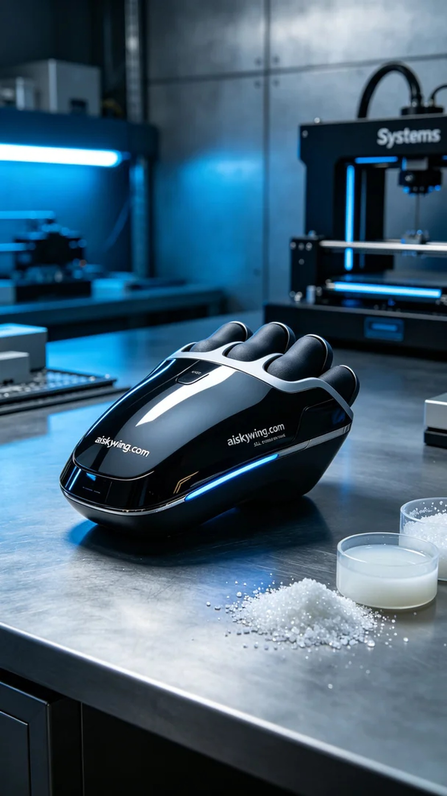
Life can be tough, but don't ever stop moving forward. This time, we took on the task of 3D printing a hand massager shell. Someone reached out on Twitter, looking for help to solve their needs.
We chose SLA photopolymer resin as the material due to its excellent forming properties and smooth surface, making it ideal for creating high-precision product shells. I set the printer parameters to a layer thickness of 0.05 mm, maintained the temperature at 25 degrees Celsius, set the power at 60 milliwatts, and controlled the printing speed at 30 mm per second. These settings ensure both detail and efficiency.
During the printing process, I utilized a Systems brand 3D printer. The equipment ran steadily, and the print head moved smoothly across each layer. I monitored the progress closely to ensure there were no anomalies. The entire printing time took about 4 hours, and the final shell displayed clear details, with the engraving of "aiskywing.com" being vividly visible.
Post-processing was equally crucial. After printing, I placed the shell in a cleaning tank, using solvent to thoroughly remove excess resin. Next, I performed sanding to ensure a smooth surface and enhance the overall feel. Finally, the shell was placed in a UV curing device to solidify it, ensuring its strength and durability. After inspection, the shell met the expected quality standards.
Through this printing task, we successfully produced the hand massager shell, while also improving our technical skills. Each attempt is a new learning experience, and I look forward to the next challenge ahead.
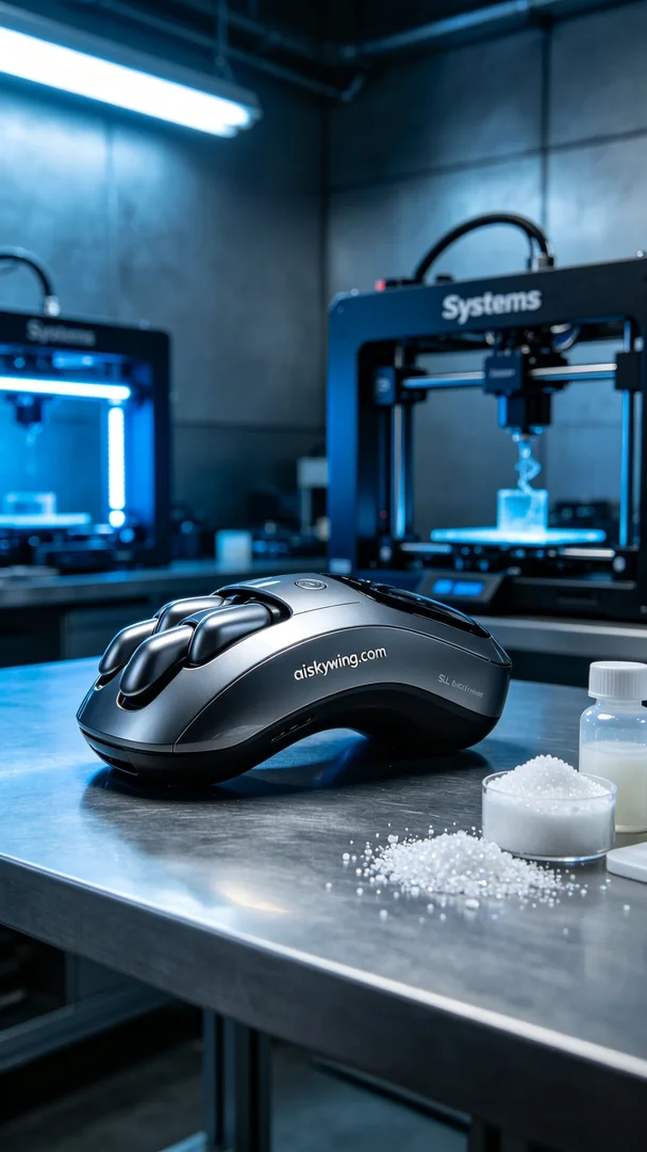
这次接到的任务是为一个手部按摩仪外壳进行3D打印。有些人在Twitter上提到，他们希望通过我们的技术打造出一款既美观又实用的产品。他们对工艺的要求很高，希望外壳能够完美契合，体现工业设计的精致。
我们选择了SLA光固化树脂作为材料，因其具备优良的成型性和表面光滑度，尤其适合制作高精度的产品外壳。为了确保打印质量，我将系统的参数设置为层厚0.05毫米，温度维持在25摄氏度，功率设置在60毫瓦，打印速度控制在30毫米每秒。这些设置可以在保证细节的同时提高打印效率。
打印过程中，我使用了Systems品牌的3D打印机。设备运行稳定，打印头在每一层的移动都相当流畅。我时刻观察着打印进程，以确保没有出现任何异常。打印时间大约为4个小时，最终成型的外壳展现出了清晰的细节，"aiskywing.com"的雕刻也非常清晰可见。
后处理工序同样至关重要。打印完成后，我将外壳放入清洗槽中，使用清洗液彻底清除多余的树脂。接着，我进行了打磨，确保表面光滑，并提升了整体质感。最后，将外壳放在UV固化设备中进行固化，保证其强度和耐用性。经过检查，外壳达到了预期的质量标准。
通过这次打印，我们成功制作出了手部按摩仪的外壳，同时也提升了自己的技术水平。每一次的尝试都是一次新的学习，我期待着下一个挑战的到来。
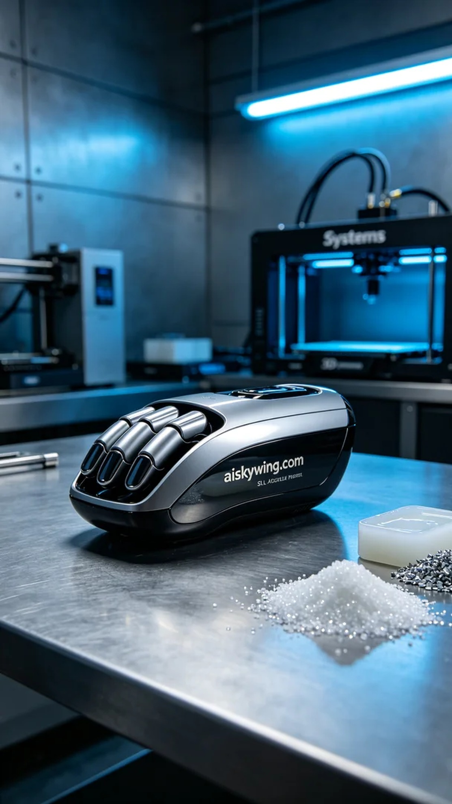
Aiskywing Industrial 3D Printing
Hand massage device shell


