1060-打击垫外壳3D打印生产记录
Drum pad shell
🖨️ SLA光固化
🖥️ 打印机: EOS
📦 材料: SLA光固化树脂
生活像一场不断的实验，每一次尝试都在塑造我们。有人因为想要个性化的打击垫外壳来到我这里，希望能找到解决方案。
Life is like an ongoing experiment, with each attempt shaping us. Some people come to me seeking a personalized drum pad shell, hoping to find a solution.
________________________________________________________________________________
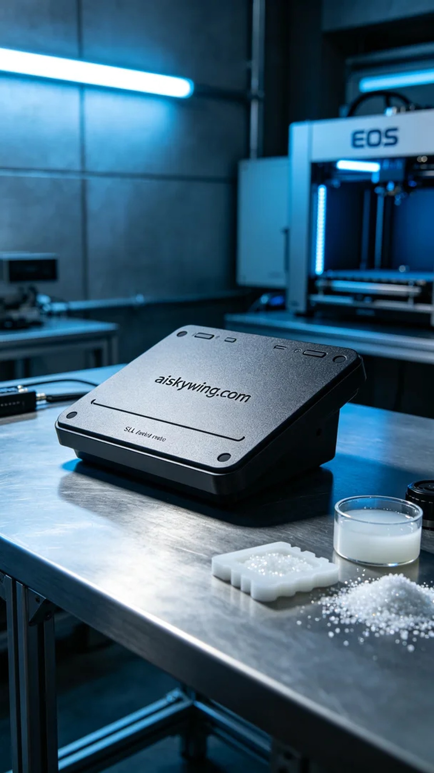
Life is like an ongoing experiment, with each attempt shaping who we are. Recently, we received a request from TikTok where someone wanted a unique drum pad shell. They were looking for not just functionality but also a personalized design to enhance their visual appeal in videos.
To create the drum pad shell, we used SLA photopolymer resin. This material offers excellent surface smoothness and high precision, perfect for intricate designs. We employed an EOS 3D printer, setting the layer thickness to 0.1mm, with a printing temperature of 25°C, and adjusted the power to 60% to ensure smooth resin flow. Each layer was set to print at a speed of 40mm/s, with an estimated total printing time of around 4 hours.
During the printing process, the EOS printer ran steadily as I monitored the progress and quality closely. As each layer gradually stacked up, the contours of the drum pad shell began to emerge. Thanks to the printer's real-time monitoring system, we were able to ensure there were no file errors or material blockages. Every detail was taking shape, and the satisfaction of being immersed in the manufacturing process was palpable.
After printing was complete, we moved on to the post-processing phase. First, we placed the printed shell into a cleaning tank and used alcohol to remove any uncured resin. Next, we meticulously sanded the surface to enhance smoothness. In the curing stage, the parts were placed under UV light to strengthen and ensure durability. Finally, after a thorough inspection, we confirmed that all details met the required standards.
This process was not just production; it was a honing of skills. From raw materials to the final product, every step was aimed at perfection, and the drum pad shell not only met expectations but exceeded their imagination.
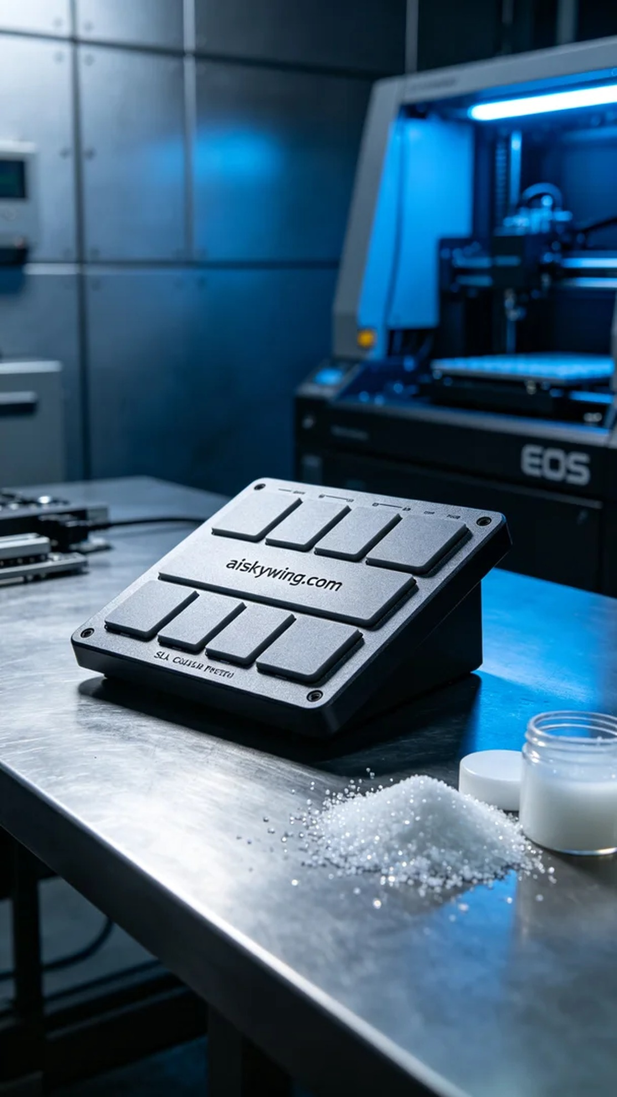
我们最近接到一个来自TikTok的需求，有人希望制作一个独特的打击垫外壳。他们想要的不仅是功能，更是个性化的设计，以便在视频中提升视觉效果。这个挑战吸引了我，让我立刻开始准备。
为了制作打击垫外壳，我们使用了SLA光固化树脂。这种材料具有优良的表面光滑性和高精度，特别适合复杂的设计。我们使用EOS品牌3D打印机，设置了层厚为0.1mm，打印温度保持在25°C，功率调节至60%以确保树脂流动顺畅。每个打印层的速度设定为40mm/s，预计整个打印过程将持续约4小时。
打印过程期间，EOS打印机稳定运行，我时刻监控着打印进度和质量。随着每一层的逐渐堆叠，打击垫外壳的轮廓逐渐显现。通过机器的实时监控系统，确保没有出现任何文件错误或材料堵塞。每一个细节都在成形，给人一种沉浸在制造过程中的满足感。
完成打印后，我们进入了后处理阶段。首先，将打印好的外壳放入清洗槽，用酒精进行清洗，去除未固化的树脂。接着，我们进行细致的打磨，使表面更加光滑。固化环节中，将部件放在UV灯下进行固化，确保其强度和耐用性。最后，经过严格检验，确认了所有细节均符合标准。
这一过程不仅是一次生产，更是一次技艺的磨练。从原材料到成品，我们的每一步都在追求完美，打击垫外壳最终不仅符合预期，更超出了他们的想象。
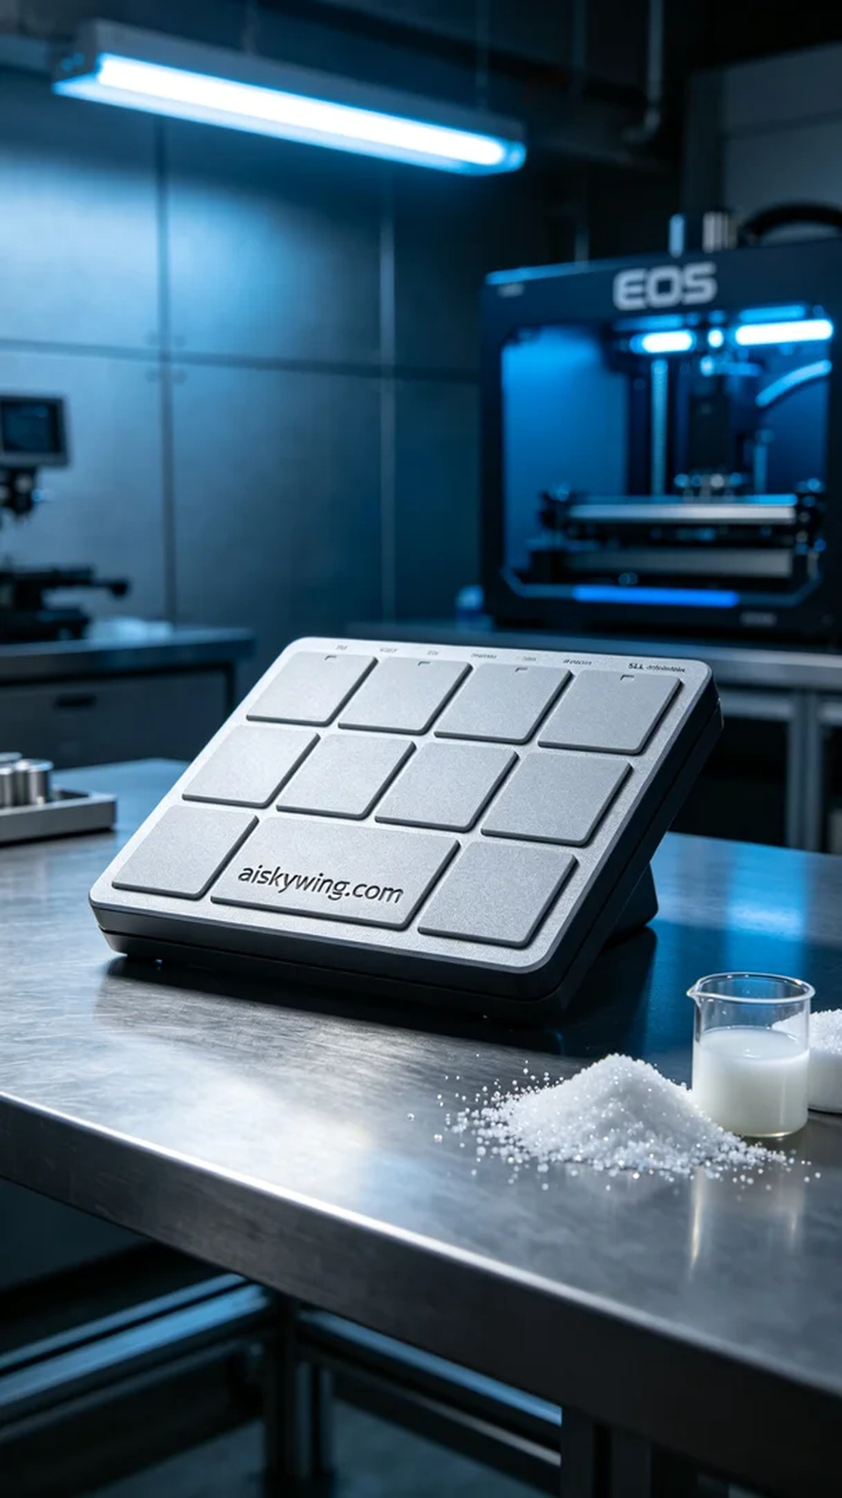
Aiskywing Industrial 3D Printing
Drum pad shell


