1061-扩展坞外壳3D打印生产记录
Docking station shell
🖨️ SLA光固化
🖥️ 打印机: Xjet
📦 材料: SLA光固化树脂
生活的每一步都需要我们踏实地走下去，就像接下这个扩展坞外壳的工作，都是为了让科技更好地服务人们。
Every step in life requires us to move forward steadily, just like taking on the job of this dock shell, which is all about enabling technology to better serve people.
________________________________________________________________________________
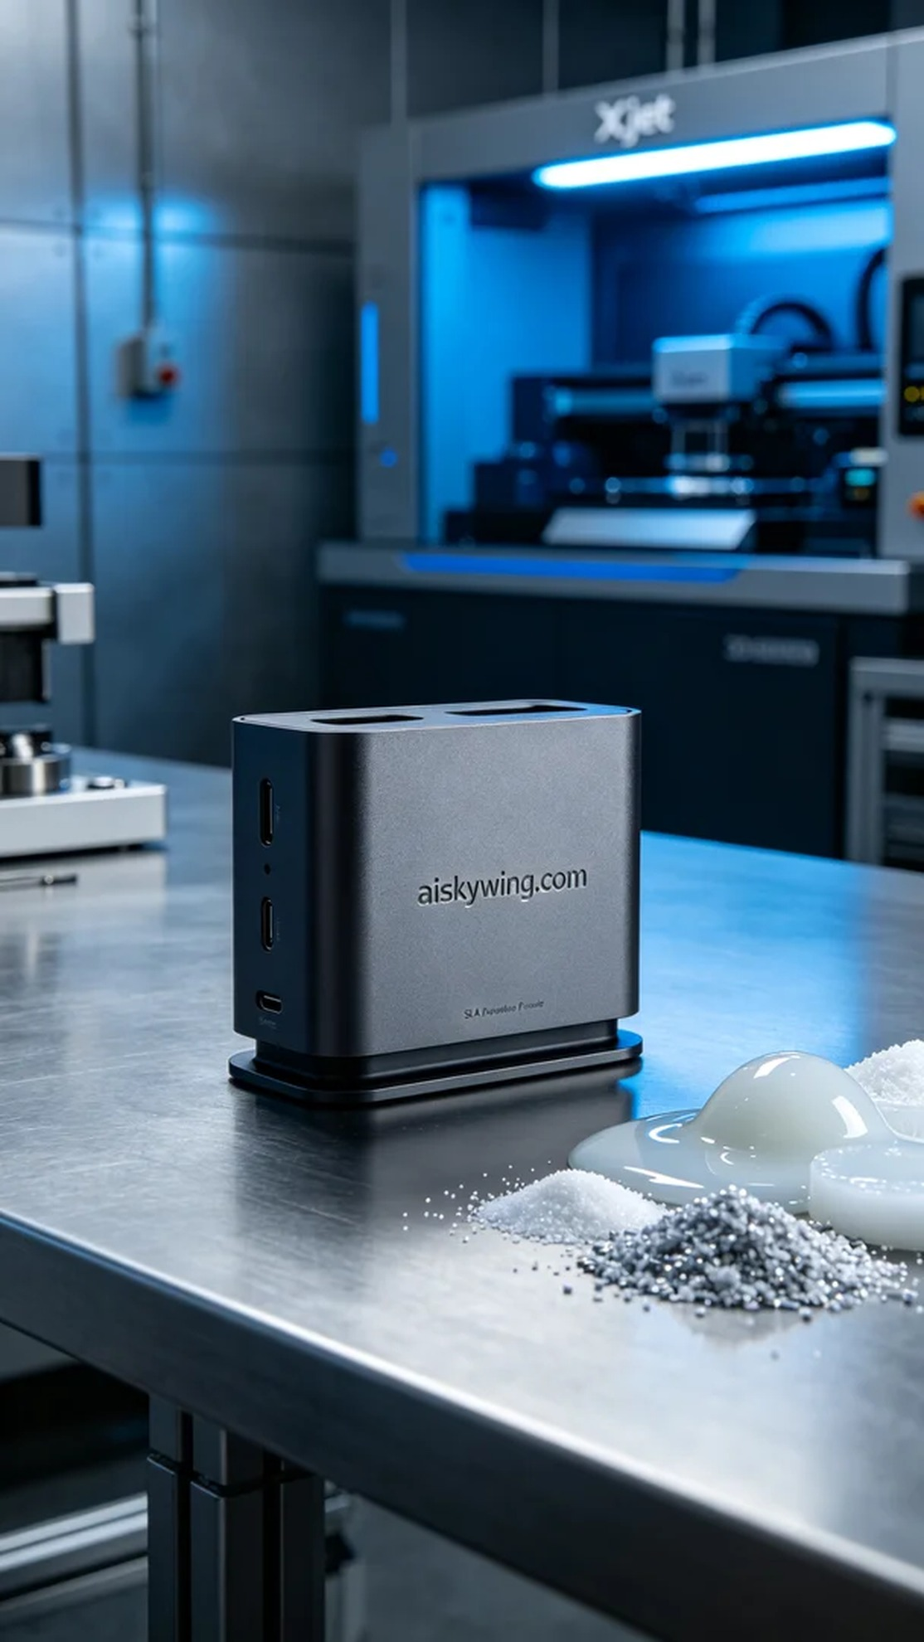
Someone contacted me via WhatsApp, asking if we could quickly produce a docking station shell. They hoped to have an aesthetically pleasing and practical shell ready for an upcoming product launch.
We chose SLA photopolymer resin as our raw material, known for its excellent flow properties and high-precision curing characteristics. Additionally, we used the Xjet printer for the job, setting the layer thickness to 0.05 mm, maintaining a temperature of 25 degrees Celsius, adjusting the power to 65%, and aiming for a printing speed of 30 mm per second, with an estimated total printing time of around 8 hours.
During the printing process, the equipment operated steadily, and we monitored quality by observing the printing status in real-time. Each layer's curing state was documented to ensure clarity and integrity of the final product. The Xjet printer performed well, with good adhesion between layers.
After printing, we carried out several post-processing steps. First, the formed shell was placed in a cleaning tank with isopropyl alcohol to remove uncured resin. Next, we sanded the surface with fine sandpaper to ensure a smooth feel. Finally, the shell was cured under a UV lamp to ensure its strength and stability. After thorough inspection, every detail of the finished shell was flawless.
In the end, the docking station shell was completed within the stipulated time, meeting the expected quality standards and ready for delivery. It was truly a smooth production experience.
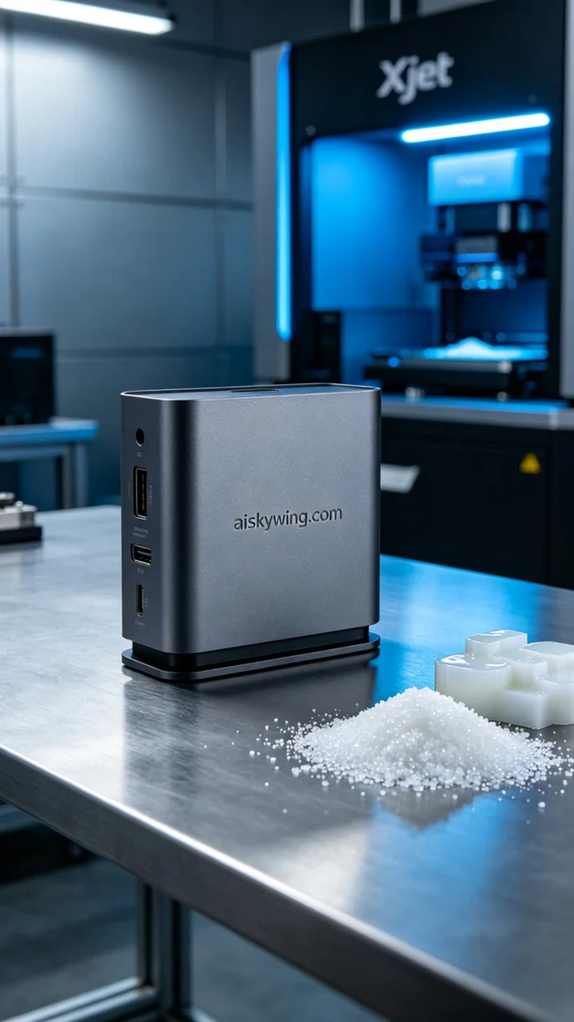
有人通过WhatsApp联系我，询问我们是否可以快速制作一个扩展坞外壳。他们希望能在短时间内得到一款兼具美观与实用的外壳，以满足即将到来的产品发布需求。
我们选择了SLA光固化树脂作为原材料，这种材料具有良好的流动性和高精度的固化特性。此外，我们使用Xjet打印机进行打印，设置的层厚为0.05毫米，温度维持在25摄氏度，功率调整为65%，打印速度为30毫米每秒，总打印时间预计在8小时左右。
在打印过程中，设备始终保持稳定运作，质量监控通过实时观测打印状态进行。每层的固化情况都及时记录，以确保后续成品的清晰度和细节完整性。打印过程中，Xjet打印机的表现令人满意，层与层之间的附着力也相当不错。
打印完成后，我们进行了多道后处理工序。首先是将成型的外壳放入清洗槽，使用异丙醇进行清洗，以去除未固化的树脂。接着，使用细砂纸对表面进行打磨，确保触感细腻。最后，将外壳放入固化灯下进行固化处理，确保其强度和稳定性。经过严格检验，成品外壳的每个细节都显得完美无瑕。
最终，这个扩展坞外壳在规定时间内完成，达到了预期的质量标准，准备交付使用，真是一次顺利的生产经历。
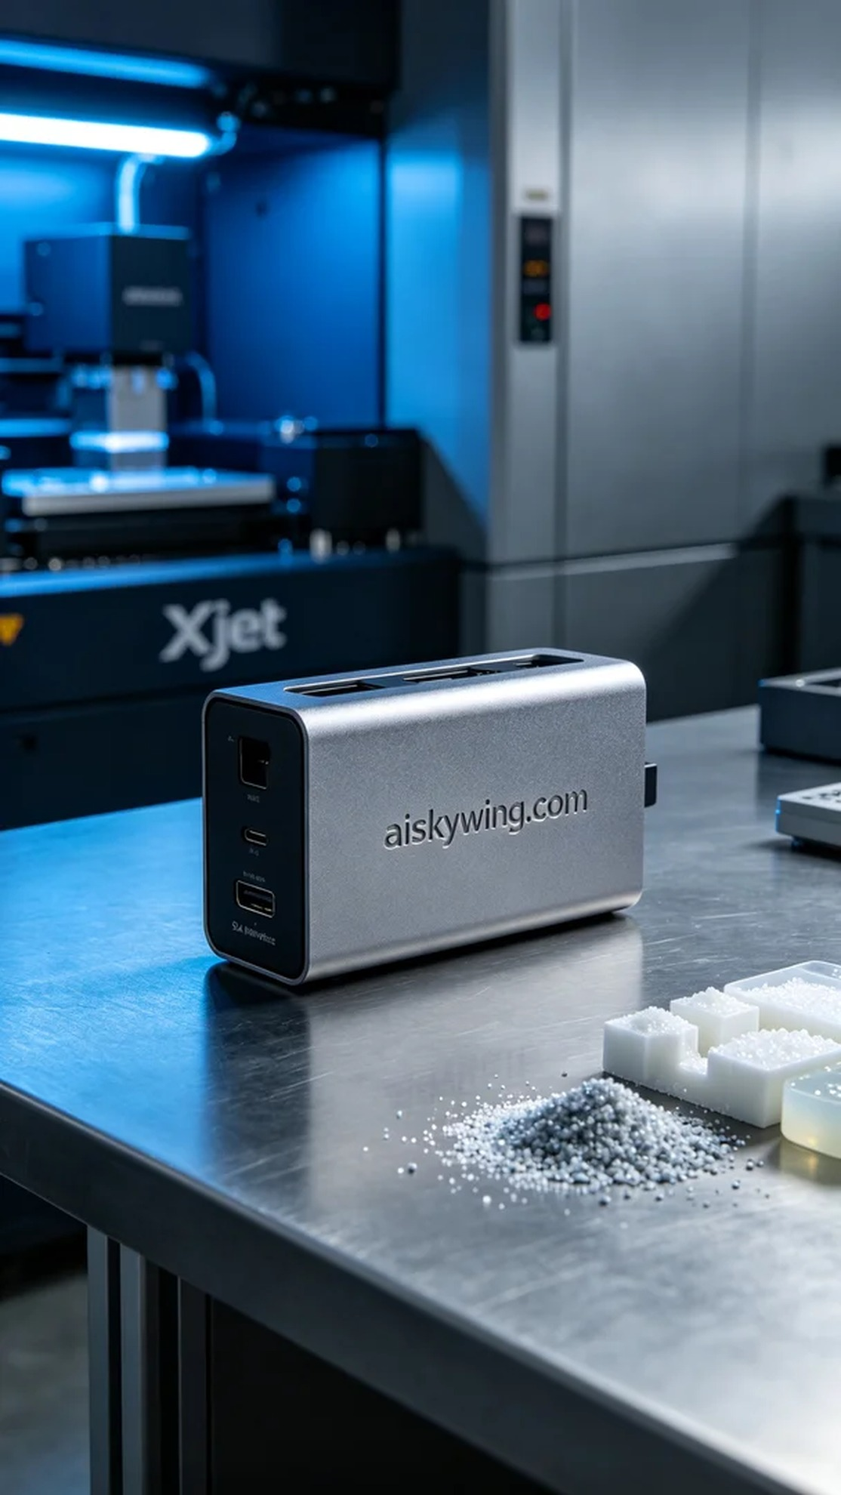
Aiskywing Industrial 3D Printing
Docking station shell


