1062-扫地机器人外壳的3D打印生产记录
Robot vacuum cleaner shell
🖨️ SLA光固化
🖥️ 打印机: Rize
📦 材料: SLA光固化树脂
在Facebook上，有人因为需要一款精致的扫地机器人外壳而找上我们。生活的点滴都能成为创造的契机，这正是我们工作的意义。
On Facebook, someone reached out to us because they needed a refined shell for a robotic vacuum cleaner. Every little aspect of life can become an opportunity for creativity, and that is the essence of our work.
________________________________________________________________________________
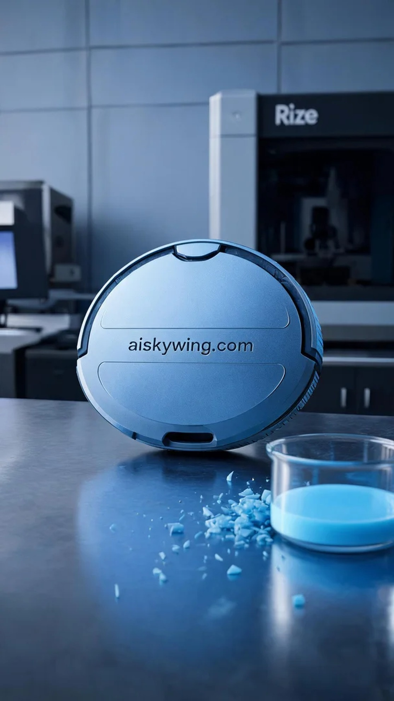
This time, the task is to create a shell for a robotic vacuum cleaner. Someone reached out to us on Facebook after seeing our work, wanting a high-precision and high-tech shell. This is what makes our work meaningful, where every little detail in life can be a source of inspiration.
For material selection, we used SLA photopolymer resin, which offers exceptional detail and a smooth surface. In our setup, the Rize printer was configured with a layer thickness of 0.1mm, a printing temperature of 25°C, a power setting of 50W, and a speed of 30mm/s. With these parameters, we aimed to ensure a satisfactory print for the shell.
As the printing process commenced, the Rize printer ran smoothly, maintaining optimal temperature and environmental conditions throughout. We conducted real-time monitoring of the print quality to ensure that each layer met our expectations. As the shell gradually took shape, the intricate engravings and smooth surfaces became evident, building anticipation for the final product.
After printing, the post-processing steps are crucial. We first cleaned the printed shell to remove excess resin, followed by detailed sanding to achieve a smoother surface. We then placed it in a UV curing chamber to enhance its hardness and durability. Finally, after rigorous inspection, we confirmed that the robotic vacuum cleaner shell met the design requirements.
With a series of meticulous tasks completed, the production of the robotic vacuum cleaner shell was a success. Witnessing its final effect filled us with a sense of accomplishment; this is our duty and passion.
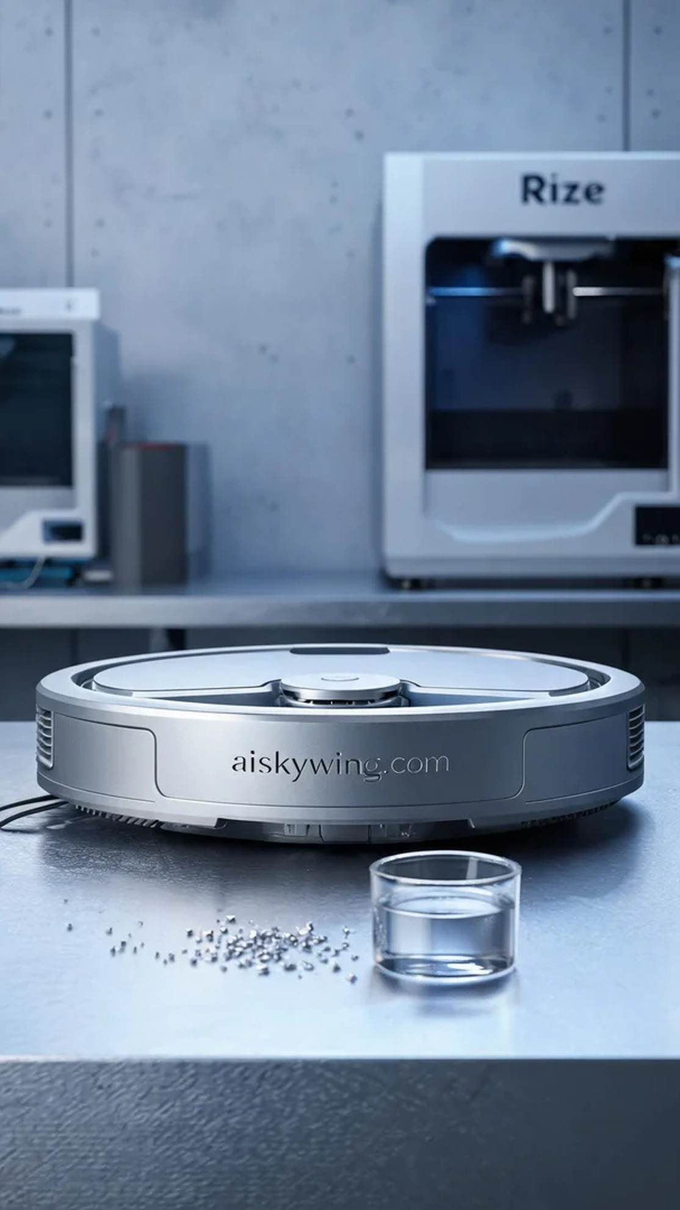
这次的任务是为一款扫地机器人制作外壳。有人在Facebook上看到我们的作品，想要一个具有高精度和科技感的外壳。为了满足他们的需求，我们决定采用SLA光固化树脂工艺来打造这一产品。
在材料选择上，我们使用了SLA光固化树脂，这种材料能够提供极高的细节表现和光滑的表面。准备工作中，Rize打印机被设定为每层厚度0.1毫米，打印温度为25℃，功率设定为50W，打印速度为30mm/s。通过这些参数，我们希望能确保打印出满意的外壳。
打印过程开始后，Rize打印机的运行相当稳定，整个设备温度和环境都保持在最佳状态。我们对打印质量进行了实时监控，确保每一层的打印都符合预期。当外壳逐渐成型时，细致的雕刻和光滑的表面显露无疑，让人期待最终成品的效果。
完成打印后，后处理工序是至关重要的一步。我们首先对打印好的外壳进行清洗，去除多余的树脂，然后进行细致的打磨，使表面更加光滑。接着，我们将其放入紫外线固化箱中固化，以增强其硬度和耐用性。最后，经过严格的检验，我们确认这款扫地机器人外壳达到了设计要求。
经过一系列的精细工作，扫地机器人外壳的制作圆满完成。看到它最终的效果，我们心中充满了成就感，这就是我们的职责所在。
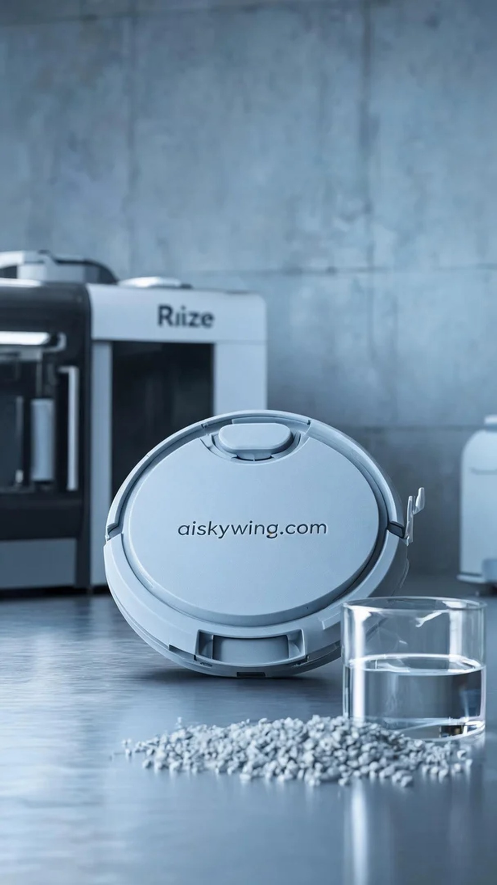
Aiskywing Industrial 3D Printing
Robot vacuum cleaner shell


