1063-投影仪外壳3D打印生产记录
Projector housing
🖨️ SLA光固化
🖥️ 打印机: Stratasys
📦 材料: SLA光固化树脂
生活再难，也别停下脚步。就像接下这个投影仪外壳的订单，有人希望我们用3D打印技术解决他们的难题。
No matter how difficult life gets, don't stop moving forward. Just like taking on this order for a projector casing, someone hopes we can solve their problem using 3D printing technology.
________________________________________________________________________________
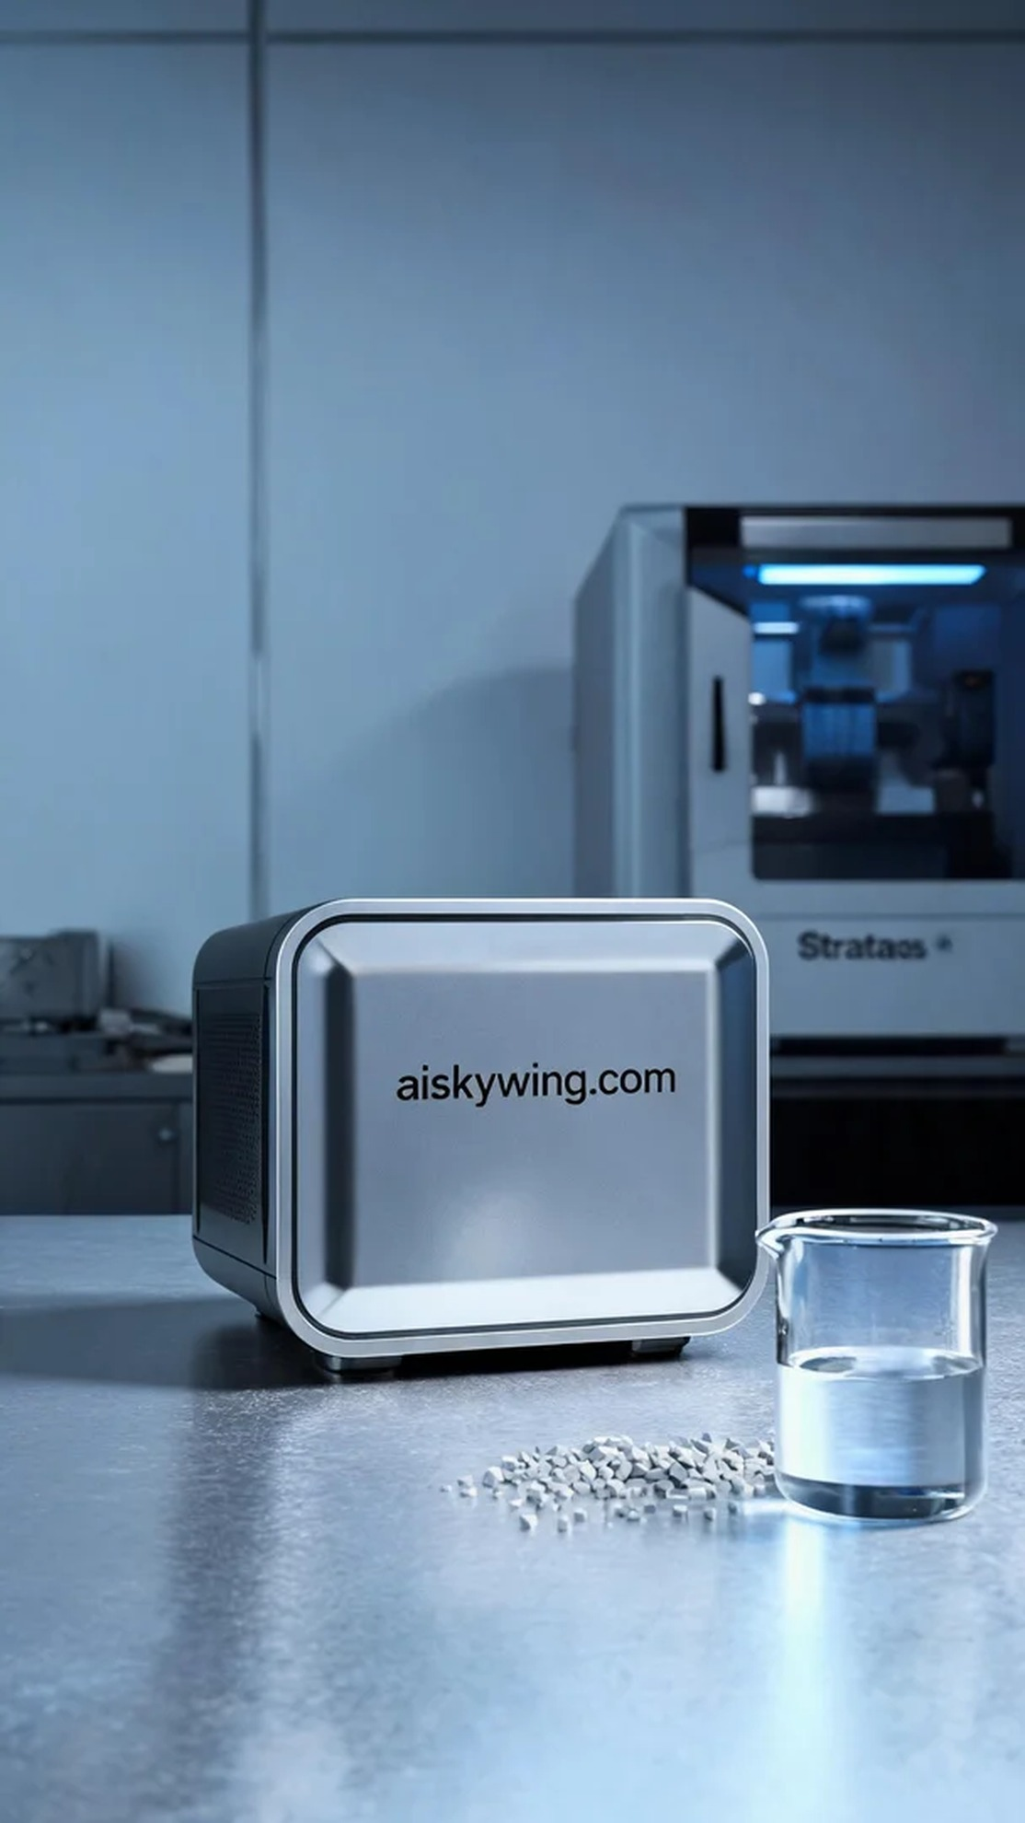
Recently, someone reached out to us on Facebook, looking for a unique projection lamp shell. They faced the challenge of needing an aesthetically pleasing and sturdy shell to enhance the product's overall image and protect internal components. To meet their needs, we decided to utilize SLA 3D printing technology.
We used SLA photopolymer resin as the raw material, known for its excellent surface smoothness and intricate detail representation. During the preparation, we selected a Stratasys 3D printer and set the printing parameters: a layer thickness of 0.1mm, a print temperature of 25°C, a laser power of 50mW, and a print speed of 30mm/s. After multiple adjustments, we ensured a stable and reliable printing process.
During the printing process, the sound of the Stratasys printer echoed in the workshop as the resin solidified layer by layer under the laser's exposure. We monitored the quality throughout, ensuring that the adhesion and surface quality of each layer met our requirements. By the end of the printing, the shell exhibited impeccable detail with a mirror-like finish, showcasing the beauty of industrial design.
Once the printing was completed, we took the shell out and proceeded to the post-processing phase. First, we cleaned it using a specialized solvent to remove any residual resin, followed by meticulous sanding to ensure every edge was smooth and flawless. Then, we placed the shell into a curing chamber, exposing it to UV light for solidification before conducting a thorough inspection to guarantee the product met our standards.
Ultimately, this projection lamp shell was a stunning success, not only providing a breathtaking visual appeal but also offering excellent protection. Every step of the process demonstrated our dedication and perseverance, and we look forward to seeing it shine for the user.
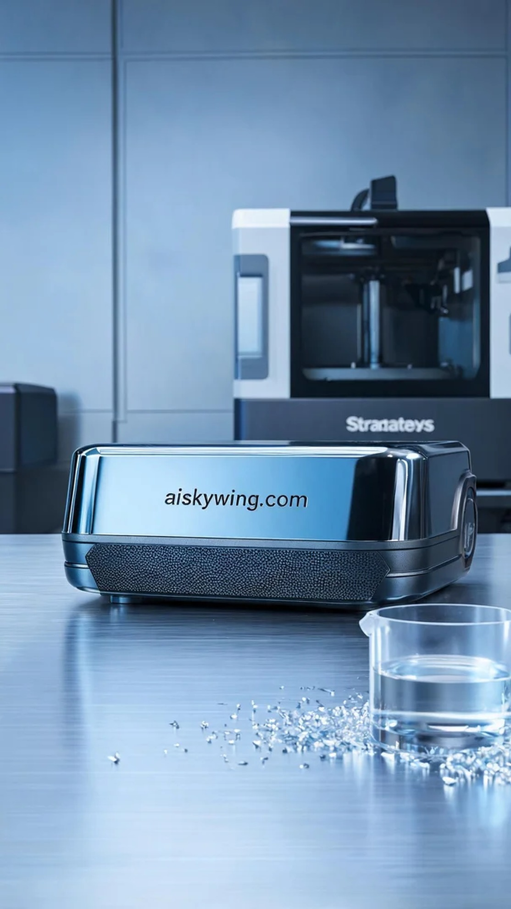
最近，有人在Facebook上找到我们，希望能制造一款独特的投影仪外壳。他们面临的问题是需要一个既美观又坚固的外壳，以便提升产品的整体形象和保护内部组件。为了满足他们的需求，我们决定采用SLA光固化技术进行打印。
我们使用了SLA光固化树脂作为原材料，它具有极佳的表面光滑度和细腻的细节呈现。准备工作时，我们选用了Stratasys品牌的3D打印机，设置了打印参数：层厚为0.1mm，打印温度保持在25℃，激光功率设置为50mW，打印速度为30mm/s。经过多次调试，确保了打印过程稳定可靠。
打印过程中，Stratasys打印机的运行声响在车间中回荡，树脂在激光的照射下逐层固化。我们全程进行了质量监控，确保每一层的附着力和表面质量都符合要求。打印完成时，外壳的细节表现无可挑剔，表面光滑如镜，充分展现了工业设计的美感。
完成打印后，我们将外壳取下，进入后处理工序。首先进行清洗，使用专用溶剂去除残余的树脂，然后进行细致的打磨，确保每个边角都光滑无瑕。接着，我们将外壳放入固化箱中，经过UV灯照射进行固化，最后进行全面检验，确保产品的质量达到标准。
最终，这款投影仪外壳完美呈现，不仅在视觉上给人以震撼，使用上也具备了良好的保护性。每一项工序都证明了我们的努力与坚持，期待着它为客户带来成功的亮点。
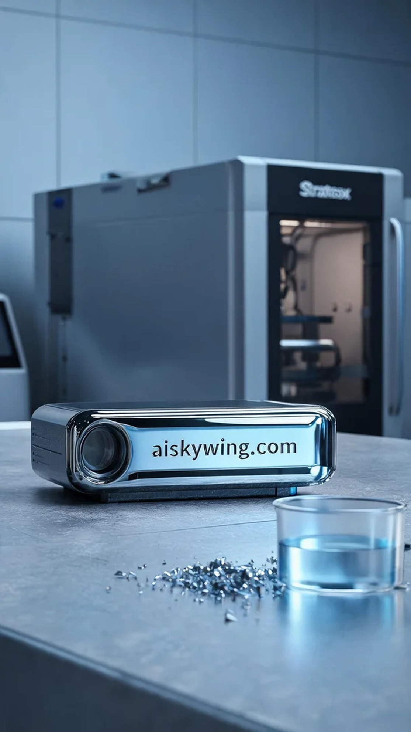
Aiskywing Industrial 3D Printing
Projector housing


