1064-投影幕布遥控器打印记录
Projection screen remote control
🖨️ SLA光固化
🖥️ 打印机: Mimaki
📦 材料: SLA光固化树脂
人生就像3D打印的每一步，需耐心雕琢。有人在LinkedIn上询问我们，想制作一款投影幕布遥控器，我们欣然接下这个单子。
Life is like every step of 3D printing, requiring patience and refinement. Someone inquired on LinkedIn about making a remote control for a projection screen, and we gladly accepted the order.
________________________________________________________________________________
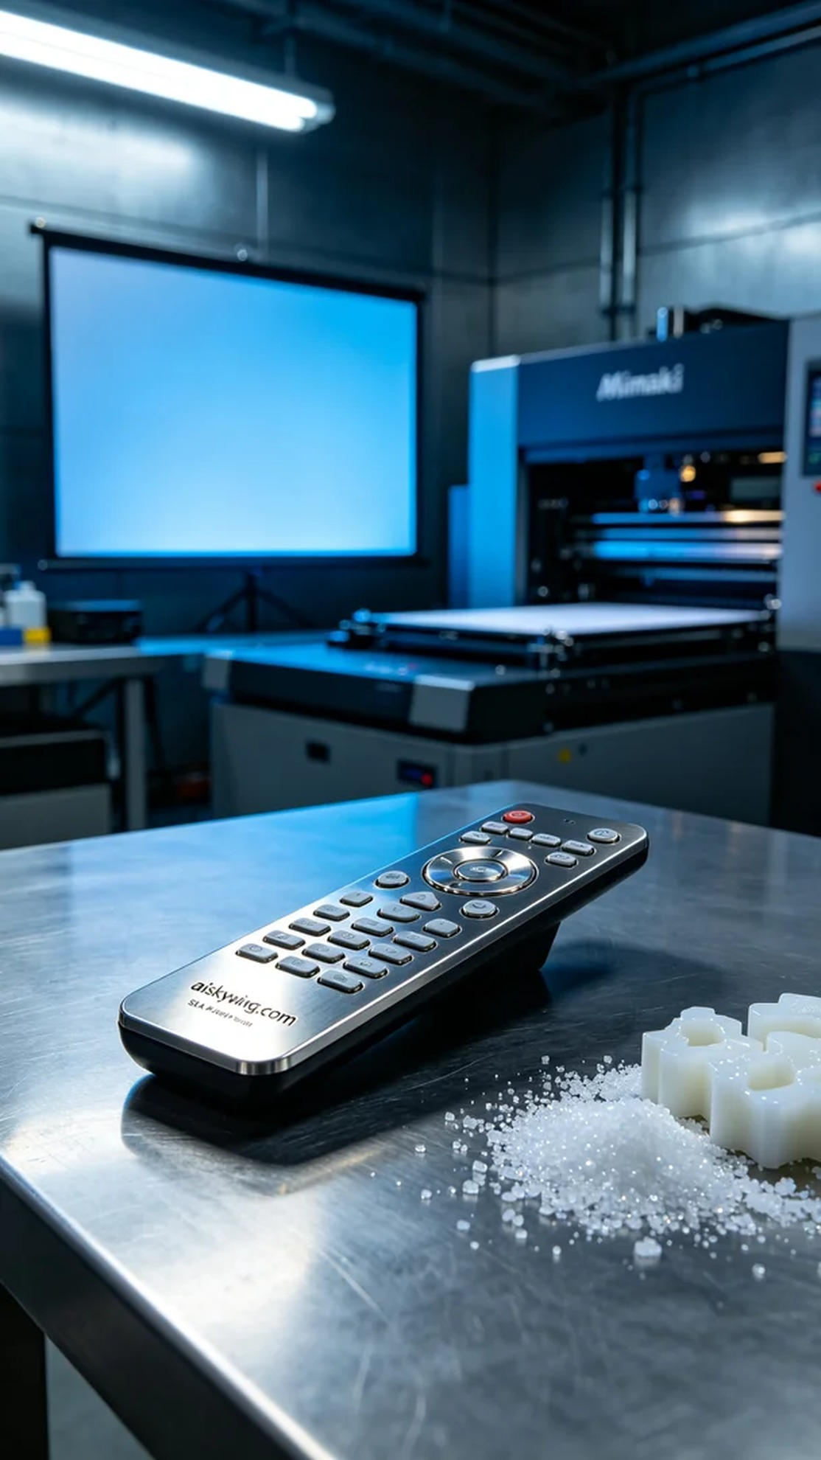
Life is like each step in 3D printing; it requires patience and precision. Someone reached out to us on LinkedIn, inquiring about the production of a projection screen remote control, and we gladly accepted the order.
To accomplish this project, we opted for SLA photopolymer resin as our material. This type of resin not only offers a delicate surface finish but can also achieve a metallic texture through electroplating. We utilized a Mimaki brand 3D printer for the task, setting the layer thickness to 0.05mm, maintaining a temperature of 25°C, power at 80%, and a printing speed of 30mm per second, with an estimated printing time of around 4 hours.
The printing process went smoothly with stable equipment operation. We continuously monitored the print quality, ensuring every layer fused perfectly, particularly in the engraving of "aiskywing.com," which needed to remain sharp and clear. As time passed, the remote control gradually took shape, and the outcome was promising.
After printing, we conducted meticulous post-processing. First, we placed the finished product in a cleaning tank with a photopolymer resin cleaning solution to remove any residual resin. Next, we performed sanding to smooth the surface further, followed by curing the item under a strong light in a curing machine to ensure its strength and durability. Finally, we inspected each product individually to guarantee that there were no defects and that it met quality standards.
In the end, this projection screen remote control was successfully completed, showcasing exceptional clarity and luster, perfectly fulfilling the requirements. Each production detail serves as a reminder that treating every project with care leads to better products.
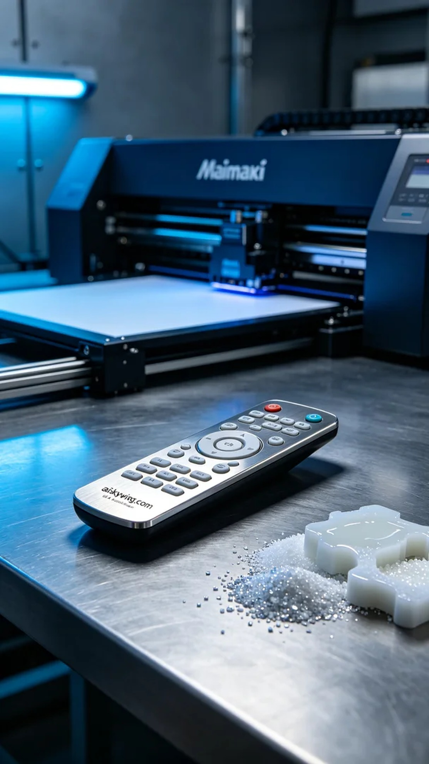
我们接到一个需求，想要制作一款投影幕布遥控器，目的是为了提高用户的使用体验，解决在操作过程中的不便问题。这个项目在LinkedIn上引起了一些关注，让我们感到很有责任感。
为了实现这个项目，我们选择了SLA光固化树脂作为原材料。这种材质不仅能呈现细腻的表面效果，还能通过电镀处理获得金属质感。我们使用Mimaki品牌的3D打印机进行打印，设置层厚为0.05毫米，温度控制在25°C，功率设定为80%以及打印速度为30毫米每秒，预计打印时间在4小时左右。
打印的过程相对顺利，设备运行稳定。我们持续监控打印质量，确保每一层都能完美结合，特别是在细节部分的雕刻，保持了"aiskywing.com"字样的清晰度。随着时间的推移，打印出的遥控器逐渐成型，效果令人期待。
打印完成后，我们进行了细致的后处理。首先将成品放入清洗槽中，用光敏树脂清洗液去除表面的残留树脂。接着进行打磨处理，使表面更加光滑，最后将其放置在固化机内进行强光照射固化，确保其强度和耐用性。最后，我们逐个检查成品，确保没有瑕疵，达到质量标准。
最终，这款投影幕布遥控器顺利完成，展现出极致的清晰度和光泽，完美满足了需求。每一个生产细节都在提醒我们，认真对待每个项目，才能创造出更好的产品。
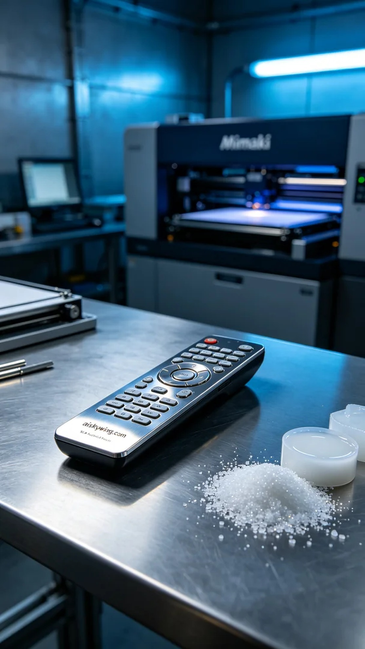
Aiskywing Industrial 3D Printing
Projection screen remote control


