1065-全彩3D打印人像模型制作记
Full-color 3D printed portrait model
🖨️ 全彩3DP
🖥️ 打印机: Voxeljet
📦 材料: 全彩3DP彩色打印
生活就像3D打印一样，逐层构建，细致入微。有人通过YouTube发现我们，想要打印一个全彩3D打印人像模型，遇到了一些技术上的问题。
Life is like 3D printing, built layer by layer, with meticulous detail. Some people discover us through YouTube and want to print a full-color 3D portrait model, but they encounter some technical issues.
________________________________________________________________________________
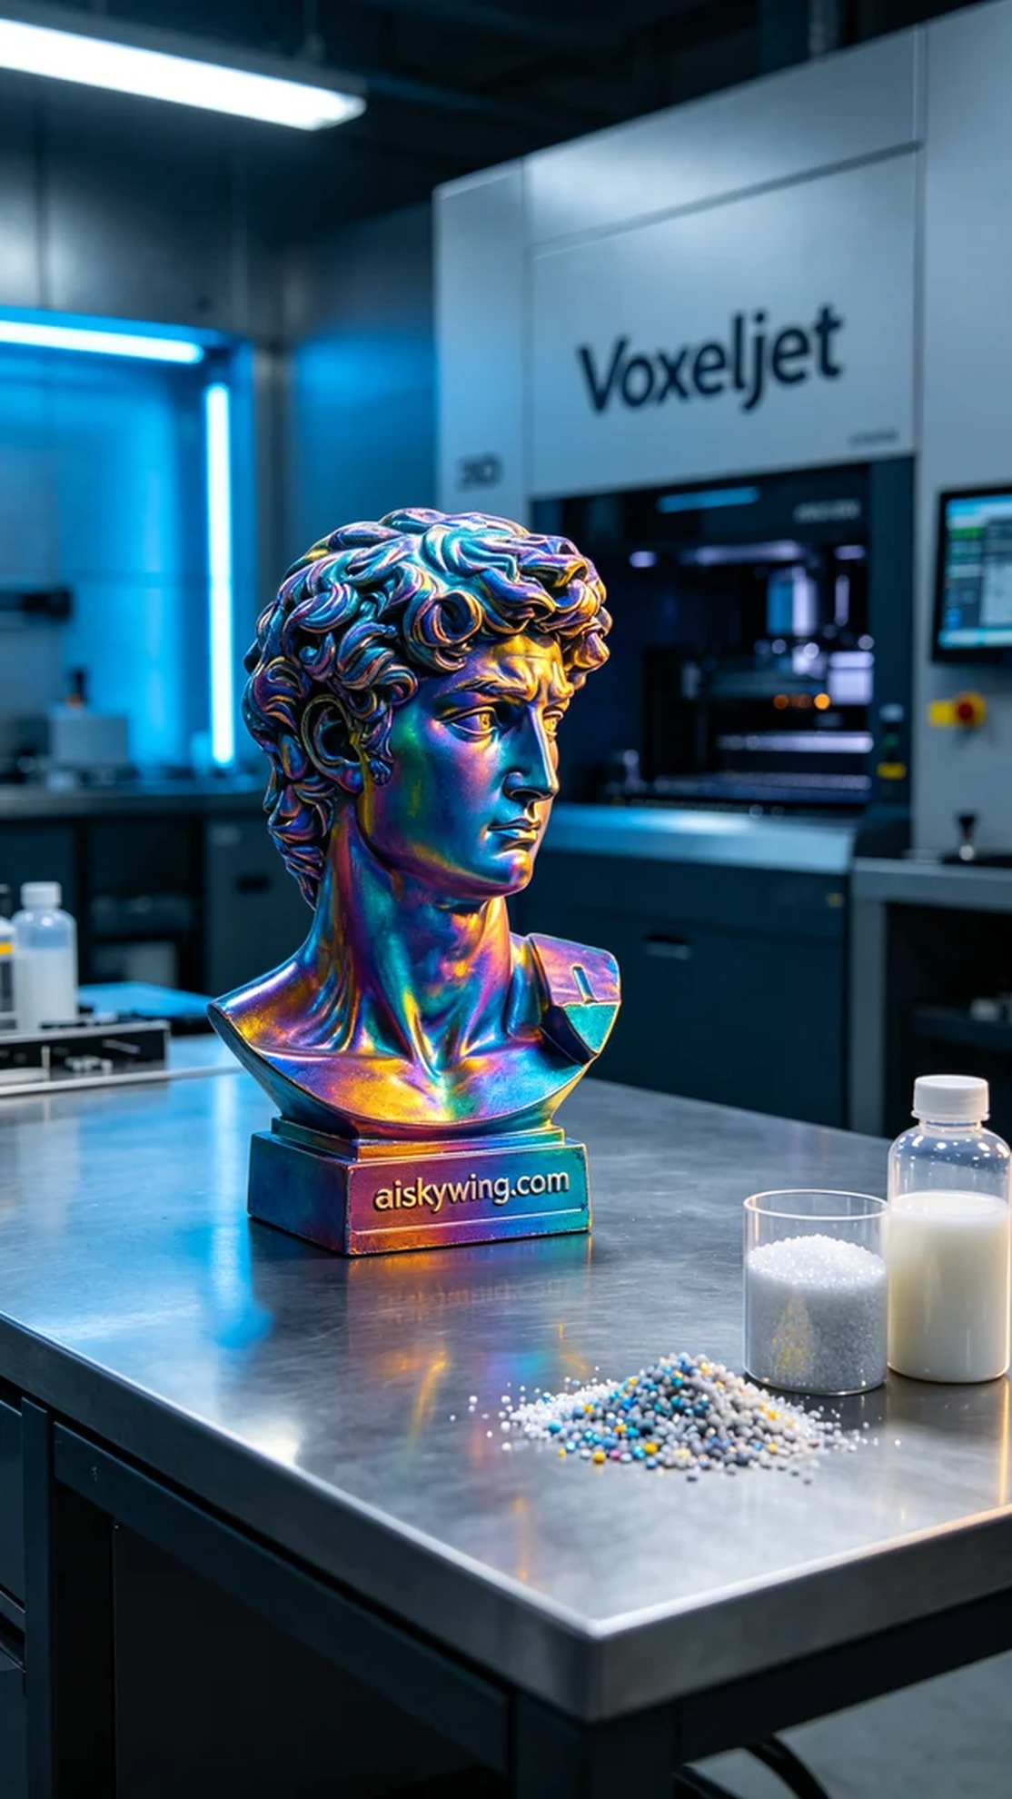
The production of the full-color 3D printed portrait model began with a need for detail and color. Someone discovered our work on YouTube and reached out for help, hoping to bring their digital likeness to life, which is exactly what our full-color 3D printed portraits excel at.
In the preparation phase, we selected full-color 3DP as the primary material. This material offers exceptional color representation and can showcase intricate details. We used a Voxeljet printer, setting the layer thickness at 0.1 millimeters, temperature controlled at 25 degrees Celsius, power set at 80%, and a printing speed of approximately 30 centimeters per hour, with the entire print process expected to take 8 hours.
As the printing commenced, the Voxeljet printer operated steadily, with all monitoring indicators displaying normal. During the printing process, we continuously checked the material flow and the nozzle's operation to ensure each layer was deposited evenly. With each layer built, the model's details gradually emerged, and the colors became richer, presenting the anticipated high-fidelity effect.
After printing, we moved on to the post-processing stage. The model was first cleaned to remove any uncured resin. Next, we used fine sandpaper to polish the surface, ensuring it was smooth to highlight the details. Then, the model was placed under UV light for curing, enhancing its durability. Finally, we conducted a thorough inspection to ensure every detail was flawless.
This process made me appreciate the charm of 3D printing, reinforcing the knowledge that every detail is critical to success. The full-color 3D printed portrait model, with its rich colors and exquisite details, ultimately manifested as we had hoped.
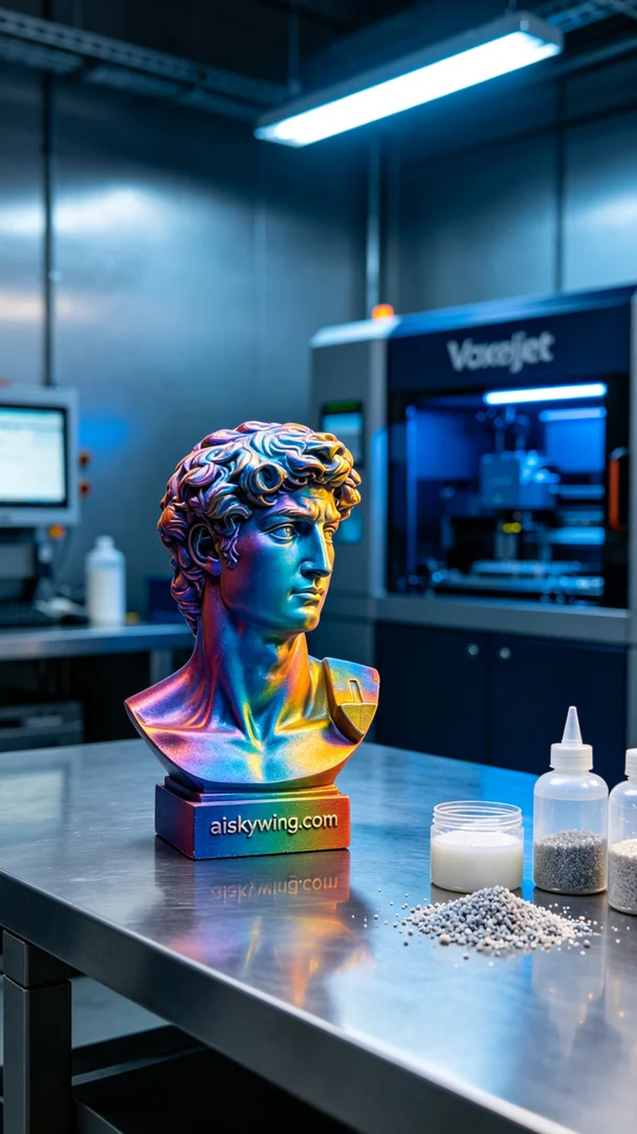
全彩3D打印人像模型的制作始于一个关于细节和色彩的需求。有人在YouTube上看到我们的作品，向我们寻求帮助，希望能将他们的数字形象转化为实体，而这正是我们全彩3D打印人像模型的强项。
在准备阶段，我们选择了全彩3DP彩色打印作为主要材料。这种材料不仅具有出色的色彩表现力，更能展现复杂的细节。我们使用的Voxeljet打印机，设置了层厚为0.1毫米，温度控制在25摄氏度，功率设定为80%，打印速度约为30厘米每小时，预计整个打印过程需时8小时。
打印开始后，Voxeljet打印机稳定地运行，所有监控指标显示正常。打印过程中，我们随时检查材料的流动性和喷头的工作状态，以确保每一层都能均匀沉积。随着层层构建，模型的细节渐渐显现，色彩逐渐丰富，呈现出预期的高保真效果。
完成打印后，我们进入后处理环节。首先对模型进行清洗，将未固化的树脂去除。接着，使用精细砂纸进行打磨，确保表面光滑，凸显细节。之后，模型置于UV灯下固化，以增强其耐用性。最后，我们进行了全面的检验，确保每个细节都完美无瑕。
这一过程让我感受到3D打印的魅力，也让我深知每个细节都是成功的关键。全彩3D打印人像模型以它的丰富色彩和精致细节，最终如愿以偿地展现在我们面前。
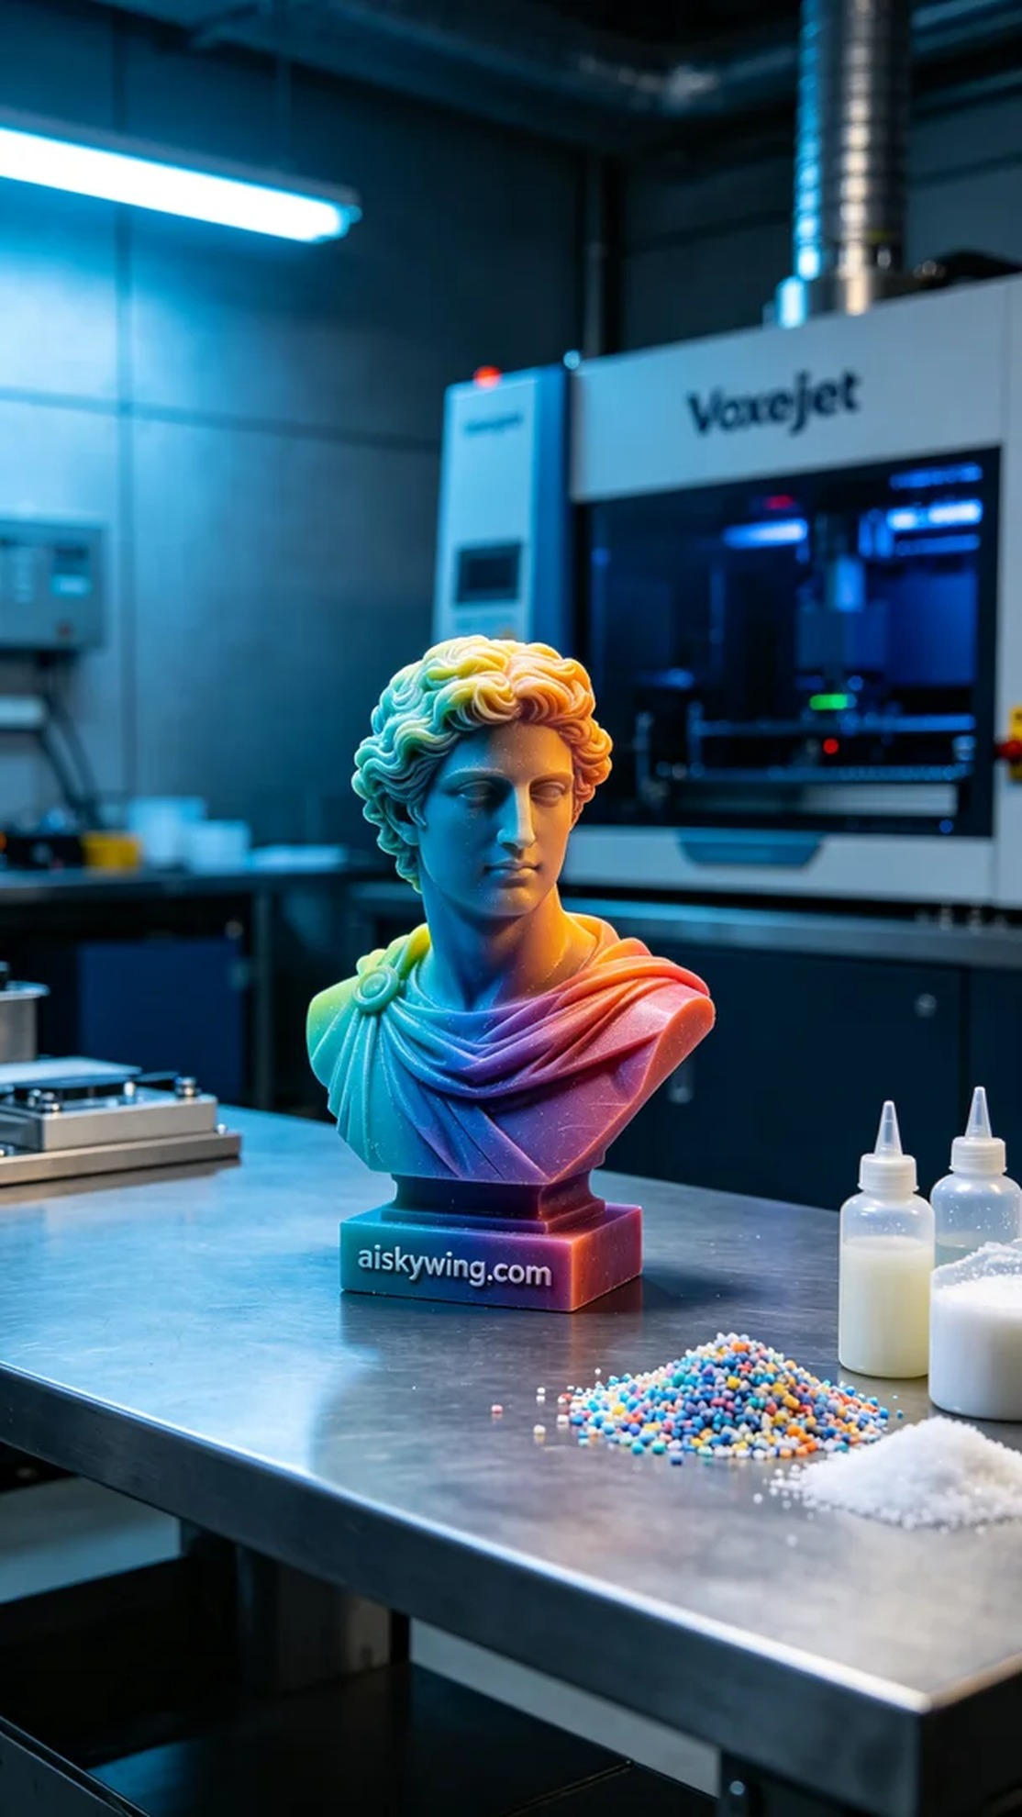
Aiskywing Industrial 3D Printing
Full-color 3D printed portrait model


