1066-全彩3D打印大象模型制作记录
Full-color 3D printed elephant model
🖨️ 全彩3DP
🖥️ 打印机: Stratasys
📦 材料: 全彩3DP
生活就像3D打印，点滴积累才能见证成果。有人在TikTok上看到我们的全彩3D打印大象模型，决定找上我们寻求帮助。
Life is like 3D printing; only through gradual accumulation can we witness the results. Someone saw our full-color 3D printed elephant model on TikTok and decided to reach out to us for help.
________________________________________________________________________________
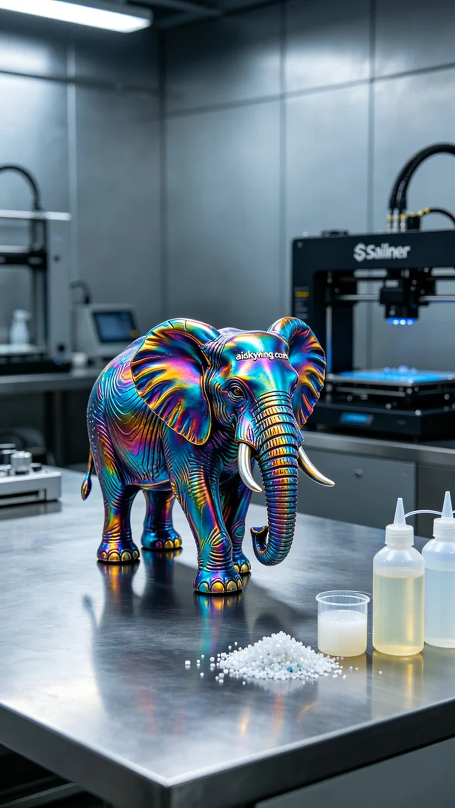
Life is like 3D printing; every little part counts towards the final result. Someone saw our full-color 3D printed elephant model on TikTok and reached out to us for assistance.
For this task, we chose full-color 3DP materials, known for their vibrant colors and intricate detail. Using the Stratasys printer, we set the layer thickness to 0.1mm, the printing temperature to 60°C, power to 80%, and speed to 40mm per second. The entire printing process was expected to take about 6 hours to ensure that every detail would be perfectly captured.
Once the printing started, the equipment ran smoothly. The cool industrial light poured in through the windows, showcasing the stunning color gradients on the elephant model. We monitored the quality throughout the process, ensuring no flaws emerged, and the print result matched our expectations, bringing us immense satisfaction.
After printing, we moved on to post-processing. First, we cleaned the model using an ultrasonic cleaner to remove excess resin, and then we carefully sanded the surface with fine sandpaper to smooth out any imperfections. Next, we performed curing to enhance the durability and color longevity of the model, followed by a thorough inspection to confirm quality standards.
After a series of steps, the full-color 3D printed elephant model stood before us—vibrant in color, rich in detail, perfectly showcasing our technical prowess and artistic ambition.
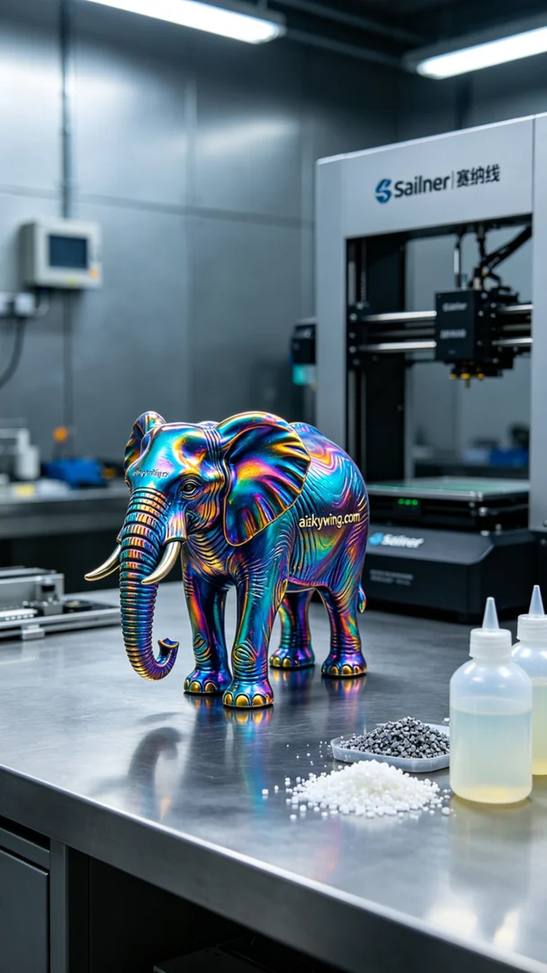
这次的任务是制作一个全彩3D打印大象模型，有人在TikTok展示了这样的作品，吸引了不少眼球。然后有人找到我们，想要制作一个既逼真又色彩丰富的模型，以满足他们的需求。
我们选择了全彩3DP材料进行打印，这种材料的优势在于色彩的丰富性与细节的完美呈现。使用Stratasys打印机时，我们将层厚设置为0.1毫米，打印温度调整为60摄氏度，功率设置在80%，速度控制在40毫米每秒。整个打印过程预计耗时大约6小时，确保每一个细节都能被完美重现。
打印开始后，设备运行稳定，冷色调的工业光线透过窗户洒入，照在大象模型的表面，展现出惊人的色彩渐变。我们全程监控质量，确保没有出现任何瑕疵，打印效果如同预期，令我们倍感欣慰。
打印完成后，进入后处理工序。首先对模型进行清洗，使用超声波清洗机去除多余的树脂，然后用细砂纸轻轻打磨表面的瑕疵，确保每一处都光滑。接下来，我们对模型进行固化处理，确保它的耐用性和色彩持久性，最后进行仔细检验，确认质量达标。
经过一系列的流程，这个全彩3D打印大象模型终于呈现在我们眼前，色彩斑斓，细节丰富，完美展现出我们的技术实力和艺术追求。
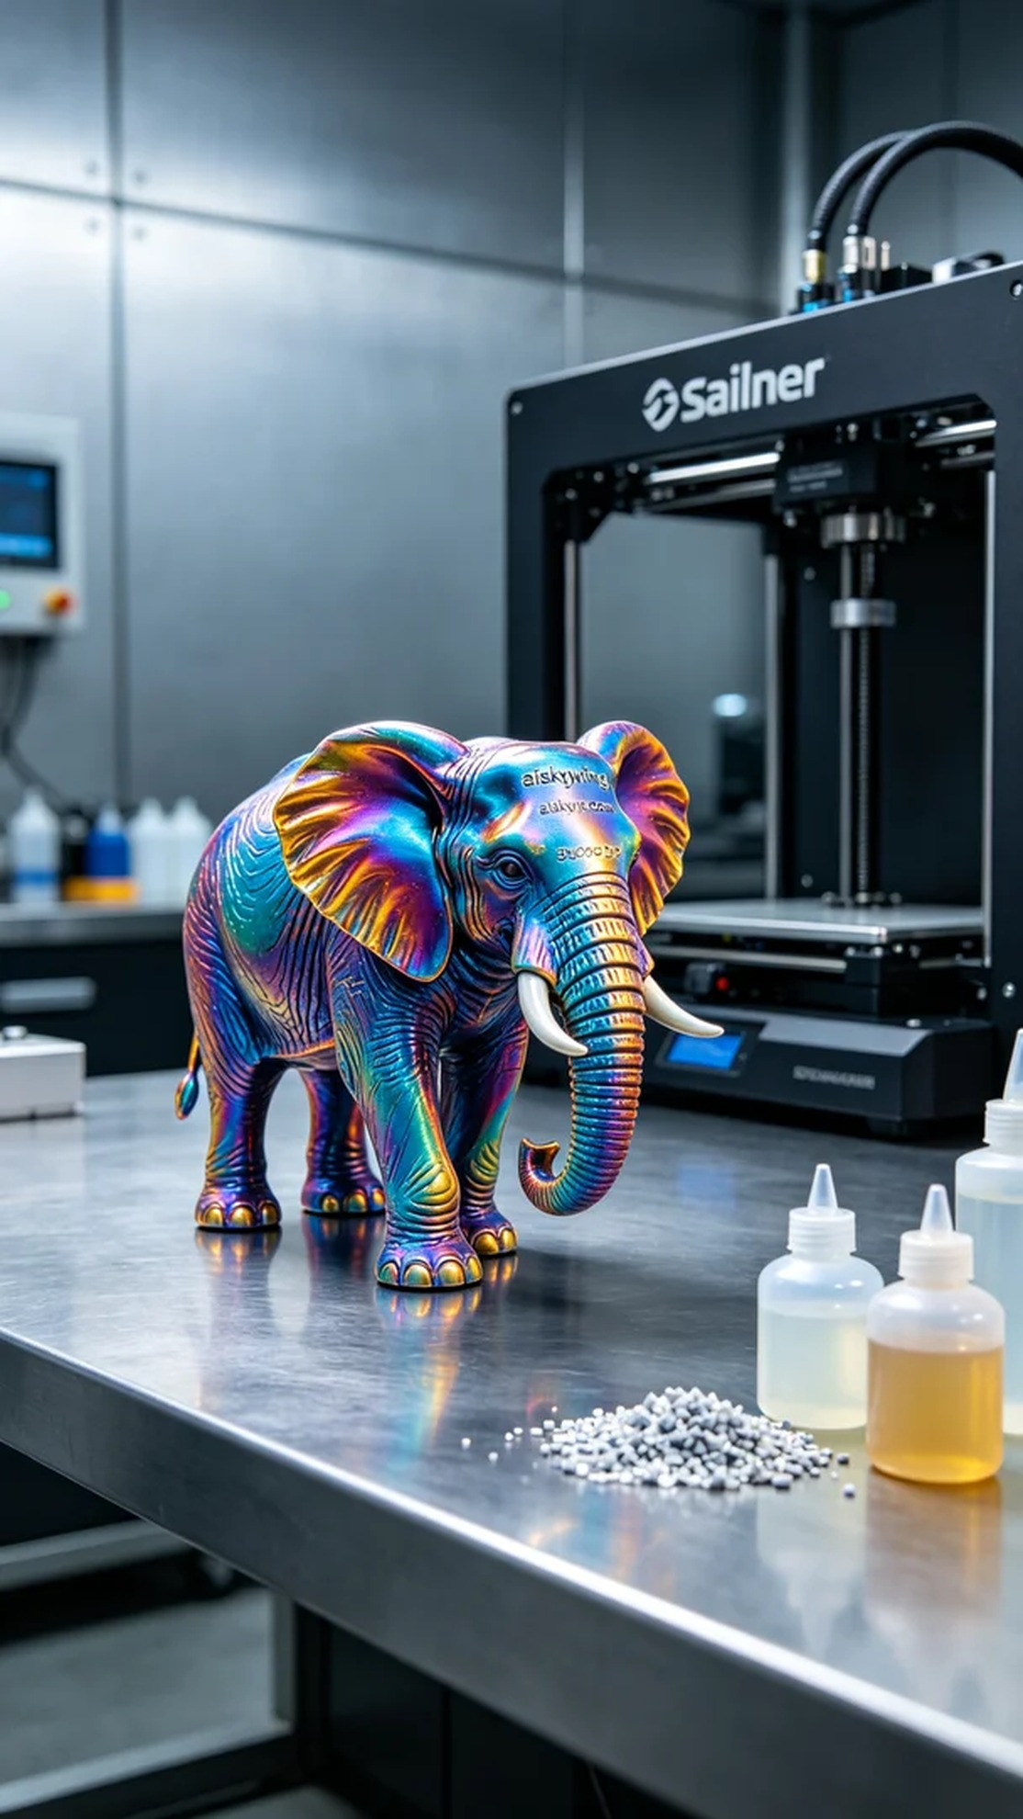
Aiskywing Industrial 3D Printing
Full-color 3D printed elephant model


