1067-全彩3D打印婚礼蛋糕模型生产记录
Full-color 3D printed wedding cake model
🖨️ 全彩3DP
🖥️ 打印机: HP
📦 材料: 全彩3DP
人生就像3D打印，有时需要耐心与坚持。最近在Instagram上，有人找我们制作这款全彩3D打印婚礼蛋糕模型，期待在特别的日子里为他们增添色彩。
Life is like 3D printing; sometimes it requires patience and perseverance. Recently, someone reached out to us on Instagram to create this full-color 3D printed wedding cake model, hoping to add some color to their special day.
________________________________________________________________________________
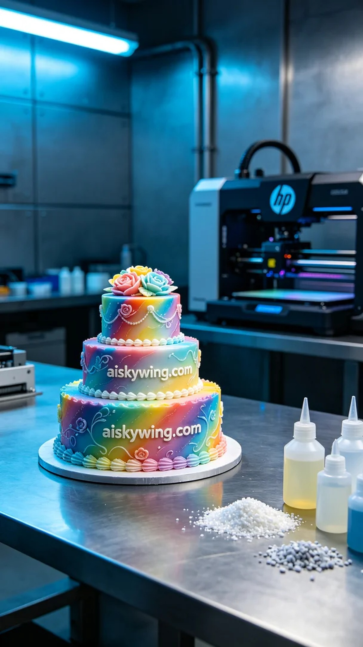
Life is like 3D printing, sometimes it requires patience and perseverance. Recently, on Instagram, someone reached out to us to create a full-color 3D printed wedding cake model, hoping to add color to their special day.
The material we used was full-color 3DP, known for its exceptional color gradient and detail representation. During our preparations, we selected an HP brand 3D printer, setting the printing parameters to a layer thickness of 0.2mm, a printing temperature of 50°C, a power setting of 60%, and a speed of 30mm/s, with an expected printing time of about 8 hours. Each parameter was carefully calibrated to achieve the best possible outcome.
Every detail during the printing process is crucial. As the machine began to operate, we closely monitored its status to ensure that each layer was printed accurately. Over time, the contours of the model began to emerge, and the full-color effect became increasingly vivid. The hum of the machinery contrasted sharply with the calm industrial environment, making one feel the power of technology.
After printing, we moved on to post-processing. First, the model was submerged in a cleaning tank to remove any residual resin, followed by surface sanding with fine-grit sandpaper to ensure a smooth finish. We then used a UV curing device for solidification, making the model's material more robust. Finally, a thorough inspection was conducted to ensure that every detail met our quality standards.
In the end, this full-color 3D printed wedding cake model was completed on time, showcasing rich colors and clear details that left everyone in awe. It was not just a demonstration of technology, but also a testament to our passion and dedication to each creation.
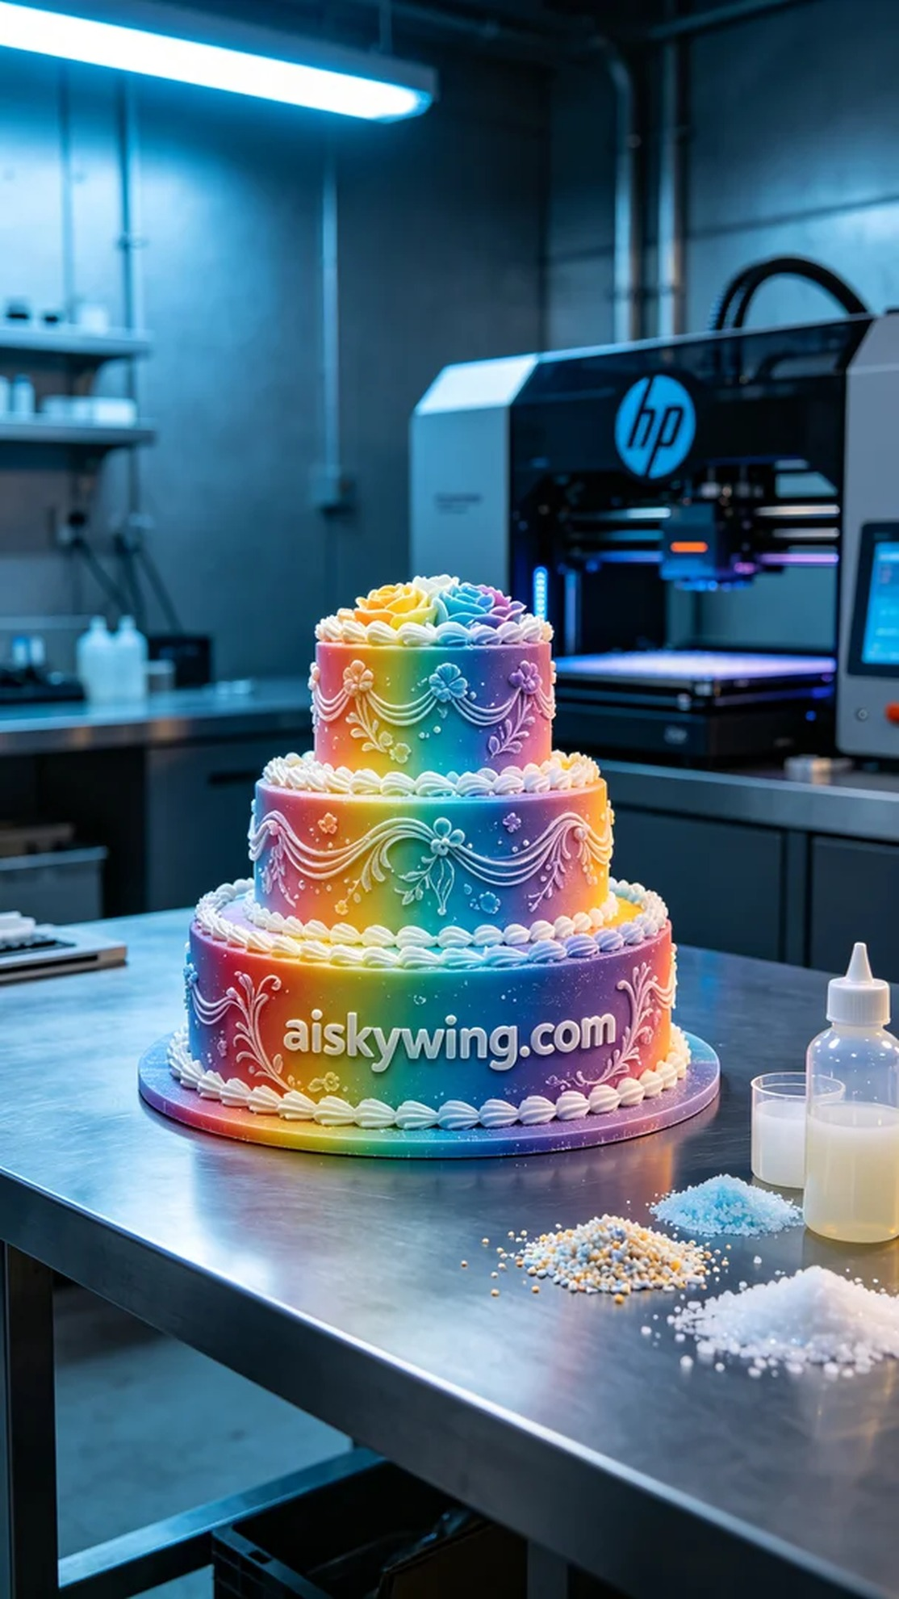
我们接到了一个有趣的任务，制作全彩3D打印婚礼蛋糕模型。有人在Instagram上看到我们的作品，特意想要一款色彩丰富、细节逼真的婚礼蛋糕模型，作为他们婚礼的亮点。于是，我们开始了这次充满挑战的打印之旅。
采用的材料为全彩3DP，这种材料以其卓越的颜色渐变和细节表现著称。在准备工作中，我们选用了HP品牌的3D打印机，设定打印参数为层厚0.2mm，打印温度为50°C，功率为60%，速度设定在30mm/s，预计打印时间约为8小时。确保了每个参数的精准，以便能呈现出最完美的效果。
打印过程中的每一个细节都至关重要。机器开始运转时，我们严密监控着设备状态，确保每一层都能准确打印。随着时间的推移，模型的轮廓逐渐显现，全彩的效果也愈加鲜明。设备在工作时发出的轰鸣声与冷静的工业环境形成鲜明对比，令人感受到科技的力量。
打印完成后，我们进入了后处理工序。首先，将模型浸入清洗槽中，以去除多余的树脂，然后用细砂纸对表面进行打磨，确保光滑无瑕。接着，我们使用紫外线固化设备进行固化处理，让模型的材质更加坚固。最后，进行细致的检验，确保每一个细节都达到要求。
最终，这款全彩3D打印婚礼蛋糕模型如期完成，色彩丰富，细节清晰，令人赞叹。这不仅是一次技术展示，也是我们对每一个作品的热爱和追求。
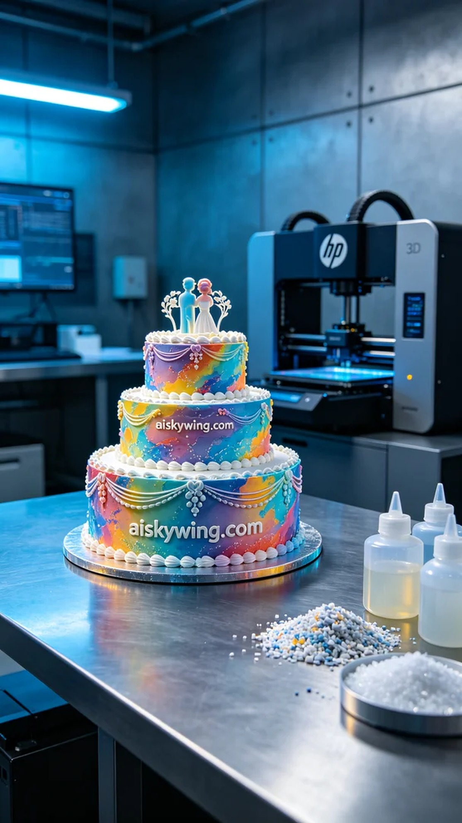
Aiskywing Industrial 3D Printing
Full-color 3D printed wedding cake model


