1068-全彩3D打印宝剑模型生产记录
Full-color 3D printed sword model
🖨️ 全彩3DP
🖥️ 打印机: Rize
📦 材料: 全彩3DP
生活再难，也别停下脚步。就像接下这个全彩3D打印宝剑模型的单子，有人希望能呈现出最完美的效果。
No matter how difficult life gets, don't stop moving forward. Just like taking on this order for a full-color 3D printed sword model, someone hopes to achieve the perfect result.
________________________________________________________________________________
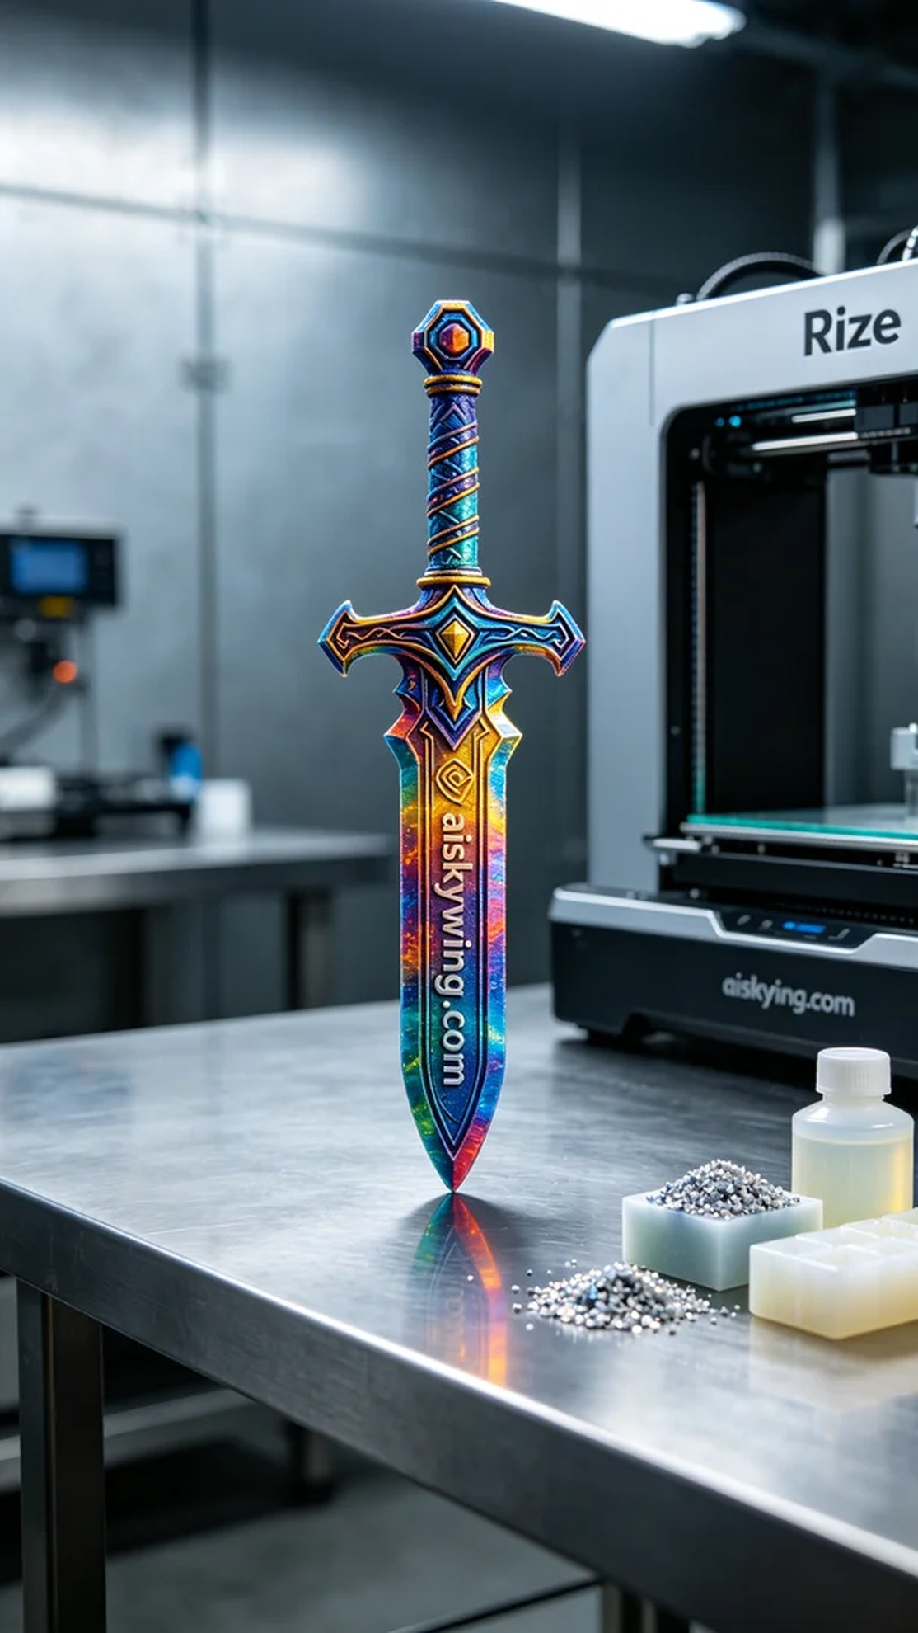
In Facebook, someone reached out to us seeking assistance in creating a full-color 3D printed sword model. This model needed to not only be rich in color but also rich in detail to meet their high standards.
We used full-color 3DP as the raw material, which offers exceptional color representation and intricate textures. During preparation, we utilized a Rize brand 3D printer, setting the printing parameters to a layer thickness of 0.1mm, a nozzle temperature of 200℃, and a printing speed of 50mm/s, with an estimated print time of 8 hours. These precise adjustments ensured that every color gradient and detail was perfectly rendered.
Throughout the printing process, the Rize printer operated smoothly, with the quality monitoring system continuously checking the print quality. As the machine hummed along, the model gradually took shape, exhibiting a rich layering of colors, reflecting the cold industrial light. We closely monitored the progress to ensure that each layer was accurately placed, avoiding any defects.
Upon completion, we conducted thorough post-processing steps. First, we cleaned the model using a specific solvent to ensure there was no residual resin on the surface. Next, we meticulously sanded the model to enhance its feel and appearance. Finally, we performed a curing process to strengthen its durability and color stability. After inspection, every detail of the model met our expected standards.
In the end, this full-color 3D printed sword model was praised for its exquisite craftsmanship and vibrant colors and was successfully delivered to the person who needed it.
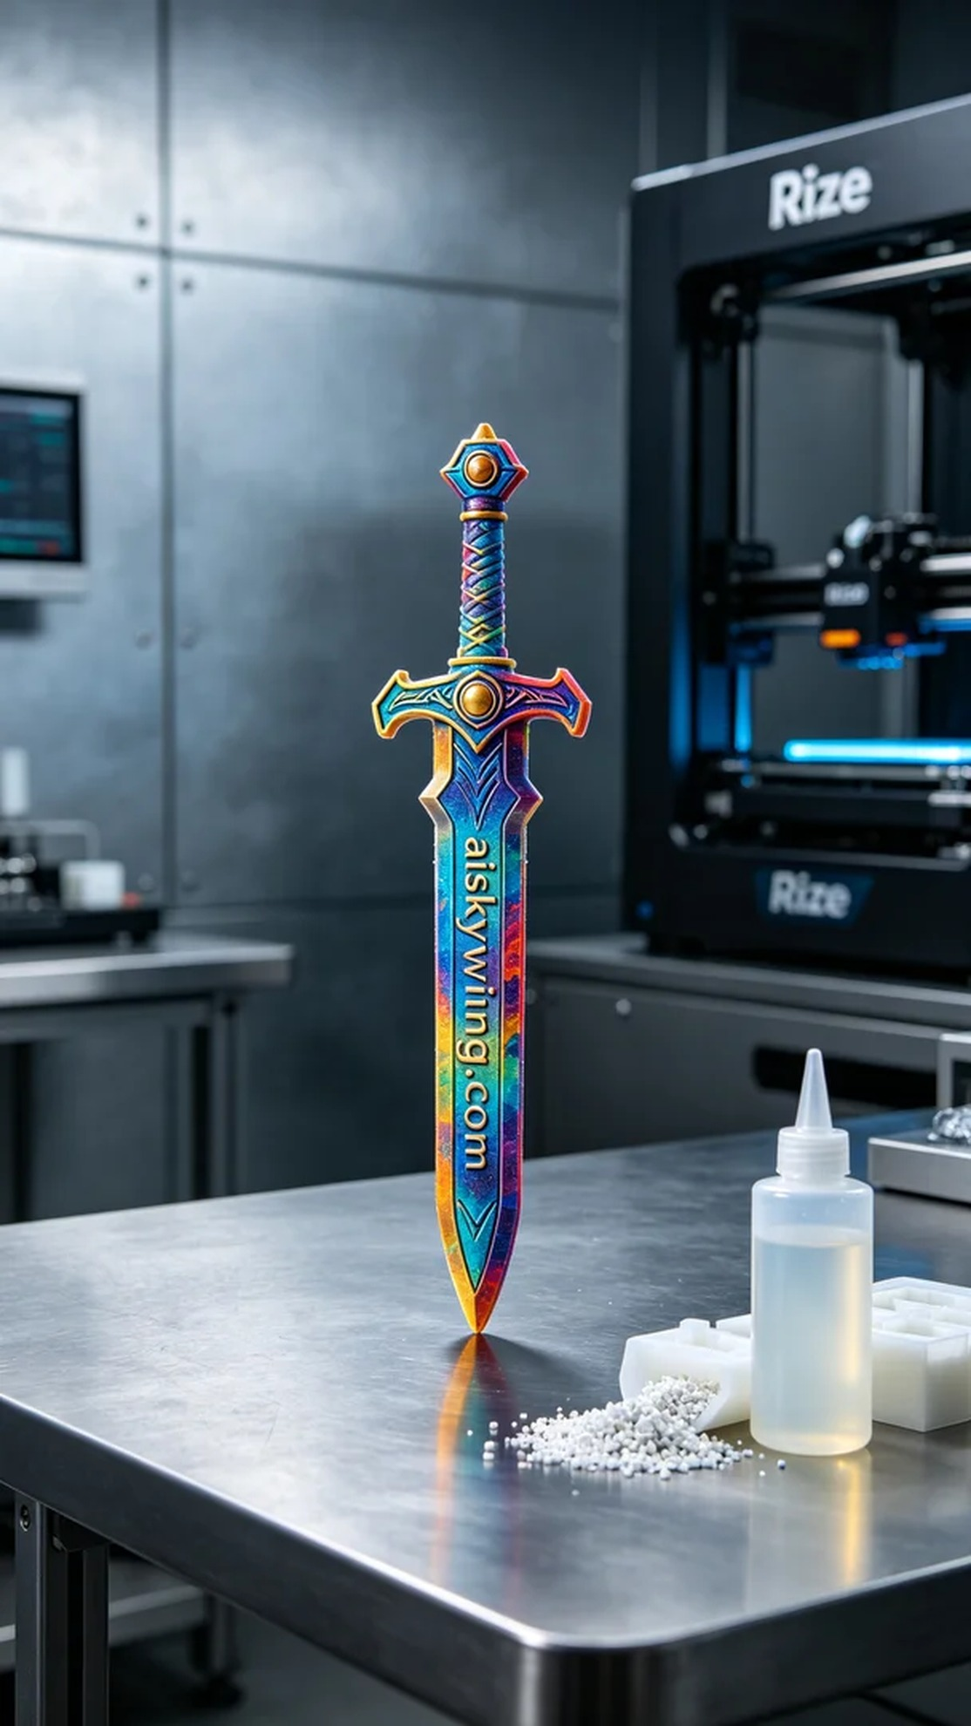
在Facebook上，有人向我们寻求帮助，希望能够制作出一款全彩3D打印宝剑模型。这个模型不仅要颜色丰富，细节也要到位，以满足他们对产品的高标准需求。
我们使用全彩3DP作为原材料，这种材料具有极强的色彩表现力和细致的纹理。在准备过程中，使用了Rize品牌的3D打印机，打印参数设置为层厚0.1mm，喷嘴温度保持在200℃，打印速度为50mm/s，预计打印时间为8小时。细致的参数调整确保了每个颜色渐变和细节的完美呈现。
打印过程中，Rize打印机的运行平稳，设备的质量监控系统实时监测着打印效果。随着机器的轰鸣声，整个模型逐渐成型，表面显现出丰富的颜色层次，反射出冷峻的工业光线。我们时刻关注着打印进度，确保每一层都能精准到位，避免任何瑕疵。
打印完成后，进行了严格的后处理步骤。首先，我们对模型进行了清洗，使用了特定的溶剂，确保表面无残留树脂。随后，进行了细致的打磨，以提升模型的手感和观感。最后，对模型进行固化处理，以增强其耐用性和色彩的稳定性。经过检验，模型的每一个细节都达到了预期的效果。
最终，这款全彩3D打印宝剑模型以其精致的工艺和鲜艳的色彩赢得了大家的赞赏，成功交付给了需要它的人。
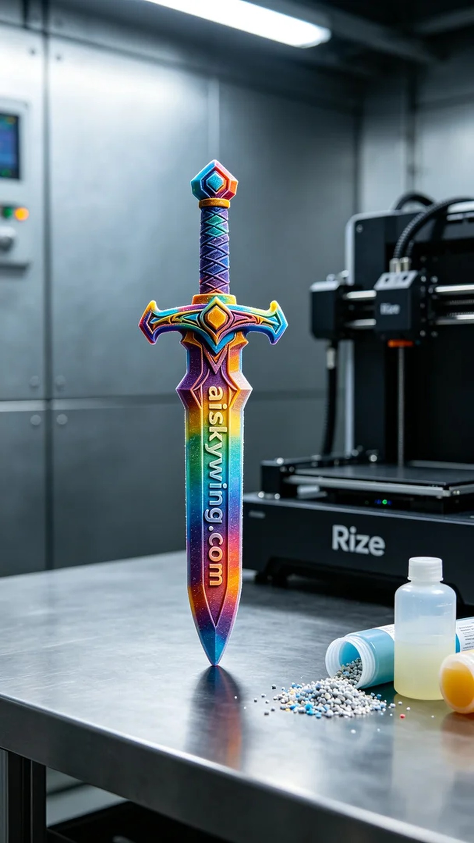
Aiskywing Industrial 3D Printing
Full-color 3D printed sword model


