1069-全彩3D打印工程车模型生产记录
Full-color 3D printed construction vehicle model
🖨️ 全彩3DP
🖥️ 打印机: Voxeljet
📦 材料: 全彩3DP
生活再难，也别停下脚步。就像接下这个全彩3D打印工程车模型的单子，有人希望它能展现出科技与艺术的完美结合。
No matter how difficult life gets, don't stop moving forward. Just like taking on the order for this full-color 3D printed engineering vehicle model, there are people who hope it can showcase the perfect combination of technology and art.
________________________________________________________________________________
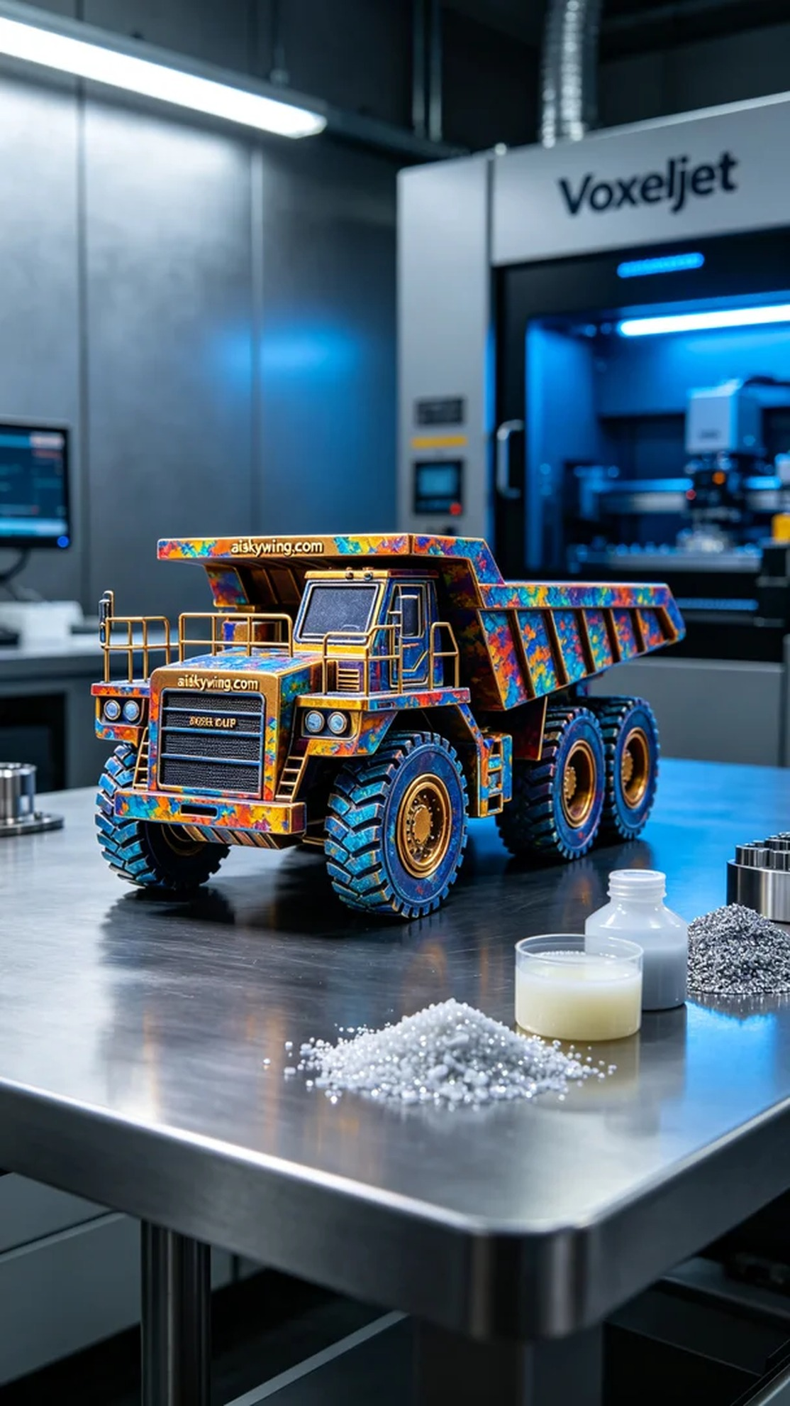
Life can be challenging, but never stop moving forward. Just like taking on the task of creating a full-color 3D printed engineering vehicle model, someone wanted it to perfectly combine technology and art.
The material we used is full-color 3DP, which provides excellent color reproduction and detail representation. For this model, I chose to use the Voxeljet printer. The print settings were a layer thickness of 0.1mm, a printing temperature of 25℃, a power setting of 1500W, and a print speed of 40mm/s, with an estimated print time of 12 hours. These settings ensured that the model's color gradient and detail representation reached optimal results.
During the printing process, the Voxeljet machine operated smoothly, with the print head accurately layering the liquid photopolymer resin. Throughout the process, I closely monitored the quality to ensure every layer was flawless. Under the cool-toned ambient lighting, the model gradually revealed its rich details and vivid colors, truly a sight to behold.
Upon completion, I carried out stringent post-processing steps. First, I cleaned the model to remove excess resin. Next, I sanded the surface to achieve a smoother finish. After that, the model was placed in the curing device to ensure material strength and durability. Finally, I conducted an inspection to ensure every detail met expectations.
Overall, the successful creation of this full-color 3D printed engineering vehicle model showcases the charm of modern technology and exquisite craftsmanship, leaving one filled with anticipation for future possibilities.
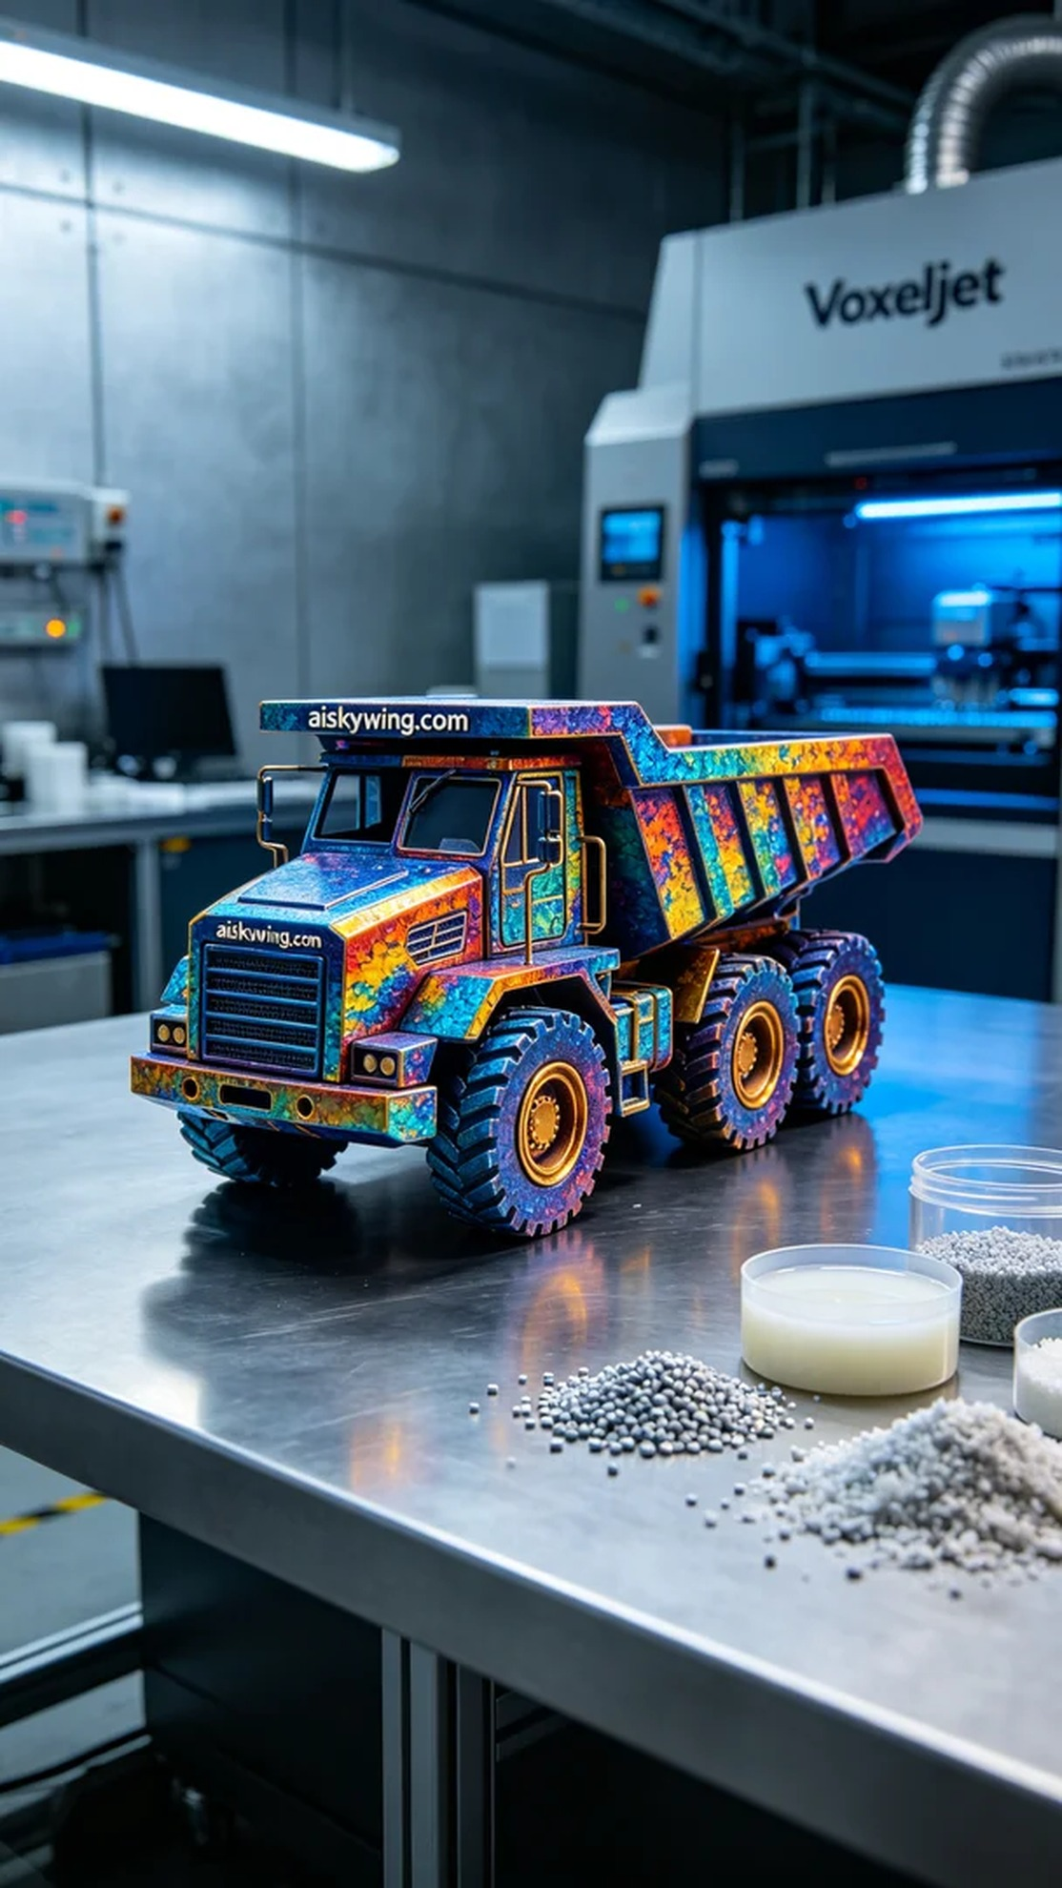
在WhatsApp上，有人联系我，希望能打造一款全彩3D打印工程车模型，要求极致清晰的细节和逼真的色彩。他们特别提到，期望这个模型能在视觉上给人以强烈的冲击感。
我们采用的原材料是全彩3DP，具有出色的色彩还原和细节表现。对于这款模型，我选择了Voxeljet打印机进行制作。打印参数设置为层厚0.1毫米，打印温度保持在25℃，功率设定为1500W，打印速度为40mm/s，预计打印时间为12小时。这样的设置能够确保模型的色彩渐变和细节呈现达到最佳效果。
在打印过程中，Voxeljet设备运行稳定，打印头准确无误地将液态光敏树脂逐层叠加。整个过程我时刻关注着质量监控，确保每一层都完美无瑕。在冷色调的氛围灯下，模型逐渐显现出其丰富的细节和生动的色彩，真是让人眼前一亮。
打印完成后，我对模型进行了严格的后处理工序。首先是清洗，将多余的树脂去除。然后进行打磨，让表面更加光滑。接着，模型被放置到固化设备中，确保材料的强度和耐用性。最后，我进行了检验，确保每个细节都符合预期。
总的来说，这个全彩3D打印工程车模型的成功制作，充分展示了现代科技的魅力和精湛的工艺，让人对未来的可能性充满期待。
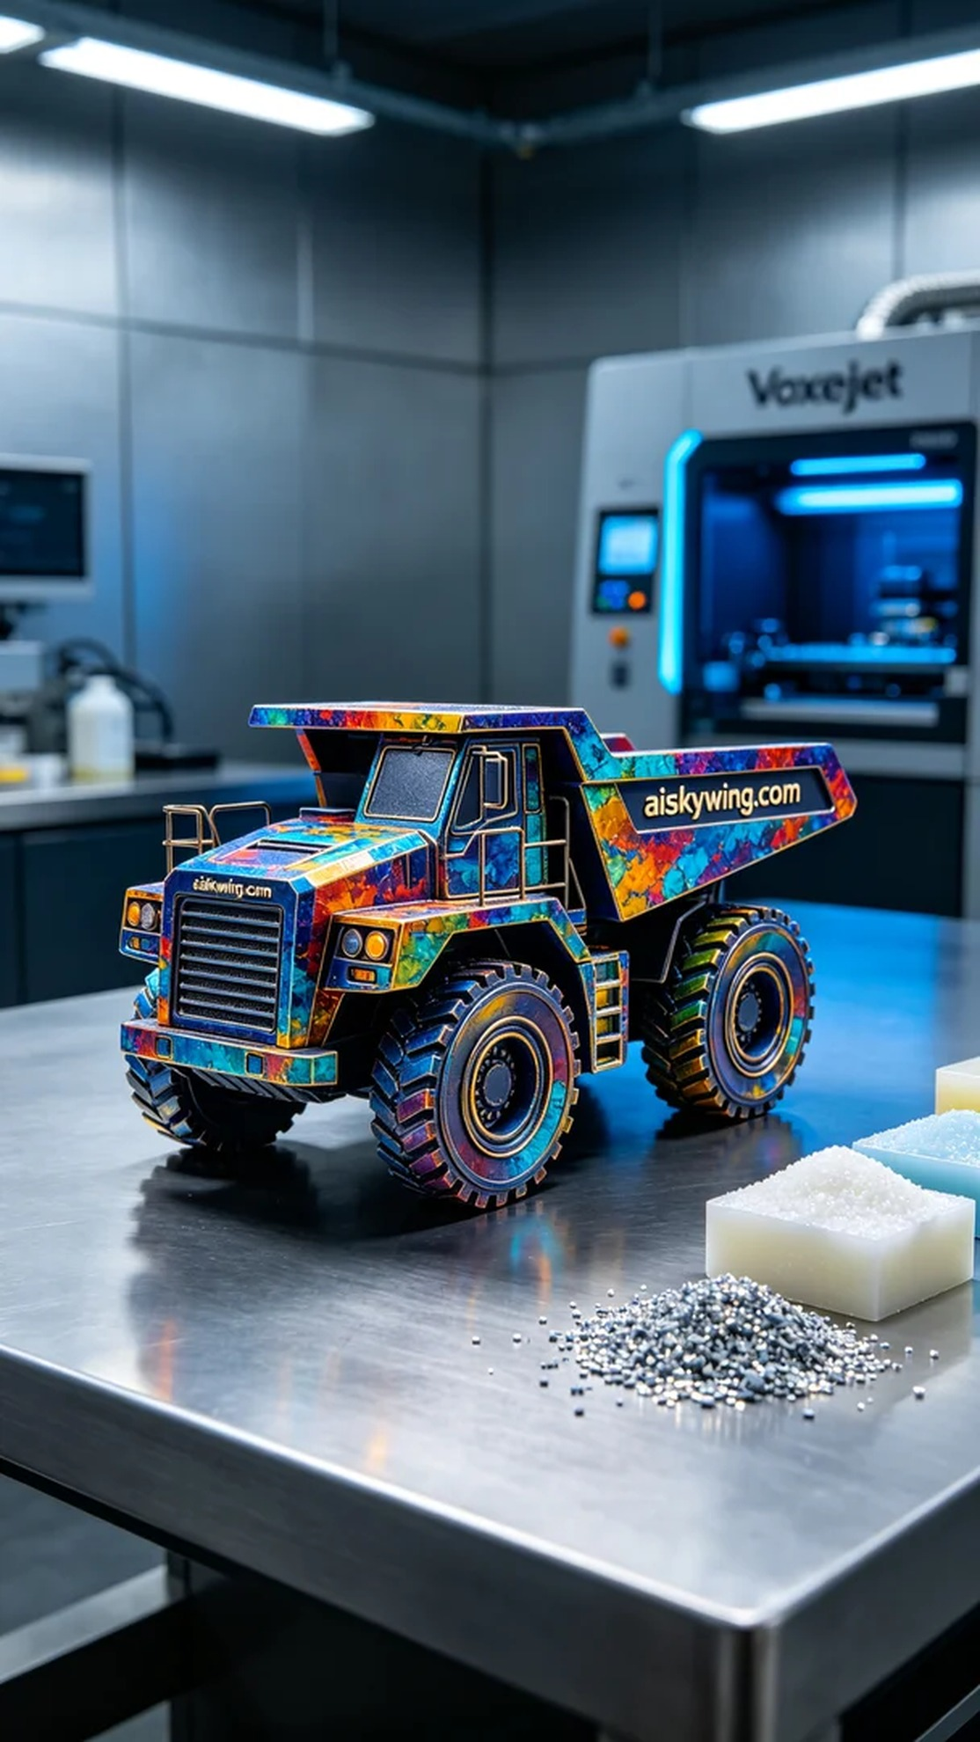
Aiskywing Industrial 3D Printing
Full-color 3D printed construction vehicle model


