1070-全彩3D打印帐篷模型制作日志
Full-color 3D printed tent model
🖨️ 全彩3DP
🖥️ 打印机: Mimaki
📦 材料: 摆放着未成型的液态光敏
生活就像3D打印，有时候需要耐心和细心。最近，有人通过YouTube找到了我，想要制作一个全彩3D打印帐篷模型。
Life is like 3D printing; sometimes it requires patience and attention to detail. Recently, someone found me through YouTube and wanted to create a full-color 3D printed tent model.
________________________________________________________________________________
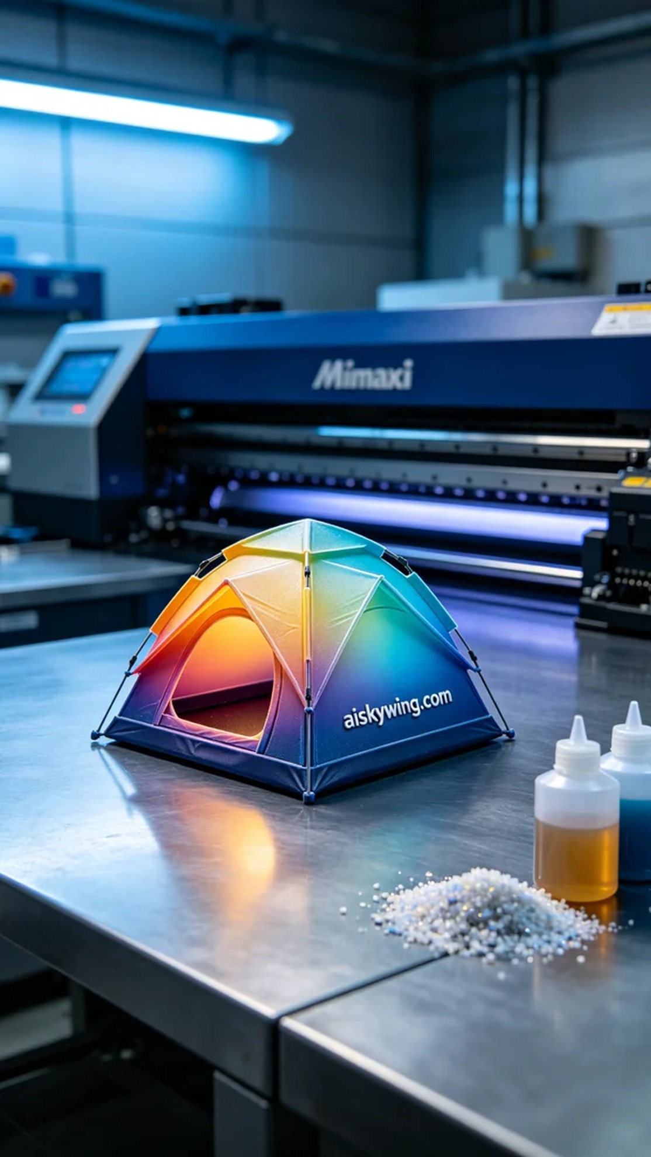
Life is like 3D printing; sometimes it requires patience and attention to detail. Recently, someone reached out to me through YouTube, seeking to create a full-color 3D printed tent model.
For this print, I prepared high-quality liquid photopolymer resin as the raw material. Using the Mimaki 3D printer, I set the printing parameters: layer thickness at 0.1 mm, printing temperature maintained at 25 degrees Celsius, power set to 100%, and printing speed at 30 mm per second, with an expected printing time of 8 hours. These parameters ensured that the printed tent model would display rich color gradients and intricate details.
During the printing process, the Mimaki printer operated smoothly, with the liquid photopolymer resin distributed evenly. I constantly monitored the print quality to ensure that each layer adhered perfectly, especially paying close attention to the detailed color gradients. Throughout the printing, the ambient blue lighting cast a tense yet exciting atmosphere over the industrial workspace.
Once the printing was complete, I began by carefully removing the model from the printer, followed by a cleaning process using a dedicated solution to remove any residual resin. After cleaning, I meticulously sanded the model to eliminate any rough edges, ensuring a smooth surface. Next, I subjected the model to curing, placing it in a UV curing box to achieve optimal strength and durability. Finally, I conducted a thorough inspection to ensure no details were overlooked.
After a series of meticulous processes, the full-color 3D printed tent model was completed, showcasing vibrant colors and lifelike details, successfully reflecting the high standards I always strive for. Each printing task is a new challenge, and this experience has further solidified my commitment to my craft.
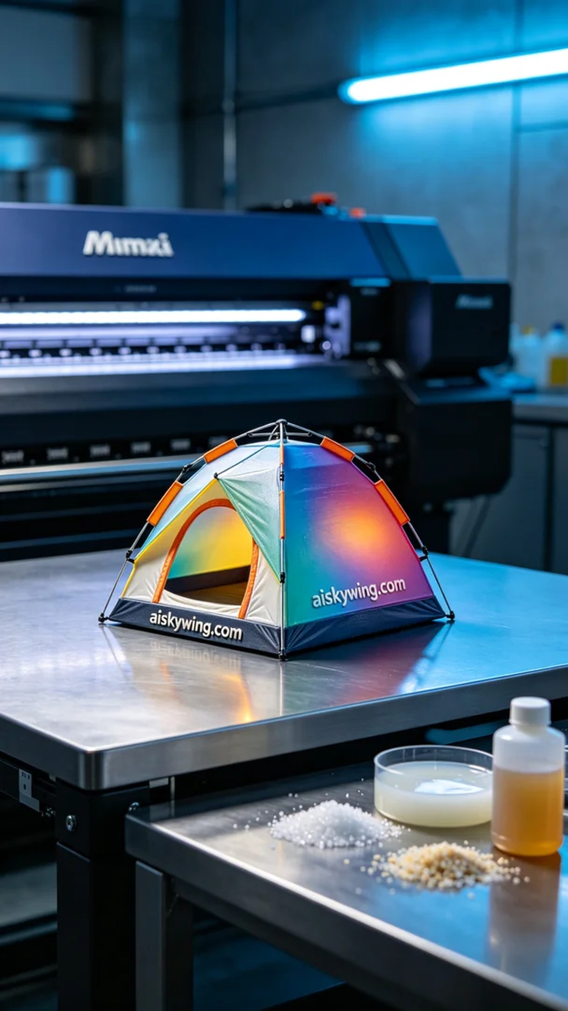
在YouTube上，有人因为想要一个独特的展示模型而联系到了我，提出了制作全彩3D打印帐篷模型的需求。他们希望这个模型能展现出丰富的色彩和细腻的细节，让他们的产品更加吸引眼球。
为了这次打印，我准备了高质量的液态光敏树脂作为原材料。使用Mimaki 3D打印机时，我设置了打印参数：层厚为0.1毫米，打印温度保持在25摄氏度，功率设置为100%，打印速度为30毫米每秒，预计打印时间为8小时。这些参数确保了打印出的帐篷模型色彩渐变和细节都能得到充分呈现。
打印过程中，Mimaki打印机运行稳定，液态光敏树脂均匀分布。我时刻监控打印质量，确保每一层都能完美贴合，特别是在颜色渐变的细节部分，更是需要高度关注。在打印的过程中，蓝色的氛围灯映衬着工业桌面，营造出一种紧张而又充满期待的气氛。
打印完成后，第一步是将模型从打印机中取出，随后进行清洗，使用专用溶液去除残留的树脂。清洗完成后，我仔细对模型进行了打磨，以去除可能存在的边角毛刺，确保表面平滑。接着，将模型进行固化处理，放置在紫外线固化箱中，确保它达到最佳的强度和耐久性。最后，我对模型进行了一次全面的检验，确保细节没有遗漏。
经过一系列的精细工序，这个全彩3D打印帐篷模型终于完工了，色彩鲜艳，细节生动，成功展示了我一贯追求的高标准。每一个打印任务都是一次新的挑战，而这次的经验，让我更加坚定了自己的方向。
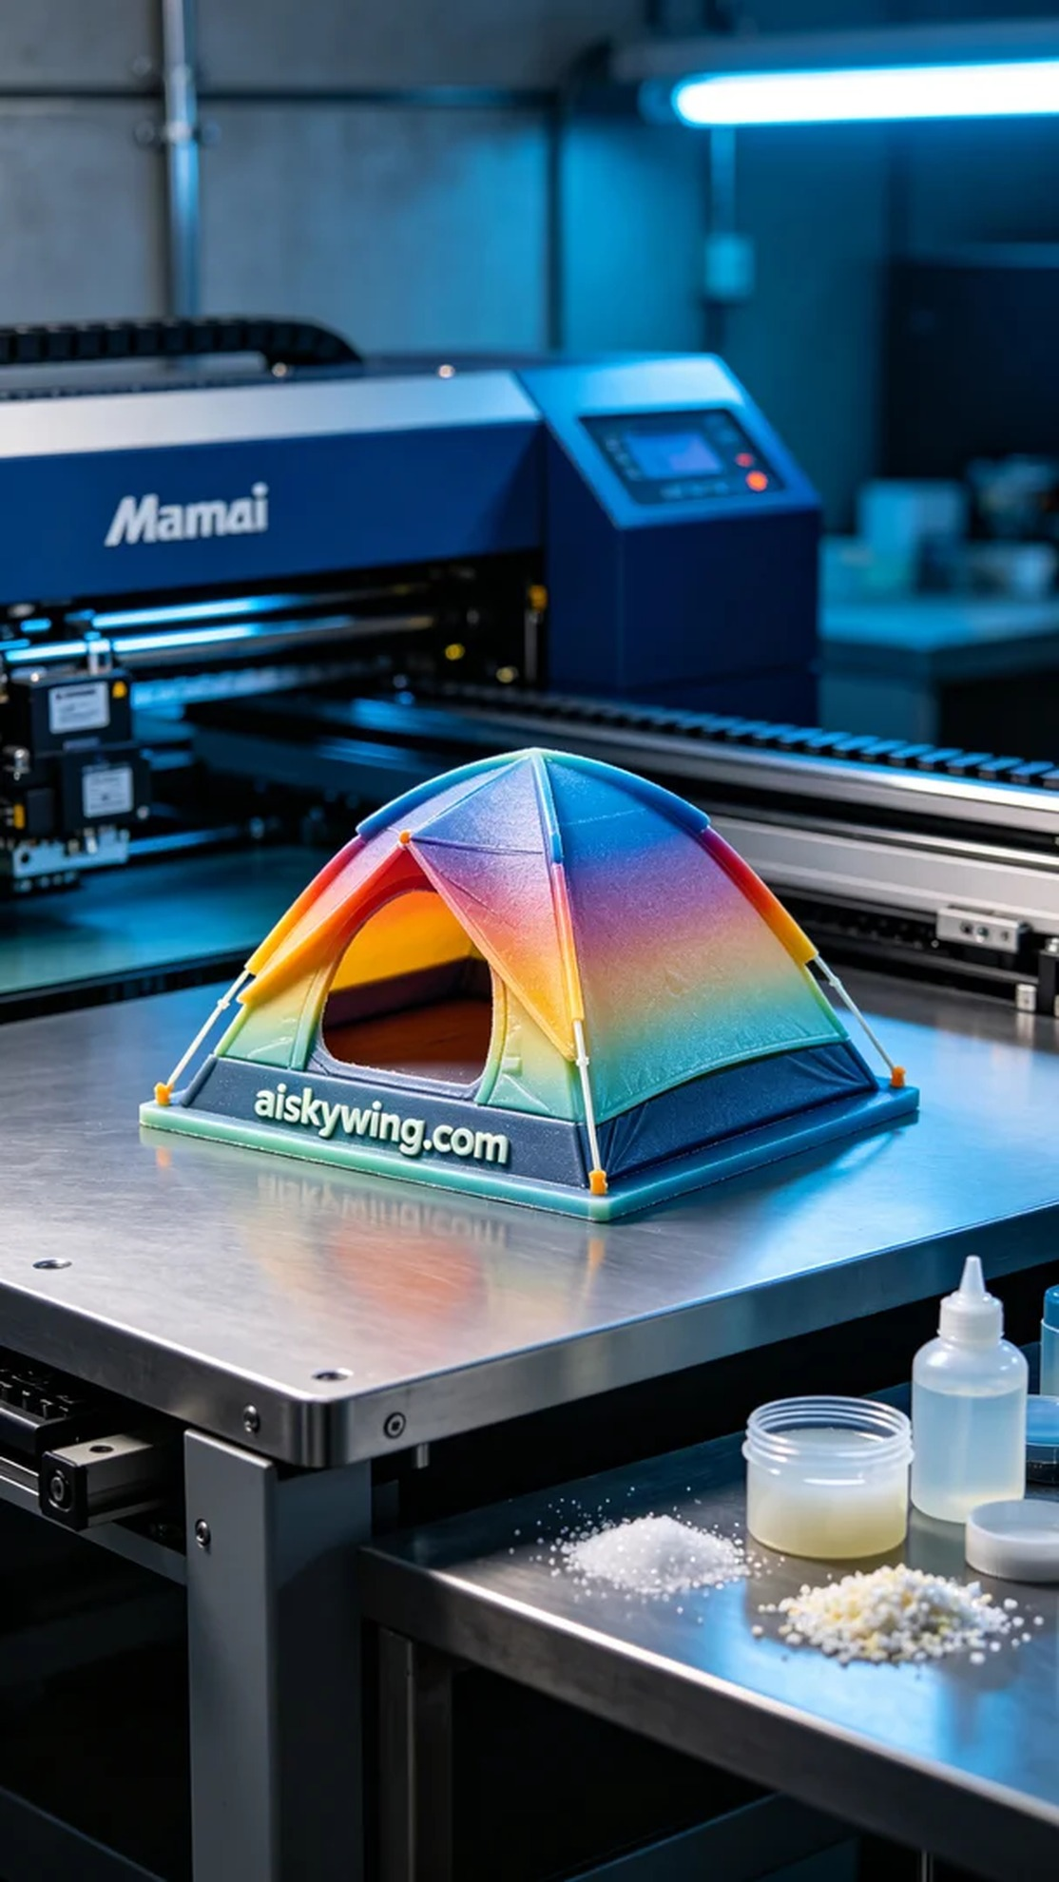
Aiskywing Industrial 3D Printing
Full-color 3D printed tent model


