1071-全彩3D打印心形模型制作记录
Full-color 3D printed heart-shaped model
🖨️ 全彩3DP
🖥️ 打印机: Stratasys
📦 材料: 摆放着未成型的液态光敏
在TikTok上看到的全彩3D打印心形模型，让我想起了我们在生活中的坚持与追求，今天就来分享这次的制作过程。
The full-color 3D-printed heart-shaped model I saw on TikTok reminded me of our persistence and pursuits in life. Today, I would like to share the process of making it.
________________________________________________________________________________
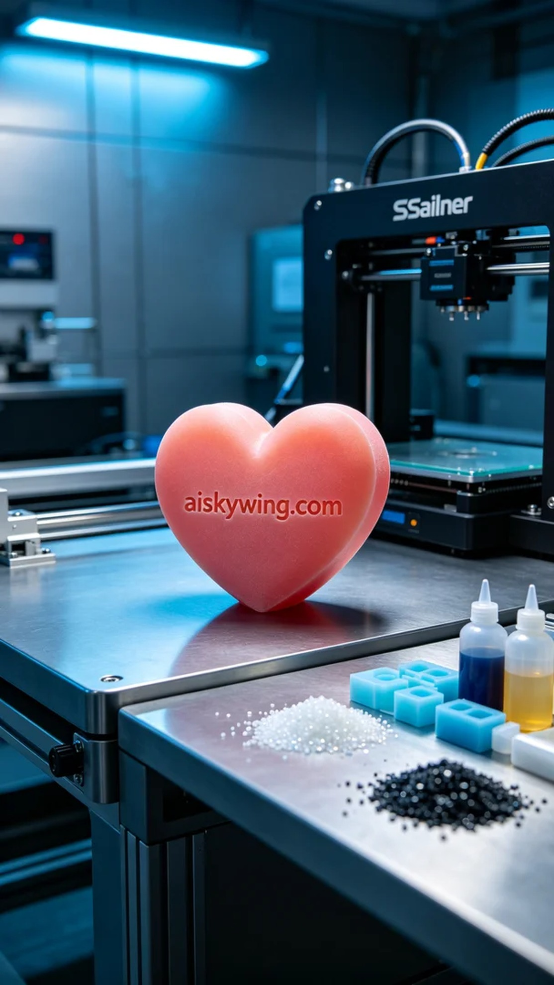
Recently, someone approached us wanting to create a full-color heart-shaped model for a special occasion. The heart shape is visually captivating, especially with its rich colors and gradient effects. The request emphasized high detail, aiming for the perfect presentation.
We chose unformed liquid photopolymer resin as the raw material for its excellent color rendering and fine surface texture, perfectly suited for creating a full-color model. For equipment, we used the Stratasys 3D printer. The printing parameters were set to a layer thickness of 0.1mm, temperature at 25 degrees Celsius, a print speed of 40mm per second, power at 80 watts, with an estimated total print time of 5 hours.
The printing process went smoothly, with the machine running steadily under my supervision. Every detail was meticulously controlled to ensure the color gradients and detail presentation met the requirements. Throughout the process, the machine emitted a consistent sound, and as time passed, the heart-shaped model took form, becoming increasingly vivid.
Once printing was completed, we proceeded with post-processing. First, we cleaned the model to remove excess resin. After that, we carefully sanded it to achieve a smoother surface. Next, we placed the model in a curing device for thorough hardening, ensuring its strength and durability. Finally, after inspection, the model's colors and details fully met the expectations of the requester.
Through this production, I realized that every detail is crucial, and it’s these efforts that culminate in a perfect full-color 3D printed heart-shaped model. This experience was not just about making a product; it was a journey into the intersection of technology and art.
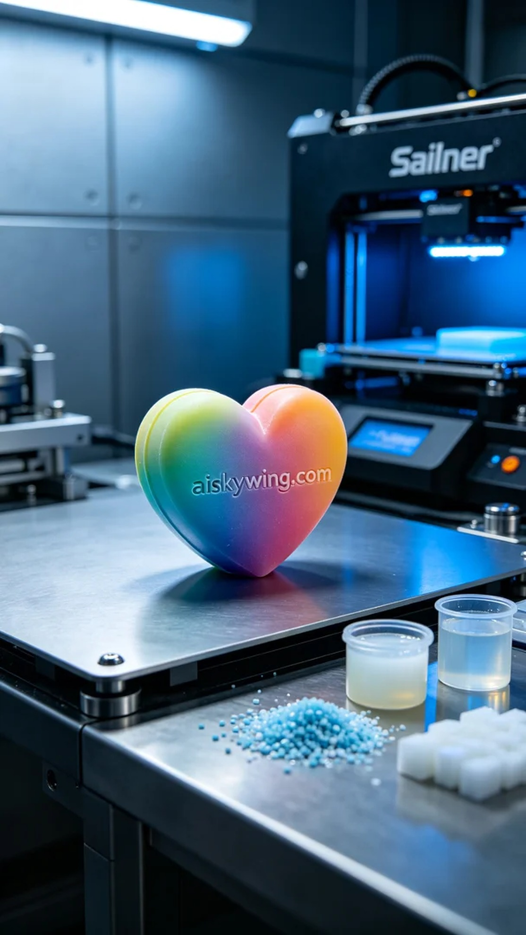
这次有朋友找我们，想要制作一个全彩的心形模型，主要是用来作为特殊场合的礼物。心形模型在视觉上非常吸引人，尤其是它那丰富的色彩和渐变效果。朋友对细节要求很高，希望能呈现出最完美的一面。
我们选择了未成型的液态光敏树脂作为原材料，这种材料具备优秀的色彩还原度和细腻的表面效果，正好符合制作全彩模型的需求。设备方面，使用的是Stratasys的3D打印机。打印参数设置为层厚0.1毫米，温度设定在25摄氏度，打印速度为40毫米每秒，功率控制在80瓦，预计总打印时间为5个小时。
打印过程非常顺利，设备运行稳定，整个过程都在我的监控下进行。每个细节都被严格把控，确保色彩渐变和细节呈现完全符合要求。打印过程中，机器发出均匀的声音，随着时间的推移，心形模型逐渐成型，视觉效果也越来越清晰。
完成打印后，我们进行了后处理工序。首先将模型进行清洗，以去除多余的树脂。随后，我们进行了细致的打磨，使表面更加光滑。接着，把模型放入固化设备中进行充分硬化，确保其强度和耐用性。最终，经过检验，模型的色彩和细节完全达到了朋友的期望。
经过这次制作，我感受到每一个细节都至关重要，正是这些努力才成就了一个完美的全彩3D打印心形模型。这不仅是一次制作经历，更是对技术和艺术的探索。
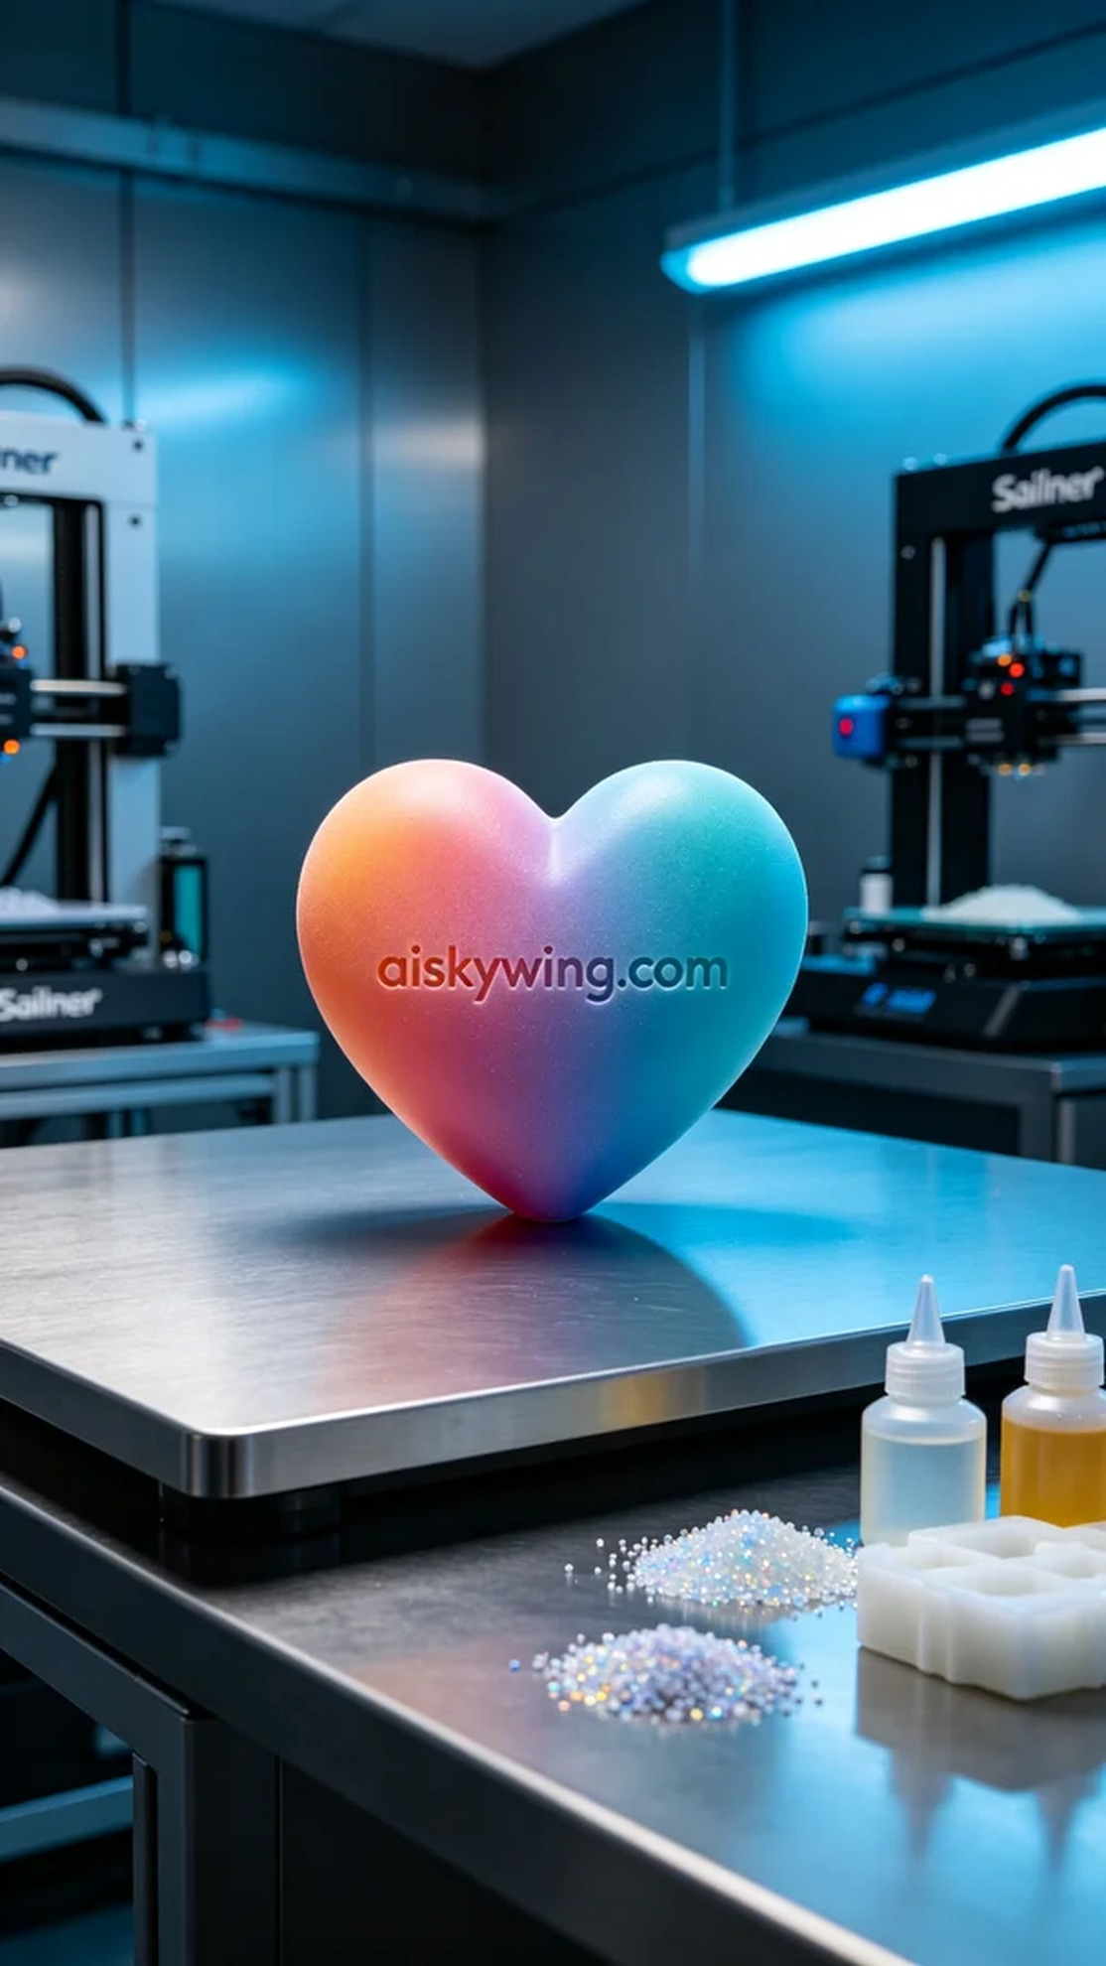
Aiskywing Industrial 3D Printing
Full-color 3D printed heart-shaped model


