1072-全彩3D打印恐龙模型制作记录
Full-color 3D printed dinosaur model
🖨️ 全彩3DP
🖥️ 打印机: Voxeljet
📦 材料: 全彩3DP
生活再难，也别停下脚步。就像处理这个全彩3D打印恐龙模型，面对挑战，唯有迎头而上。
No matter how difficult life gets, don't stop moving forward. Just like tackling this full-color 3D printed dinosaur model, when faced with challenges, the only way is to confront them head-on.
________________________________________________________________________________
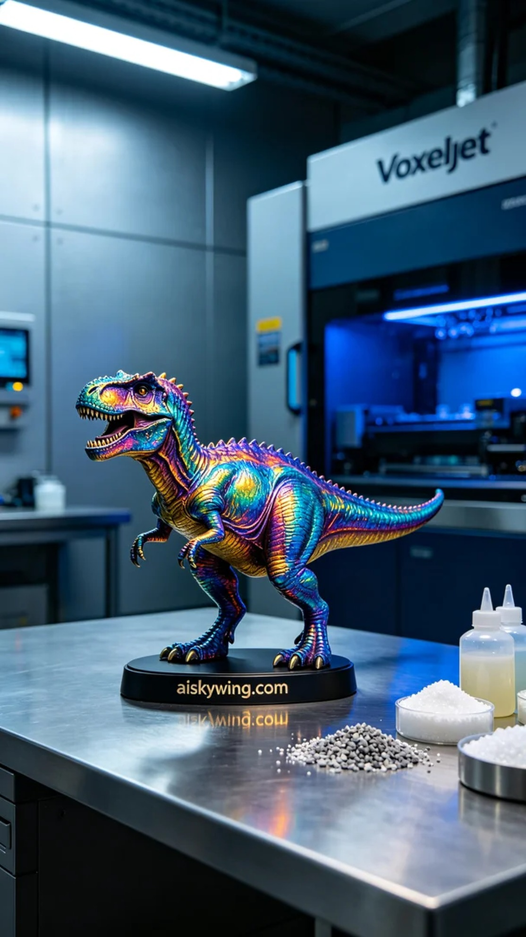
Recently, someone saw our full-color 3D printed dinosaur model on TikTok and asked if we could fulfill their creative needs. This model is particularly intricate and vibrant, requiring precise craftsmanship to capture every detail. So, I decided to take on this challenge and get ready for the full-color 3DP printing process.
We used high-quality full-color 3DP materials, which boast excellent color saturation and detail representation. During the preparation stage, I adjusted the Voxeljet printer, setting the printing parameters to a layer thickness of 0.1mm, maintaining a temperature of 25 degrees, setting the power at 80%, and a printing speed of 15 mm/s. Once everything was ready, I loaded the materials into the printer and kicked off this creative journey.
The printing process was tense yet filled with anticipation. As the Voxeljet printer roared to life, the liquid resin solidified layer by layer. I continuously monitored the print quality to ensure each layer met the standards without any flaws. This print took about 12 hours in total, the machine ran steadily without any issues, ultimately presenting a colorful dinosaur model.
After completing the print, the post-processing steps were equally crucial. First, I soaked the model in a cleaning tank to remove excess resin from the surface. Then, I meticulously sanded the model to ensure a smooth finish. After that, it went into a curing device for UV curing, enhancing the model's durability and color depth. Lastly, after multiple inspections confirmed there were no flaws, the model was considered complete.
This experience of creating the full-color 3D printed dinosaur model not only allowed me to enjoy the process of creation but also improved my technical skills, resulting in a perfect finished product that is hard to believe.
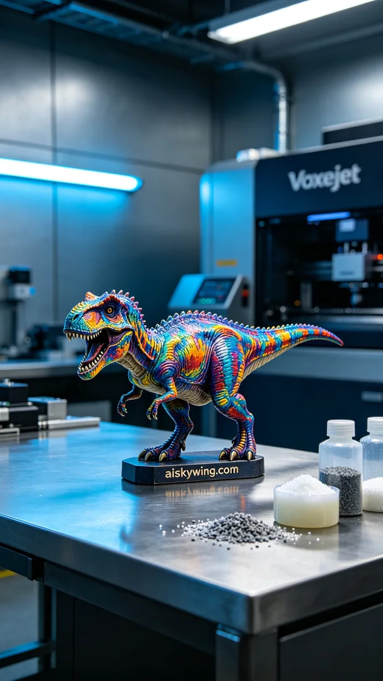
最近，有人在TikTok上看到我们的全彩3D打印恐龙模型，询问是否能实现他们的创意需求。这款模型特别复杂，色彩丰富，需要精密的工艺来呈现出每一个细节。于是，我决定接下这个挑战，准备好迎接全彩3DP的打印过程。
我们使用的是高品质的全彩3DP材料，具有优异的色彩饱和度和细节表现力。在准备阶段，我先对Voxeljet打印机进行调试，设置打印参数为：层厚0.1毫米，温度保持在25度，功率设定为80%，打印速度为15毫米/秒。所有准备就绪之后，我将材料装入打印机，开启了这一创作之旅。
打印过程紧张而充满期待。随着Voxeljet打印机的轰鸣声响起，液态的树脂逐层固化成型。我不断监控打印质量，确保每一层都符合要求，并没有出现任何瑕疵。这次打印总共耗时约12小时，机器稳定运行，没有发生任何故障，最终呈现出一个色彩斑斓的恐龙模型。
完成打印后，后处理工序同样至关重要。首先，我将模型在清洗槽中浸泡，去除表面的多余树脂。接下来，模型经过细致的打磨，以确保表面平滑。然后，我将其放入固化设备中，进行UV固化，增强模型的耐久性和色彩深度。最后，经过多次检查，确认没有瑕疵后，模型才算制作完成。
这次制作全彩3D打印恐龙模型的过程不仅让我体验到创作的乐趣，也提升了我的技术水平，最终我们得到了一个完美的成品，让人难以置信。
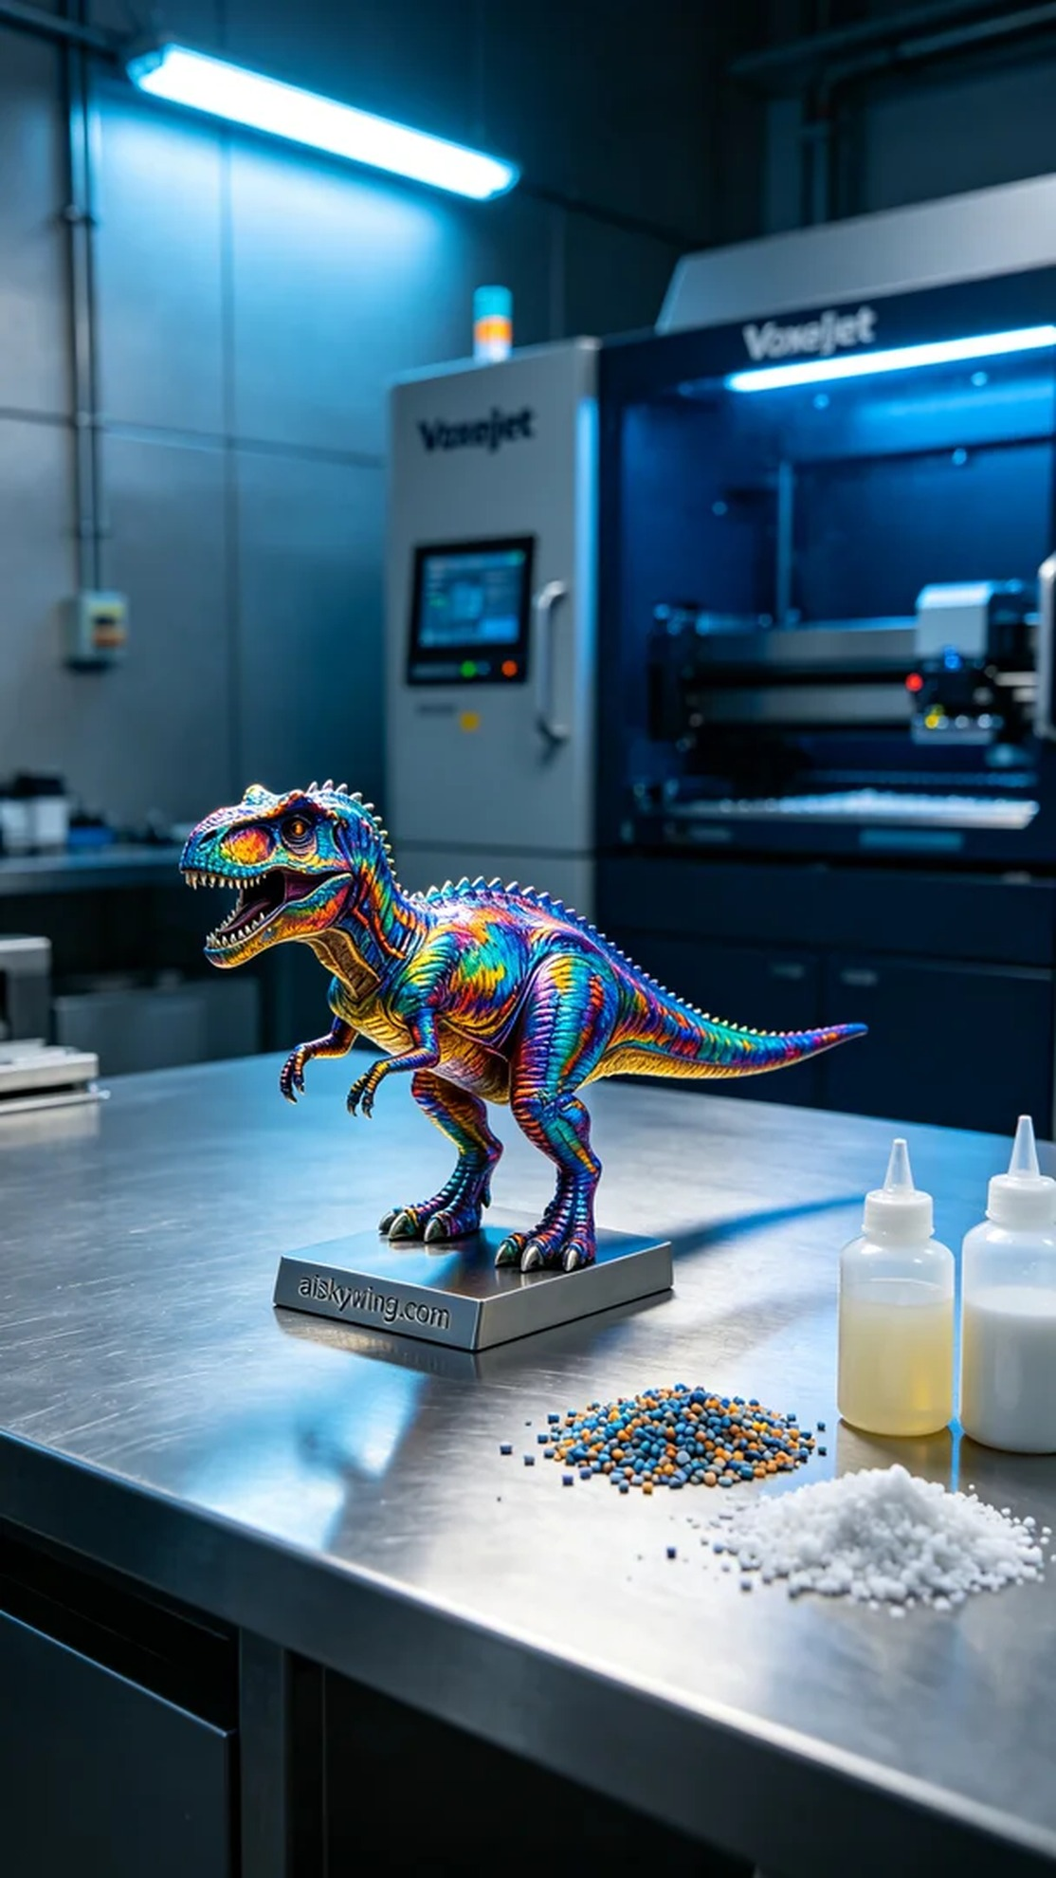
Aiskywing Industrial 3D Printing
Full-color 3D printed dinosaur model


