1073-全彩3D打印扑克牌模型制作记录
Full-color 3D printed playing card model
🖨️ 全彩3DP
🖥️ 打印机: Mimaki
📦 材料: 全彩3DP彩色打印
生活就像一副扑克牌，充满了未知与挑战。正如这款全彩3D打印扑克牌模型，有人因为它的细致与颜色丰富而找到了我们，希望能够在视觉上给人带来惊喜。
Life is like a deck of playing cards, full of unknowns and challenges. Just like this full-color 3D printed playing card model, some people have found us because of its intricate details and vibrant colors, hoping to bring a visual surprise to others.
________________________________________________________________________________
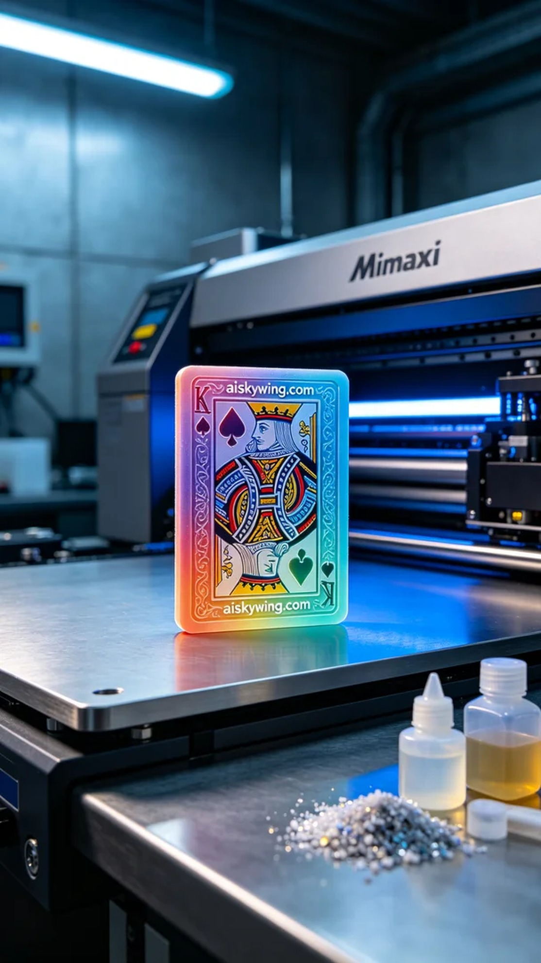
Life is like a deck of cards, full of unknowns and challenges. Just like this full-color 3D printed playing card model, someone approached us seeking the intricate details and rich colors to create a visual surprise for their audience.
To achieve this goal, we chose full-color 3DP as the material, ensuring the model's colors would reach their best effect. During the preparation phase, we utilized a Mimaki printer and set the printing parameters to: layer thickness of 0.1mm, printing temperature at 30 degrees Celsius, power at 80%, printing speed of 50mm per hour, and an estimated printing time of 24 hours. This setup ensures perfect detail presentation and smooth color transitions.
During the printing process, the Mimaki equipment operated steadily, accompanied by soft machine sounds as we carried out quality monitoring. At intervals, we checked the model's progress and details to ensure each layer's colors aligned precisely, avoiding any color discrepancies. The entire process went smoothly, and the model's contours and color gradients gradually came to life, creating anticipation.
Post-processing is an essential part of model creation. First, we cleaned the printed model to remove excess resin from the surface, then we sanded it down to ensure every edge was smooth and flawless. Following this, we performed UV curing to guarantee the model's durability. Finally, after rigorous inspection to ensure every detail was impeccable, the model was deemed complete.
The entire process was not just a technical challenge but also an exploration of color and creativity. After completing this full-color 3D printed playing card model, we felt a sense of accomplishment and satisfaction, looking forward to creating more unique works in the future.
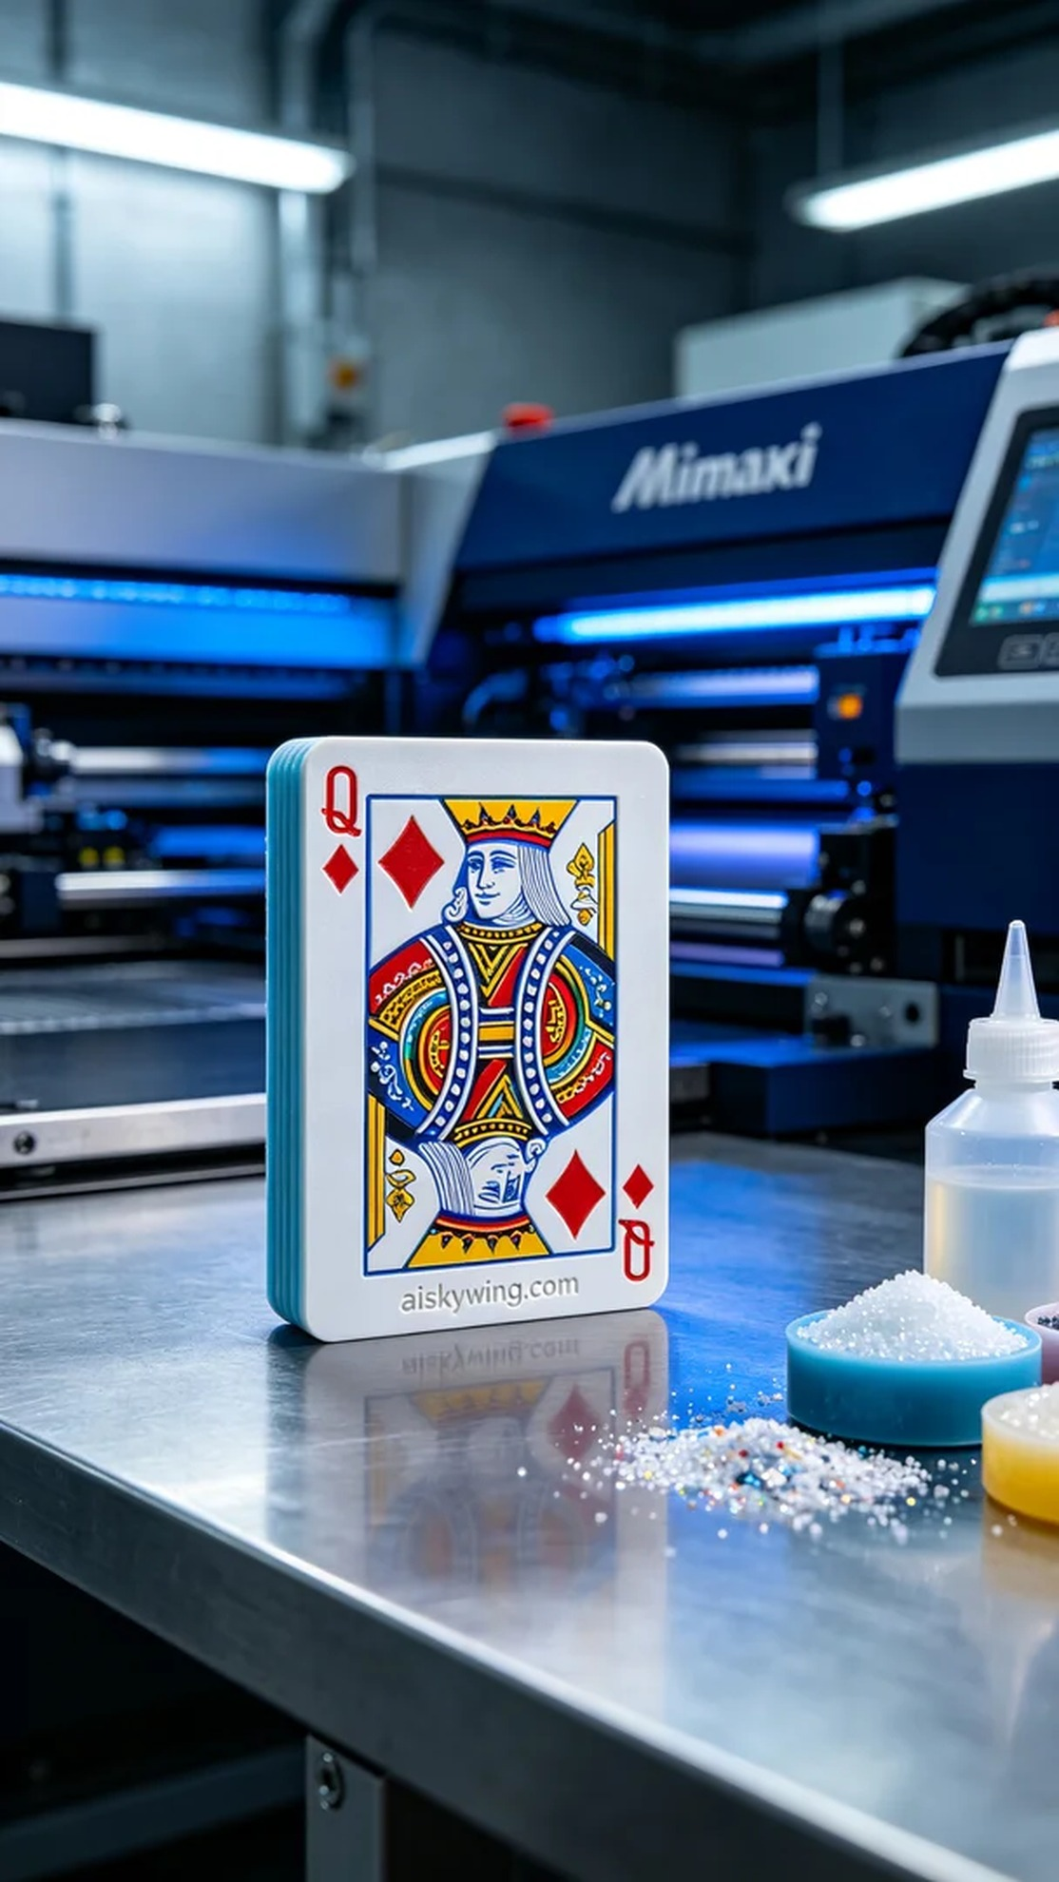
在Instagram上，有人因为寻找一款独特的扑克牌而向我们求助，想要一款全彩3D打印扑克牌模型来吸引更多的关注和喜爱。他们希望能够展现色彩的丰富性和逼真度，以此来引起用户的兴趣。
为了实现这一目标，我们选择了全彩3DP彩色打印作为材料，确保模型的色彩能够达到最佳效果。在准备阶段，我们使用Mimaki打印机，将打印参数设置为：层厚0.1毫米，打印温度设定在30摄氏度，功率保持在80%，打印速度为每小时50毫米，预计打印时间为24小时。这样的设置能够确保细节的完美呈现，并保证色彩的平滑过渡。
打印过程中，Mimaki设备稳定运行，伴随着柔和的机器音响，我们一直在进行质量监控。每隔一段时间，我们都会检查模型的进度和细节，确保每一层的色彩能够精准对齐，避免出现色差。整个过程顺利进行，模型的轮廓和色彩渐变逐渐显现，令人期待。
完成后处理是模型制作中不可或缺的一环。首先，我们将打印好的模型进行清洗，去除表面多余的树脂，然后进行打磨，确保每一个边缘都光滑无瑕。接下来，我们使用UV灯进行固化处理，确保模型的耐用性。最后，经过严格的检验，确保每个细节都无可挑剔，模型才算完成。
整个过程不仅是一次技术上的挑战，更是对色彩与创意的探索。在这款全彩3D打印扑克牌模型制作完成后，我们也感受到了那份成就与满足，期待将来能创造出更多别具一格的作品。
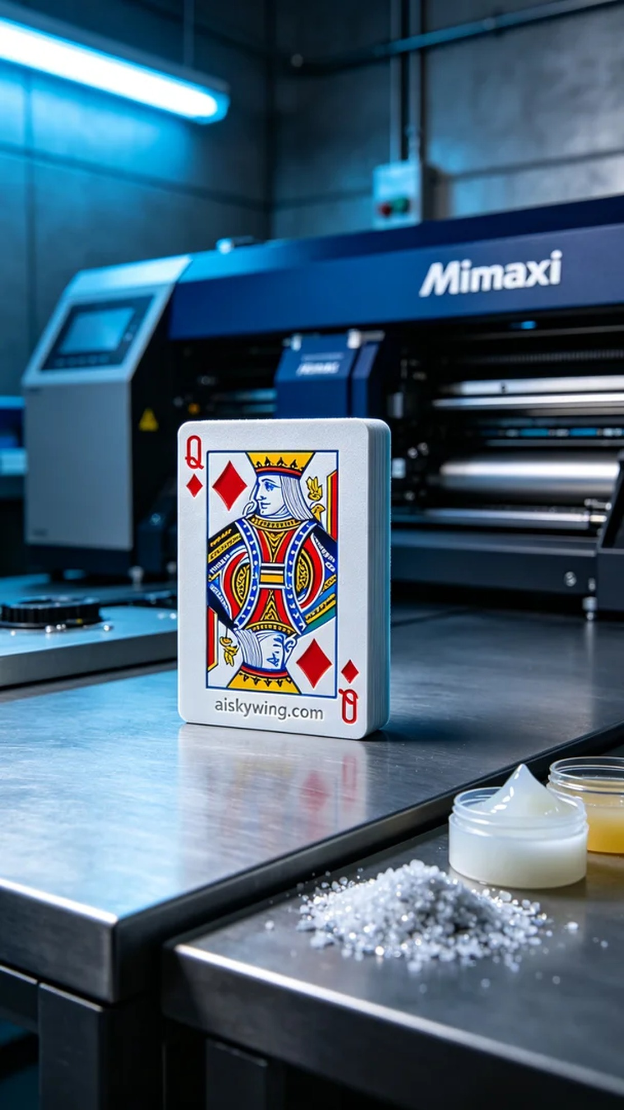
Aiskywing Industrial 3D Printing
Full-color 3D printed playing card model


