1074-全彩3D打印打字机模型生产记录
Full-color 3D printer model
🖨️ 全彩3DP
🖥️ 打印机: Xjet
📦 材料: 全彩3DP彩色树脂
生活中，总有那么一些时刻，让我们选择坚守。就像有人在Facebook上找到我们，希望制作这个全彩3D打印打字机模型，让梦想具象化。
In life, there are always moments that make us choose to persevere. Just like when someone finds us on Facebook, hoping to create this full-color 3D printed typewriter model to bring dreams to life.
________________________________________________________________________________
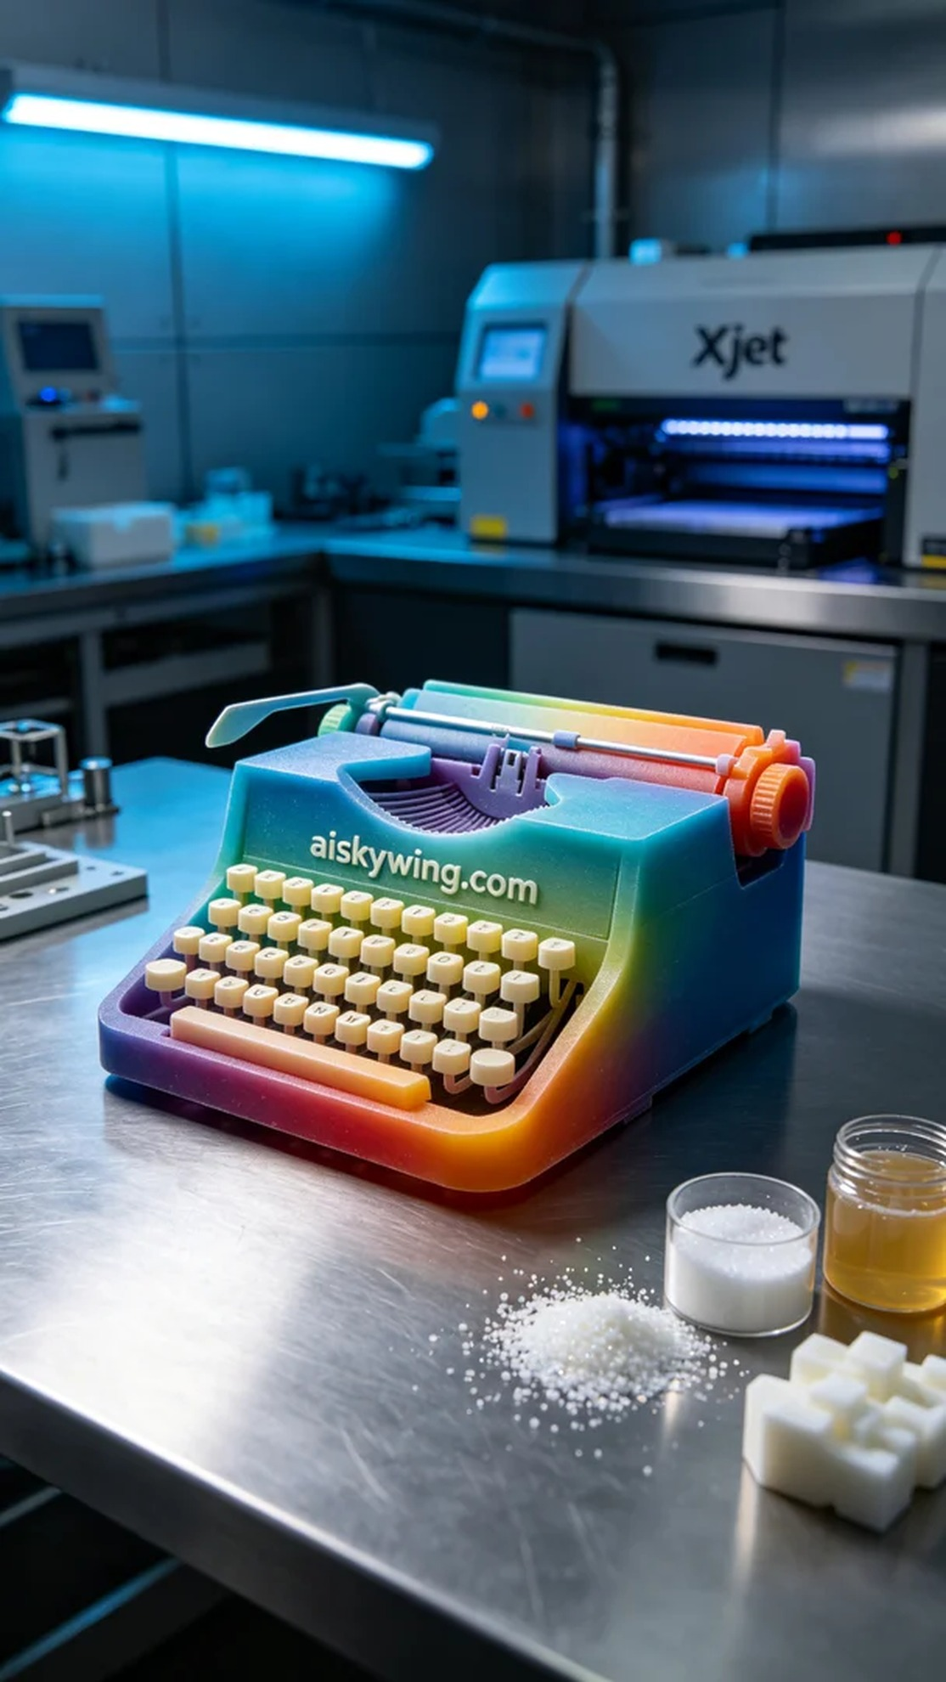
In life, there are always moments that make us choose to persevere. Recently, someone reached out on Facebook, seeking to create a full-color 3D printed typewriter model, bringing a dream to life.
The project stemmed from someone looking for a way to create a vibrant and detailed full-color 3D printed typewriter model. They faced challenges in selecting materials and manufacturing processes. After a thorough discussion, we decided to use full-color 3DP resin, ensuring the quality of the model’s presentation.
To ensure the best results, we prepared the necessary equipment and chose the Xjet 3D printer. We set the layer thickness to 0.1mm, maintained a printing temperature of 25°C, with a power of 50W and a speed of 50mm/s, estimating a printing time of 6 hours. Each of these parameters was crucial for achieving the final effect.
During the printing process, the Xjet printer operated steadily, and the advanced full-color 3DP technology allowed for vivid color gradients and clear details in the model. We conducted real-time quality monitoring throughout the printing to ensure every detail was perfectly presented, avoiding any flaws.
After printing, we conducted a thorough post-processing procedure. First, we cleaned the model with water to remove any residual resin. We then performed light sanding to ensure a smooth surface. Next, we cured the model in a UV curing machine to enhance its strength and color longevity, followed by a comprehensive inspection to meet quality standards.
With all the meticulous work completed, we successfully delivered the full-color 3D printed typewriter model. It’s truly rewarding to turn a dream into reality.
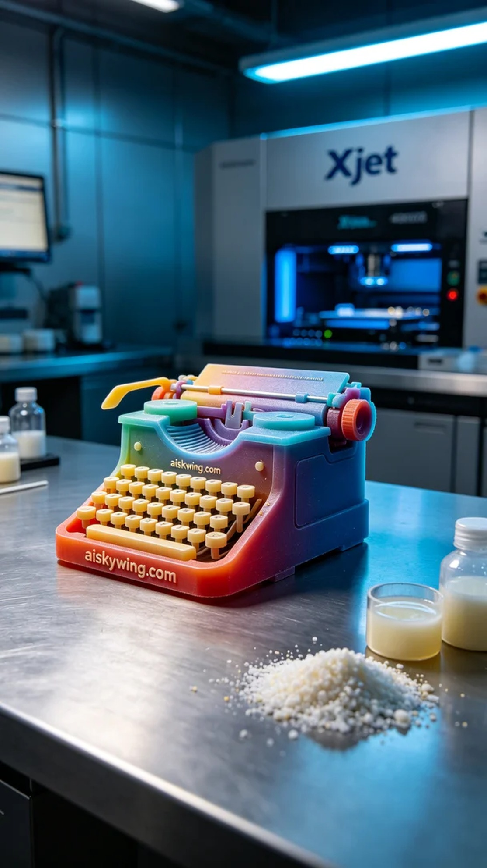
这次的项目源自于有人在Facebook上询问，想要制作一款全彩3D打印打字机模型，突出其独特的色彩与细节。然而，他们在选择材料和制造工艺上遇到了困扰。我们深入交流后，决定使用全彩3DP彩色树脂，确保模型的呈现质量。
为了确保打印效果，我们准备了必要的设备，选用了Xjet 3D打印机。我们设定了层厚为0.1mm，打印温度保持在25°C，功率为50W，打印速度为50mm/s，预计打印时间为6小时。这些参数的选择对于最终效果的实现至关重要。
打印过程中，Xjet打印机运行稳定，先进的全彩3DP技术使得模型的颜色渐变和细节清晰可见。我们在打印过程中进行了实时质量监控，确保每一个细节都能完美呈现，避免出现任何瑕疵。
完成打印后，我们进行了详细的后处理工序。首先，使用清水对模型进行了清洗，去除表面的残余树脂。随后，进行轻微打磨，以确保表面光滑。接着，在UV固化机中固化，让模型的强度和色彩更为持久，最后进行了全面检验，确保满足质量标准。
经过一系列精细的工作，我们顺利交付了这款全彩3D打印打字机模型。能够将梦想变为现实，真是让人感到欣慰。
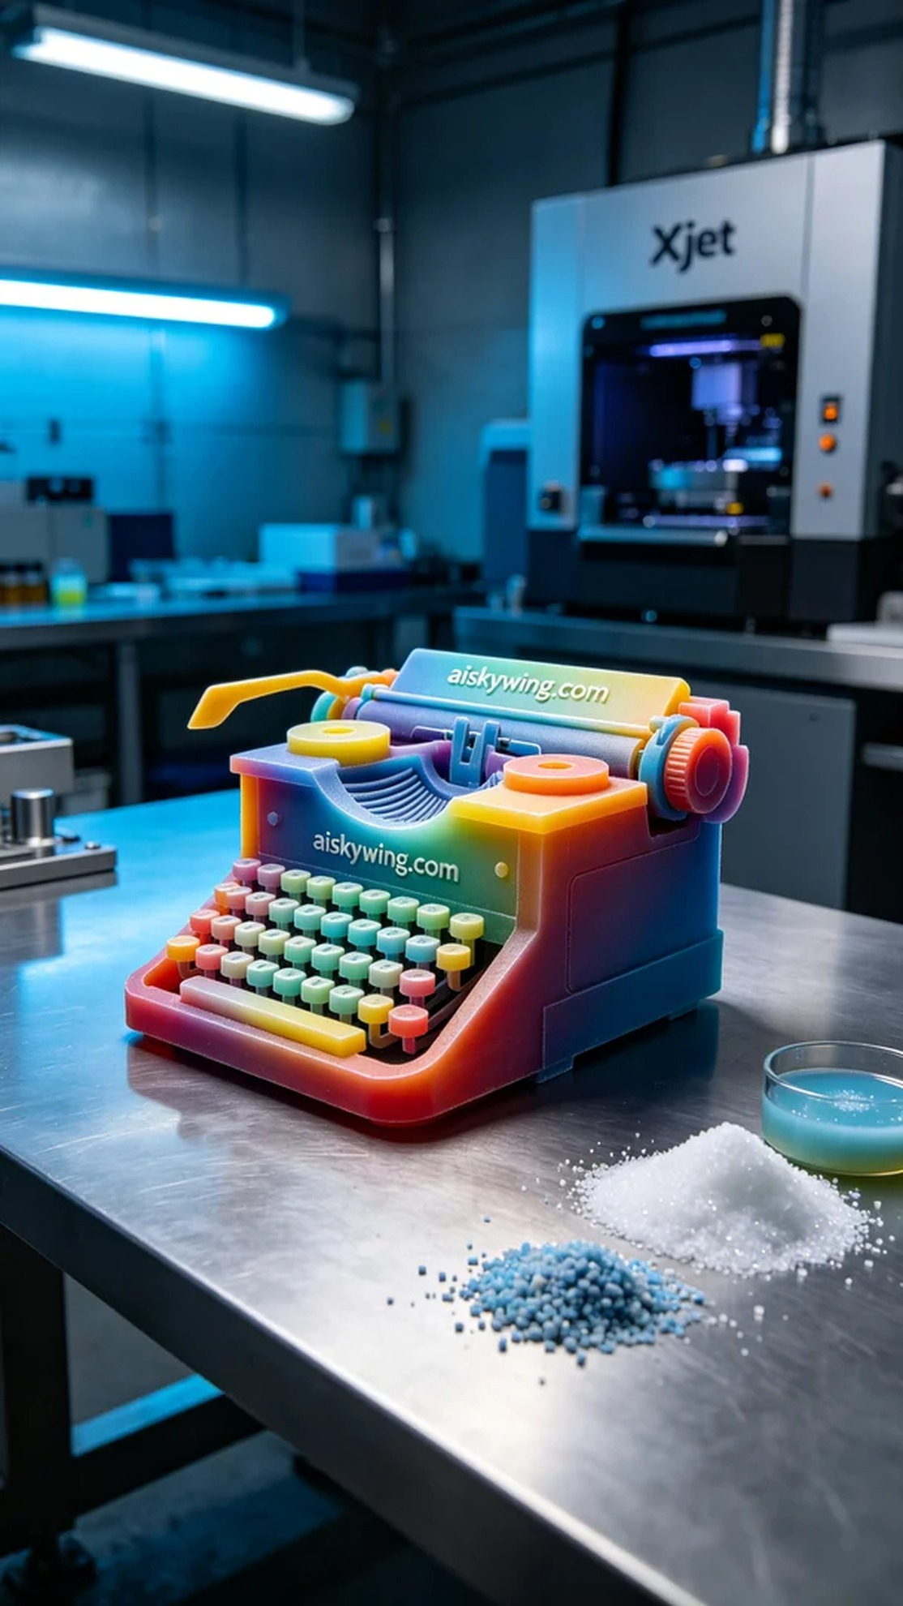
Aiskywing Industrial 3D Printing
Full-color 3D printer model


