1075-3D打印台灯支架的生产记录
Table lamp stand
🖨️ SLA光固化
🖥️ 打印机: Mimaki
📦 材料: SLA
生活就像一块未成型的光敏树脂，只有经过耐心雕琢才能发光发热。最近在Twitter上，有人因为台灯支架的问题找上我们。
Life is like an unshaped photosensitive resin; it can only shine and emit heat after being patiently carved. Recently, someone reached out to us on Twitter regarding an issue with their lamp stand.
________________________________________________________________________________
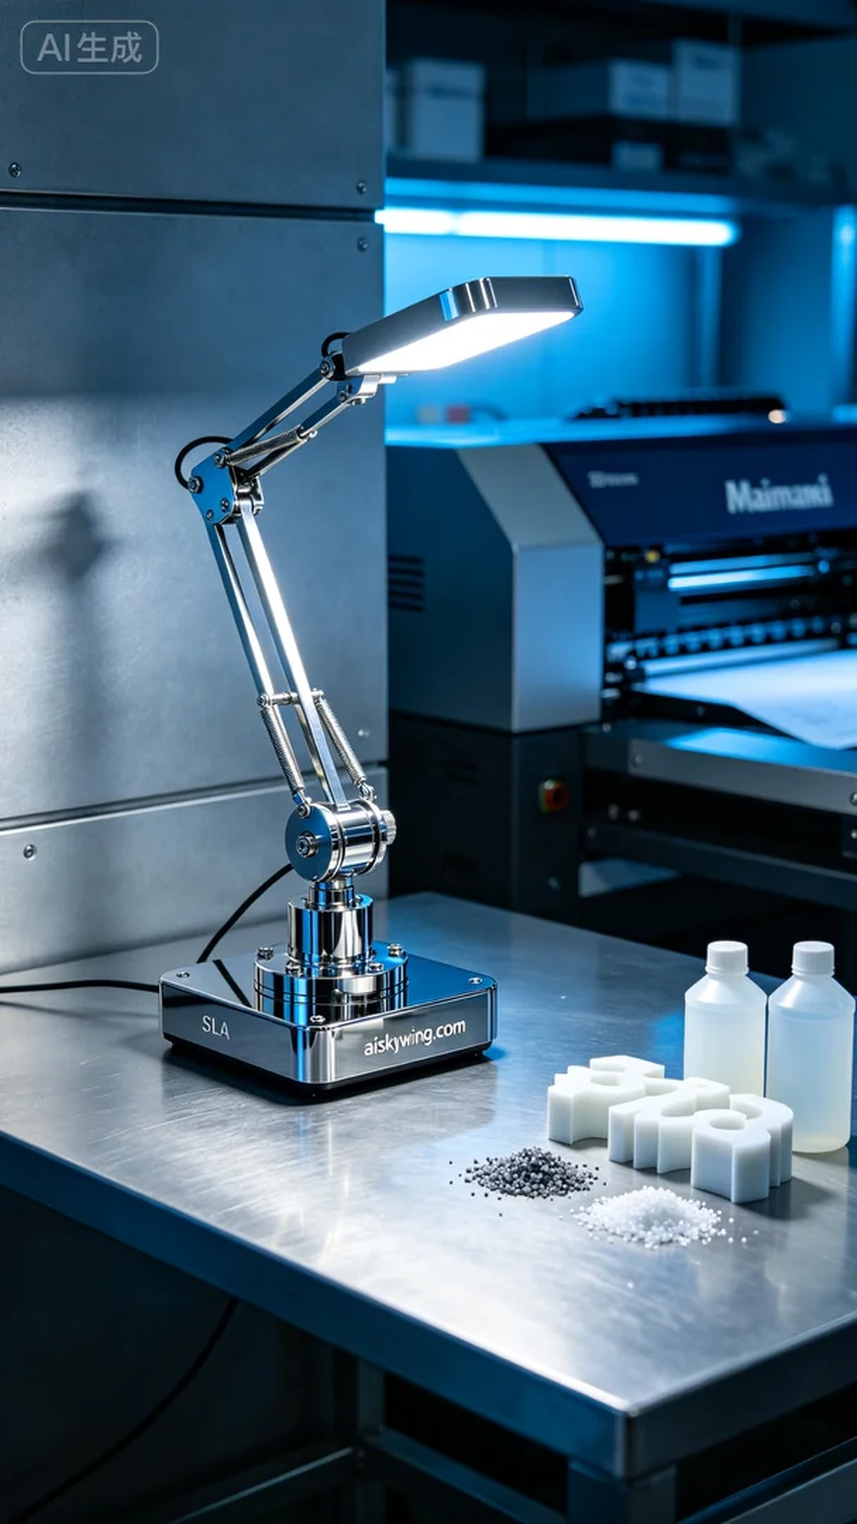
Life is like a piece of uncured photopolymer resin; it only shines when patiently crafted. Recently on Twitter, someone reached out to us regarding an issue with a lamp stand.
The request was to produce a lamp stand with specific design requirements and material choices, making the project quite challenging. Someone mentioned their keen interest in light control and hoped we could provide a perfect stand to help achieve their ideal lighting.
In the production process, we opted for SLA (Stereolithography) technology using high-quality photopolymer resin. Our favored printer, the Mimaki, was set up with a layer thickness of 0.05mm, keeping the temperature at 25°C, the power adjusted to 80% for optimal curing, and a speed of 45mm/s to ensure fine detail. The entire print was estimated to take around 8 hours.
During the printing process, we closely monitored the machine's operation. The Mimaki printer performed stably, with the liquid resin curing evenly in the print chamber. The process was smooth and efficient, as we ensured every layer was accurate, allowing for a seamless post-processing phase.
Once printing was complete, we immediately began a series of post-processing steps. The finished product was first placed in a cleaning solution to remove any residual photopolymer. Next, we meticulously sanded the surface to achieve the desired high-gloss finish. Finally, the stand was placed in a UV curing machine to enhance the material's strength and durability. After rigorous inspection, the final product met our stringent quality standards.
In the end, this lamp stand was delivered on schedule, perfectly showcasing the expected design, providing a blend of technological appeal and industrial aesthetics. Every detail was carefully crafted and nurtured to perfection.
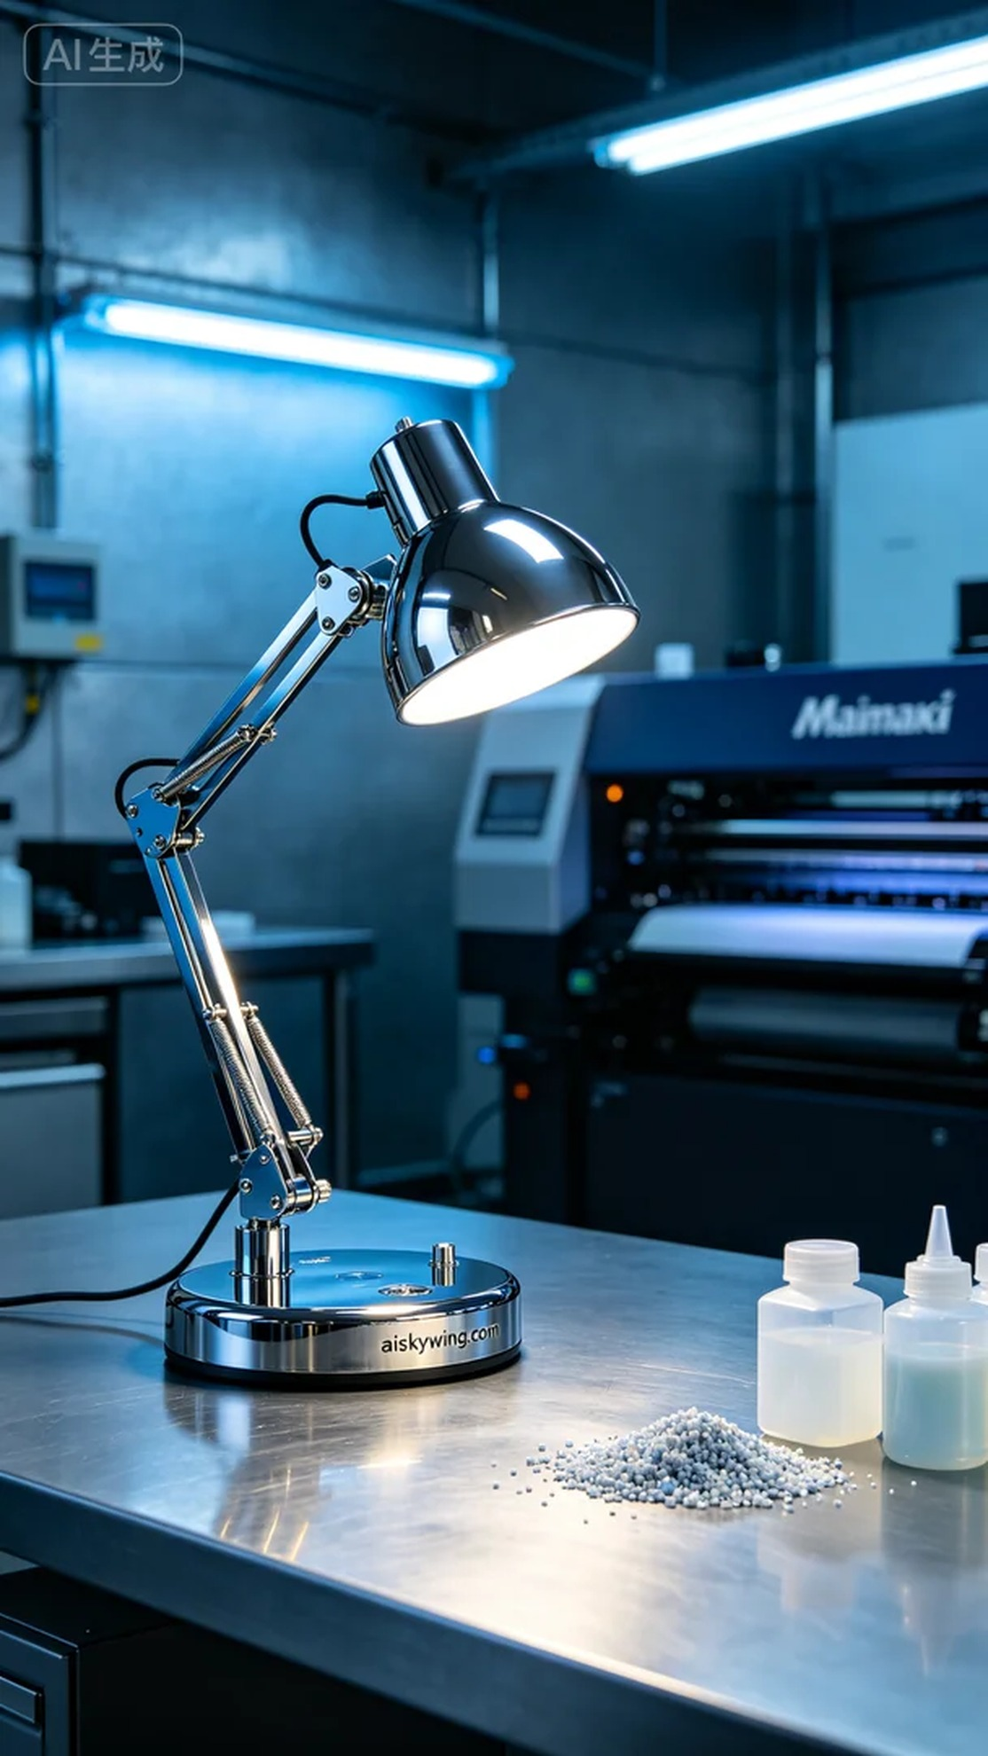
我们接到的需求是为一款台灯支架进行生产，特殊的设计要求以及材料的选择都让这个项目变得颇具挑战性。有人在社交平台上提到他们对光线的把控非常在意，希望我们能够提供一款完美的支架，帮助他们实现理想中的照明效果。
制作过程中，我们选择了SLA光固化技术，使用的材料是高质量的光敏树脂。打印机则是我们常用的Mimaki，设置了0.05mm的层厚，保持在25°C的温度下，功率调至80%以达到理想的光固化效果，速度则调整为45mm/s，以确保细节的完美呈现。整个打印预计耗时约8小时。
在打印过程中，我们仔细监控设备运行的状态。Mimaki的打印技术表现得非常稳定，液态树脂在打印舱内均匀固化。整个过程顺利且高效，通过实时观察确保每一层都是精准无误，使得后期的处理能更加顺利。
打印完成后，我们立即进行了一系列的后处理工序。首先将成品放入清洗液中，去除残留的光敏树脂。接下来，我们对表面进行了细致的打磨，以确保高光镜面质感的实现。最后，将支架放入UV固化机中进行固化，以增强材料的强度和耐用性。经过严格检验，最终的产品达到了预期的品质标准。
最终，这款台灯支架如期而至，完美呈现了预期的设计效果，给人一种既科技感又具有工业风格的视觉享受。每一个细节都得到了我们的精心打磨和呵护。
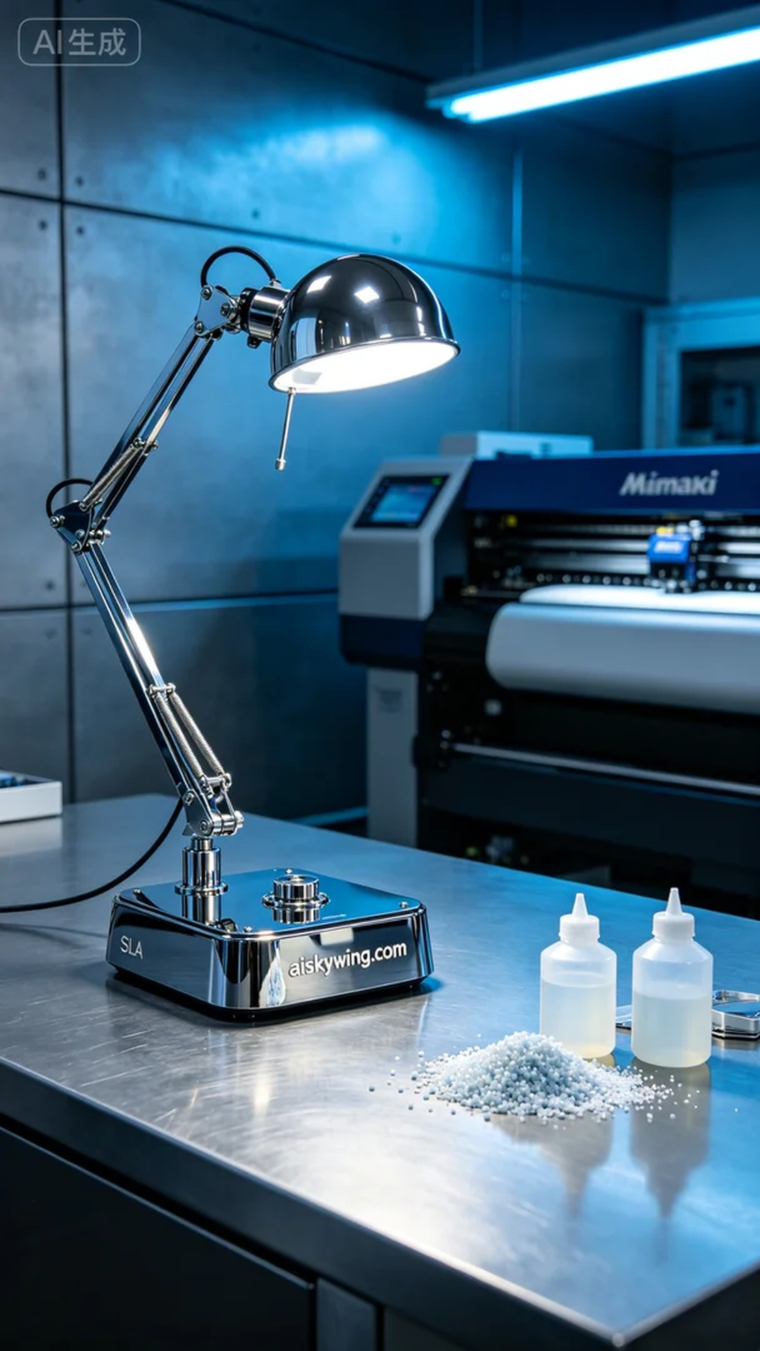
Aiskywing Industrial 3D Printing
Table lamp stand


