1076-精密制作台灯灯罩的工艺记录
Table lamp shade
🖨️ SLS尼龙烧结
🖥️ 打印机: Stratasys
📦 材料: 摆放着未成型的液态光敏
生活就像这盏台灯，点亮了黑暗，带来了希望。有人因设计需求在Twitter上找到了我们，我们的任务便是制作这个别致的台灯灯罩。
Life is like this table lamp, illuminating the darkness and bringing hope. Someone found us on Twitter due to a design need, and our task is to create this stylish lampshade.
________________________________________________________________________________
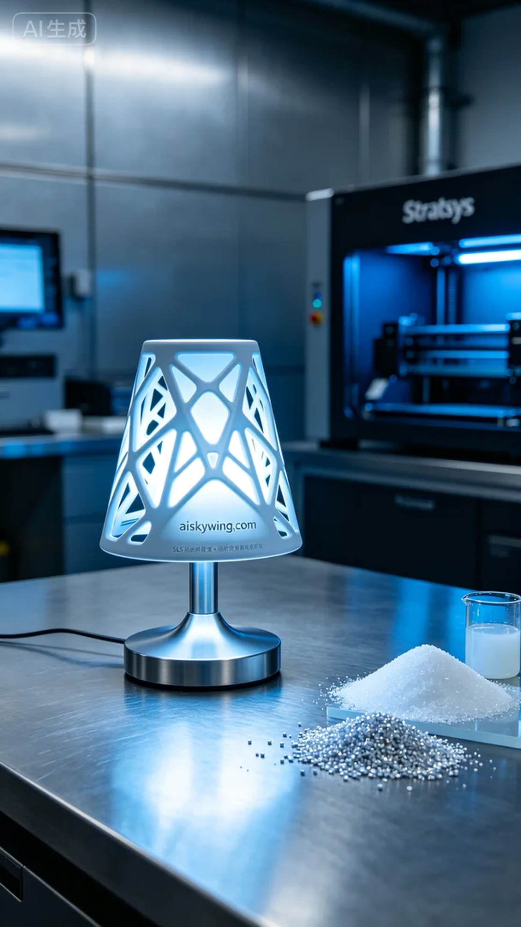
Life is like this lamp, lighting up the darkness and bringing hope. Someone found us on Twitter, requesting that we create a unique lampshade, and our task was to bring this exquisite lampshade to life.
Our production began with selecting the right materials. To ensure the quality of the final product and the flexibility of the design, we opted for the liquid photopolymer resin that was placed before us. This material has excellent forming properties and adaptability for post-processing, making it ideal for our 3D printing process. Using the Stratasys printer, we set the printing parameters with a layer thickness of 0.1 mm, a temperature of 25°C, a power adjustment of 80%, and a speed of 40 mm/s, ensuring efficient and delicate printing.
As the printing process commenced, the equipment ran smoothly, with the printer's indicator light remaining green, signaling all was well. We closely monitored the print quality, ensuring each layer was precisely aligned. With time passing, the outline of the lampshade became increasingly clear, and the engraved "aiskywing.com" text emerged, showcasing the design's details.
Upon completion of the printing, the post-processing stages were crucial for ensuring product quality. First, we cleaned the finished product with a professional cleaning solution to remove any residual resin from the surface. Then, we proceeded to sanding, ensuring a smooth and flawless finish. Finally, we cured the piece using UV light to enhance the material's stability and strength. After inspection, every detail of the final product met our expected standards.
Thus, a lampshade that is both practical and artistic was born through our efforts. Each print is a new experience, and this achievement has strengthened our team's commitment to pursuing excellence.
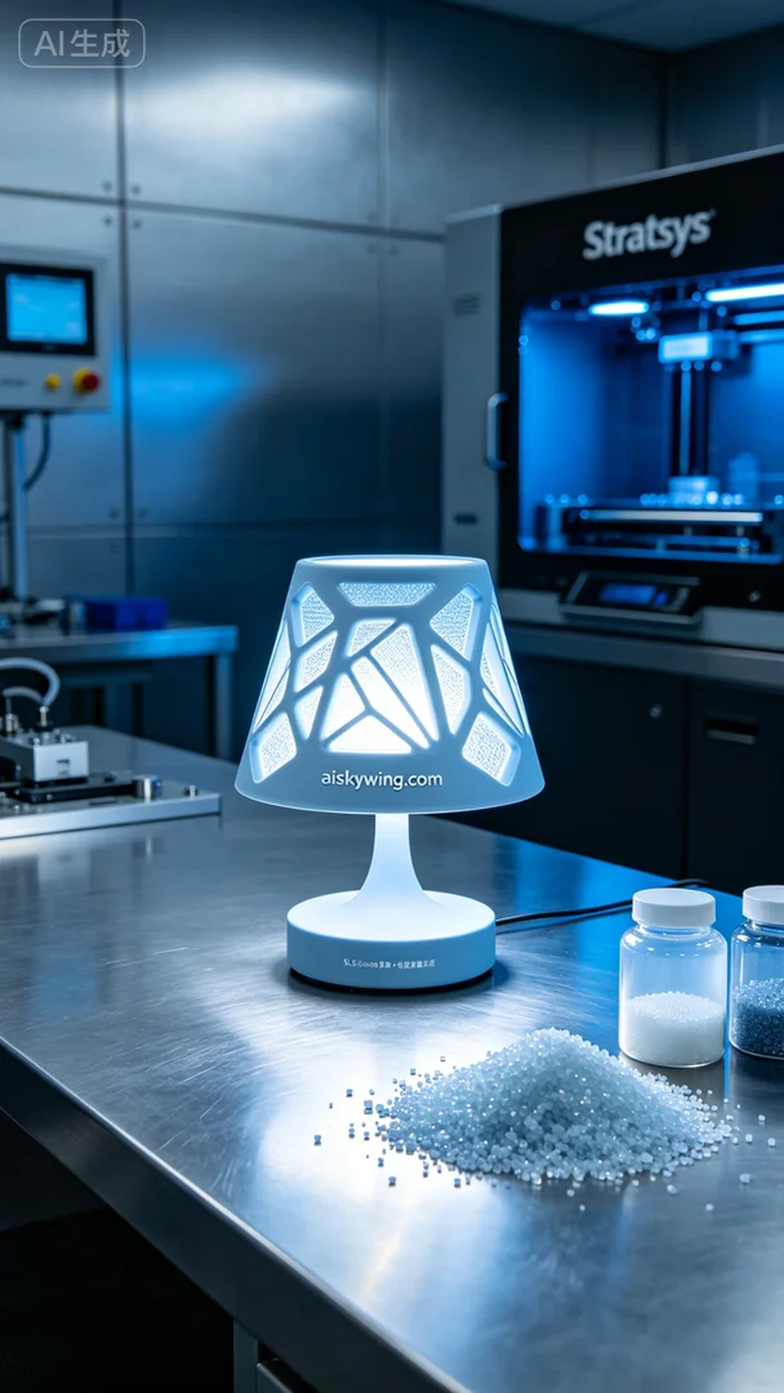
在一次Twitter的互动中，我们接到有人请求，希望我们能制作一款独特的台灯灯罩。这不仅是个简单的照明工具，更是一件艺术品，设计师希望它能展现出企业的科技感和品牌个性。
我们的制作首先涉及到原材料的选择。为了确保成品的质量与设计的灵活性，我们选择了摆放着未成型的液态光敏树脂。这种材料具有优良的成型性能和后期加工适应性，特别适合于我们的3D打印工艺。我们使用的Stratasys打印机能够精准控制打印参数，设置层厚为0.1毫米，打印温度为25°C，功率调整在80%，速度保持在40mm/s，这样的参数组合确保了打印的高效与细腻。
打印过程开始后，设备运行稳定，打印机的指示灯始终保持绿色，显示一切正常。我们密切监控打印质量，确保每层都精确叠加。随着时间推移，灯罩的轮廓逐渐清晰，表面雕刻的“aiskywing.com”字样也愈发明显，展现出设计的细节。
完成打印后，后处理工序则是保证成品质量的关键环节。首先，我们对成品进行了清洗，使用专业的清洗液去除表面残留的树脂。接着进行打磨，确保表面光滑无瑕，最后我们将其进行固化处理，使用UV灯照射以增强材料的稳定性和强度。经过检验，成品的每个细节都达到了预期的标准。
就这样，一个既实用又具有艺术价值的台灯灯罩通过我们的努力诞生了。每一次打印都是一次新体验，而这次的成就让我们的团队更加坚定了继续追求卓越的信念。
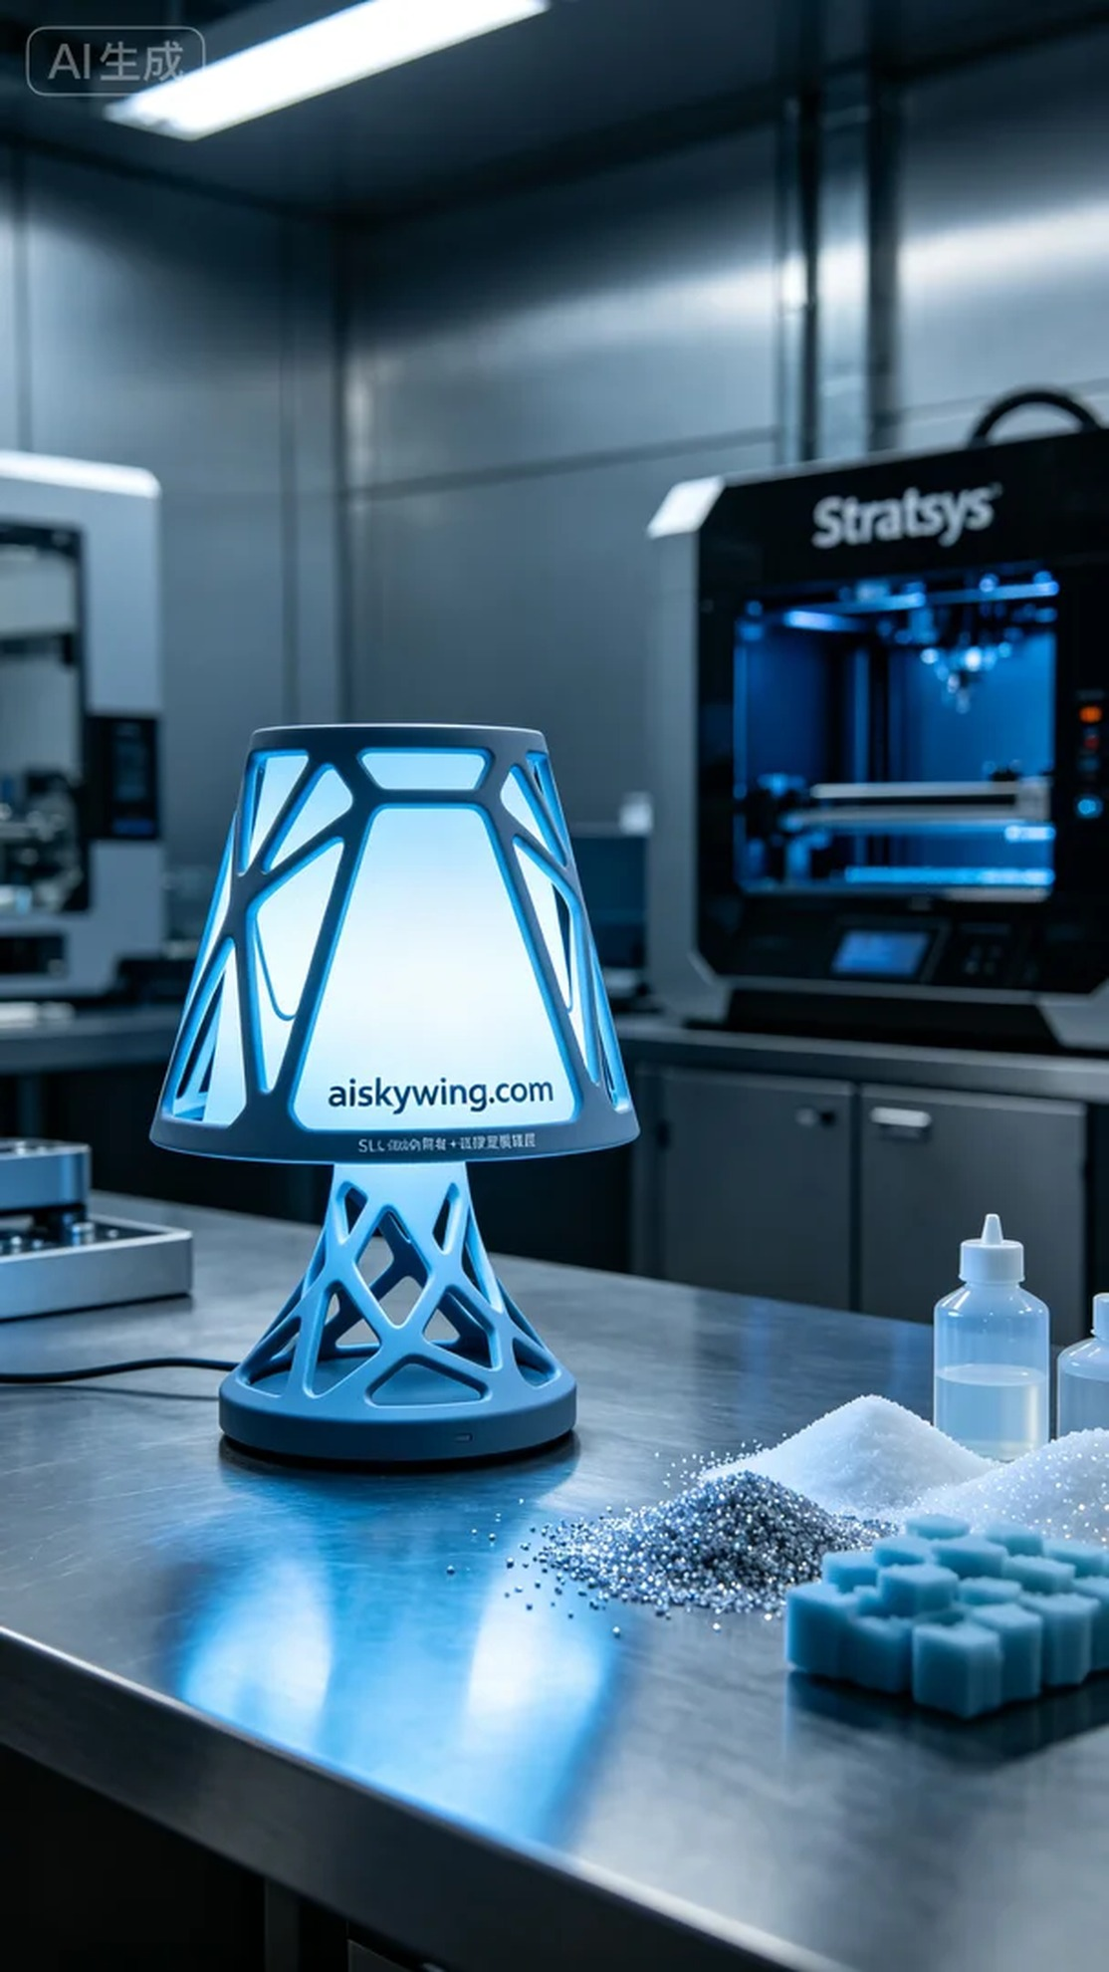
Aiskywing Industrial 3D Printing
Table lamp shade


