1077-吸尘器风道管生产记录
Vacuum cleaner duct pipe
🖨️ SLM金属打印
🖥️ 打印机: Voxeljet
📦 材料: 摆放着未成型的液态光敏
生活再难，也别停下脚步。就像接下这个吸尘器风道管的单子，有人通过WhatsApp找到我们，想要解决他们的设计需求。
No matter how difficult life gets, don't stop moving forward. Just like when we received the order for this vacuum cleaner hose, someone reached out to us via WhatsApp, looking to address their design needs.
________________________________________________________________________________
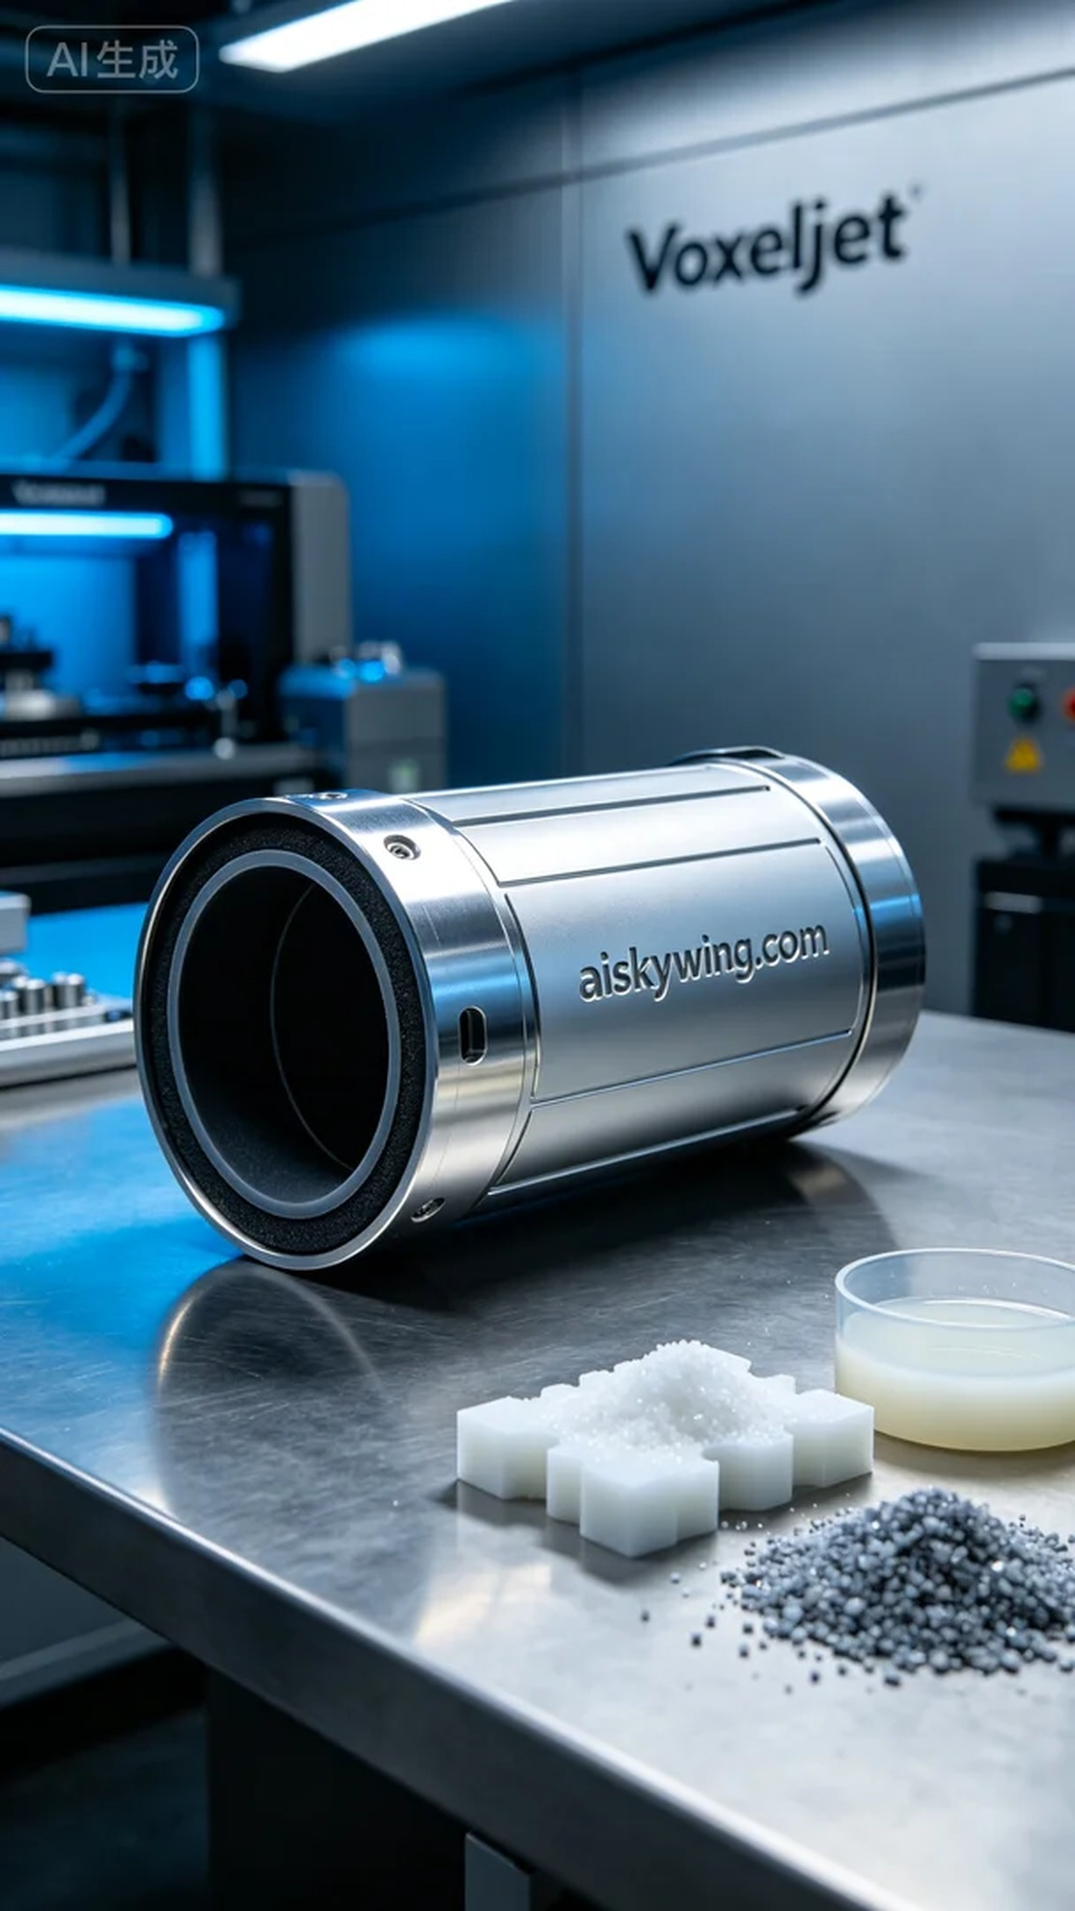
No matter how hard life gets, don't stop moving forward. Like when a friend reached out to us via WhatsApp about a vacuum cleaner duct he needed, we took on the challenge to bring his design to life.
We prepared to use unformed liquid photosensitive resin as the main material to ensure the best printing results. After detailed equipment adjustments, we chose the Voxeljet printer for this task. The printing parameters were set to a layer thickness of 0.1mm, a temperature of 25℃, a power of 2000 watts, and a speed of 50mm per second. This ensured that the details would be clear and the surface smooth.
As the printing process began, the Voxeljet printer operated in an orderly manner, with each layer adding to the vacuum cleaner duct's shape. Throughout the process, we closely monitored the printing results to ensure there were no defects and maintained consistent quality. After several hours of operation, the printing task was completed successfully.
Once printing was done, we removed the product for post-processing. First, we used clean water to wash the printed part, removing any excess resin residue. Next, we meticulously sanded the surface to ensure it was smooth and flawless. Then, we placed the product in a curing device for UV curing treatment to enhance its strength and durability. Finally, we conducted rigorous inspections to ensure every detail met the standards.
After this series of tasks, the production of the vacuum cleaner duct was successfully completed. Bringing a design to life always fills us with immense satisfaction.
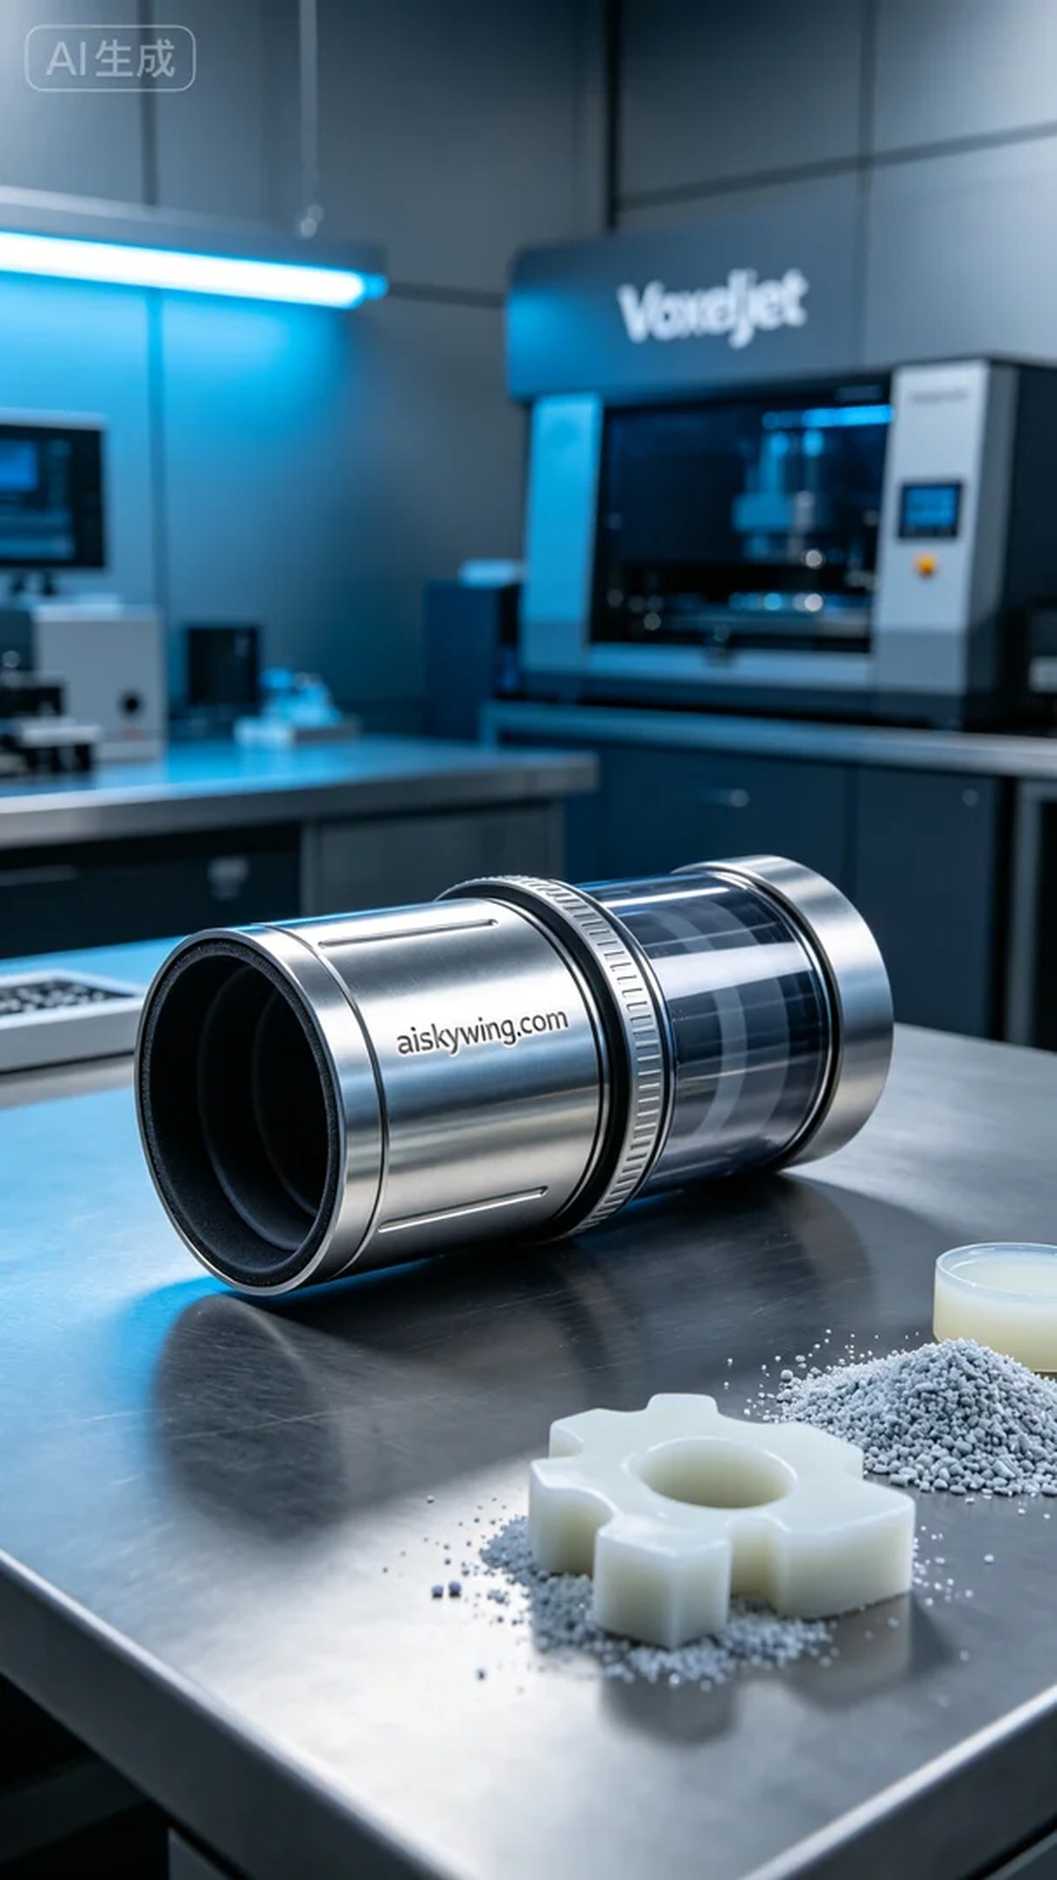
在与一位朋友的交流中，他提到他需要制造一款吸尘器风道管，想要通过我们来实现这个想法。他希望用高品质的材料和先进的打印技术来完成这一项目，于是我们开始了这个有趣的过程。
我们准备使用未成型的液态光敏树脂作为主要原材料，确保打印效果达到最佳。经过详细的设备调试，我们选定了Voxeljet打印机进行此项工作。打印参数设定为：层厚0.1毫米，温度保持在25℃，功率为2000瓦，打印速度为50毫米每秒。这样可以确保细节清晰，表面光滑。
打印过程开始后，Voxeljet打印机开始有序工作，随着每一层的叠加，吸尘器风道管逐渐显现出来。在整个过程中，我们不断监控打印效果，确保没有出现任何瑕疵，保持质量的稳定性。经过几个小时的运转，打印任务顺利完成。
完成打印后，我们将产品取出并进行后处理。首先，使用清水对打印件进行清洗，以去除多余的树脂残留。随后，我们进行细致的打磨，确保表面平滑无瑕。接着，将产品放置在固化设备中，进行UV固化处理，以增强其强度和耐用性。最后，经过严格的检验，确保每一个细节都符合标准。
经过这一系列的工作，吸尘器风道管的生产圆满完成。能够将设计变为现实，总是让人感到无比欣慰。
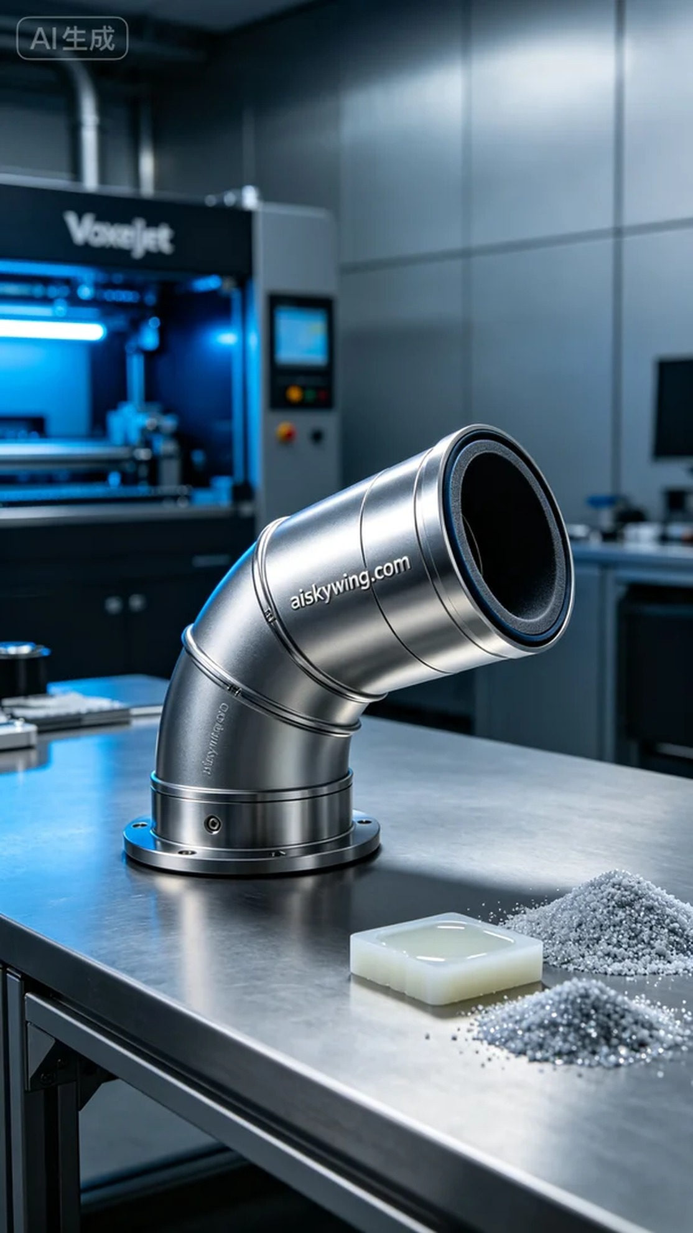
Aiskywing Industrial 3D Printing
Vacuum cleaner duct pipe


