1078-咖啡机豆仓的3D打印生产记录
Coffee machine bean hopper
🖨️ SLA光固化
🖥️ 打印机: HP
📦 材料: SLA
有人在Twitter上晒出自己的新咖啡机，但却对豆仓的设计不满意，于是我接下了这个咖啡机豆仓的项目。
Someone shared their new coffee machine on Twitter but was not satisfied with the design of the bean hopper, so I took on the project of redesigning the coffee machine's bean hopper.
________________________________________________________________________________
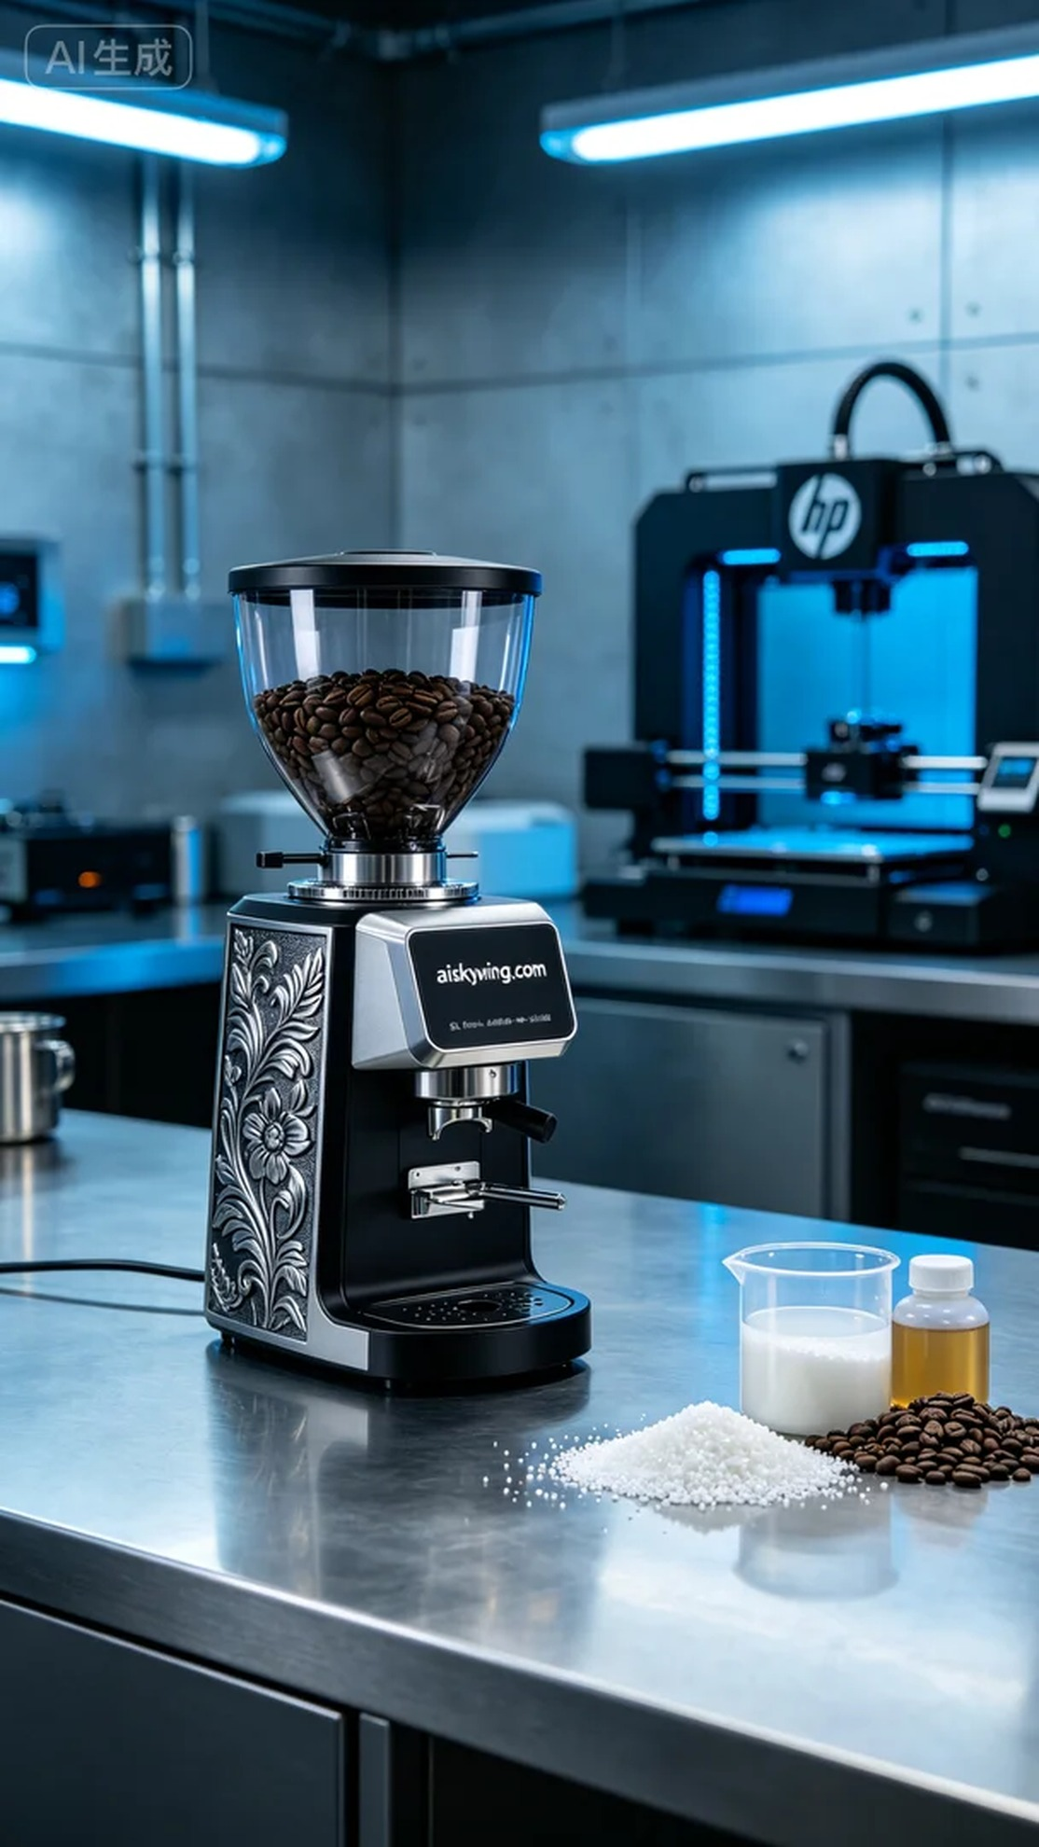
The process of creating this coffee bean hopper began when someone expressed dissatisfaction with the design of their new coffee machine, which they posted about on Twitter. To meet their needs, we decided to utilize SLA (Stereolithography) technology, ensuring that the product would achieve perfection in detail. We chose an HP 3D printer for its stability and high precision, and after thorough communication, we clarified the specific requirements and design concepts, moving into the preparation phase.
We selected high-quality SLA resin as the raw material for this project, known for providing exceptional clarity and fine surface quality. Before printing, we carefully set the printing parameters: a layer thickness of 0.05 mm, a printing temperature of 25 degrees Celsius, a power setting of 60%, and a printing speed of 30 mm/s, with the entire printing process expected to take around 6 hours. These settings ensured we could achieve the desired print results.
During the printing process, the HP printer operated smoothly, with resin supplied evenly throughout, leading to an uninterrupted workflow. Once printing was complete, we conducted a preliminary inspection of the finished hopper, ensuring that every detail met our standards, particularly the visibility of the engraved text "aiskywing.com," which perfectly aligned with the design requirements.
Post-processing is equally crucial. First, we placed the printed hopper in a cleaning tank and thoroughly washed it with isopropyl alcohol to remove any excess resin from the surface. Next, we proceeded to sand the hopper to ensure a smooth finish. Finally, it was placed into a UV curing unit for solidification, ensuring structural strength and durability. After a series of rigorous inspections, we confirmed that the product was flawless and met quality standards.
In the end, this coffee bean hopper 3D printing project was successfully completed. Through our efforts, it not only satisfied aesthetic requirements but also enhanced usability, providing a better experience for the user.
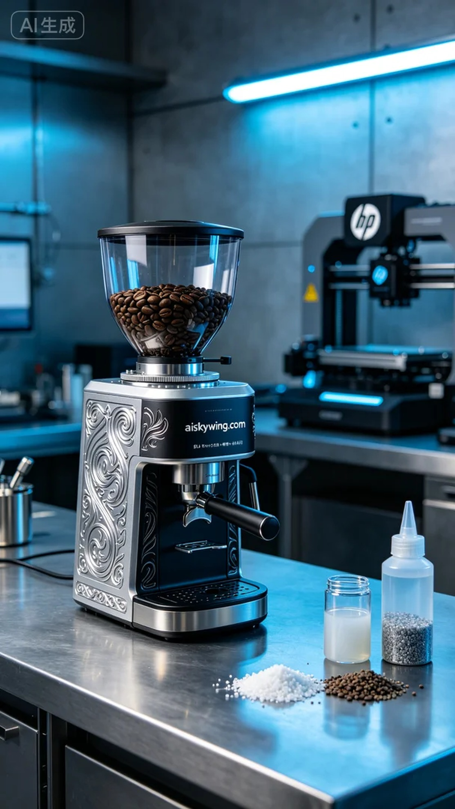
制作这个咖啡机豆仓的过程，始于有人对其外观和实用性的疑虑。为了满足他们的要求，我们决定采用SLA光固化技术，确保产品能够在细节上达到完美。为了实现这一目标，我们选择了HP品牌的3D打印机，以其稳定的性能和高精度的打印质量著称。经过沟通协商，我们明确了具体需求和设计理念，开始进入准备阶段。
我们选用了高质量的SLA光敏树脂作为原材料，其优点在于能提供极高的清晰度和细致的表面质量。在打印前，我们仔细设定了打印参数。层厚定为0.05毫米，打印温度保持在25摄氏度，功率设置为60%，打印速度为30毫米/秒，预计整个打印过程需要6小时完成。这些参数的设置确保了我们能够得到理想的打印效果。
打印过程中，HP打印机工作稳定，树脂均匀供给，整个打印过程顺畅无阻。在每一个细节上，我们都时刻保持关注。打印结束后，开始对成型的豆仓进行初步观察，确保每个部分的质量都达到标准，尤其是“aiskywing.com”字样的雕刻清晰可见，完美符合设计要求。
后处理工序同样至关重要。首先，将打印好的豆仓放入清洗槽中，用异丙醇进行彻底清洗，去除表面多余的树脂。随后，我们对豆仓进行打磨，以确保表面光滑。最后，将其引入UV固化设备中进行固化处理，确保结构的坚固和耐用性。经过一系列严格的检验，我们确认产品没有任何瑕疵，质量达标。
最终，这个咖啡机豆仓的3D打印项目圆满完成。经过我们的努力，它不仅在外观上令人满意，更在使用上也能带来更好的体验。
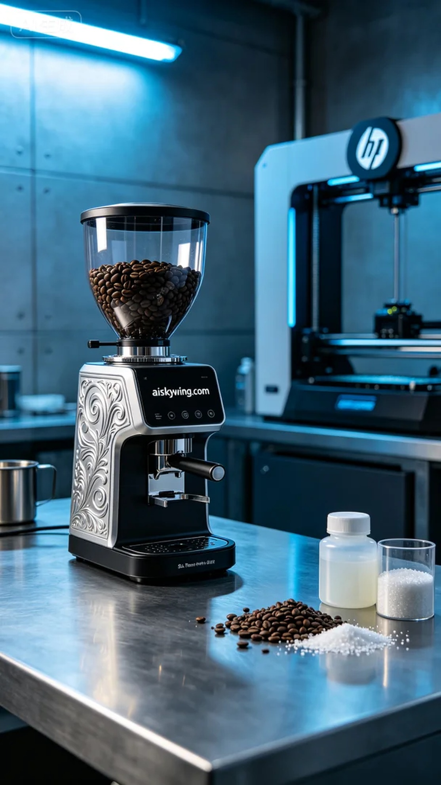
Aiskywing Industrial 3D Printing
Coffee machine bean hopper


