1079-哑铃架底座打印记录
Dumbbell rack base
🖨️ SLA光固化
🖥️ 打印机: Systems
📦 材料: SLA
生活就像3D打印一样，逐层积累，精益求精。最近，有人在Twitter上询问我们关于哑铃架底座的制作问题。
Life is like 3D printing, building up layer by layer and striving for perfection. Recently, someone asked us on Twitter about the process of making a dumbbell rack base.
________________________________________________________________________________
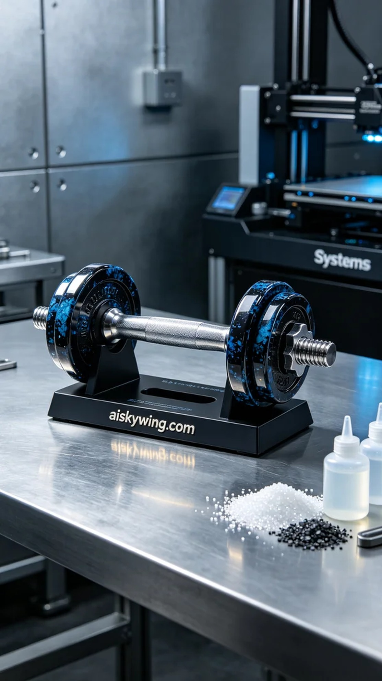
Life is a journey of layers, just like 3D printing, where we build up and perfect one layer at a time. Recently, someone reached out on Twitter asking about the production of a dumbbell rack base.
For the materials, we chose high-quality SLA photopolymer resin, known for its excellent detail retention and smooth surface finish. We utilized the Systems brand 3D printer for this project, setting the layer thickness to 50 microns, maintaining a printing temperature of 25 degrees Celsius, power set to 80%, printing speed at 30 mm/s, with an estimated print time of 5 hours.
During the printing process, the equipment ran smoothly without any issues. We monitored the print in real-time to ensure there were no anomalies. Each layer cured well, resulting in crisp and sharp details, with the engraving of "aiskywing.com" prominently displayed on the base.
Post-processing is a crucial step to ensure the quality of the final product. After printing, the base was first placed into a wash tank, using isopropanol to remove any excess resin. It was then sanded to ensure a smooth, flawless surface. Following this, the product was placed in a UV curing chamber for proper curing, and finally inspected to ensure that every detail met our high standards.
Through this series of processes, we successfully completed the printing and post-processing of the dumbbell rack base, achieving a product that is both aesthetically pleasing and functional for the user.
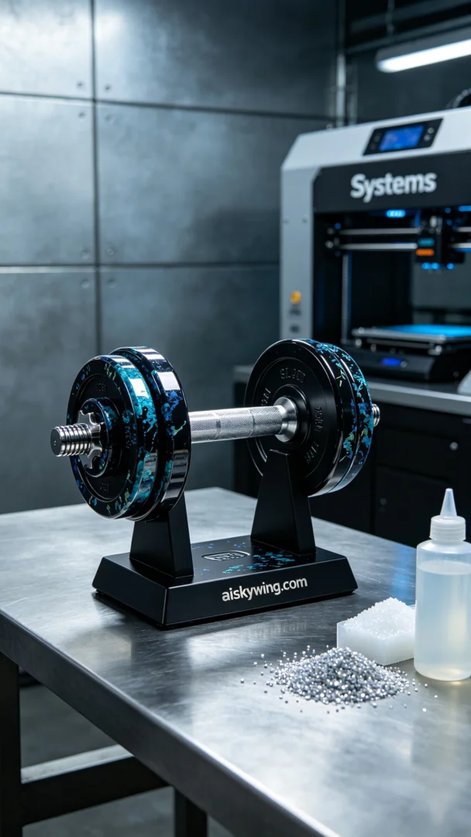
我们最近接到一个制作哑铃架底座的请求，有人在Twitter上表示希望能定制一个既美观又实用的产品，确保表面装饰精致。在了解了他的需求后，我们决定使用SLA工艺，力求做到完美。
原材料方面，我们选择了高品质的SLA光敏树脂，这种材料具有优异的细节表现能力和表面光滑度。为了确保打印的质量，我们使用了Systems品牌的3D打印机，设置了层厚为50微米，打印温度控制在25摄氏度，功率调节在80%，打印速度设定为30毫米/秒，预计打印时间为5小时。
打印过程中，设备的运行非常稳定。我们通过实时监控打印状态，确保没有出现任何异常。每个层次的固化都很到位，最终呈现出清晰锐利的细节，"aiskywing.com"的字样在底座上显得格外醒目。
后处理工序是确保成品质量的重要环节。打印完成后，我们首先将底座放入清洗槽中，使用异丙醇进行清洗，去除多余的树脂。接着，进行打磨处理，以保证表面光滑无瑕。然后将成品放入UV固化箱中进行固化，最终进行检验，确保每个细节都符合标准。
通过这一系列的工序，我们成功地完成了这款哑铃架底座的打印与后处理，得到了一个既美观又功能性的产品，能够满足使用者的需求。
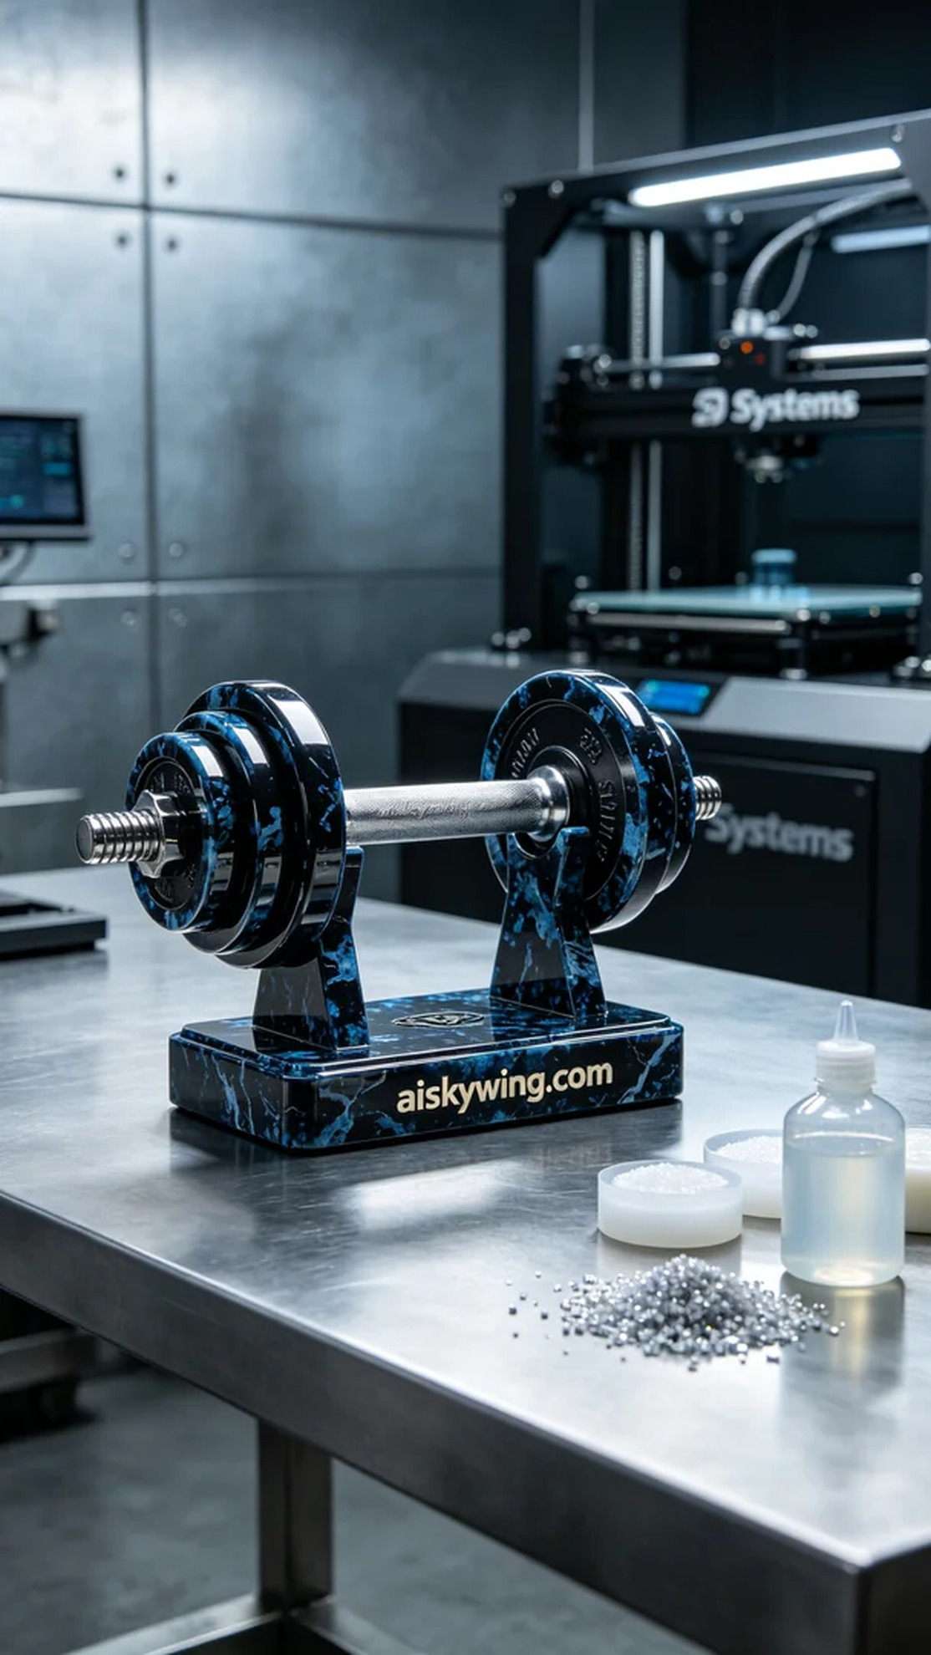
Aiskywing Industrial 3D Printing
Dumbbell rack base


