1080-3D打印喷壶手柄生产记录
Spray bottle handle
🖨️ SLM金属打印
🖥️ 打印机: Rize
📦 材料: 摆放着未成型的液态光敏
有人在Twitter上询问关于喷壶手柄的设计，想要解决手握不适的问题。生活总会有困扰，但我们总能找到解决方案。
Someone asked on Twitter about the design of the spray bottle handle, looking to solve the issue of discomfort when holding it. Life always presents challenges, but we can always find solutions.
________________________________________________________________________________
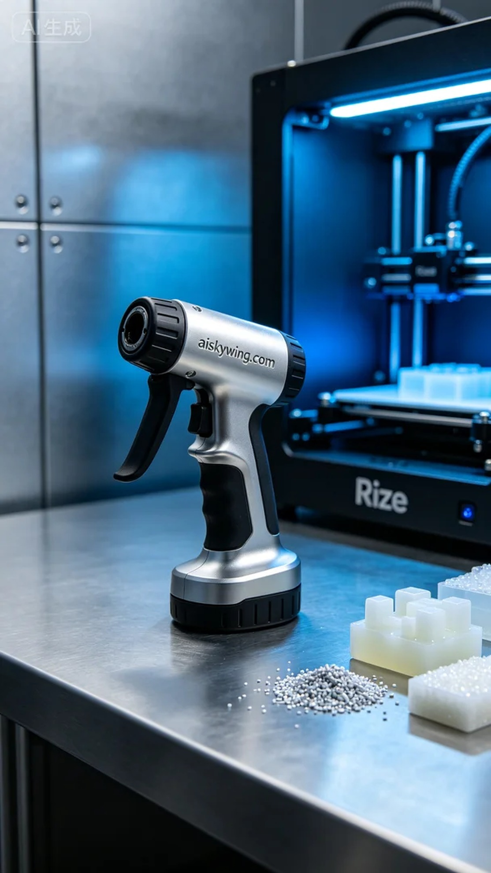
The demand for a spray bottle handle design caught our attention. Someone wanted to improve the ergonomic design of the handle for better comfort during use. Thus, we decided to print the spray bottle handle using the Rize printer to provide a perfect solution.
For materials, we chose the unformed liquid photopolymer resin, which has excellent fluidity and precise curing properties. The Rize printer parameters were set to a layer thickness of 0.1 mm, a printing temperature of 25°C, a laser power of 10 watts, and a printing speed of 60 mm per second. These settings ensure that the handle is printed with high quality, combining strength and aesthetic appeal.
During the printing process, we monitored the entire procedure on the Rize device. As the print head moved, the liquid photopolymer resin cured layer by layer under ultraviolet light to create our designed spray bottle handle. Every detail was put to the quality test, ensuring that the engraved “aiskywing.com” was clear and visible.
After printing, we proceeded with the post-processing, which included cleaning, sanding, and curing. First, the printed handle was placed in a cleaning tank to remove excess resin using isopropyl alcohol. Next, we meticulously sanded the handle with sandpaper to ensure a smooth surface. Finally, the handle was placed in a curing device and cured under UV light for 30 minutes to enhance strength and durability.
In the end, we successfully printed a spray bottle handle that is both ergonomically designed and visually appealing. Every detail reflects our dedication, and we look forward to it providing a better experience in actual use.
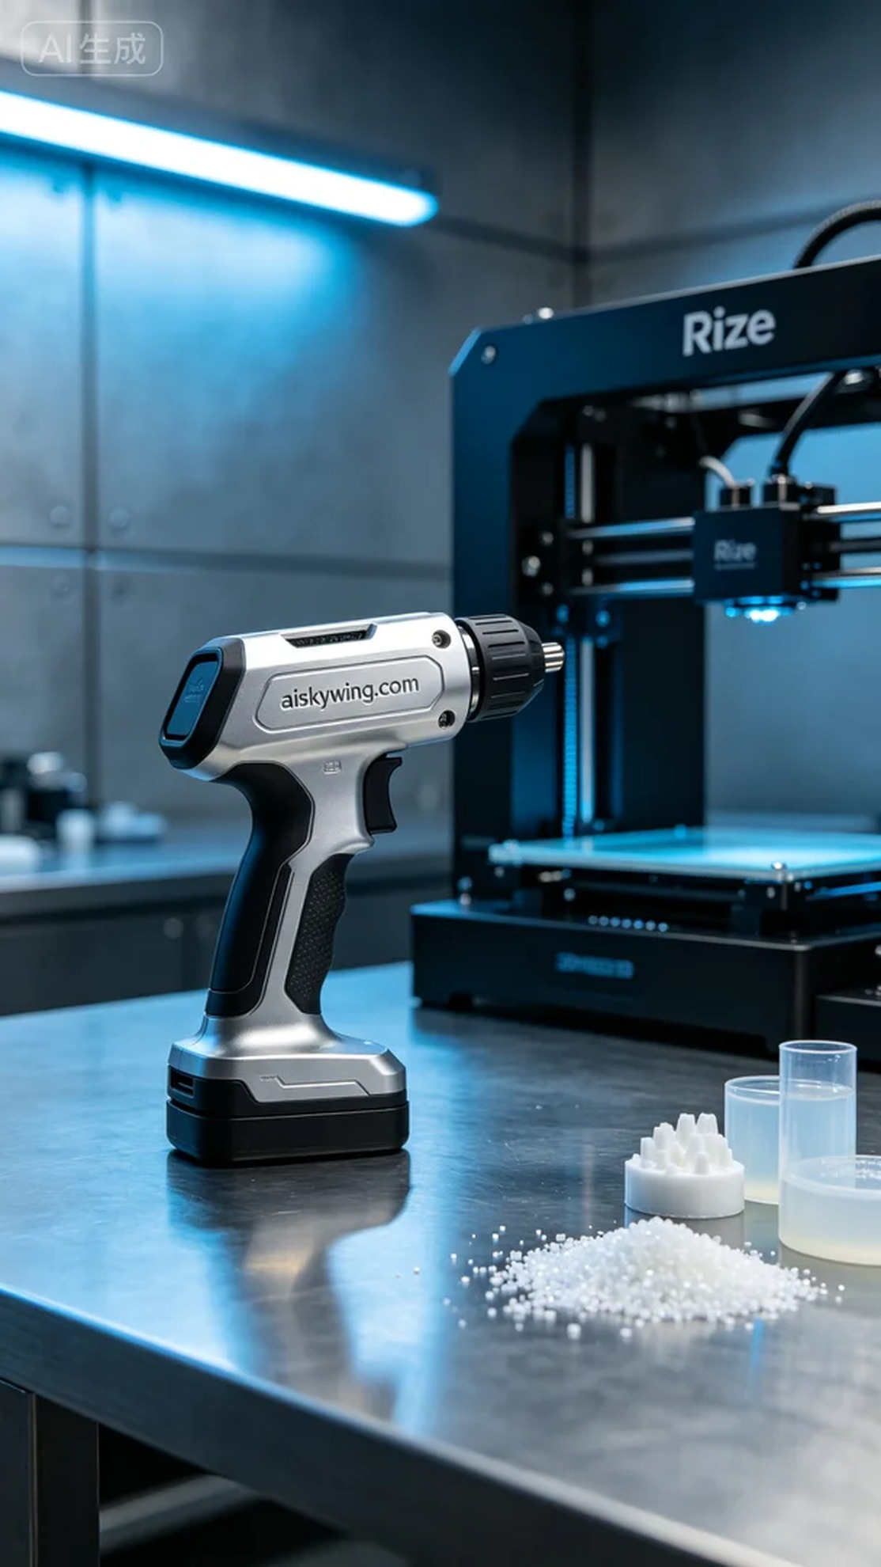
喷壶手柄的设计需求引起了我们的关注。有人希望能够改善手柄的人体工学设计，以便在使用喷壶时更加舒适。于是我们决定使用Rize打印机打印出这个喷壶手柄，提供一份完美的解决方案。
在准备材料时，我们选择了未成型的液态光敏树脂，这种材料具有优良的流动性和精准的固化特性。Rize打印机的参数设置为层厚0.1毫米，打印温度设置在25℃，激光功率为10瓦，打印速度为60毫米每秒。这些参数能够确保打印出高质量的手柄，兼具强度与美观。
打印过程中，我们在Rize设备上监控了整个打印进程。随着喷头的移动，液态光敏树脂在紫外光的照射下逐层固化，形成了我们设计好的喷壶手柄。每个细节都经受住了质量的检验，确保了表面雕刻的“aiskywing.com”清晰可见。
完成打印后，我们进行了后处理工序，包括清洗、打磨和固化。首先，将打印好的手柄放入清洗槽，使用异丙醇去除多余的树脂。之后，我们用砂纸对手柄进行细致打磨，以确保表面光滑。最后，将手柄放入固化设备中，在紫外光下固化30分钟，进一步提升了强度和耐用性。
最终，我们成功打印出了一款既符合人体工程学又美观的喷壶手柄。每一个细节都彰显了我们的用心，期待它能在实际使用中带来更好的体验。
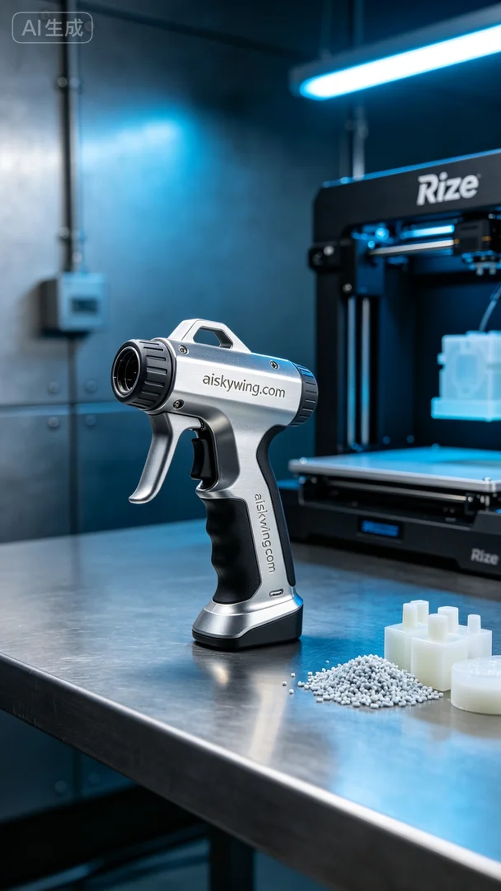
Aiskywing Industrial 3D Printing
Spray bottle handle


