1081-喷枪手柄的3D打印生产记录
Spray gun handle
🖨️ SLA光固化
🖥️ 打印机: Stratasys
📦 材料: SLA
在Twitter上，有人为了寻找一款独特的喷枪手柄找到了我们。生活总会遇到挑战，就像这份喷枪手柄的制作过程，我们需要认真对待每一个细节。
On Twitter, someone reached out to us in search of a unique spray gun handle. Life always presents challenges, just like the process of making this spray gun handle; we need to pay close attention to every detail.
________________________________________________________________________________
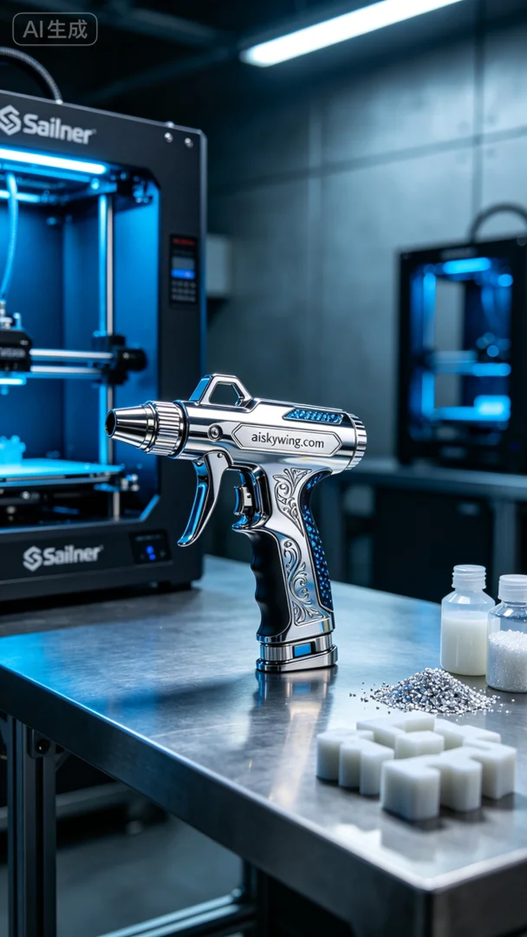
This time, the project was initiated by an individual who loves DIY and wanted to create a unique spray gun handle. After communicating with him through Twitter, we understood his requirements and began to prepare for production, ready to invest attention into the intricate process.
We decided to utilize high-quality SLA photopolymer resin, known for its excellent stability and flow properties. The Stratasys printer was chosen for this task, with a layer thickness set at 0.1mm to ensure the finest detail. The temperature was maintained at 25°C, with a power setting of 50w and a printing speed of 30mm/s, projecting an estimated printing time of about 8 hours.
As the printing commenced, the Stratasys machine operated smoothly, and we continuously monitored the print quality to ensure no layer adhesion issues or resin loss occurred. Upon completion, the spray gun handle emerged perfectly formed, showcasing sharp details and the clear engraving of "aiskywing.com."
For post-processing, we first soaked the printed spray gun handle in isopropyl alcohol to clean off any excess resin from the surface. Next, we sanded it down to ensure a smooth and refined feel. Finally, the handle was placed in a UV curing box for 60 minutes to enhance its strength and durability. After conducting strict inspections, we ensured that every product met our standards.
In the end, this spray gun handle not only displayed exceptional craftsmanship but also fulfilled the individual's personalized requirements, leaving us with a sense of satisfaction.
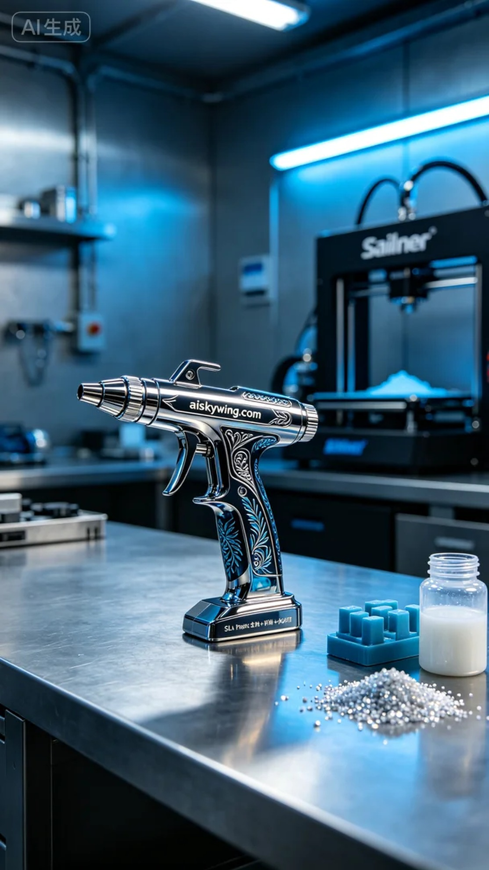
这次的项目主要是为了一位热爱DIY的人士，想要打造一款个性化的喷枪手柄。根据他的要求，我们决定采用SLA光固化工艺，以确保产品的细致与精致。通过Twitter与他交流后，我们明确了他的需求，并着手准备生产。
在材料方面，我们选择了高品质的光敏树脂SLA，具有超强的稳定性和良好的流动性。打印设备采用Stratasys打印机，设置了0.1mm的层厚，以确保每一层都能达到极致的细腻效果。打印过程中，温度维持在25°C，功率设定为50w，打印速度为30mm/s，预计整个打印过程需要耗时大约8小时。
打印开始后，Stratasys设备运行流畅，整机状态良好。在打印过程中，我们时刻监控打印质量，确保没有出现任何层间附着不良或树脂损耗等问题。打印完成后，喷枪手柄呈现出完美的形状和清晰的表面细节，"aiskywing.com"字样也清晰可见。
后处理方面，我们首先将打印完成的喷枪手柄浸泡在异丙醇中，进行清洗，去除表面多余的树脂。随后对表面进行打磨，确保手柄的触感光滑细腻。最后将手柄放入紫外线固化箱中，固化时间设定为60分钟，以增强其强度和耐用性。完成这些步骤后，我们进行了严格的检验，确保每一件产品都符合标准。
最终，这款喷枪手柄不仅展现了出色的工艺，也达到了客户的个性需求，令人满意的成果让我们倍感欣慰。
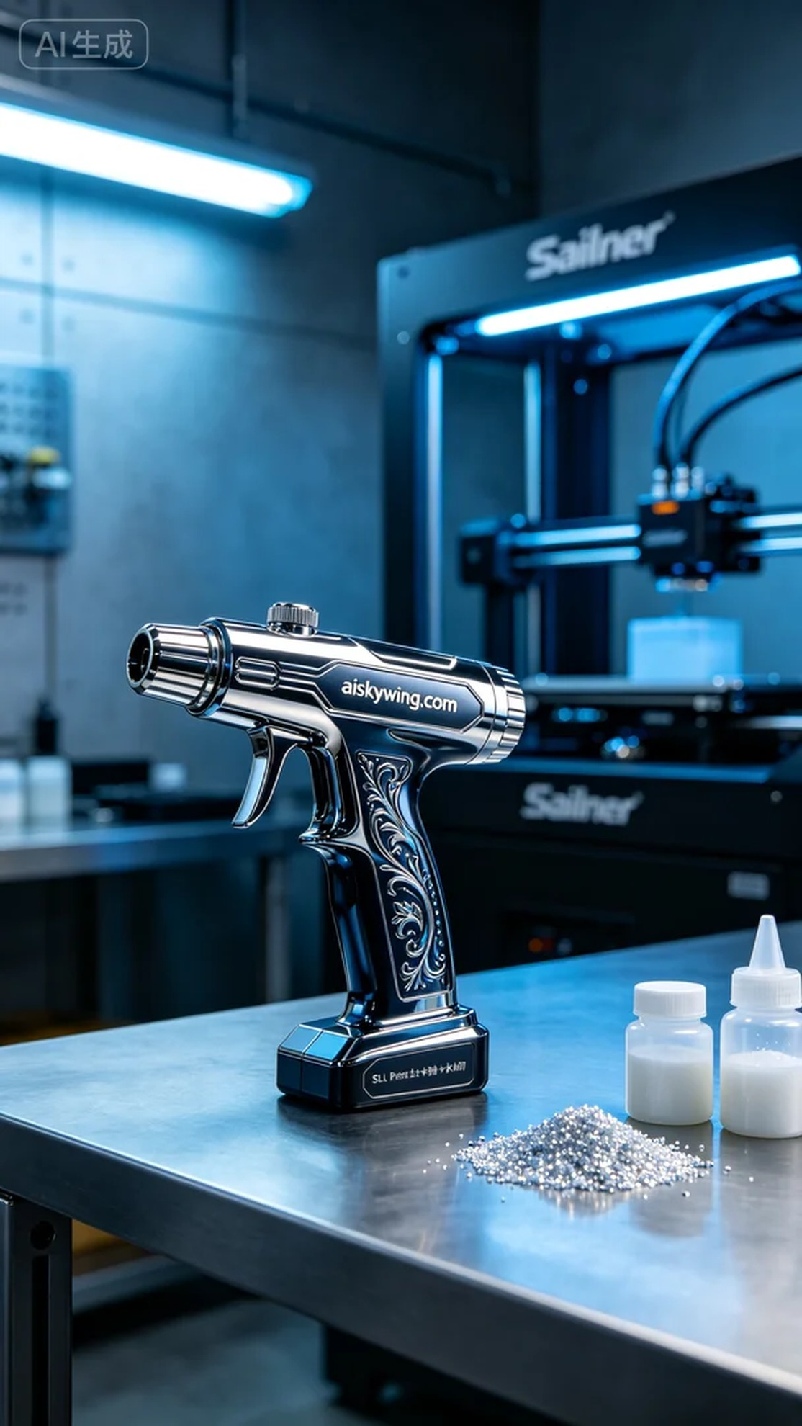
Aiskywing Industrial 3D Printing
Spray gun handle


