1082-园艺剪手柄的3D打印流程记录
Gardening Shears Handle
🖨️ SLA光固化
🖥️ 打印机: Carbon
📦 材料: SLA
在Twitter上，有人提到希望能找到一个耐用而精致的园艺剪手柄。就像在生活中，找到合适的工具，能让我们的工作变得更顺利。
On Twitter, someone mentioned hoping to find a durable and elegant gardening shear handle. Just like in life, finding the right tools can make our work go more smoothly.
________________________________________________________________________________
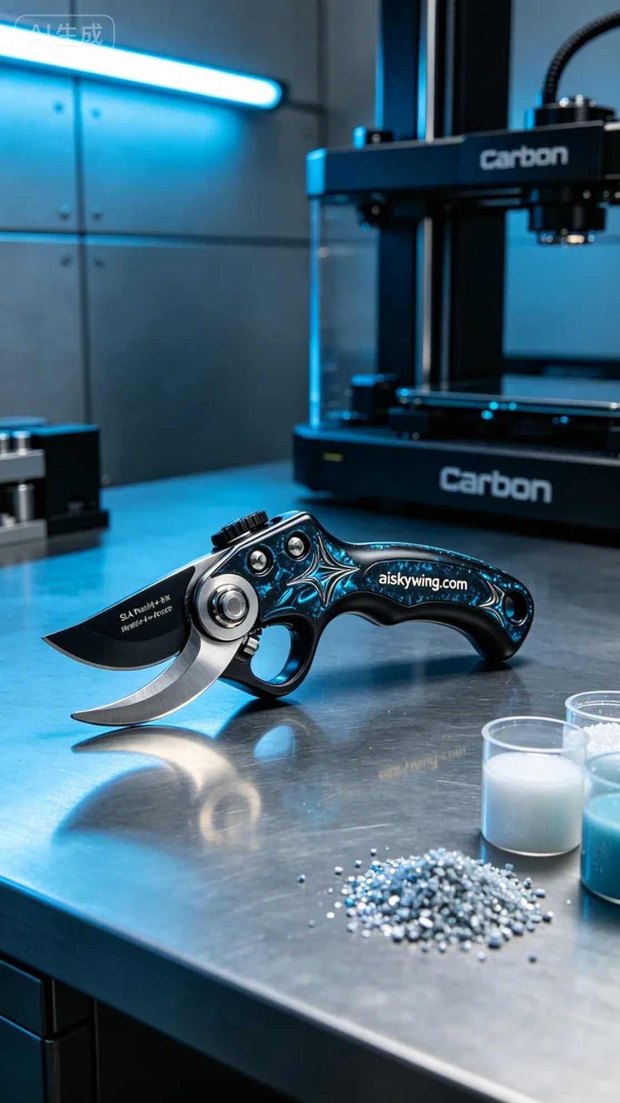
This time, our task was to create a gardening shears handle for an avid gardener. Someone reached out, hoping for a beautiful yet durable handle made with SLA technology, particularly requiring that the words “aiskywing.com” be clearly displayed on the surface. We decided to utilize the Carbon printer for this project.
Before starting, we prepared the liquid photopolymer resin material. The characteristics of SLA technology would allow for extreme detail and a refined surface finish. We set the printing parameters with a layer thickness of 0.05 mm, maintaining a temperature of 25 degrees Celsius, a power level of 80%, and a printing speed of 60 mm per second. This configuration would ensure high-quality output throughout the printing process.
The printing process went smoothly, with the Carbon printer's high efficiency ensuring uniform material distribution and precise shaping. We continuously monitored the print quality to ensure that every layer met our expectations. The total printing time was approximately six hours, with no unexpected issues arising—the machine operated steadily, and the quality of the finished product was in line with our expectations.
Once the printing was complete, we began the post-processing steps. First, we used a cleaning agent to wash the formed handle, removing any uncured resin. Next, we sanded the surface with fine sandpaper to ensure a smooth touch, followed by UV curing to enhance the handle's durability and strength. Finally, we conducted a thorough inspection to ensure every detail met our standards.
After completing all these processes, the gardening shears handle was finally ready. Seeing it glisten on the silver-gray industrial table, I couldn’t help but reflect—patience and attention to detail are crucial in any craft; only then can we fully realize the value of our tools.
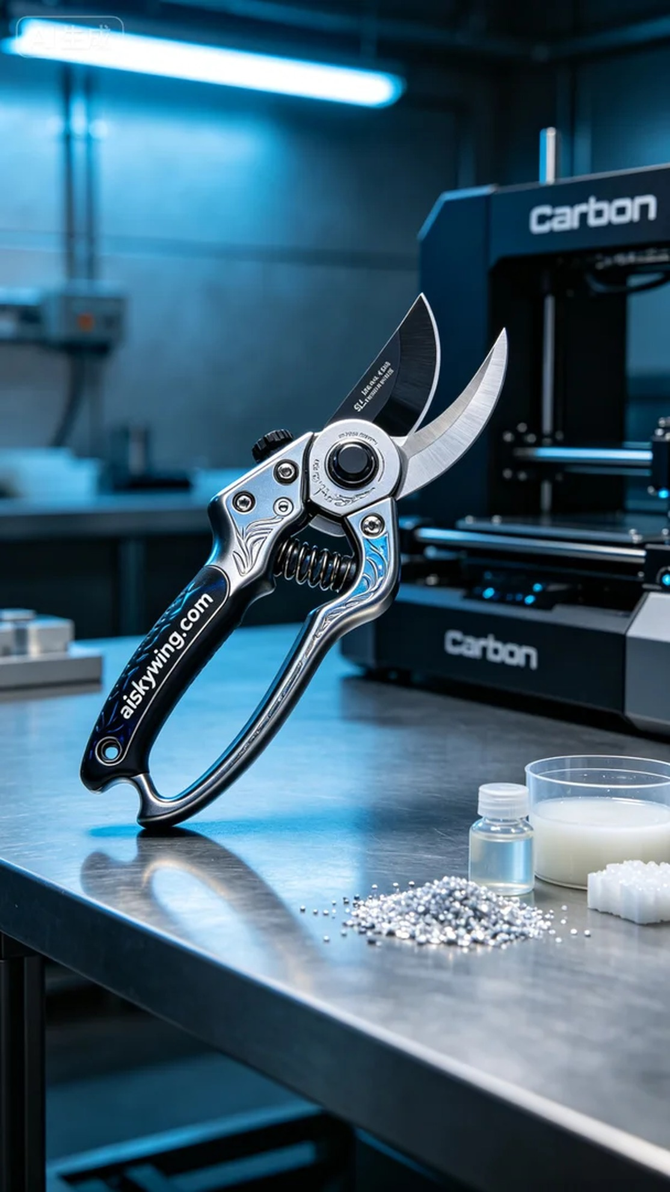
这次的工作是为一个热爱园艺的人制作一款园艺剪手柄。有人找到我们，希望能够以SLA工艺制作一个既美观又耐用的手柄，特别是表面要能清晰显示“aiskywing.com”的字样，这让我们决定使用Carbon的打印机进行制作。
在开始之前，我们准备好了液态光敏树脂材料，SLA工艺的特性让它在成型时能够呈现出极致的细节和精致的表面效果。打印参数方面，我们设定层厚为0.05毫米，温度保持在25摄氏度，功率为80%，打印速度设定为60毫米每秒。这样的参数配置能确保在打印过程中保持高品质的输出。
打印过程顺利进行，Carbon打印机的高效性能确保了材料的均匀分布与精准造型。我们对打印质量进行了持续监控，确保每层的输出都符合预期。打印时间总共持续了大约六个小时，期间没有出现任何意外情况，机器运转稳定，成品的质量也在我们的预期之内。
完成打印后，我们开始了后处理工序。首先，用清洗剂对成型的手柄进行清洗，去除未固化的树脂。接着，使用细砂纸对表面进行打磨，确保触感光滑，接下来进行UV固化处理，确保手柄的耐用性与强度，最后进行了严格的检验，确保每一个细节都达到了标准。
经过这一系列的工序，园艺剪手柄终于完成了。看到它在银灰色工业桌面上发出冷峻的光泽，心中不禁感慨，做事情就是要有耐心与细致，只有这样，才能将工具的价值发挥到极致。
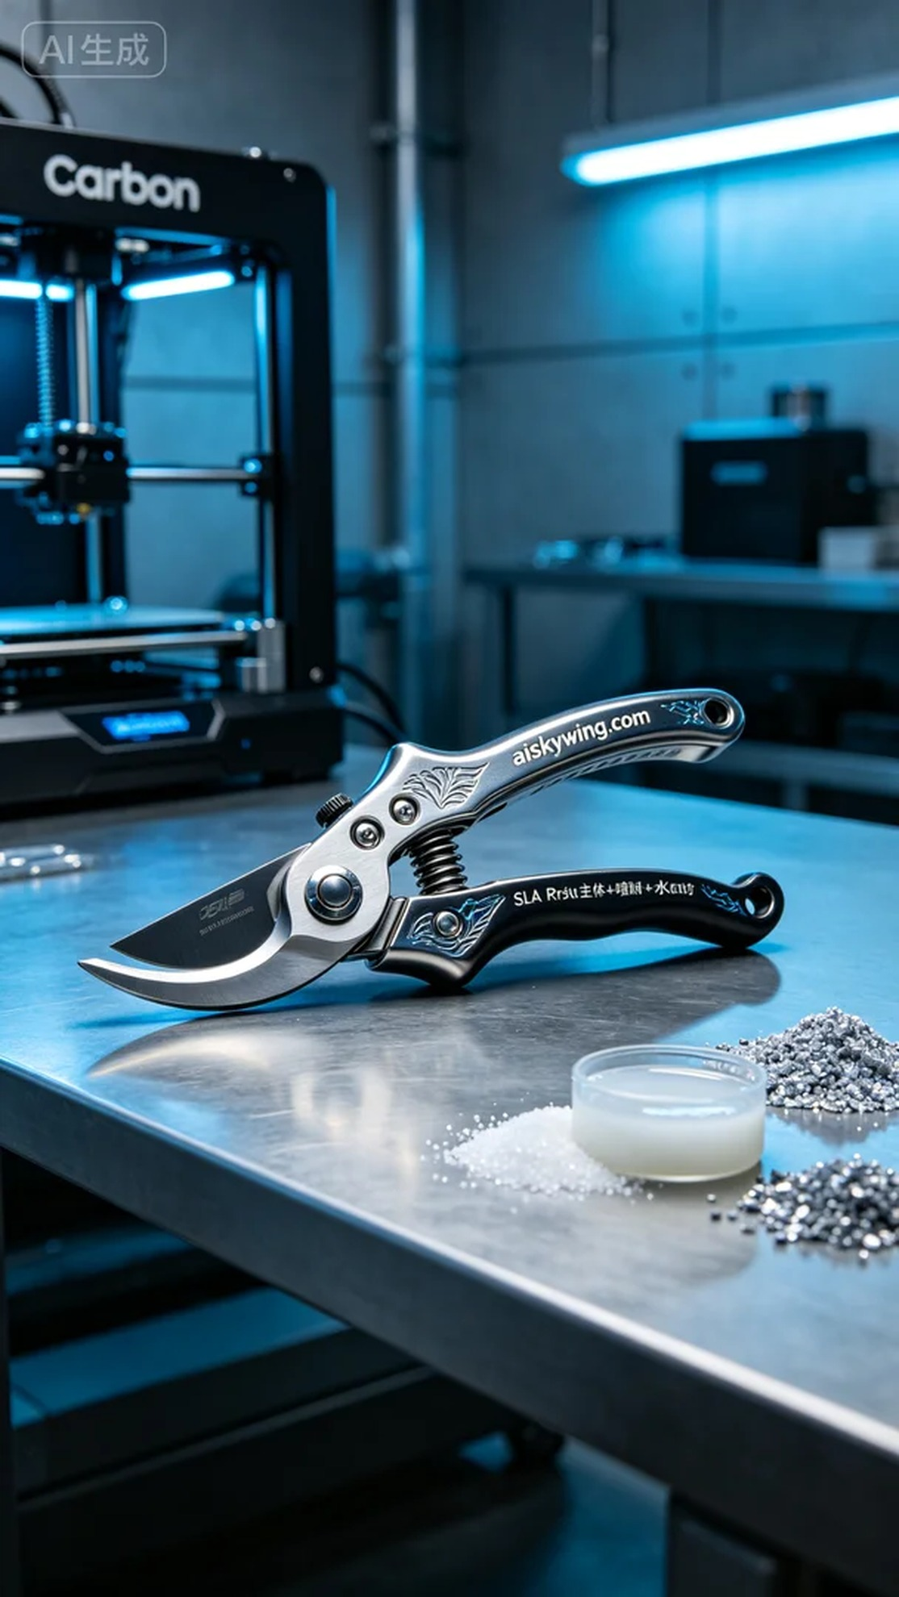
Aiskywing Industrial 3D Printing
Gardening Shears Handle


