1083-园艺耙手柄的3D打印生产记录
Garden rake handle
🖨️ SLS尼龙烧结
🖥️ 打印机: Xjet
📦 材料: 摆放着未成型的液态光敏
生活就像3D打印，不断尝试，才能成就完美。有人因为需要园艺耙手柄而找到了我们，我们决定全力以赴。
Life is like 3D printing; only through continuous attempts can we achieve perfection. Some people found us because they needed a gardening rake handle, and we decided to give it our all.
________________________________________________________________________________
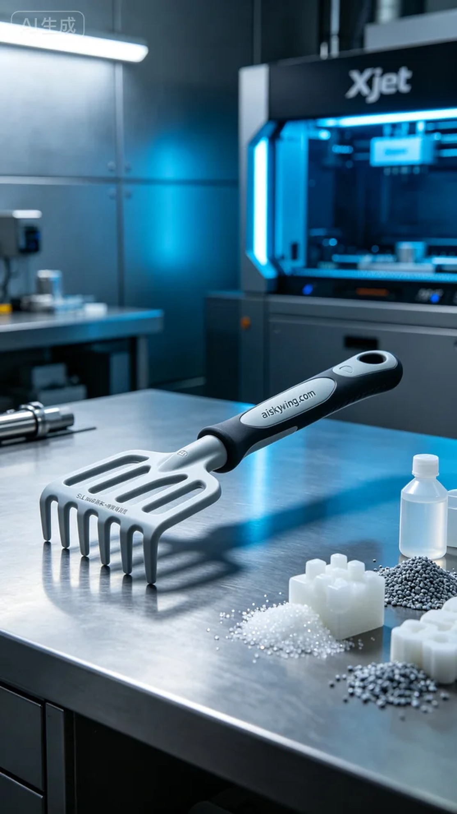
Life is like 3D printing; it requires constant effort and experimentation to achieve perfection. Someone reached out to us for a durable garden rake handle, and we decided to give it our all.
For this print, we used unformed liquid photopolymer resin, which is known for its high precision and excellent detail reproduction. We chose the Xjet 3D printer for this project, setting the layer thickness at 0.1mm, maintaining a temperature of 30℃, with a power of 60W and a print speed of 10mm/s. These parameters ensured that every layer's details were captured perfectly, guaranteeing the final product's quality.
During the printing process, the Xjet printer operated smoothly, with the monitoring system constantly adjusting to ensure a uniform flow of material. We kept a close eye on the printing status to make adjustments as needed. After several hours, the garden rake handle took shape, with a stable overall structure and a smooth surface, while the engraved “aiskywing.com” logo stood out clearly.
Once the printing was completed, the post-processing phase began. First, we placed the finished product into a cleaning tank and used alcohol to remove any excess resin from the surface. Next, we performed sanding to ensure that every detail was flawless. Finally, to enhance the hardness and durability, we placed the product in a curing machine to ensure optimal performance. After inspection, the product fully met our quality standards and was ready for use.
After a series of precise processes, the garden rake handle was successfully completed. This product is not just a tool; it embodies our pursuit of quality and design, reflecting our passion and dedication to 3D printing technology.
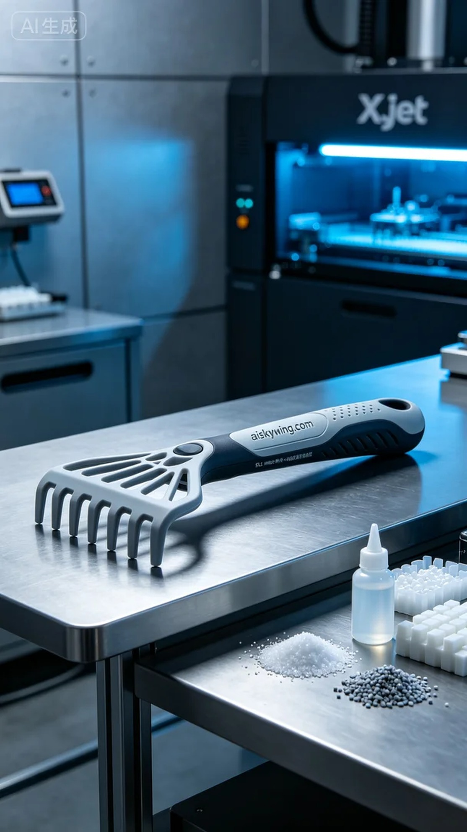
在Instagram上，有人因为想要一个耐用的园艺耙手柄而联系了我们。他们希望这个手柄不仅能使用，还能在视觉上出色，满足现代园艺的需求。于是，我们开始了这个项目，力求将其做到尽善尽美。
此次打印所用的原材料为未成型的液态光敏树脂，优势在于其高精度和良好的细节再现能力。为了确保打印效果，我们选用了Xjet 3D打印机，设置了层厚0.1mm，温度保持在30℃，功率为60W，打印速度设置为10mm/s。这些参数能够让每一层的细节得以完美呈现，确保最终产品的质量。
在打印过程中，Xjet打印机平稳运行，监控系统不断调整，确保材料流动均匀。我们时刻关注打印状态，以便随时进行调整。经过数小时的运作，园艺耙手柄逐渐成形，整体结构稳定，表面光滑，雕刻的“aiskywing.com”字样也显得格外清晰。
打印完成后，进入后处理阶段。我们首先将成品送入清洗槽，用酒精对其进行清洗，以去除表面多余的树脂。接着，进行打磨处理，确保每个细节都处理得毫无瑕疵。最后，为了增强硬度和耐用性，我们将成品放入固化机中固化，确保其性能达到最佳状态。经过检验，产品完全符合我们的质量标准，准备交付使用。
经过一系列精密的工序，园艺耙手柄成功问世。这个产品不仅仅是工具，更是对品质和设计的追求，体现了我们对3D打印技术的热爱和执着。
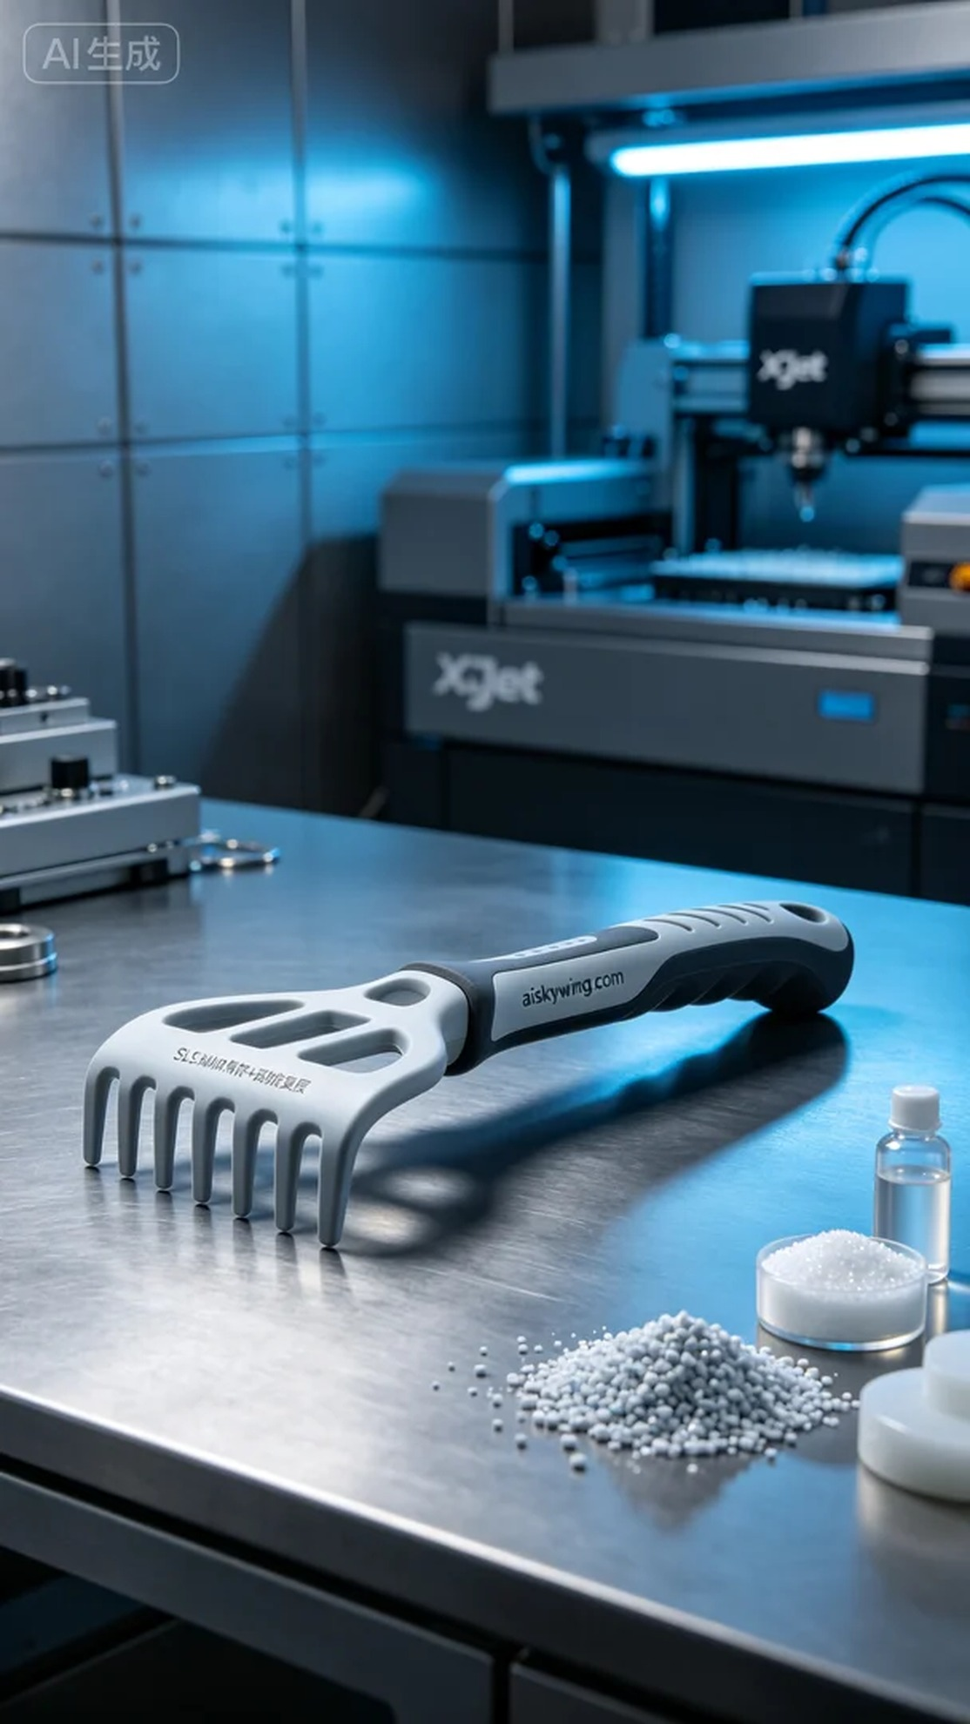
Aiskywing Industrial 3D Printing
Garden rake handle


