1084-园艺铲手柄3D打印生产记录
Garden shovel handle
🖨️ SLM金属打印
🖥️ 打印机: Systems
📦 材料: 摆放着未成型的液态光敏
生活就像做这个园艺铲手柄，遇到问题时，别忘了用WhatsApp沟通，找到解决方案。
Life is like making this gardening tool handle; when you encounter problems, don't forget to communicate via WhatsApp to find a solution.
________________________________________________________________________________
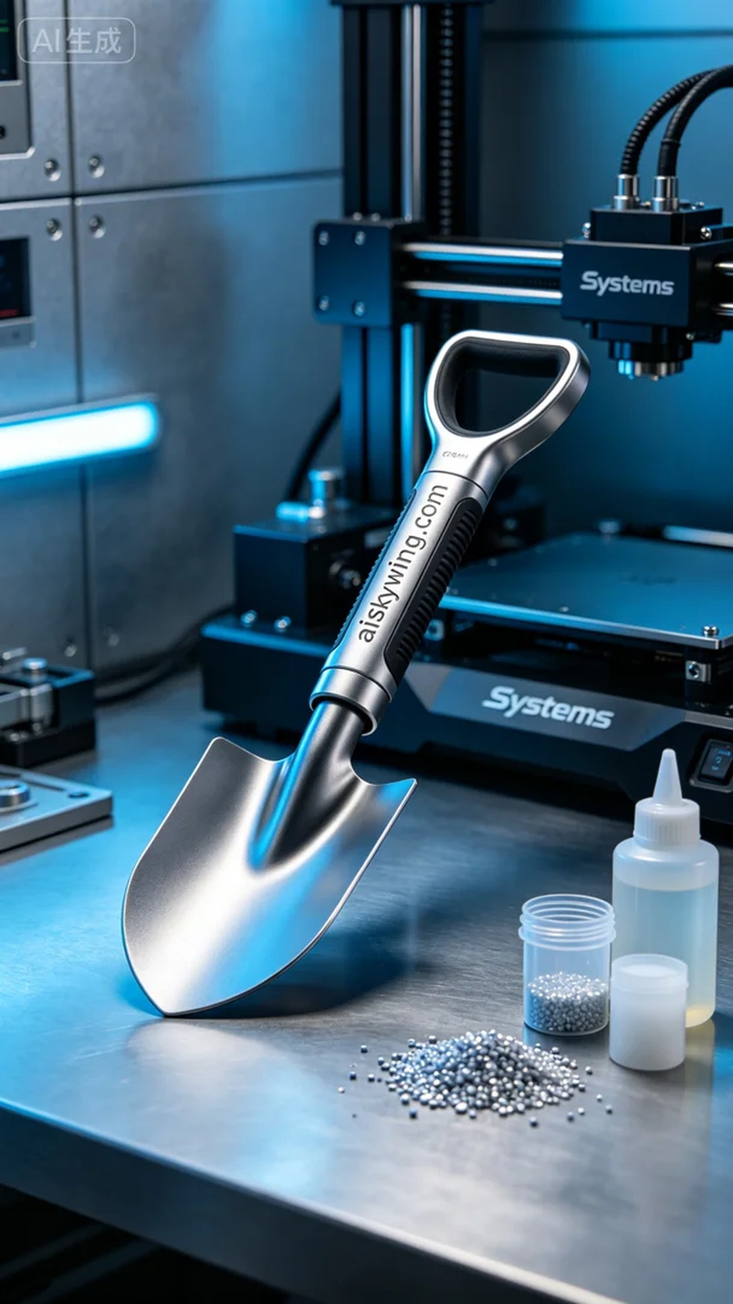
Recently, someone contacted us via WhatsApp to inquire about the 3D printing of a gardening shovel handle. They wanted to create a handle that is both sturdy and aesthetically pleasing for better gardening work. To meet their needs, we decided to use the SLM metal printing process.
The raw material we selected is the unformed liquid photopolymer resin, which cures rapidly under light to form a high-strength structure. During the preparation stage, we utilized the Systems brand 3D printer and set the printing parameters: layer thickness of 0.05mm, printing temperature at 30℃, laser power adjusted to 100W, and a printing speed of 40mm/s. The entire printing process was estimated to take about six hours.
The printing process went smoothly, with the Systems printer operating steadily, and real-time monitoring ensured the quality of each layer. During printing, we regularly checked key points to prevent any potential quality issues, ensuring that every detail of the shovel handle was accurately in place.
Once printing was completed, we moved on to the post-processing stage. First, the finished product was cleaned to remove excess resin from the surface. Then, we polished it to eliminate any imperfections and ensure the smoothness of the handle. Next, it was placed in a curing chamber for hardening, and finally, it was inspected to ensure that every shovel handle met our quality standards.
In the end, the gardening shovel handle was successfully completed, showcasing our technical strength and commitment to quality. Each print is a new challenge, and this time, we succeeded once again.
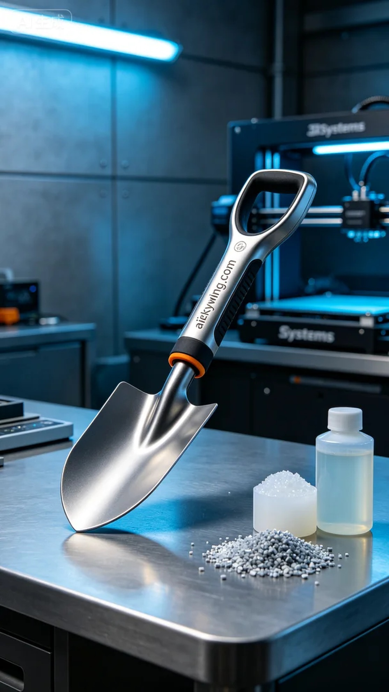
最近，有人通过WhatsApp给我们发来消息，询问关于园艺铲手柄的3D打印需求。他们希望能制作出既坚固又美观的铲手柄，以便更好地进行园艺工作。为了满足他们的需求，我们决定采用SLM金属打印工艺。
我们选用的原材料是未成型的液态光敏树脂，这种材料在光照下能够迅速固化，形成高强度的结构。在准备阶段，我们使用了Systems品牌的3D打印机，设置了打印参数：层厚为0.05mm，打印温度设置在30℃，激光功率调整为100W，打印速度为40mm/s。整个打印过程预计耗时约六小时。
打印过程进行得相当顺利，Systems打印机运转稳定，实时监控确保了每一层的质量。在打印过程中，我们定期检查各个关键节点，以防止出现任何潜在的质量问题，确保铲手柄的每个细节都精确到位。
打印完成后，我们进入了后处理工序。首先，对成品进行了清洗，去除表面的多余树脂。接着，进行了打磨，以消除可能存在的瑕疵，确保手柄的光滑度。然后，将其放入固化箱中进行固化处理，最后经过检验，确保每一个铲手柄都达到我们的质量标准。
最终，这个园艺铲手柄顺利完成，充分展示了我们的技术实力与对品质的追求。每一次的打印都是一次新的挑战，而这一次，我们又一次成功了。
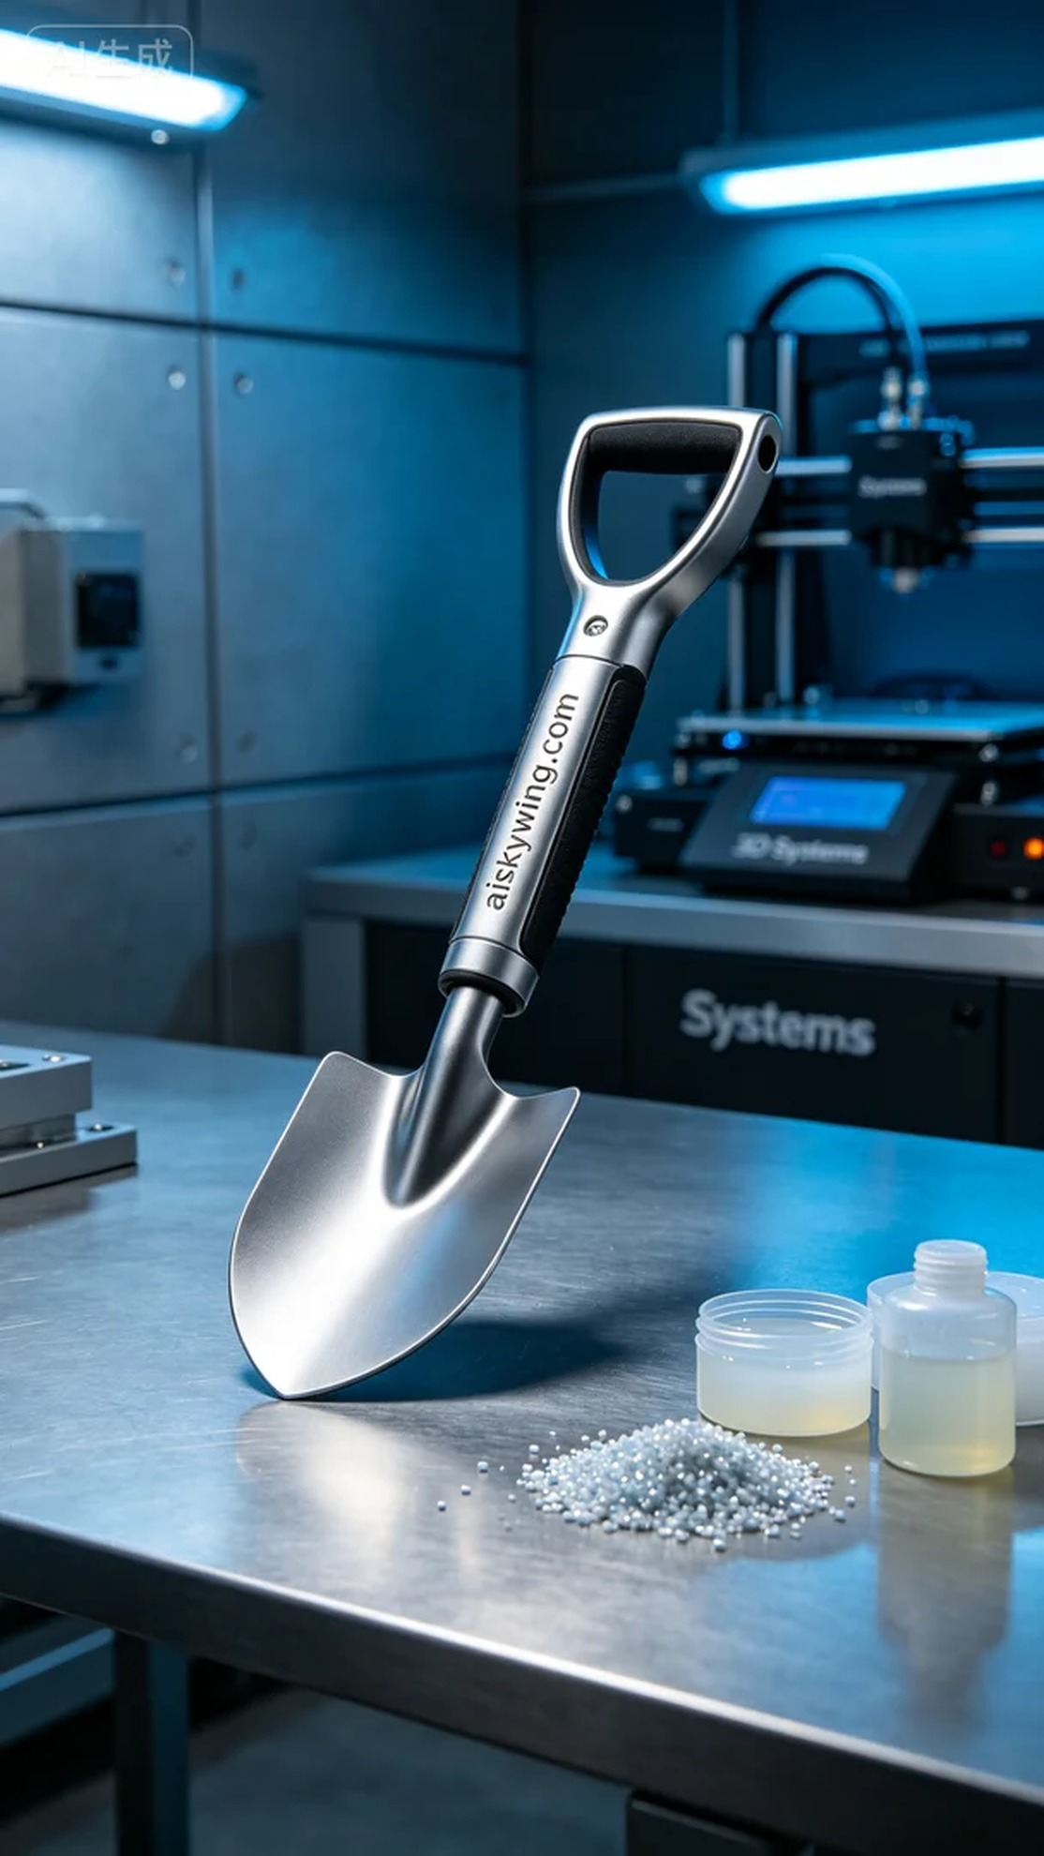
Aiskywing Industrial 3D Printing
Garden shovel handle


