1085-宠物水盆支架3D打印记录
Pet Water Bowl Stand
🖨️ SLM金属打印
🖥️ 打印机: Mimaki
📦 材料: 摆放着未成型的液态光敏
生活就像3D打印，填补每个空白，打造出意想不到的形状。今天，我们接到一个关于宠物水盆支架的消息，充满着期待和挑战。
Life is like 3D printing, filling in every gap to create unexpected shapes. Today, we received news about a pet water bowl stand, filled with anticipation and challenges.
________________________________________________________________________________
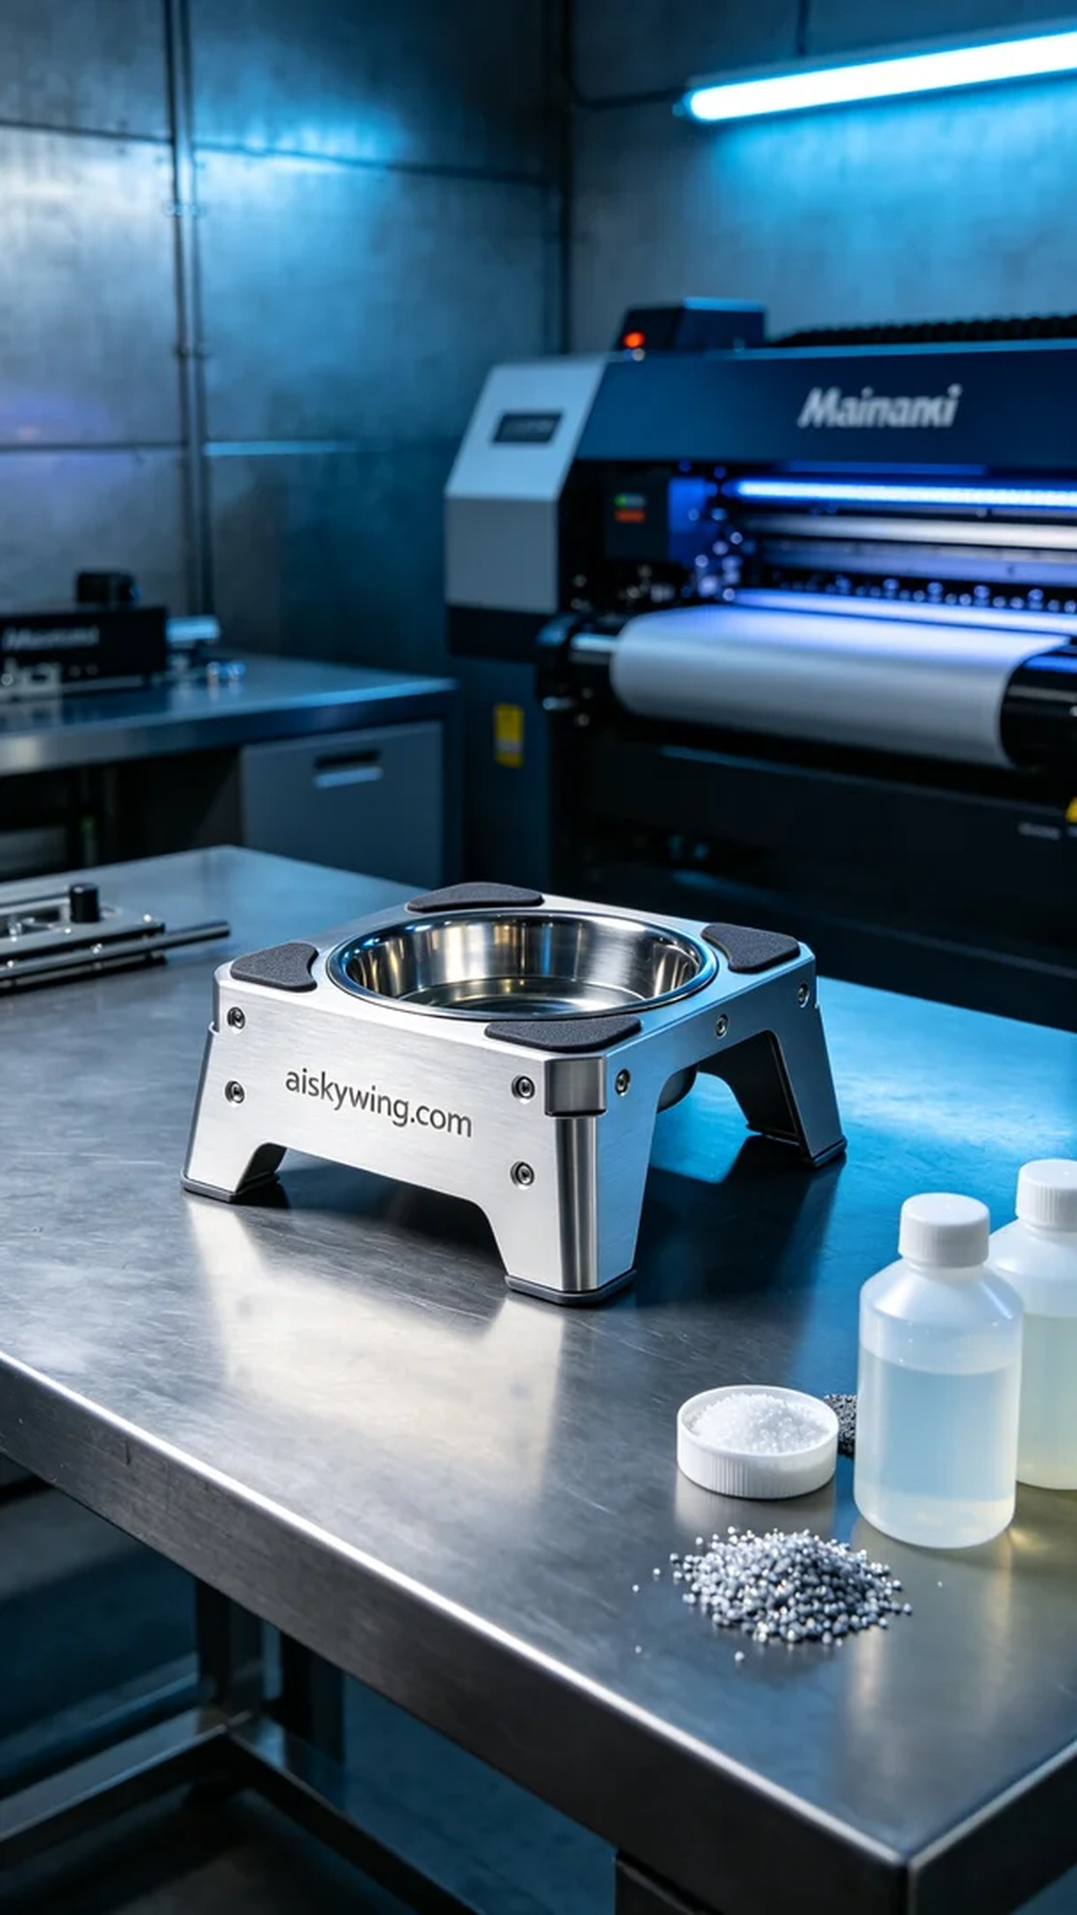
Life is like 3D printing, filling every void and creating unexpected shapes. Today, we received a message regarding a pet water bowl stand, filled with anticipation and challenges.
Someone reached out to us via WhatsApp with a request for a pet water bowl stand. This stand needs to be not only aesthetically pleasing but also functional and durable. We needed to select the right materials for this project to ensure the final product meets all usage requirements.
We decided to use unformed liquid photopolymer resin as the printing material, as it offers excellent flow and curing properties. For the equipment, we chose the Mimaki 3D printer for this task. The parameters were set to a layer thickness of 0.1 mm, a printing temperature of 25℃, a power level of 80%, and a printing speed of 50 mm per second. The entire printing process was expected to take about 4 hours, ensuring every detail was perfectly captured.
Once the printing process started, the Mimaki printer ran steadily, layering the liquid photopolymer resin onto the print platform. We closely monitored the printer's status to ensure each layer cured properly without any bubbles or defects. Throughout this process, we continuously checked the print quality, ensuring the structural integrity of the stand and the smoothness of its surface.
After the printing was completed, we moved on to the post-processing stage. First, we cleaned the stand using a cleaning solution to remove any uncured resin from the surface. Next, we sanded it down with fine sandpaper to enhance the smoothness and feel of the surface. Finally, we placed the stand under a curing lamp to ensure complete curing. After inspection, the stand quality was outstanding, meeting our expectations.
Through this production, we not only achieved our goal but also gained experience that will be invaluable for future projects.
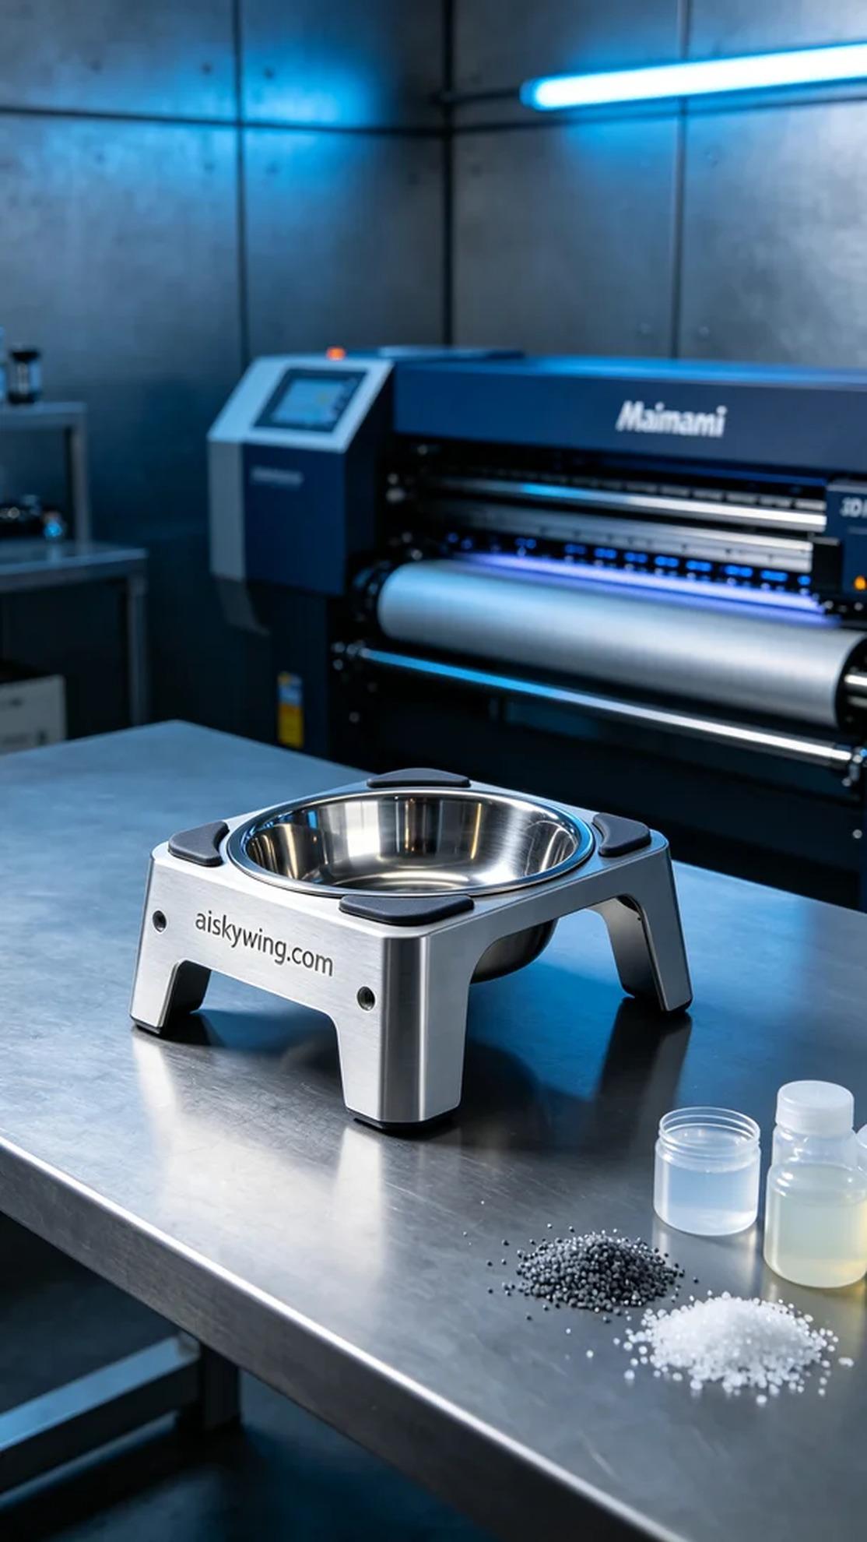
有人通过WhatsApp找到了我们，提出了制作宠物水盆支架的需求。这款支架不仅要美观，还要具备良好的实用性和耐用性。我们需要为这个项目选择合适的材料，确保最终产品能够满足使用要求。
我们决定使用未成型的液态光敏树脂作为打印材料，这种材料具备优良的流动性和固化性能。设备方面，我们选择了Mimaki 3D打印机进行打印。参数方面，层厚设置为0.1毫米，打印温度为25℃，功率调整在80%，打印速度为50毫米每秒。预计整个打印过程将耗时约4小时，确保每个细节都得到完美呈现。
打印过程开始后，Mimaki打印机稳稳运行，液态光敏树脂在打印平台上逐层凝固。我们全程监控打印机的状态，确保每层的固化到位，没有出现气泡或缺陷。在此过程中，我们不断观察打印质量，确保支架结构的完整性和表面的光滑度。
完成打印后，我们进入后处理阶段。首先使用清洗液对支架进行清洗，去除表面附着的未固化树脂。接着，用细砂纸进行打磨，提升表面的光滑度和触感。最后，我们将支架放置在固化灯下进行照射，确保其完全固化。经过检验后，支架的质量非常出色，达到了预期的效果。
通过这次的制作，我们不仅实现了目标，更在过程中收获了经验，为未来的项目积累了宝贵的财富。
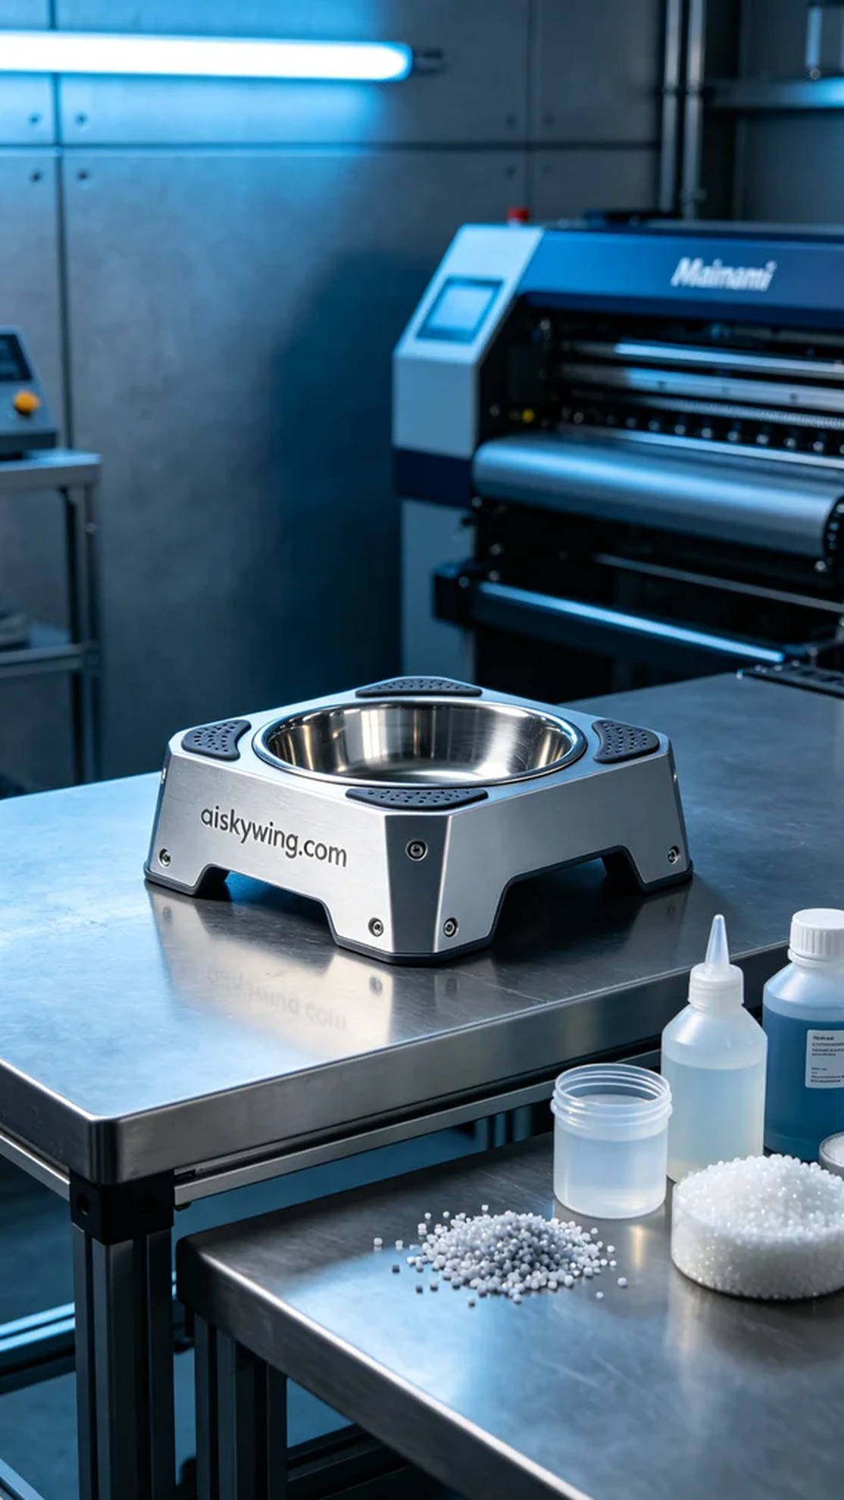
Aiskywing Industrial 3D Printing
Pet Water Bowl Stand


