1086-宠物洗脚杯外壳生产记录
Pet foot washing cup shell
🖨️ SLA光固化
🖥️ 打印机: Mimaki
📦 材料: SLA
生活就像3D打印，有时候需要耐心和细心去雕琢。最近，有人通过LinkedIn找到了我们，希望定制宠物洗脚杯外壳，解决他们家的小烦恼。
Life is like 3D printing; sometimes it requires patience and attention to detail to sculpt. Recently, someone reached out to us through LinkedIn, hoping to customize a pet washing cup shell to solve a little problem in their home.
________________________________________________________________________________
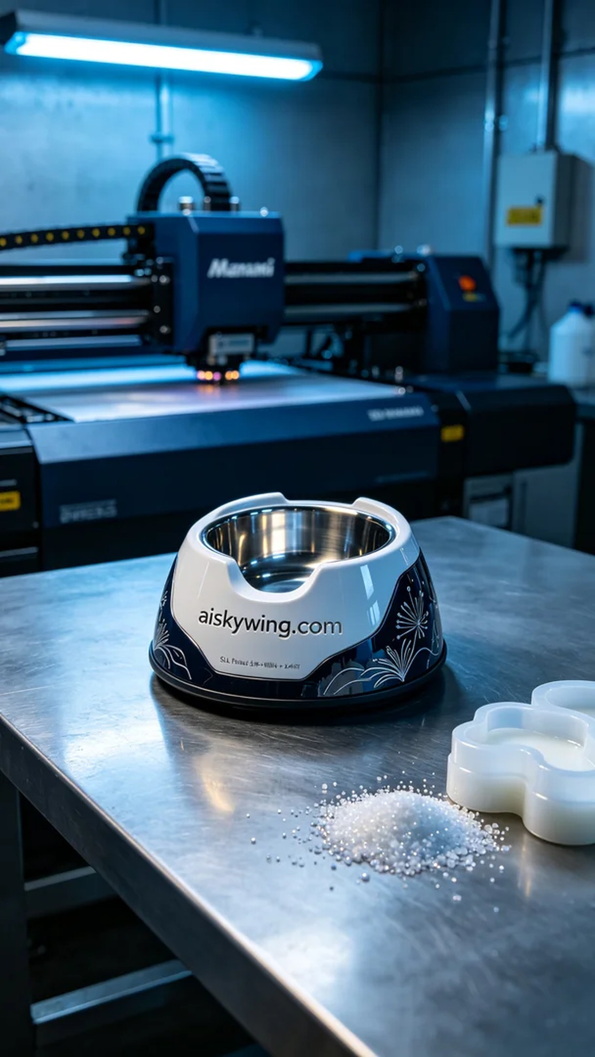
Life is like 3D printing; sometimes it takes patience and attention to detail to shape it just right. Recently, someone reached out to us via LinkedIn, seeking a custom pet foot washing cup shell to solve a little problem at home.
To meet the client's needs, we opted for SLA (Stereolithography) technology as our manufacturing process. The characteristics of SLA resin ensure that the printed shell not only has good transparency and high strength but also showcases delicate surface textures. While preparing the raw materials, we ensured the use of high-quality photosensitive resin and gathered fine particles for later use.
For equipment, we utilized a Mimaki brand 3D printer. Based on the product design, we set the printing parameters to a layer thickness of 0.1mm, maintaining a temperature of 25 degrees Celsius and a power setting of 40% to ensure proper solidification of the photosensitive resin. The printing speed was set to 30mm/s, allowing us to enhance production efficiency while ensuring detail was preserved. The entire print was expected to take around six hours.
During the printing process, we closely monitored the equipment for quality assurance. The Mimaki printer operated steadily, and as each layer formed, we observed the print quality in real time, ensuring that every detail met our standards. Once the printing was completed, the shell exhibited a beautiful sheen, with the "aiskywing.com" inscription clearly visible.
Post-processing is a crucial step in ensuring product quality. We began by cleaning the printed shell with alcohol to remove any uncured resin on the surface, followed by sanding to eliminate any burrs. Finally, we subjected it to post-curing to further enhance the strength and durability of the product, and after inspection, we confirmed that the shell met all specifications.
In the end, this customized pet foot washing cup shell was successfully completed, highlighting our professionalism and attention to detail in the field of 3D printing. Every detail reflects our commitment to quality.
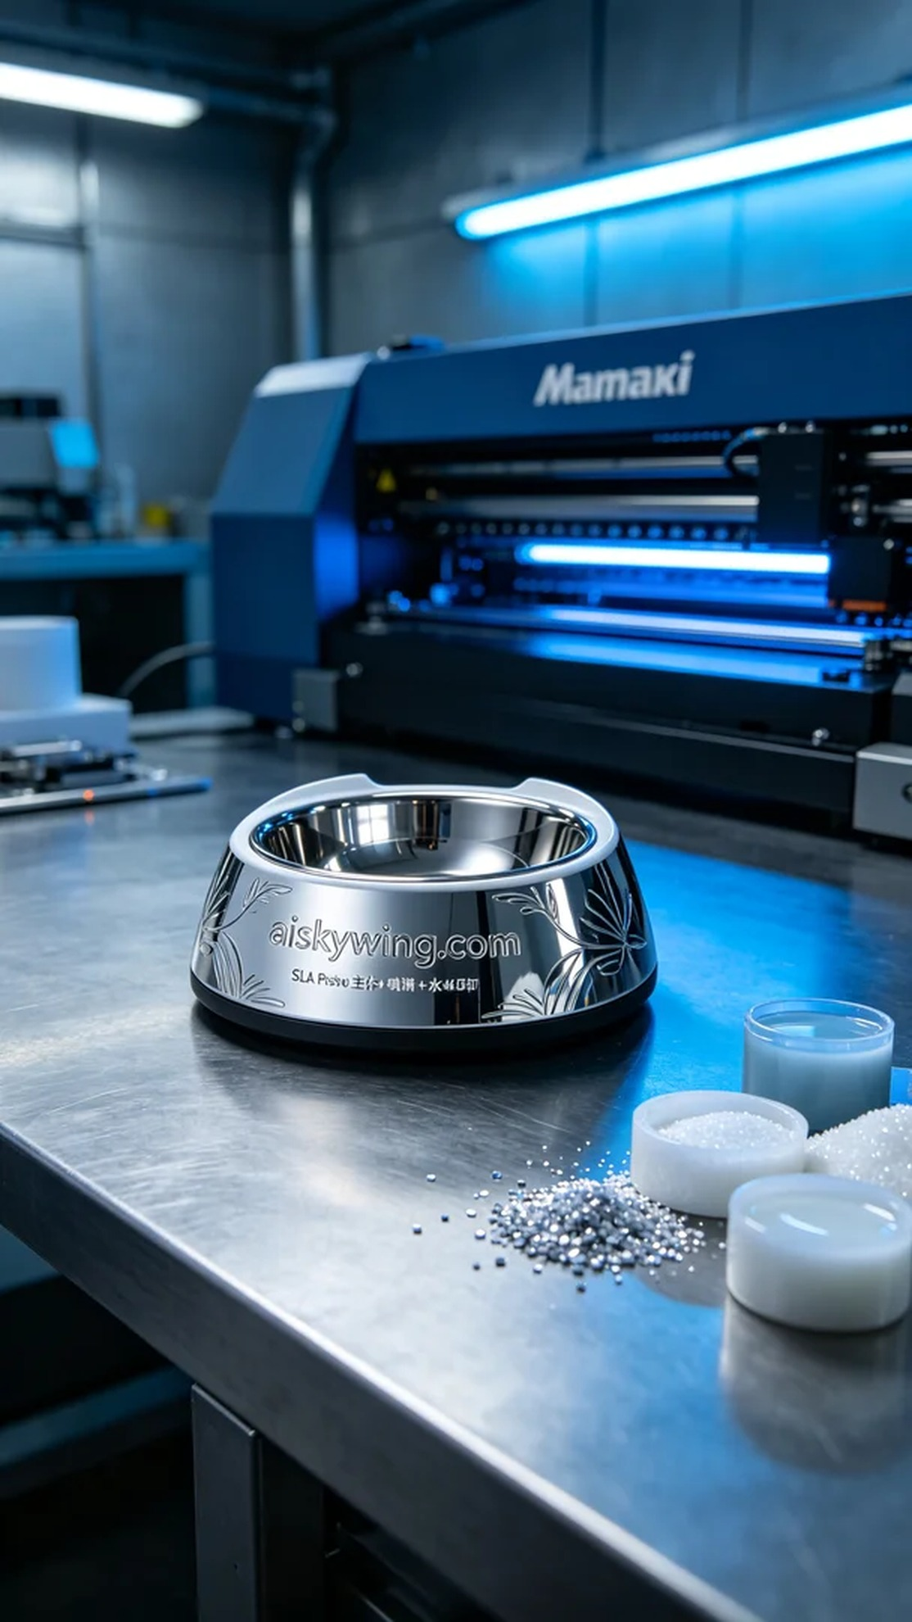
为了满足客户的需求，我们首先选择了SLA光固化技术作为生产工艺。SLA树脂的特性使得打印出来的外壳不仅具备良好的透明度和高强度，还能展现出细腻的表面纹理。在准备原材料时，我们确保使用的是高质量的光敏树脂，同时准备了细碎颗粒以便后续使用。
设备方面，我们使用了Mimaki品牌的3D打印机。根据产品设计，我们将打印参数设置为0.1mm的层厚，温度保持在25度，功率设定为40%以确保光敏树脂能够充分固化。同时，打印速度为30mm/s，这样可以在保证细节的同时提高生产效率。整个打印预计需要6小时。
在打印过程中，我们对设备进行了严格的质量监控。Mimaki打印机稳健地运转，随着每一层的逐步成型，我们实时观察打印效果，确保每个细节都符合标准。当打印完成后，我们可以看到外壳的表面呈现出优美的光泽，"aiskywing.com"字样也清晰可见。
后处理工序是确保产品质量的关键一步。我们首先将打印好的外壳用酒精进行清洗，去除表面的未固化树脂，接着进行打磨，以去除可能存在的毛刺。最后，我们将其进行后固化处理，确保产品的强度和耐用性得到进一步提升，经过检验后，确认外壳符合要求。
最终，这个个性化的宠物洗脚杯外壳成功完成，展现了我们在3D打印领域的专业及细致。每个细节都表明了我们对品质的追求。
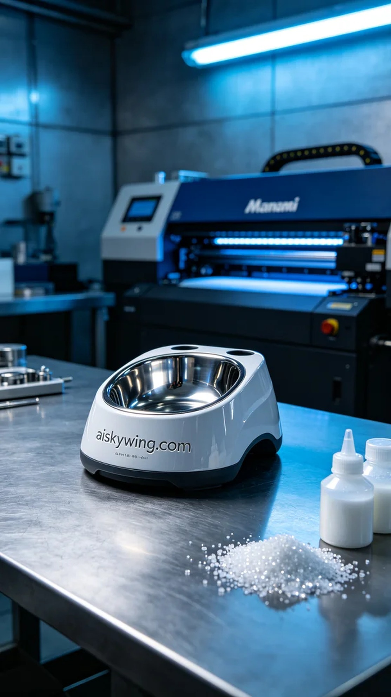
Aiskywing Industrial 3D Printing
Pet foot washing cup shell


