1087-宠物漏食球外壳3D打印生产记录
Pet Food Dispensing Ball Shell
🖨️ SLS尼龙烧结
🖥️ 打印机: Systems
📦 材料: 摆放着未成型的液态光敏
生活再难，也别停下脚步。就像接下这个宠物漏食球外壳的单子，很多人为了照顾他们的毛孩子，总是想尽办法来解决难题。
No matter how difficult life gets, don't stop moving forward. Just like taking on the task of making a pet food dispensing ball shell, many people go to great lengths to solve problems for their furry kids.
________________________________________________________________________________
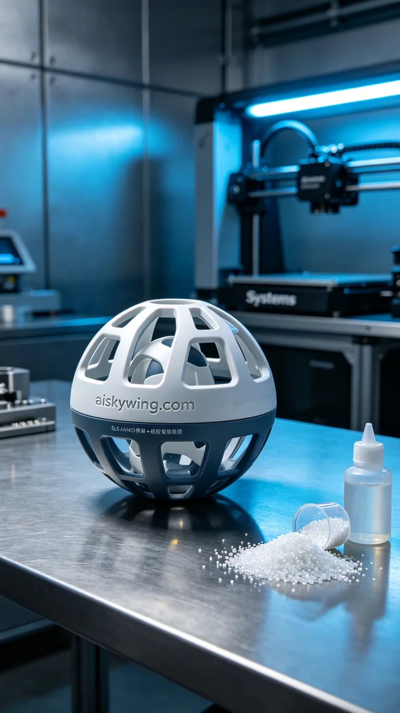
Recently, someone saw our product on TikTok and inquired if we could print a shell for a pet food dispensing ball. Their pet always scattered food everywhere, and they wanted a ball that could control the flow. So, we took on this project.
The raw material used was unformed liquid photopolymer resin, which has good fluidity and exceptional strength after curing. To ensure print quality, we set the parameters on the Systems printer, including a layer thickness of 0.1mm, a printing temperature of 25℃, a power setting of 80%, and a printing speed of 50mm/s, with the entire process estimated to take 8 hours.
Once the printing began, the Systems printer operated smoothly. We closely monitored the device status, ensuring each layer formed as expected. Throughout the printing process, we performed regular checks to confirm the fluidity of the resin and curing conditions, ensuring there were no bubbles or defects.
After printing was completed, we first removed the formed shell from the print platform, then proceeded with cleaning using an ultrasonic cleaner to remove any residual resin. Next, we sanded the surface to eliminate any roughness and finally placed it under UV light for curing, ensuring surface hardness and durability. After completing all post-processing steps, we conducted a final inspection to verify that every detail was perfect.
Through this 3D printing process, we successfully created a high-quality pet food dispensing ball shell, helping pet owners solve real problems, making it a rewarding experience.
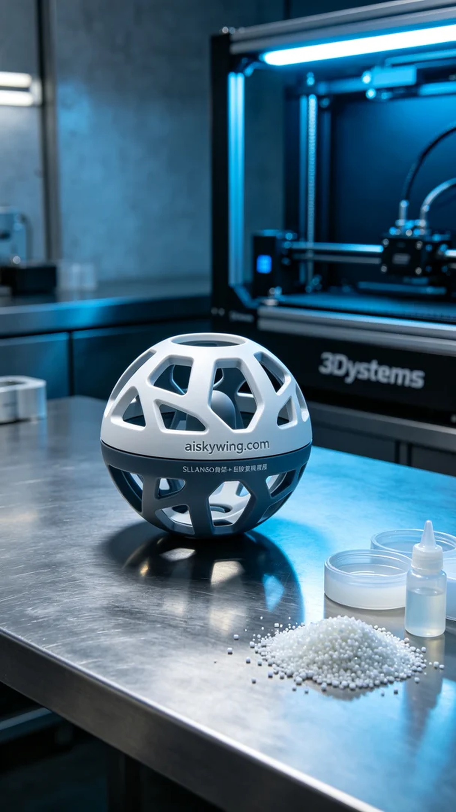
最近，有人在TikTok上看到我们的产品，询问能否打印一款宠物漏食球外壳。他们的宠物总是把食物弄得满地都是，想要一个能够控制食物流出的漏食球。于是，我们接下了这个项目。
采用的原材料是摆放着未成型的液态光敏树脂，这种材料具有良好的流动性和固化后优异的强度。为了确保打印的质量，使用的Systems打印机设置了适合的参数，包括层厚0.1毫米、打印温度为25℃、功率设置为80%、打印速度为50毫米/秒，整个打印过程预计需要8小时。
打印开始后，Systems打印机顺利运行。我们密切监控设备状态，确保每一层的成型都能达到预期的效果。在打印过程中，时不时会进行检查，确认液态光敏树脂的流动性和固化情况，确保没有气泡和缺陷。
打印完成后，首先将成型的外壳从打印平台上取下，然后进行清洗，使用超声波清洗机将残留的树脂清理干净。接着，进行打磨以去除表面粗糙感，最后将其放入UV灯中进行固化，确保表面硬度和耐用性。所有的后处理工序完成后，进行最后的检验，确保每个细节都没有遗漏。
通过这次的3D打印过程，我们成功制作出了高质量的宠物漏食球外壳，帮助那些爱宠人士解决了实际问题，真是一次愉快的体验。
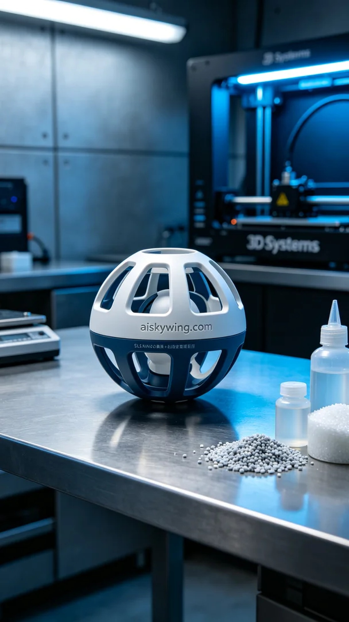
Aiskywing Industrial 3D Printing
Pet Food Dispensing Ball Shell


