1088-宠物牙刷手柄3D打印生产记录
Pet toothbrush handle
🖨️ SLA光固化
🖥️ 打印机: EOS
📦 材料: SLA
在Twitter上有人说，宠物牙刷手柄的设计影响了宠物的口腔健康。我们接下了这个挑战，准备为他们打造出理想的产品。
Someone on Twitter mentioned that the design of pet toothbrush handles affects pets' oral health. We accepted this challenge and are ready to create the ideal product for them.
________________________________________________________________________________
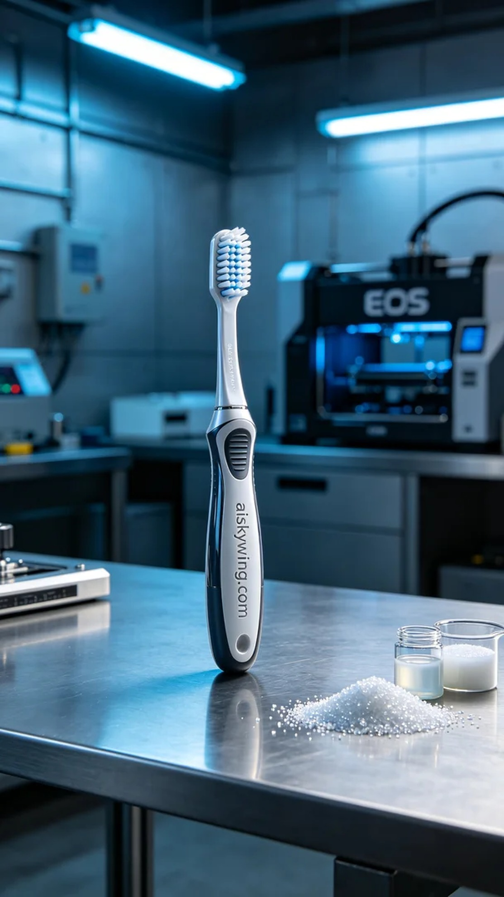
On Twitter, someone mentioned that the design of a pet toothbrush handle affects their pet's oral health. We took on this challenge, preparing to create the ideal product for them.
The pet toothbrush handle is designed with precision, using SLA photopolymer resin that offers excellent durability and smooth surfaces. We prepared an EOS brand 3D printer to ensure that every step achieves optimal quality. The printing parameters are set as follows: layer thickness 0.1mm, temperature at 25℃, power at 80mW, printing speed at 50mm/s, with an estimated print time of 6 hours.
During the printing process, the EOS printer started smoothly and operated steadily. We meticulously monitored each layer's formation to ensure there were no bubbles or defects. As the liquid resin was exposed to UV light, it quickly cured into the perfect handle structure, with details accurately replicated.
After the printing was complete, a series of post-processing steps were conducted. First, the formed handle was placed in a cleaning solution to thoroughly remove any residual resin. Next, it was sanded to eliminate tiny imperfections, ensuring a smooth feel. The handle was then placed in a curing machine to ensure its structure was fully reinforced. During inspection, the engraved "aiskywing.com" on the handle was clearly visible, meeting our expectations.
In the end, we successfully produced a high-quality pet toothbrush handle that is both aesthetically pleasing and functional. This project not only fulfilled a need but also advanced our skills in 3D printing technology.
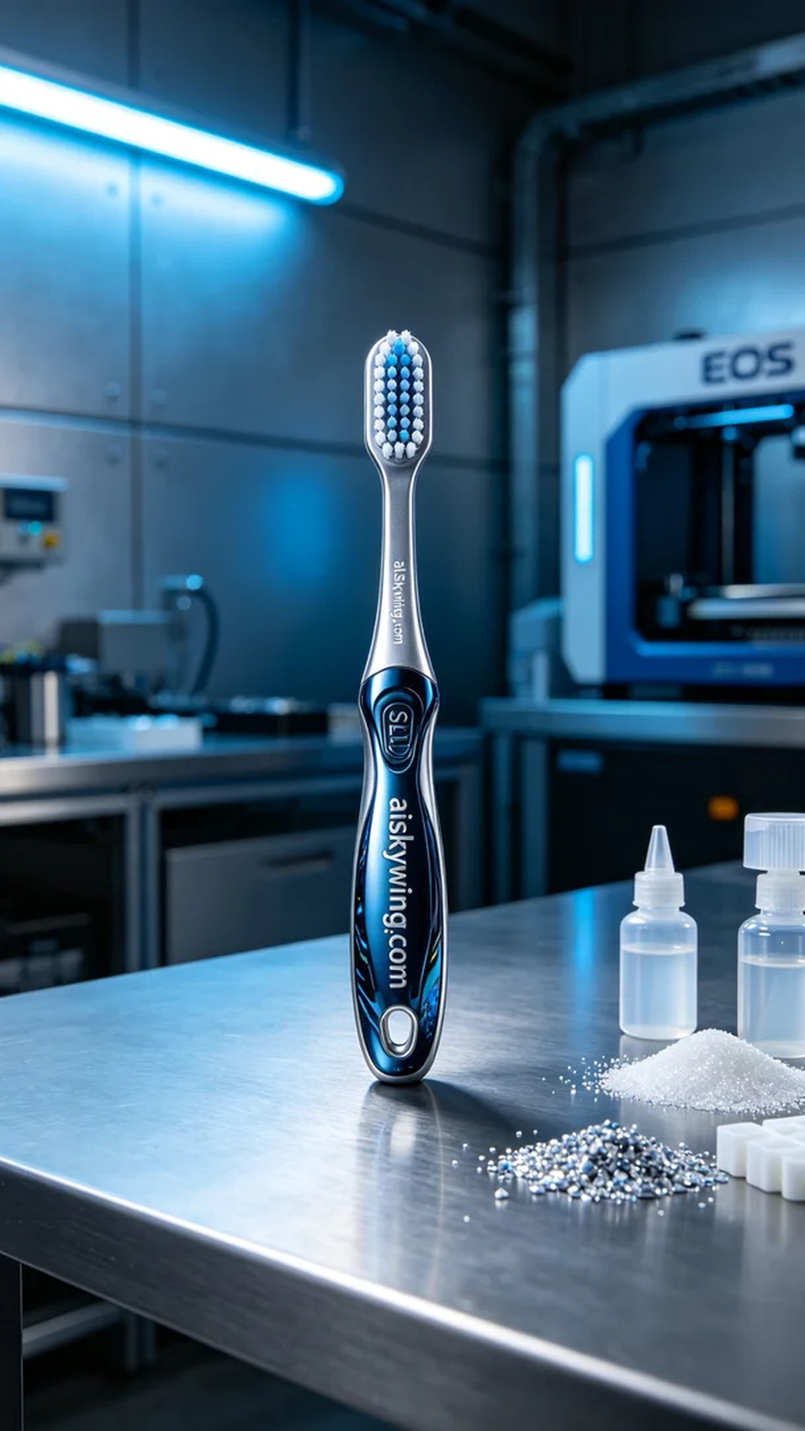
这款宠物牙刷手柄的设计需要极高的精准度，使用的材料是SLA光固化树脂，具有优良的耐久性和表面光滑度。我们准备了EOS品牌的3D打印机，确保每一步都能达到最佳质量。打印参数设置如下：层厚0.1mm，温度设定在25℃，功率为80mW，打印速度为50mm/s，预计打印时间为6小时。
在打印过程中，EOS打印机顺利启动，设备运转稳定。我们仔细监控每一层的成型情况，确保没有气泡或缺陷。打印过程中，液态树脂在UV光照射下迅速固化，形成完美的手柄结构，细节得以完美还原。
完成打印后，进行一系列后处理工序。首先将成型的手柄放入清洗液中，彻底去除表面残留的树脂。接着对手柄进行打磨，以去掉微小的瑕疵，确保手感光滑。然后将手柄放入固化机中，确保其结构得到充分的强化。检查的过程中，手柄表面雕刻的"aiskywing.com"字样清晰可见，达到了预期效果。
最终，我们成功制作出高质量的宠物牙刷手柄，既美观又实用。这个项目不仅满足了需求，也让我们在3D打印技术上又走得更远了一步。
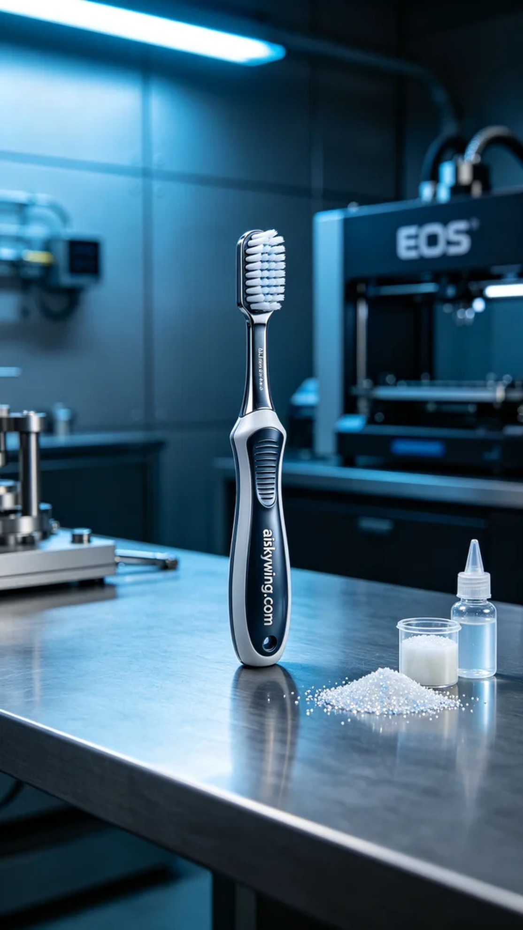
Aiskywing Industrial 3D Printing
Pet toothbrush handle


