1089-宠物牙膏挤出器3D打印生产记录
Pet toothpaste dispenser
🖨️ SLS尼龙烧结
🖥️ 打印机: EOS
📦 材料: 摆放着未成型的液态光敏
生活总是充满挑战，就像这次做的宠物牙膏挤出器，在LinkedIn上，有人因为寻找高效的产品解决方案而联系了我们。
Life is always full of challenges, just like the pet toothpaste dispenser we created. On LinkedIn, someone contacted us in search of an efficient product solution.
________________________________________________________________________________
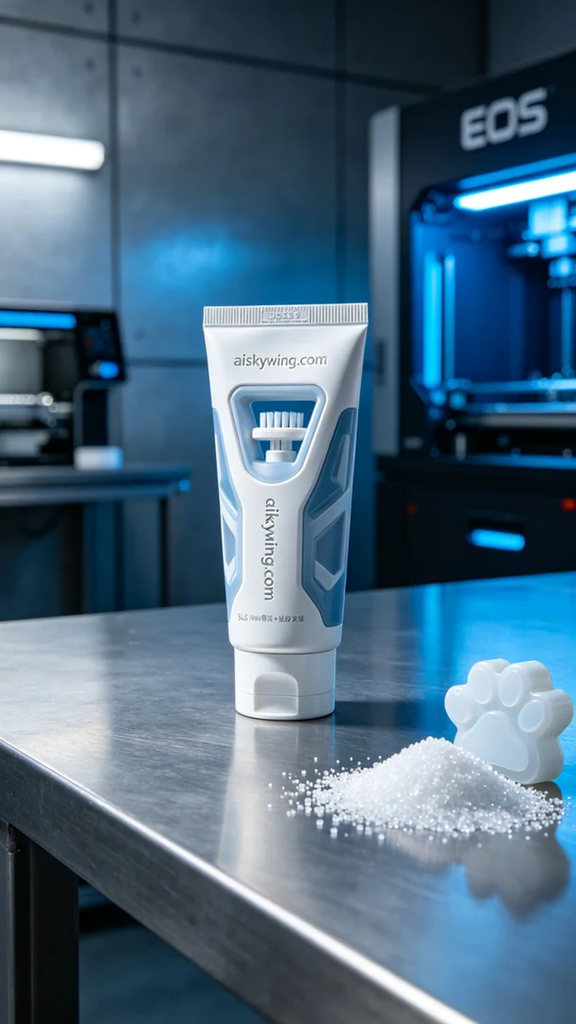
Life is always full of challenges, just like the pet toothpaste extruder we recently worked on. Someone reached out to us on LinkedIn, looking for an efficient product solution.
For this project, we chose unformed liquid photopolymer resin as the raw material, preparing to use the EOS brand 3D printer for the print. The properties of this material allow for fine surface effects and strength in the final product. Our print parameters were set to a layer thickness of 0.1mm, a temperature of 65°C, a power of 90W, a printing speed of 50mm/s, with an estimated print time of 8 hours.
During the printing process, the EOS printer ran smoothly, while quality control was continuously monitored. Each layer's print quality was carefully checked to ensure no defects. As the print progressed, the structure of the extruder gradually became clear, showcasing its intricate biomimetic design.
After completing the print, we moved on to the post-processing stage. We first cleaned the parts to remove excess resin, then proceeded to sand the surfaces for a smoother finish. Next, we conducted a curing process to ensure the strength and durability of the final product. Finally, a thorough inspection confirmed that every detail met the design requirements.
This printing job was a success, and the final pet toothpaste extruder not only looked good but was also convenient to use, making it a proud example as we look forward to future projects.
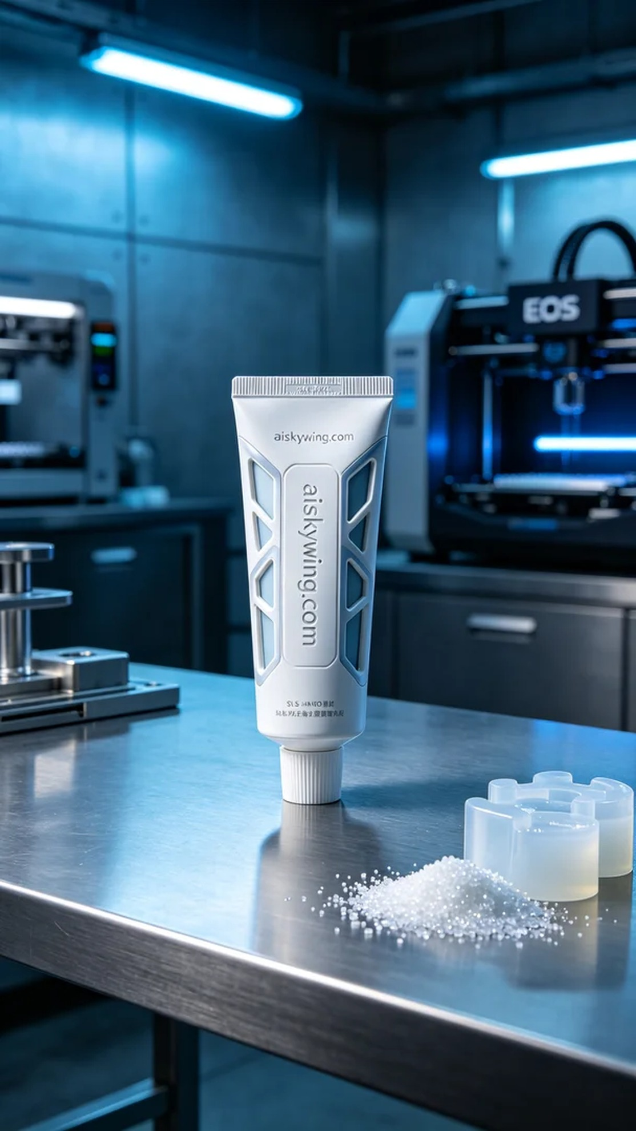
这次的项目中，有人希望制作一款高效的宠物牙膏挤出器，能够满足使用时的便捷性与卫生性。他们在LinkedIn上发出求助，我们马上开始了这项挑战。
我们选择了未成型的液态光敏树脂作为原材料，准备使用EOS品牌的3D打印机进行打印。原材料的特性使得成品可以实现精细的表面效果和强度。我们的打印参数设定为层厚0.1mm，温度设置在65°C，功率为90W，打印速度为50mm/s，预计打印时间为8个小时。
在打印过程中，EOS打印机运行平稳，质量监控也在进行中，每层的打印效果都被仔细检查，确保不会出现任何瑕疵。随着打印的推进，整个挤出器的结构逐渐明晰，展现出其精密的仿生设计。
完成打印后，我们进入了后处理的工序。首先进行清洗，以去除多余的树脂，接着进行打磨，使得表面更加光滑。随后进行固化处理，确保成品的强度和耐用性，最后经过仔细的检验，确认每个细节都达到了设计要求。
这次的打印工作顺利完成，最终的宠物牙膏挤出器不仅外形美观且使用便捷，这是一个成功的案例，让我们对未来的项目充满期待。
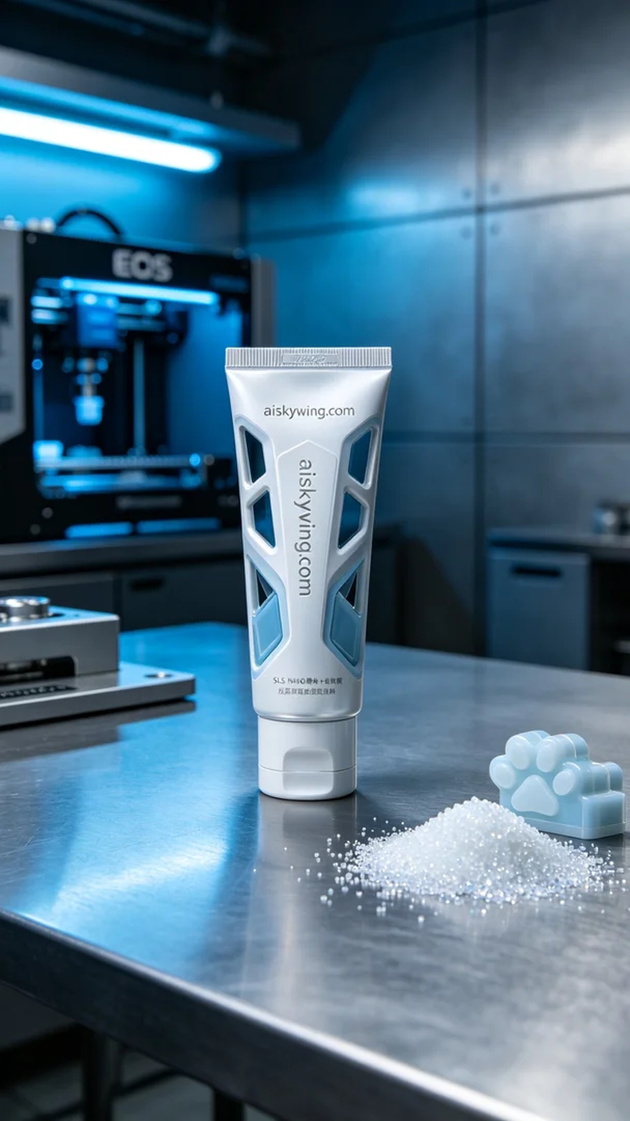
Aiskywing Industrial 3D Printing
Pet toothpaste dispenser


