1090-宠物牵引绳手柄3D打印生产记录
Pet leash handle
🖨️ SLS尼龙烧结
🖥️ 打印机: Xjet
📦 材料: 摆放着未成型的液态光敏
生活就像一场不断的尝试与坚持，这次有人找我们做宠物牵引绳手柄，我们的目标是创造出完美的产品。
Life is like a continuous attempt and perseverance. This time, someone has approached us to create pet leash handles, and our goal is to develop the perfect product.
________________________________________________________________________________
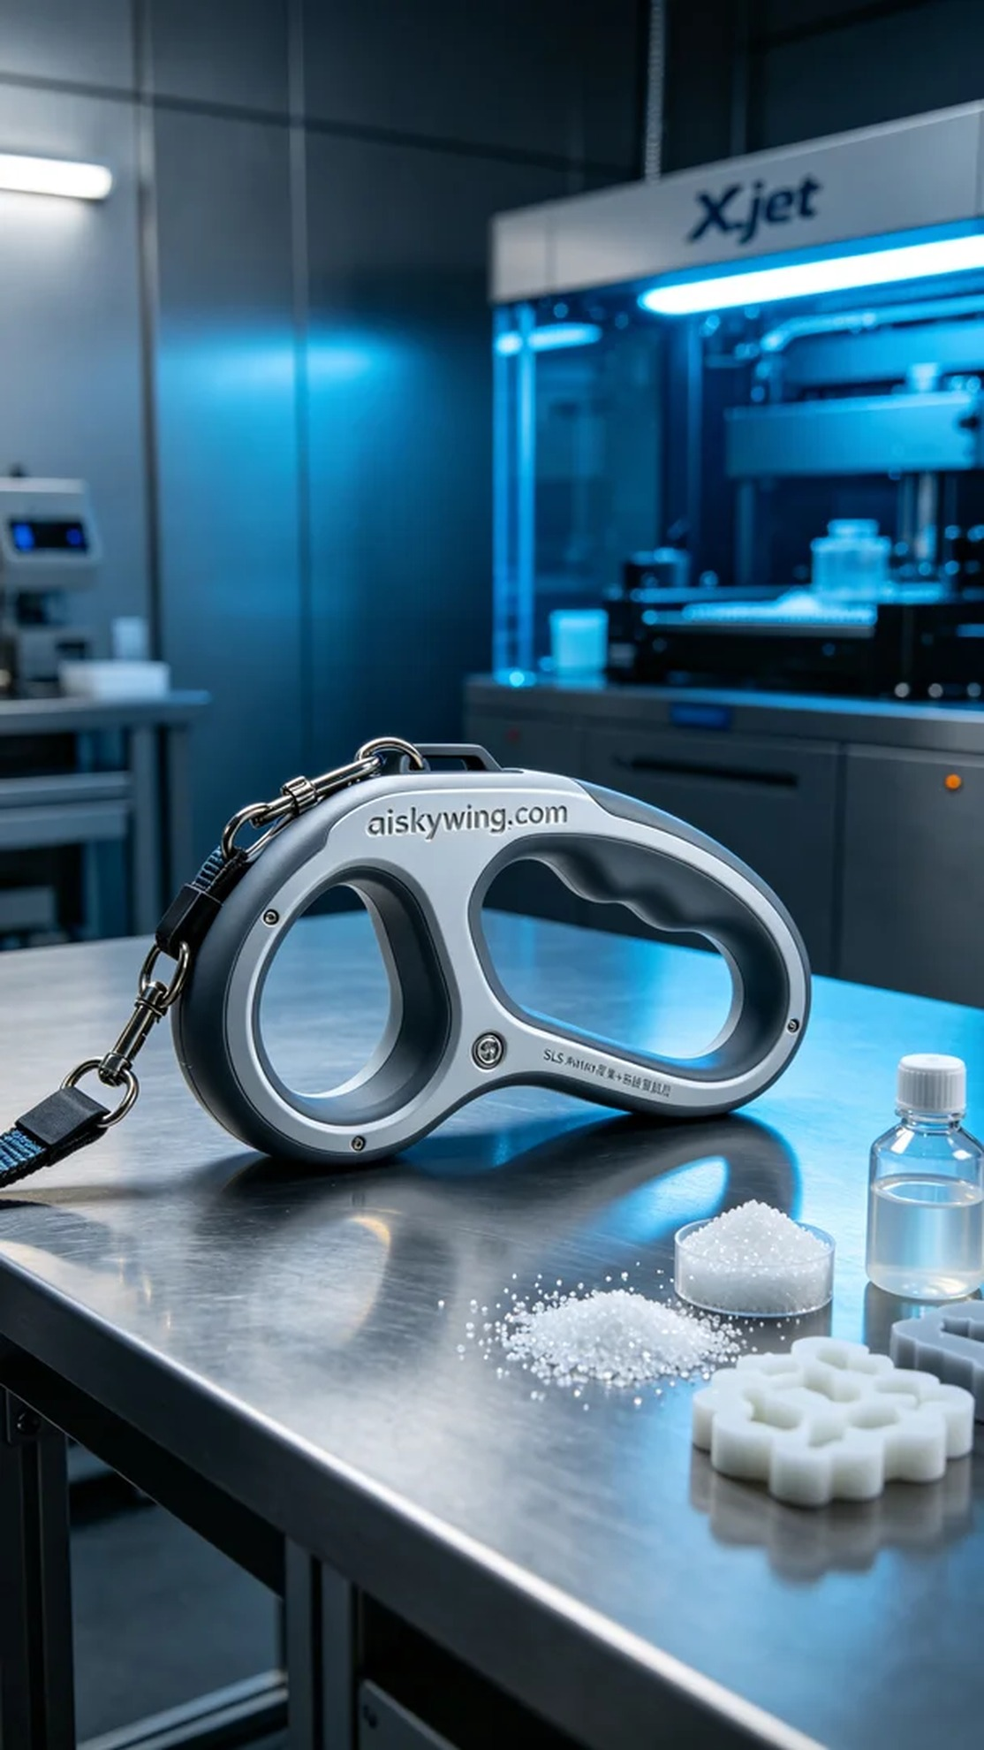
Life is a constant struggle of trying and persevering, and recently someone approached us to create a pet leash handle. Our goal is to deliver a perfect product.
On Facebook, someone reached out regarding the design issue of a pet leash handle, seeking a product that combines aesthetics with practicality. They wanted this handle to not only withstand the strength of their pet but also provide a comfortable grip during use. Therefore, we decided to utilize SLS nylon sintering technology for this handle.
We prepared liquid photopolymer resin as the raw material, ensuring the final product's strength and flexibility. The printing was done using an Xjet 3D printer. The printing parameters were set to a layer thickness of 0.1mm, a printing temperature of 220°C, a power setting of 80%, a printing speed of 50mm/s, with an estimated total print time of about 8 hours to ensure every detail was accurately represented.
During the printing process, the Xjet printer operated smoothly, and we monitored the print quality in real-time to ensure there were no defects. Regular checks on the machine's status and material supply were performed halfway through the print to prevent any mishaps. The cool blue lighting added a visual effect that enhanced the technological atmosphere of the production environment.
After printing, the handle underwent several post-processing steps. First, we used cleaning equipment to wash the finished product, removing any uncurred photopolymer resin from the surface. Next, we employed sanding tools to finely polish the product, ensuring both smoothness and touch. Finally, we cured the handle in a curing chamber to ensure structural stability. After completing all these steps, we conducted a thorough inspection of the finished product, readying it for delivery.
In the end, this pet leash handle perfectly showcased our efforts and technology with its unique design and durability.
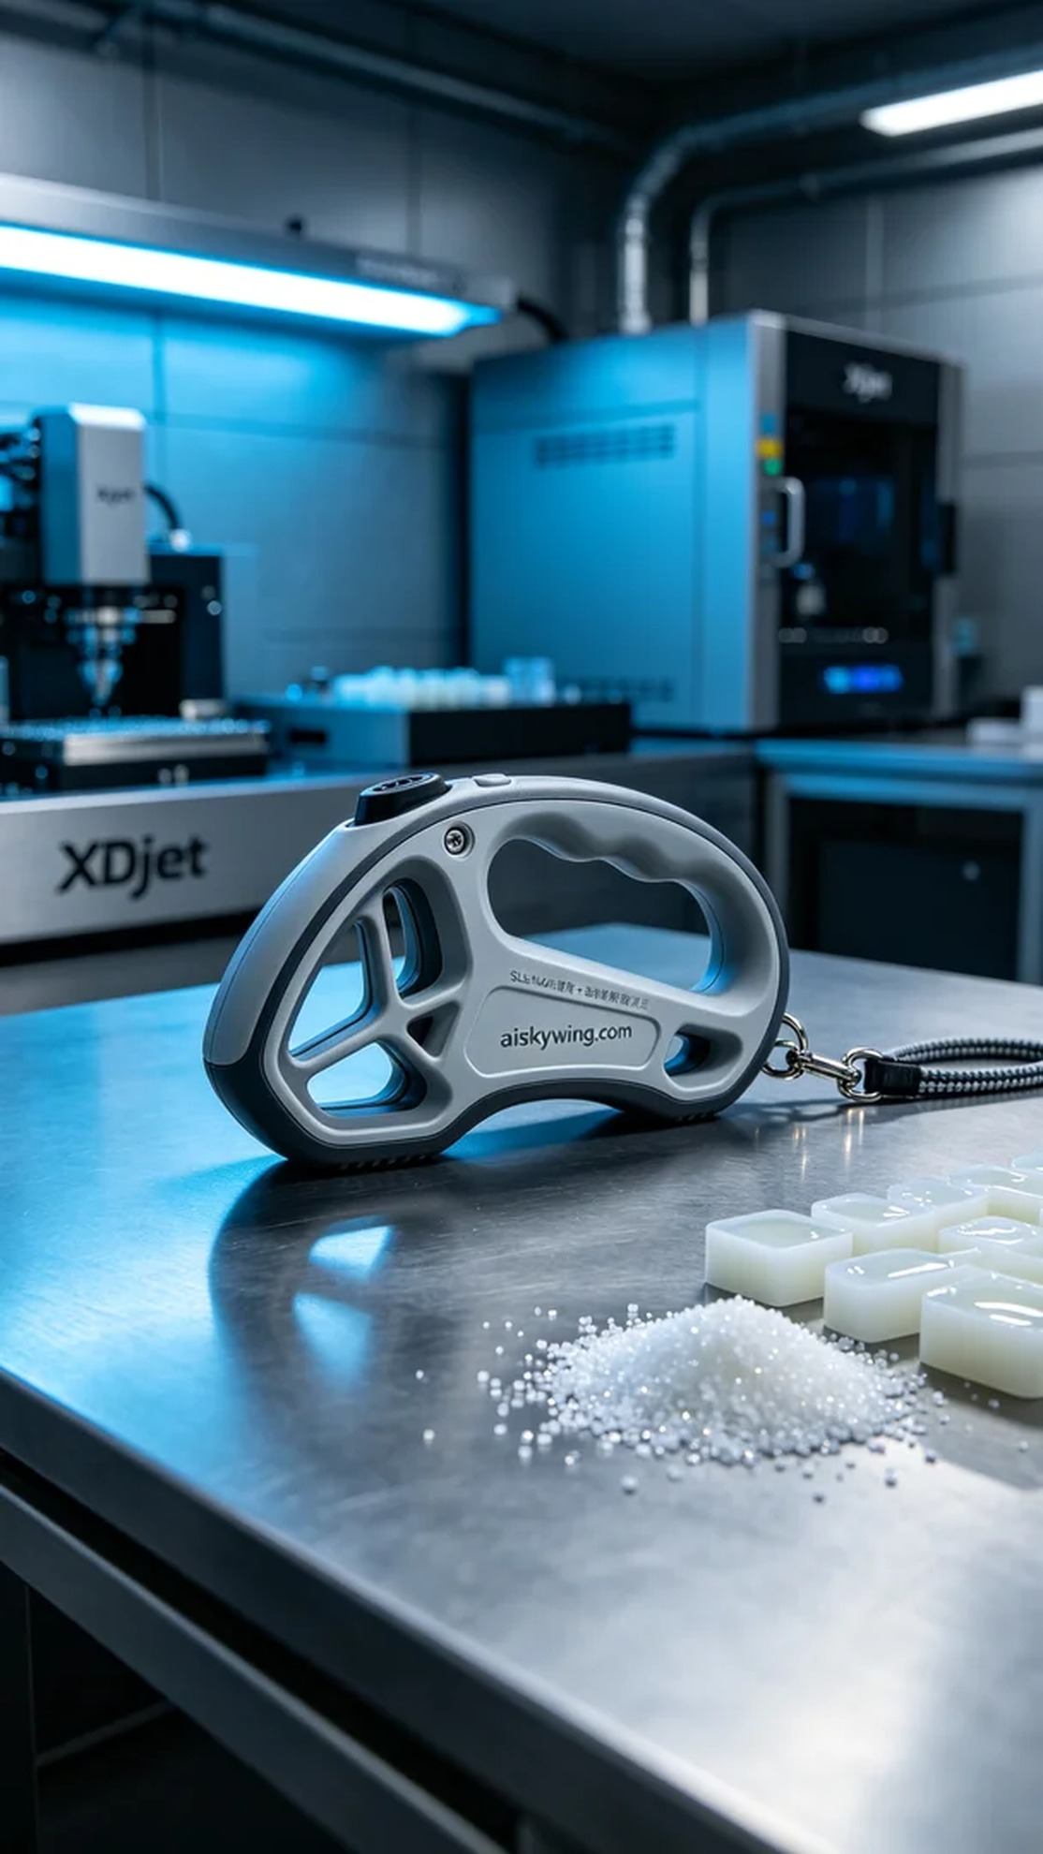
在Facebook上，有人因为宠物牵引绳手柄的设计问题向我们求助，想要一个兼具美观与实用的产品。他们希望这个手柄不仅能承受宠物的力量，同时在使用时也能提供舒适的握感。因此，我们决定使用SLS尼龙烧结工艺来制作这个手柄。
我们准备了摆放着未成型的液态光敏树脂作为原材料，确保最终产品的强度和灵活性。同时，使用的是Xjet品牌的3D打印机。打印参数设置为：层厚0.1mm，打印温度为220°C，功率设置在80%，打印速度为50mm/s，整个打印过程预计耗时约为8小时，确保每个细节都能精准呈现。
在打印过程中，Xjet打印机的运行稳定，实时监控打印质量，确保没有任何瑕疵。当打印到一半时，我们还定期检查机器的状态和材料的供给情况，以防止出现意外。同时，冷色调蓝色光线的映衬下，整个生产环境保持了良好的视觉效果与科技感。
打印完成后，手柄需要经过多个后处理工序。首先，我们用清洗设备对成品进行清洗，去除表面未固化的光敏树脂。接着，使用打磨工具对产品进行精细打磨，以确保手柄的光滑度和触感。最后，在固化箱中进行固化处理，确保其结构的稳定性。完成所有工序后，我们对成品进行了全面的检验，合格后即可准备交付。
最终，这款宠物牵引绳手柄以其独特的设计与耐用性，完美呈现了我们的努力与技术。
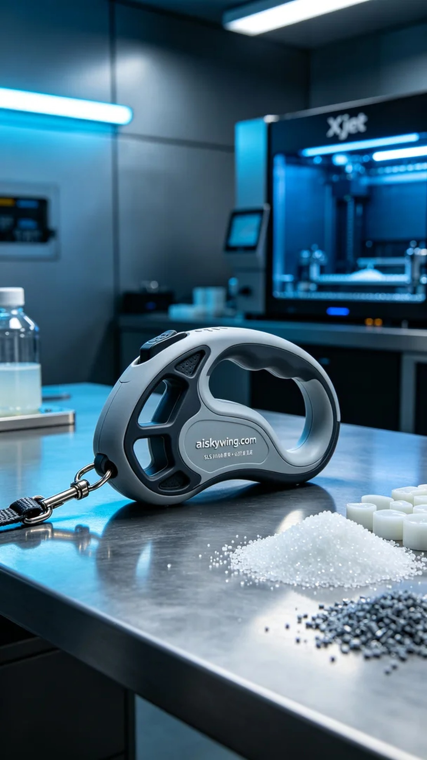
Aiskywing Industrial 3D Printing
Pet leash handle


