1091-宠物猫爬架连接件生产记录
Pet cat climbing frame connector
🖨️ SLS尼龙烧结
🖥️ 打印机: Voxeljet
📦 材料: 摆放着未成型的液态光敏
生活就像3D打印，有时候需要一步步走出困境。就像这个宠物猫爬架连接件在Instagram上引起的关注，解决了许多宠物主人的烦恼。
Life is like 3D printing; sometimes you need to take it step by step to overcome difficulties. Just like the attention this pet cat climbing frame connector has garnered on Instagram, it has solved many pet owners' troubles.
________________________________________________________________________________
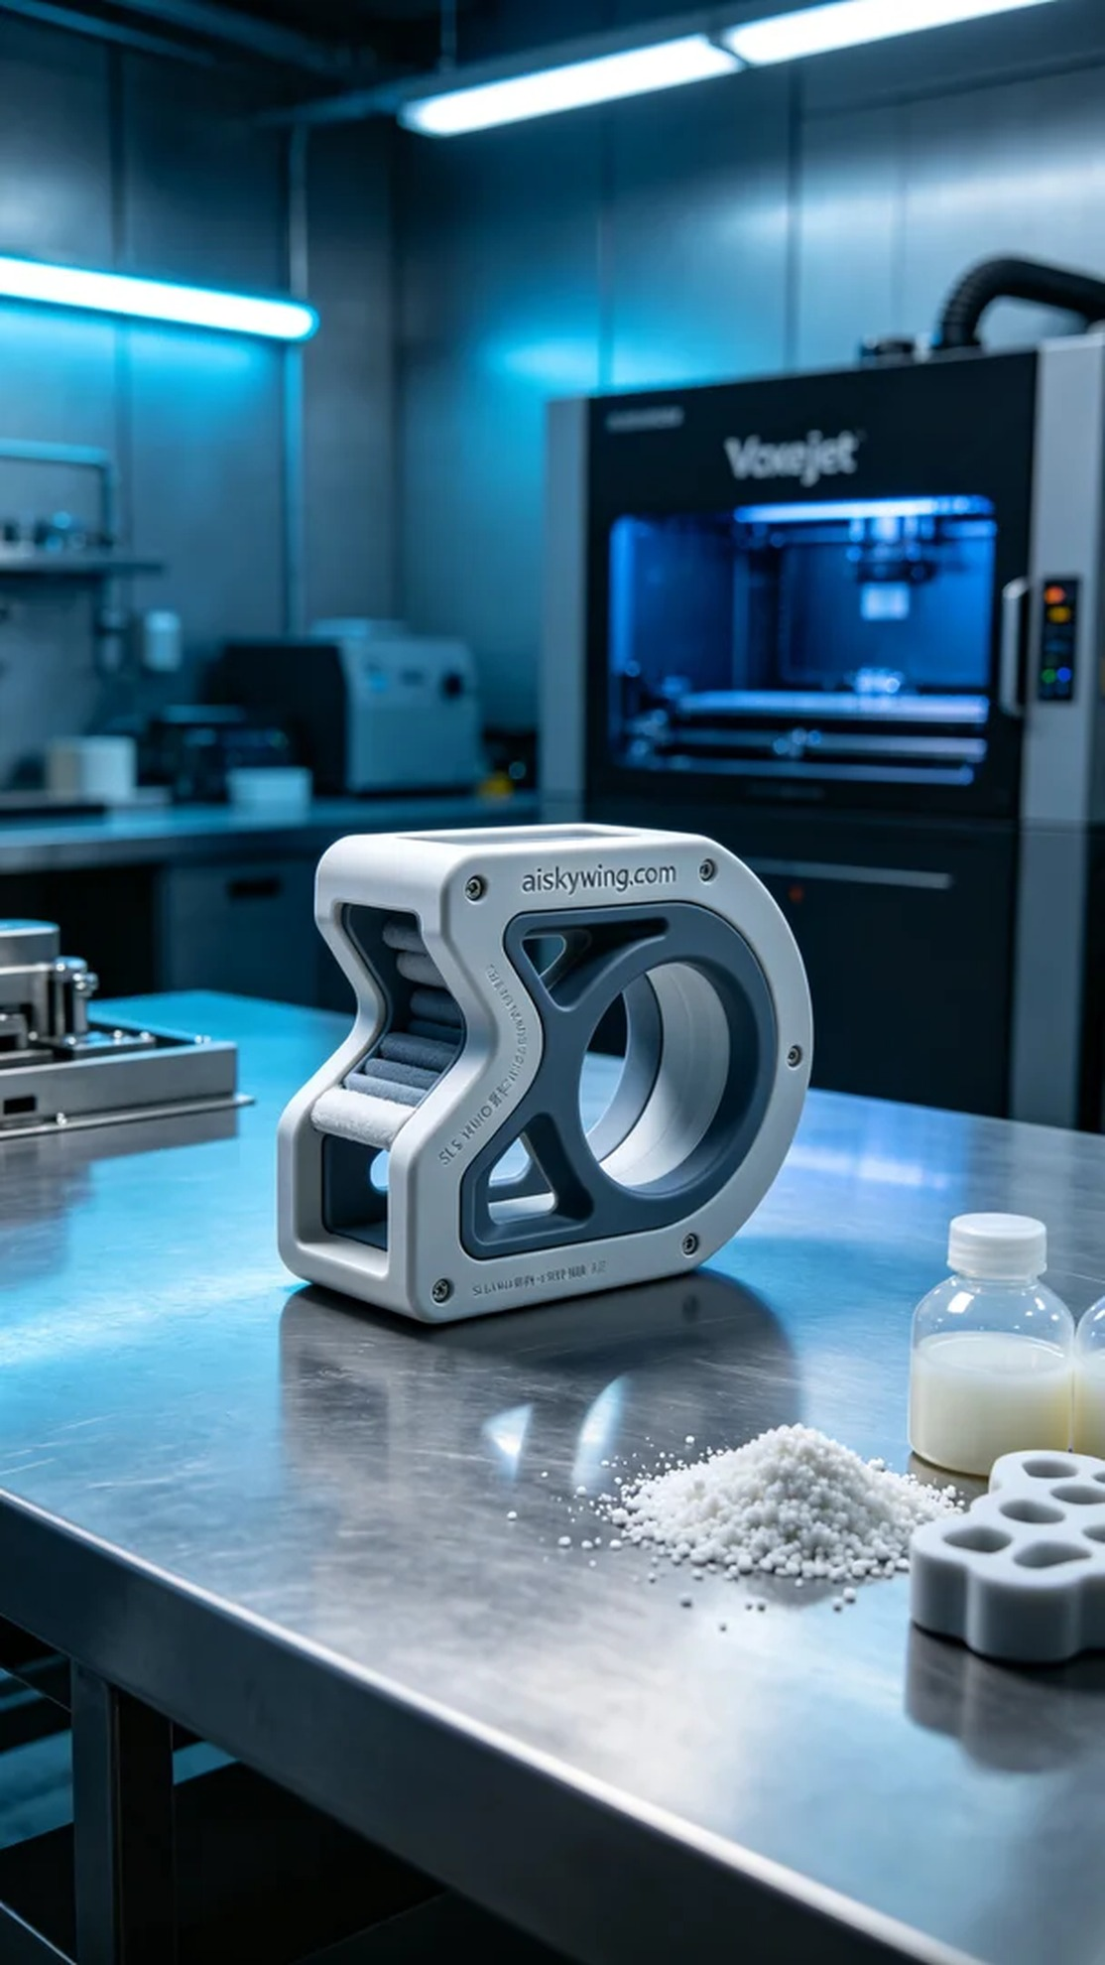
Recently, someone reached out to us through Instagram, expressing their struggles in finding a suitable connector for their pet cat climbing frame. They needed a solution that was both sturdy and flexible to ensure their pet's safety and comfort. Thus, we decided to utilize Voxeljet's printing technology to meet this demand.
To achieve this, we chose the SLS nylon sintering process and prepared liquid photopolymer resin as our raw material. This material boasts excellent flexibility and strength, ensuring the durability of the final product. In our print settings, we opted for a layer thickness of 0.1mm, maintained a temperature of 200 degrees Celsius, set the power to 60 watts, and a printing speed of 30mm/s, with an estimated total printing time of 5 hours.
During the printing process, the Voxeljet printer operated smoothly, with both temperature and pressure held at optimal levels. We monitored the print quality in real-time, ensuring that each layer formed evenly. Through careful observation, we found that the outcome exceeded our expectations, with the connector's intricate details vividly captured.
After printing, we entered the post-processing stage. First, we cleaned the printed parts with a solvent to remove any residual resin on the surface. Then, we proceeded to sand the connectors to ensure a smooth finish and cured them under UV light to enhance their strength. Finally, each connector was subjected to rigorous inspection to ensure high quality standards.
Throughout this production process, we witnessed the fusion of technology and creativity. The emergence of this pet cat climbing frame connector not only solved a problem but also provided fresh perspectives for future designs.
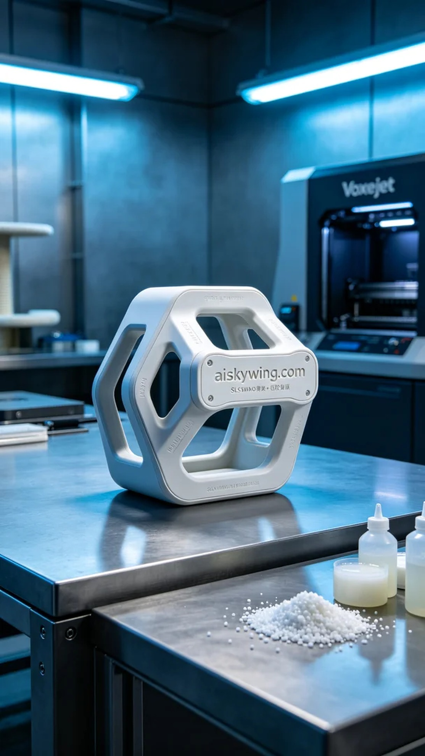
最近，有人通过Instagram找到我们，分享了他们在寻找合适的宠物猫爬架连接件时的困扰。他们希望得到一种既结实又灵活的连接方案，以确保宠物的安全与舒适。于是我们决定利用Voxeljet的打印技术来满足这个需求。
为了实现这个目标，我们选择了SLS尼龙烧结工艺，并准备了未成型的液态光敏树脂。原材料具有优异的柔韧性和强度，确保了成品的耐用性。我们在打印设置中选择了层厚0.1mm，温度控制在200摄氏度，功率设定为60瓦，打印速度则为30mm/s，预计总打印时间为5个小时。
在打印过程中，Voxeljet打印机稳定运行，温度和压力保持在最佳状态。我们实时监测打印质量，确保每一层都均匀成型。通过细致的观察，我们发现这次的成品效果远超预期，连接件的每一个细节都展现得淋漓尽致。
完成打印后，我们进入了后处理环节。首先使用清洗剂对打印件进行清洗，去除表面残留的树脂。接着，我们对连接件进行打磨，确保表面光滑，并用UV灯固化以增强强度。最后，经过严格的检验，确保每个连接件都能达到高标准。
在整个生产过程中，我们见证了技术与创意的结合。这个宠物猫爬架连接件的诞生，不仅解决了问题，也为未来的设计提供了新的思路。
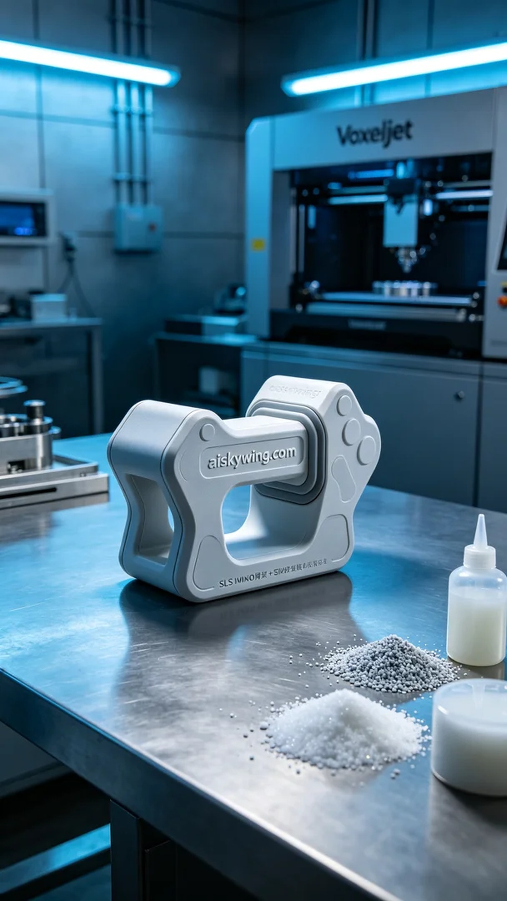
Aiskywing Industrial 3D Printing
Pet cat climbing frame connector


