1092-宠物电推剪外壳的3D打印记录
Pet grooming clipper shell
🖨️ SLM金属打印
🖥️ 打印机: EOS
📦 材料: 摆放着未成型的液态光敏
生活中总会遇到一些挑战，正如有人在LinkedIn上寻求我们帮助，为他们的宠物电推剪外壳的生产提供解决方案。
In life, we always encounter challenges, just like someone on LinkedIn seeking our help to provide a solution for the production of pet clipper casings.
________________________________________________________________________________
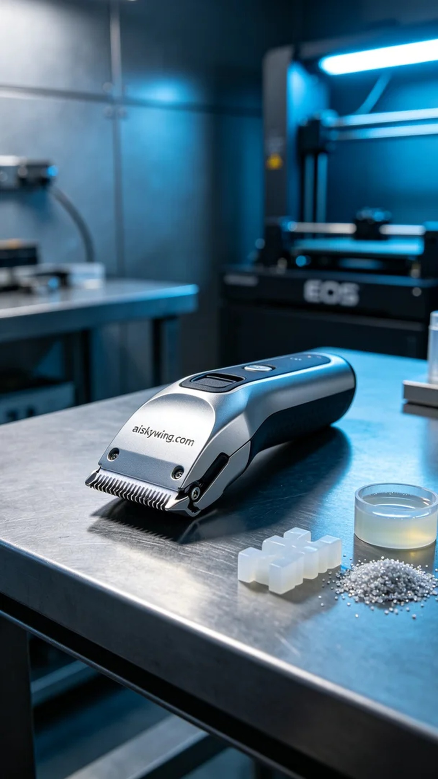
In the world of LinkedIn, someone pointed out their struggles in finding an ideal outer casing for their pet clippers, seeking our help to develop a new solution. I immediately thought that with 3D printing technology, we could bring their vision to life and make the process smoother.
We opted to use liquid photopolymer resin, which was placed in a container prior to printing. This material has excellent fluidity and precision in molding. During preparation, we utilized an EOS printer, setting a layer thickness of 0.05 mm, maintaining a temperature of 25 degrees Celsius, with a power of 1000 milliwatts and controlling the printing speed at 50 mm per second to ensure the perfect detailing.
Throughout the printing process, the EOS printer operated smoothly, with liquid photopolymer resin curing layer by layer through a precise nozzle, gradually revealing the outline of the casing. We continuously monitored the print quality to ensure that every layer's adhesion and shape met our expectations, avoiding any defects.
After printing, we conducted a series of post-processing steps. First, the molded casing was placed in a cleaning tank, utilizing a specialized solvent to remove excess resin. Next, we proceeded with a sanding process to refine the edges and surface, achieving a smoother finish. Finally, the casing was placed in a curing device to ensure that the resin was completely hardened, followed by a rigorous quality inspection to ensure durability and strength.
After much effort through these processes, we successfully completed the production of this pet clipper casing, resulting in a high-quality product that showcases the wonders of technology.
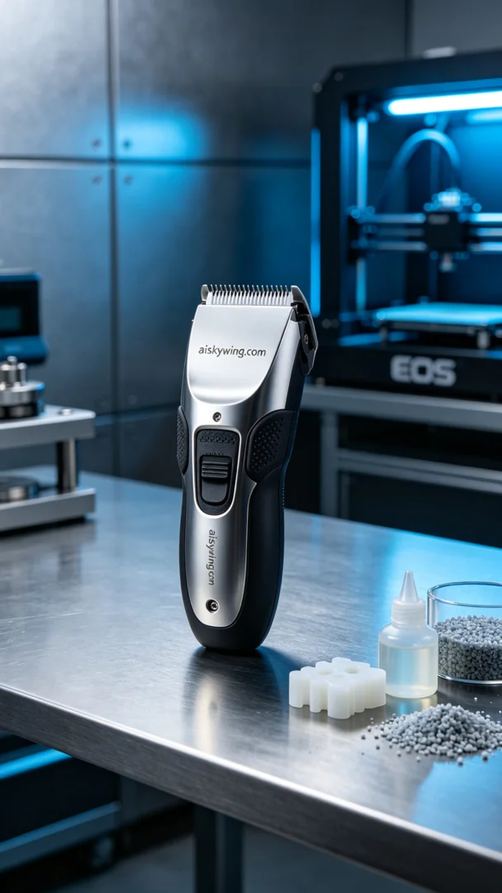
在LinkedIn上，有人指出他们在市场上无法找到理想的宠物电推剪外壳，希望我们能帮助他们开发一种新的外壳。我立刻想到，借助3D打印技术，我们可以实现他们的想法，让这项工作变得更加顺畅。
我们选择使用摆放着未成型的液态光敏树脂作为原材料，这种树脂具有优良的流动性和细致的成型能力。准备过程中，我们使用EOS打印机，并设定了层厚为0.05毫米，温度保持在25摄氏度，功率为1000毫瓦，打印速度则控制在50毫米每秒，以确保细节的完美呈现。
在打印的过程中，EOS打印机平稳运行，随着液态光敏树脂通过精密的喷头逐层固化，外壳的轮廓逐渐显现。我们时刻监控打印质量，确保每一层的附着力和形状都达到预期标准，避免出现任何瑕疵。
打印完成后，我们进行了一系列后处理工序。首先，将成型的外壳放入清洗槽中，使用专用溶剂去除多余的树脂。接着，通过打磨工序，处理外壳的边缘和表面，以达到更为光滑的效果。最后，将外壳放进固化设备中，确保树脂完全硬化，并经过严格的质量检验，确保外壳的强度和耐用性都符合要求。
经过诸多工序的努力，我们成功完成了这款宠物电推剪外壳的生产，得到了一个优质的成品，让人不禁感叹科技的魅力。
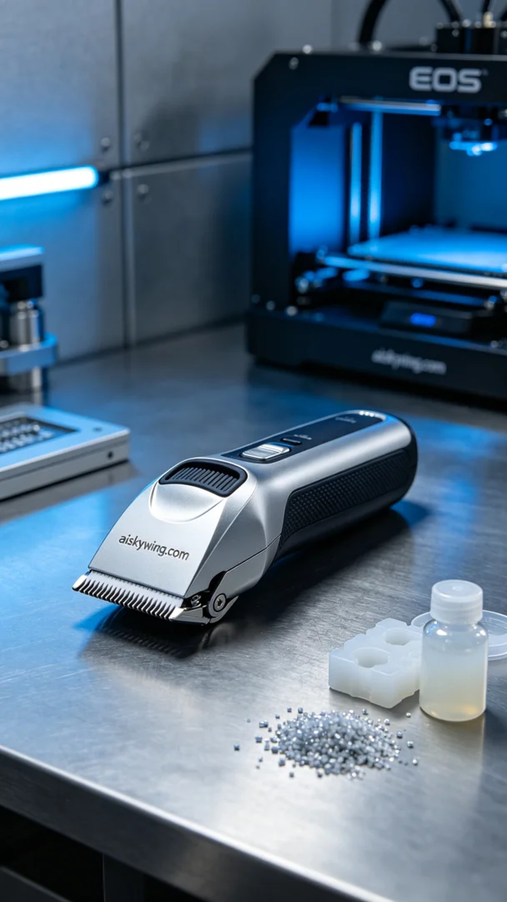
Aiskywing Industrial 3D Printing
Pet grooming clipper shell


