1093-宠物胸背带扣的3D打印记录
Pet harness buckle
🖨️ SLA光固化
🖥️ 打印机: Stratasys
📦 材料: SLA
在Twitter上，有人为宠物的安全不断探索解决方案。于是，我们接到了这个宠物胸背带扣的订单，任务就是将它完美呈现。
On Twitter, people are continuously exploring solutions for pet safety. Thus, we received an order for this pet harness buckle, and our task is to present it perfectly.
________________________________________________________________________________
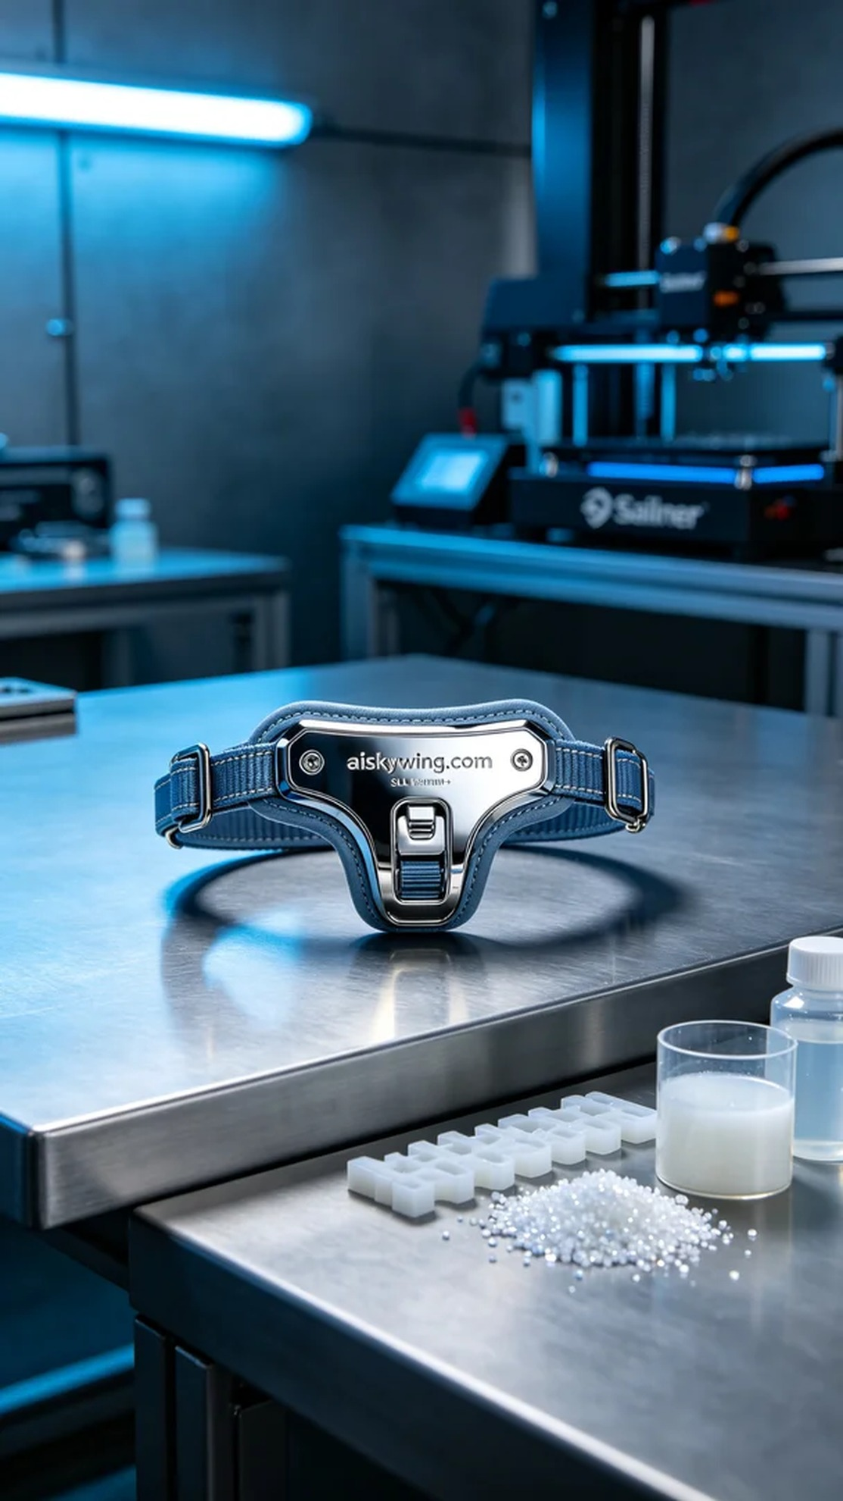
This project involved creating a pet chest strap buckle, aimed at enhancing the safety and comfort of pets. Someone reached out to us, seeking solutions for their pet's travel safety, and so we embarked on our journey of SLA printing, with the goal of producing a high-quality product.
We utilized SLA photopolymer resin known for its precision and excellent surface smoothness. Preparatory work included ensuring our Stratasys printer was in optimal condition, with settings configured to a layer thickness of 0.05mm, a printing temperature of 25℃, a laser power of 100mW, and a speed of 40mm/s. After thorough testing, we confirmed these parameters would ensure a high-quality print.
During the printing process, the performance of the Stratasys printer was stable. We meticulously monitored the machine's operation to ensure each layer formed clearly. The photosensitive resin cured layer by layer under the laser, gradually taking shape. The entire process took about four hours, and the details were brilliantly represented, with the surface being smooth and the engraved “aiskywing.com” text clearly visible.
After printing, we proceeded with post-processing. First, the product was submerged in a cleaning tank for ultrasonic cleaning to remove any excess resin. Next, we polished the surface to achieve a smoother finish. The final step was curing, where the product was placed under UV light to ensure its strength and durability were optimized. Following a stringent inspection, we confirmed that this chest strap buckle met our quality expectations.
Thus, the project concluded successfully, with the pet chest strap buckle not only being aesthetically pleasing but also practical, providing assurance for safe travels for pets.
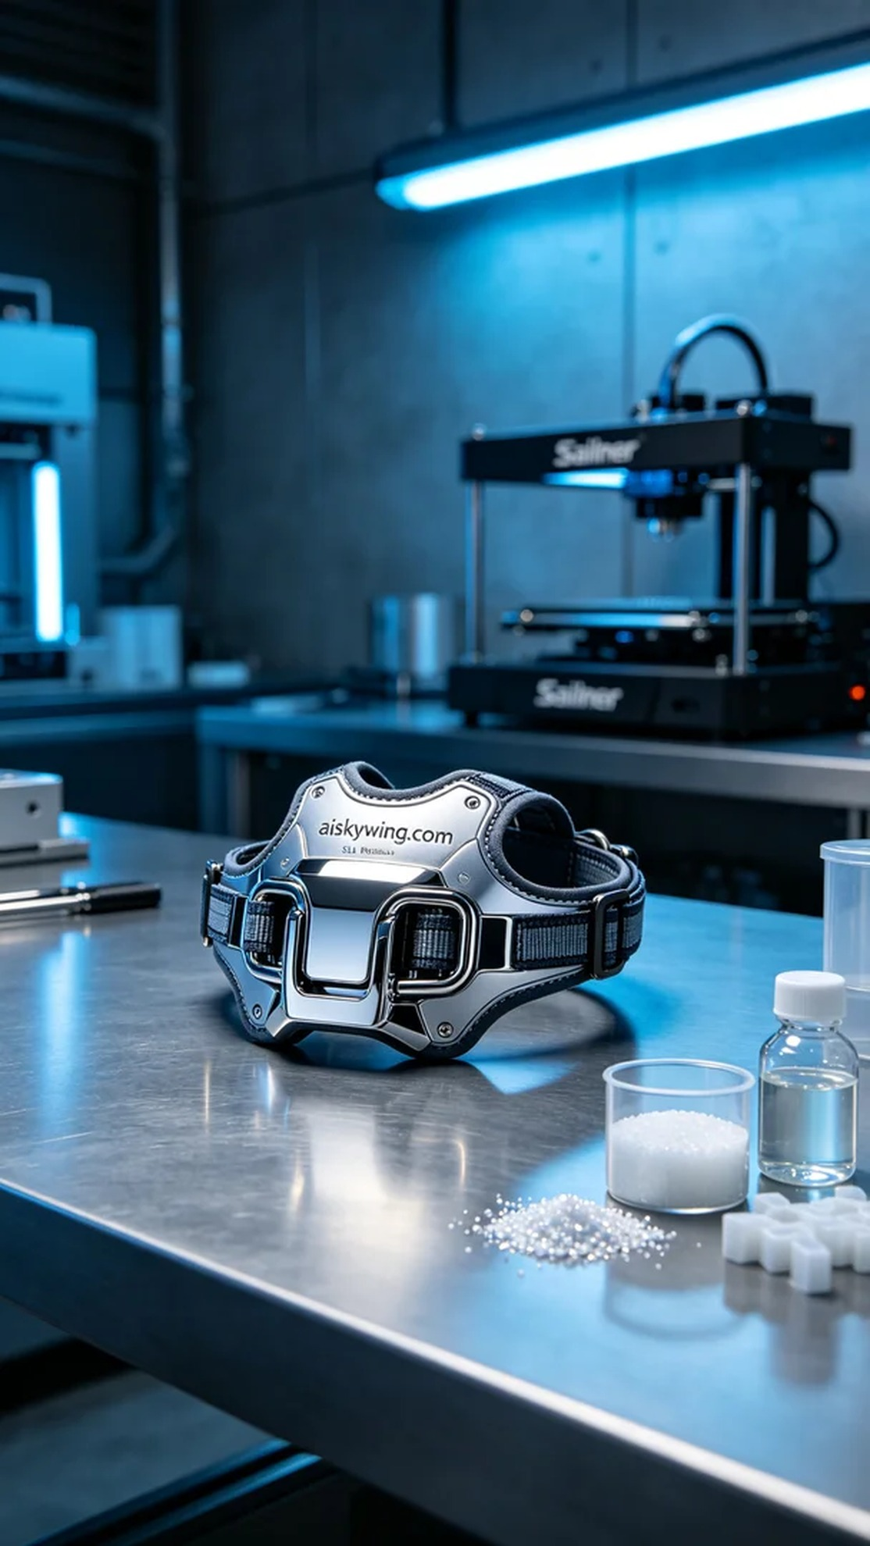
这次的项目是制作一款宠物胸背带扣，旨在为宠物提供安全与舒适。有人因为想要提高他们宠物的出行安全，找到了我们。于是，我们开始了这次SLA光固化打印的旅程，目标是生产出一件质量卓越的产品。
我们使用的是SLA光固化树脂，具有高精度和优秀的表面光滑度。准备工作包括确保设备Stratasys打印机处于最佳状态，设置参数为层厚0.05毫米、打印温度25℃、激光功率为100mW、打印速度为40mm/s。经过细致的测试，我们确认了这些参数能确保较高的打印质量。
在打印过程中，Stratasys打印机的表现非常稳定。打印时，我们仔细监控设备运行，确保每个层的成型都非常清晰。光敏树脂在激光照射下逐层固化，逐步形成了我们想要的形状。整个过程大约耗时四个小时，成品的细节展现得淋漓尽致，表面光滑且雕刻的“aiskywing.com”字样清晰可见。
打印完成后，我们对产品进行了后处理。首先是将成品放入清洗槽中，使用超声波清洗去掉多余的树脂。接着，我们进行了打磨，使表面更加光滑。最后一步是固化，将成品放入UV灯下，确保其强度和耐用性达到最佳状态。经过严格的检验，我们确认这款胸背带扣的质量符合预期。
项目到此圆满结束，这款宠物胸背带扣不仅美观大方，还具备了实用性，为宠物的安全出行提供了保障。
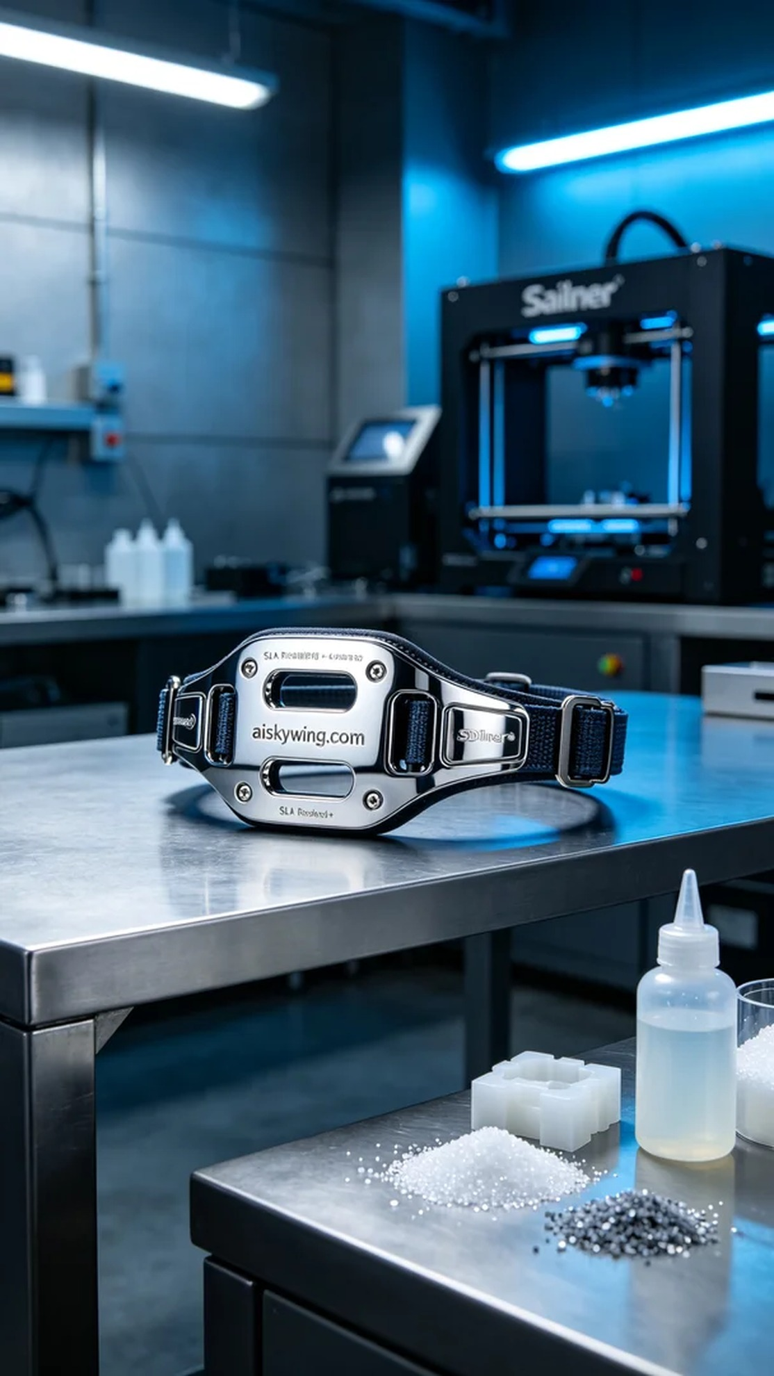
Aiskywing Industrial 3D Printing
Pet harness buckle


