1094-宠物自动逗猫棒底座的3D打印记录
Pet Automatic Cat Teaser Stick Base
🖨️ SLA光固化
🖥️ 打印机: Systems
📦 材料: SLA
生活的每一步都在创造，正如有人在Twitter上寻找解决方案时，决定让我们为他们制作一款宠物自动逗猫棒底座。
Every step in life is a creation, just like when someone on Twitter is looking for a solution and decides to have us make a base for an automatic cat toy.
________________________________________________________________________________
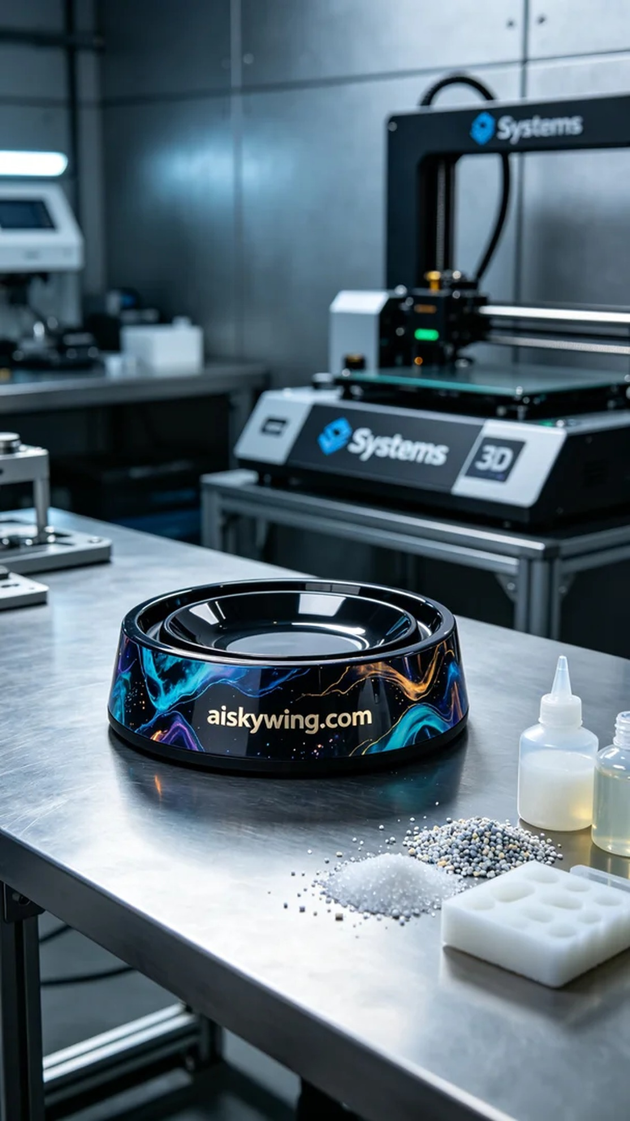
Every step in life is a creation, much like when someone on Twitter looked for a solution and decided to have us create a pet automatic cat teaser base for them.
We chose high-quality liquid photopolymer resin as the raw material, possessing excellent flow properties and curing performance to ensure every detail is perfectly displayed. Preparation included calibrating the Systems brand 3D printer, setting the print parameters to a layer thickness of 0.05 mm, maintaining a temperature of 20°C, setting the power to 60mW, and a print speed of 30mm/s, with an estimated print time of 8 hours.
During the printing process, the Systems printer operated steadily, and the liquid resin cured layer by layer under the light to form the shape of the base. We monitored the print quality throughout to ensure there were no bubbles or other defects. Each layer appeared extremely clear, showcasing the fine carving details and perfectly representing the "aiskywing.com" inscription.
Post-processing is equally important. After the print was complete, we first dipped the finished product in a cleaning solution to remove any uncured resin from the surface, then sanded it down with fine sandpaper to ensure a smooth surface, followed by curing in a UV curing device, and finally conducting an appearance inspection to ensure the product met the predetermined standards.
Ultimately, after stringent printing and post-processing, we successfully completed the production of this pet automatic cat teaser base. The product is exquisitely designed and fully functional, making it an ideal addition to any home and providing joy for pets.
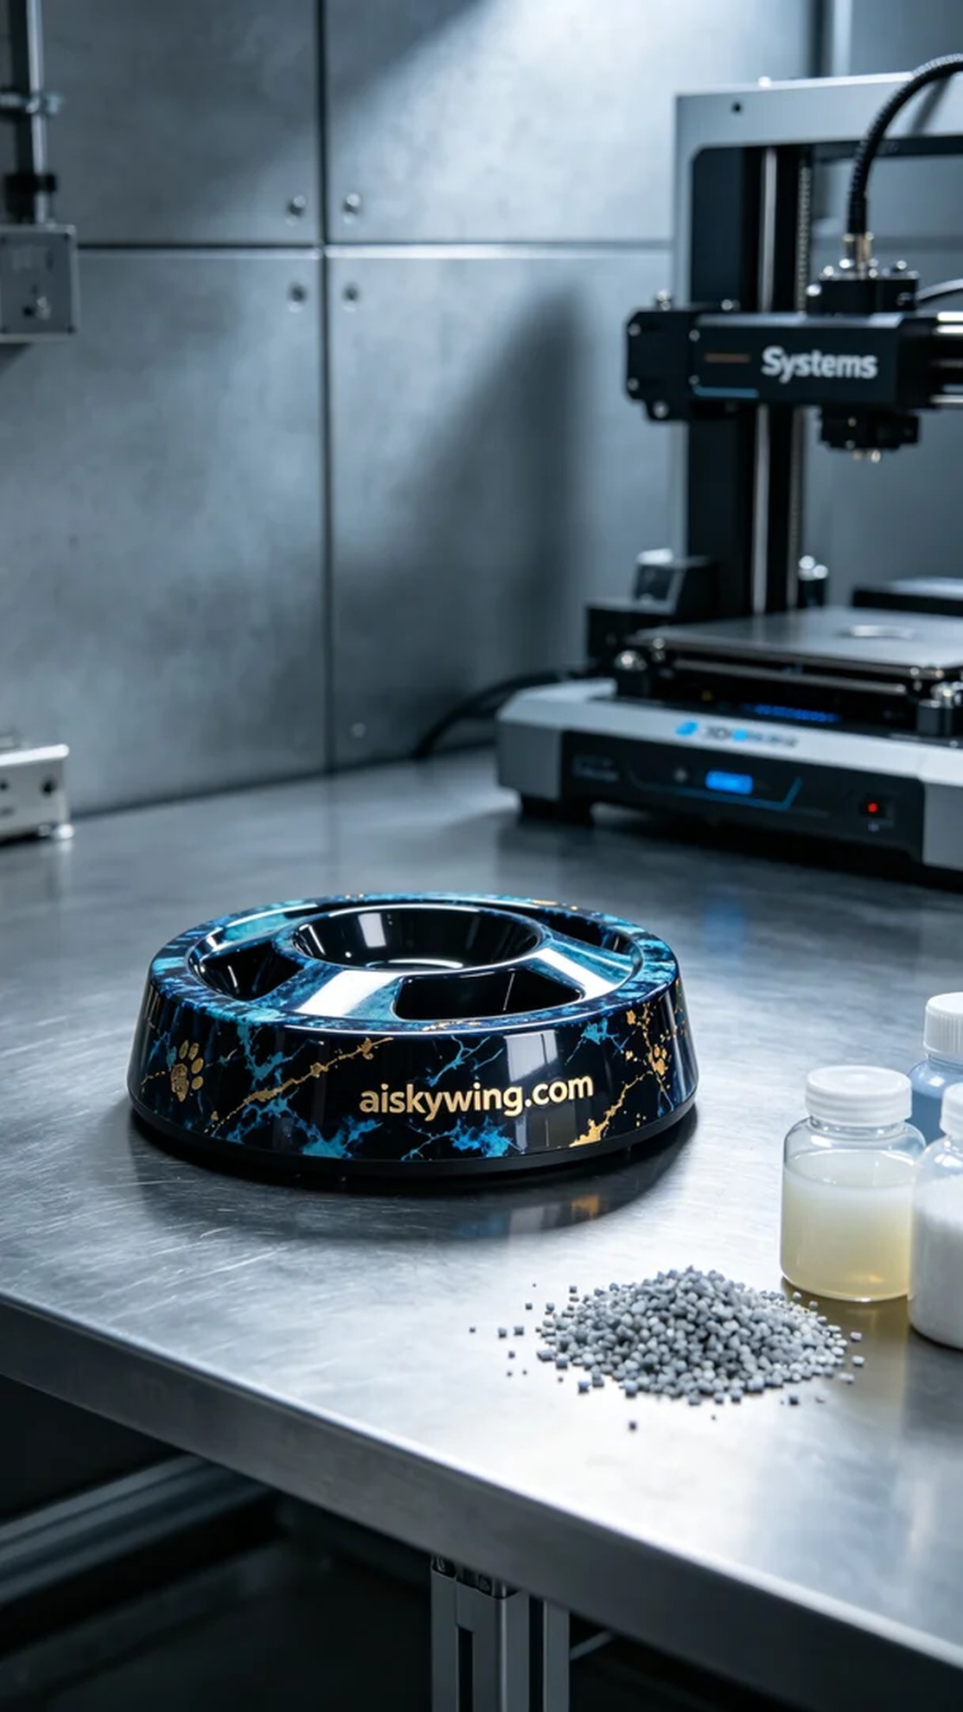
在Twitter上，有人因为寻找一款高质量的宠物自动逗猫棒底座而联系了我们。他们希望能够得到一个既耐用又美观的产品，能在家庭环境中吸引宠物的注意力。为此，我们决定采用SLA光固化工艺，确保打印精度和细腻度。
我们选用了优质的液态光敏树脂作为原材料，具备出色的流动性和固化性能，确保每个细节都能得到完美展现。准备工作包括对Systems品牌3D打印机进行校准，设置打印参数：层厚为0.05毫米，温度保持在20°C，功率设置为60mW，打印速度为30mm/s，预计打印时间为8小时。
在打印过程中，Systems打印机稳定运行，液态树脂在光照下逐层固化，形成底座的形状。我们全程监控打印质量，确保没有出现气泡或其他缺陷。每一层的呈现都极为清晰，显示出精细的雕刻细节，以及"aiskywing.com"字样的完美再现。
后处理工序同样重要。打印完成后，我们首先将成品置于清洗液中，去除表面的未固化树脂，然后使用细砂纸进行打磨，确保表面光滑，再经过 UV 固化设备固化，最后进行外观检验，确保产品符合预先设定的标准。
最终，经过严格的打印和后处理，我们顺利完成了这款宠物自动逗猫棒底座的制作。产品外观精致，功能完备，非常适合家庭使用，为宠物带来了乐趣。
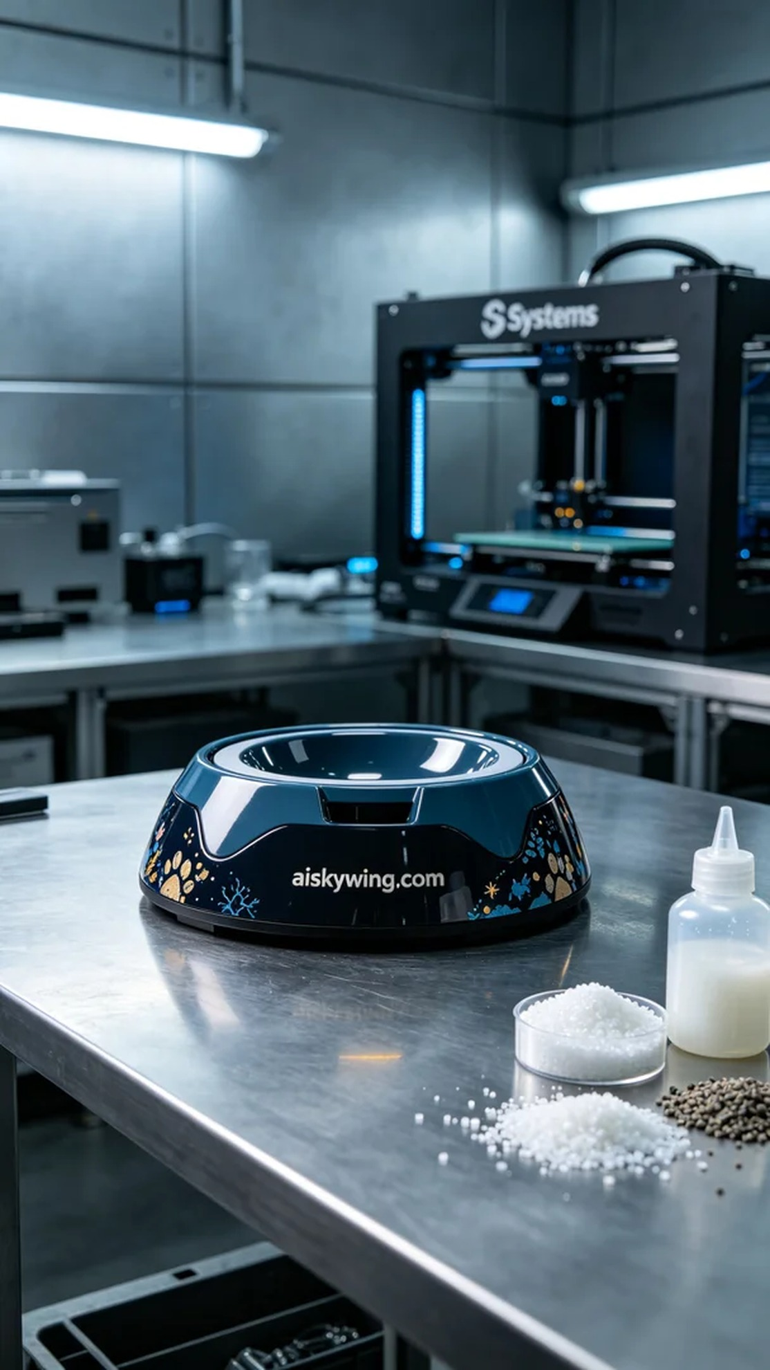
Aiskywing Industrial 3D Printing
Pet Automatic Cat Teaser Stick Base


