1095-冷敷硅胶袋的3D打印记录
Cold compress silicone bag
🖨️ 硅胶复模
🖥️ 打印机: Systems
📦 材料: 硅胶复模
在这个快节奏的时代，我们需要耐心去打磨每一个细节。就像有人在Facebook上找我们，要求制作这款冷敷硅胶袋一样，背后是对品质的追求。
In this fast-paced era, we need patience to refine every detail. Just like when someone reaches out to us on Facebook, requesting the production of this cold gel pack, it reflects a pursuit of quality behind it.
________________________________________________________________________________
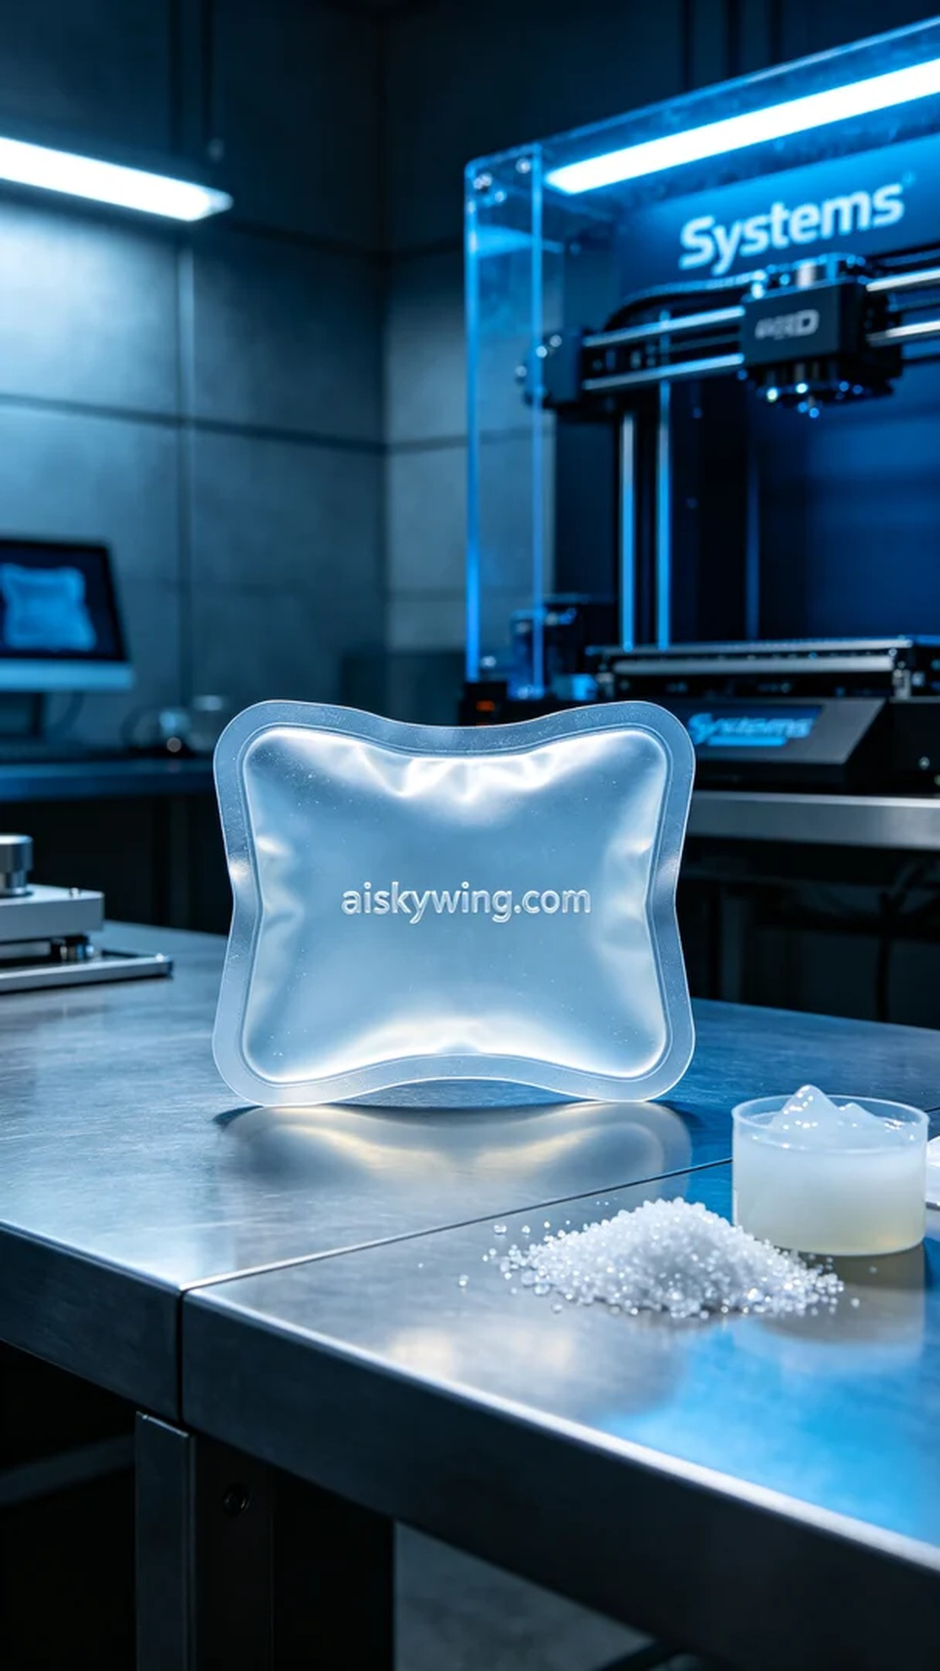
In this fast-paced world, we need patience to refine every detail. Just like when someone reached out to us on Facebook, asking for the production of this cold compress silicone bag, reflecting the pursuit of quality behind it.
The demand for this cold compress silicone bag originated from an individual looking to enhance product comfort and practicality. After seeing our work on Facebook, he decided to collaborate with us, aiming to create a product that better meets market needs using silicone molding technology.
We chose medical-grade silicone molding as the raw material due to its translucent, soft, and elastic properties, which effectively maintain cooling effects at low temperatures. For the equipment, we used the Systems brand 3D printer, setting the layer thickness to 0.1mm, printing temperature at 200 degrees Celsius, and keeping the power and speed within reasonable ranges, with an expected printing time of approximately 4 hours.
During the printing process, the Systems printer operated smoothly. Quality was monitored continuously to ensure each layer adhered properly and details remained crisp. Controlling ambient humidity and temperature was also crucial to maintain the stability of the silicone material, avoiding any defects.
After printing, we entered the post-processing stage. The formed silicone bags were first cleaned to remove any uncured residue from the surface. Then, we polished them to ensure a smooth finish. Following this, the bags were placed in a curing device to ensure the silicone fully hardened. Finally, we conducted rigorous quality inspections to ensure the products met usage standards.
Through this production, we not only completed the cold compress silicone bag but also reaffirmed the reliability and precision of the Systems printer, ultimately delivering high-quality products that met expectations.
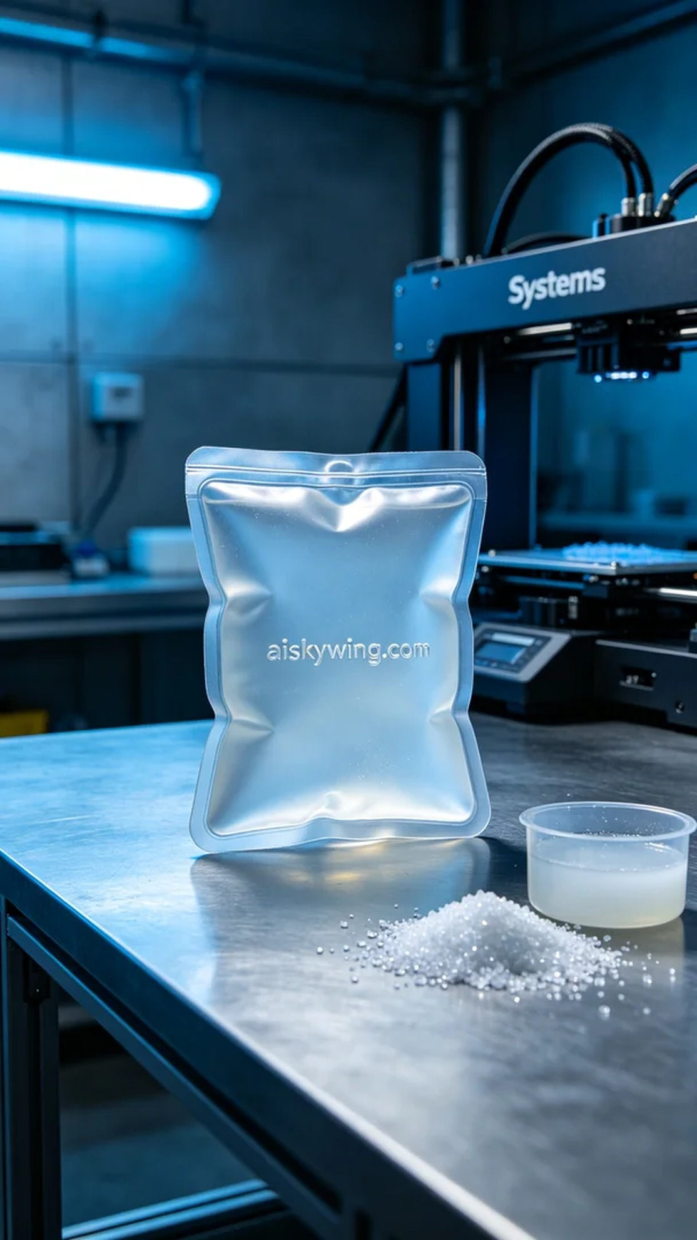
制作这款冷敷硅胶袋的需求来源于一位希望提高产品舒适度和实用性的人。他在Facebook上看到我们的作品后，决定找我们合作，期望能够通过硅胶复模技术，打造出更符合市场需求的产品。
我们选用医用级硅胶复模作为原材料，因其半透明、柔软且具有良好的弹性，能够在低温下有效保持冷敷效果。设备方面，我们使用的是Systems品牌的3D打印机，设置层厚为0.1毫米，打印温度控制在200摄氏度，功率和速度都在合理范围内，预计打印时间为4小时。
在打印过程中，Systems打印机的运行相当平稳。我们时刻监控打印质量，确保每一层的粘合效果和细节清晰度都达到预期。打印过程中，空气湿度和温度的控制也尤为重要，确保硅胶材料的稳定性，避免出现瑕疵。
完成打印后，进入后处理阶段。首先对成型的硅胶袋进行清洗，去除表面的未固化残留物，然后进行打磨，以确保表面光滑平整。接着，将其放入固化设备中，确保硅胶充分硬化，最后进行严格的质量检验，确保产品符合使用标准。
通过这次的制作，我们不仅完成了冷敷硅胶袋的生产，还再次验证了Systems打印机的可靠性与精密性，最终交付出符合客户期望的高品质产品。
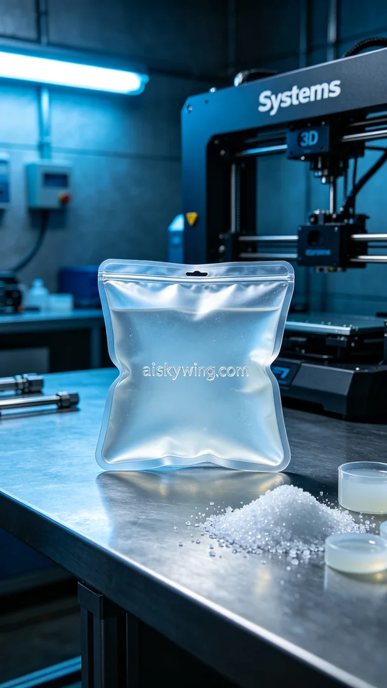
Aiskywing Industrial 3D Printing
Cold compress silicone bag


