1096-精细制作减速机密封垫
Sealing gasket for reducer
🖨️ 硅胶复模
🖥️ 打印机: Stratasys
📦 材料: 硅胶复模
生活就像3D打印，耐心和细心才能成就完美。这次有人找我们做一个减速机密封垫，要求很高，我们必须全力以赴。
Life is like 3D printing; patience and attention to detail are essential to achieving perfection. This time, someone has asked us to create a sealing gasket for a reducer, and the requirements are very high. We must give it our all.
________________________________________________________________________________
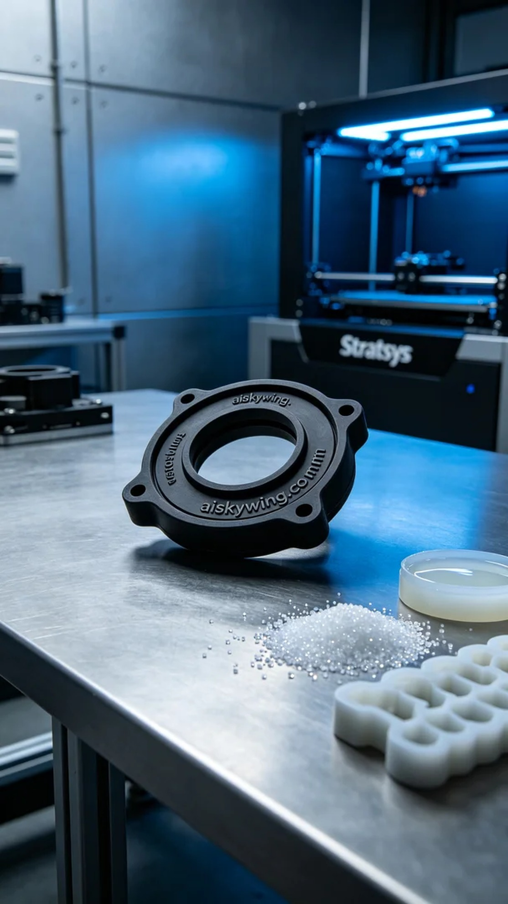
Life is like 3D printing; patience and attention to detail lead to perfection. Recently, someone approached us to create a gearbox sealing pad, with high standards we had to meet.
We used silicone molding material, known for its softness and durability, making it ideal for various sealing applications. In preparation, we focused on the properties of the material to ensure it had excellent flexibility and anti-slip texture. When setting the printing parameters on the Stratasys printer, we opted for a layer thickness of 0.1mm, maintained a printing temperature of 60 degrees Celsius, set the power to 80%, and chose a printing speed of 30mm/s, with an estimated printing time of 3 hours.
During the printing process, the Stratasys printer operated steadily, producing each layer with clarity. We continuously monitored the machine’s performance to ensure print quality. Throughout this process, maintaining the right temperature and humidity in the environment was crucial to prevent material moisture from affecting the printing results.
Post-processing was equally important. After printing, we started with cleaning to remove excess resin, followed by sanding to ensure a smooth surface. Then, we cured the material to enhance the strength and durability of the silicone. Finally, we inspected the sealing pad for dimensions and sealing effectiveness to ensure every detail met the required standards.
Through this production, we successfully crafted a high-quality gearbox sealing pad, fulfilling the needs of our partner and ensuring the machinery can operate smoothly. This is the true essence of our work.
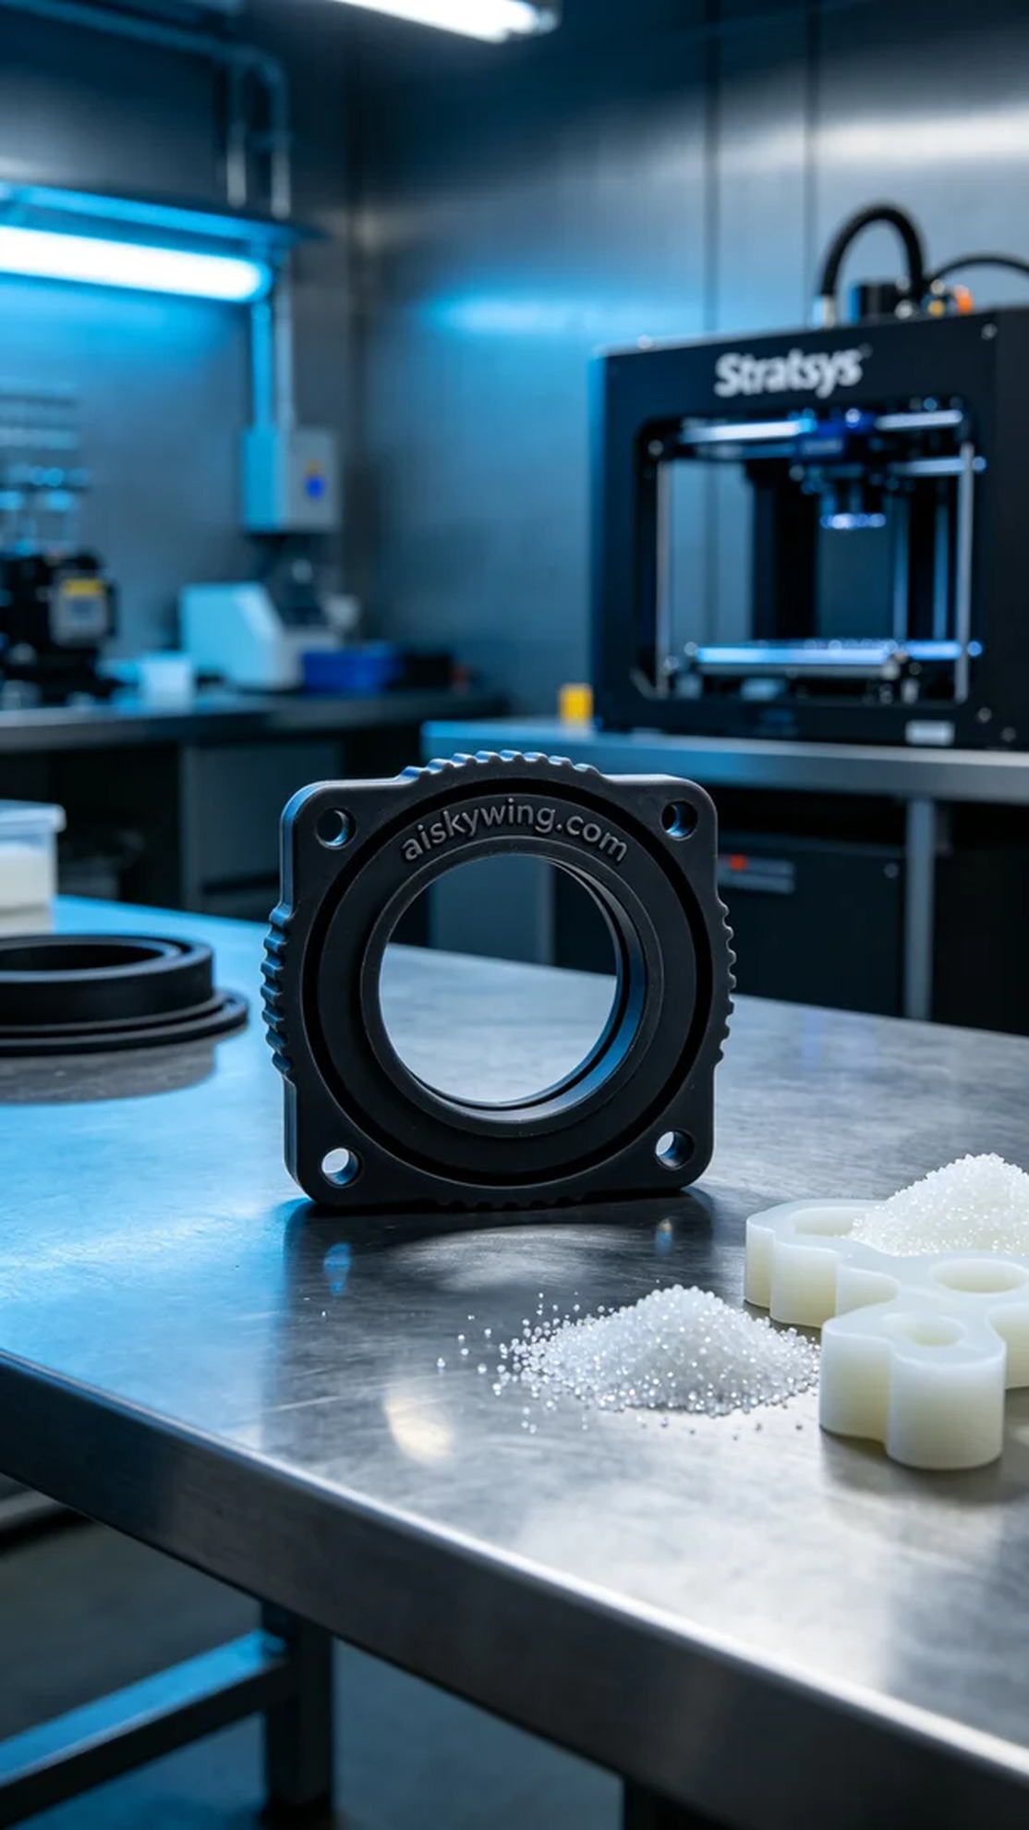
在Instagram上，有人因为机器漏油的问题找到我们，希望定制一个减速机密封垫。这款产品在功能和外观上都有很高的要求，必须具备良好的密封性和耐用性，以适应工业环境的挑战。
我们使用的是硅胶复模材料，这种材料柔软而耐用，适合制作各种密封件。准备工作中，我们从材料的特性入手，确保选择的硅胶复模具备优良的柔性和防滑纹理。设定打印参数时，我们使用Stratasys打印机，层厚设定为0.1mm，打印温度保持在60摄氏度，功率设定在80%，打印速度为30mm/s，预计打印时间为3小时。
打印过程中，Stratasys打印机稳定地运行，输出的每一层都清晰可见。我们时刻监控机器的工作状态，确保打印质量。在这个过程中，保持环境温度和湿度也是至关重要的，以防止材料受潮影响打印效果。
后处理工序同样重要。在完成打印后，首先进行清洗，去除多余的树脂，接着进行打磨，确保表面光滑。然后进行固化处理，以增强硅胶的强度与耐久性。最后，根据标准检验密封垫的尺寸和密封效果，确保每一个细节都达到要求。
通过这次的生产，我们成功制作出了高质量的减速机密封垫，客户的需求得到了满足，工业设备也因此能正常运转。这就是我们工作的意义所在。
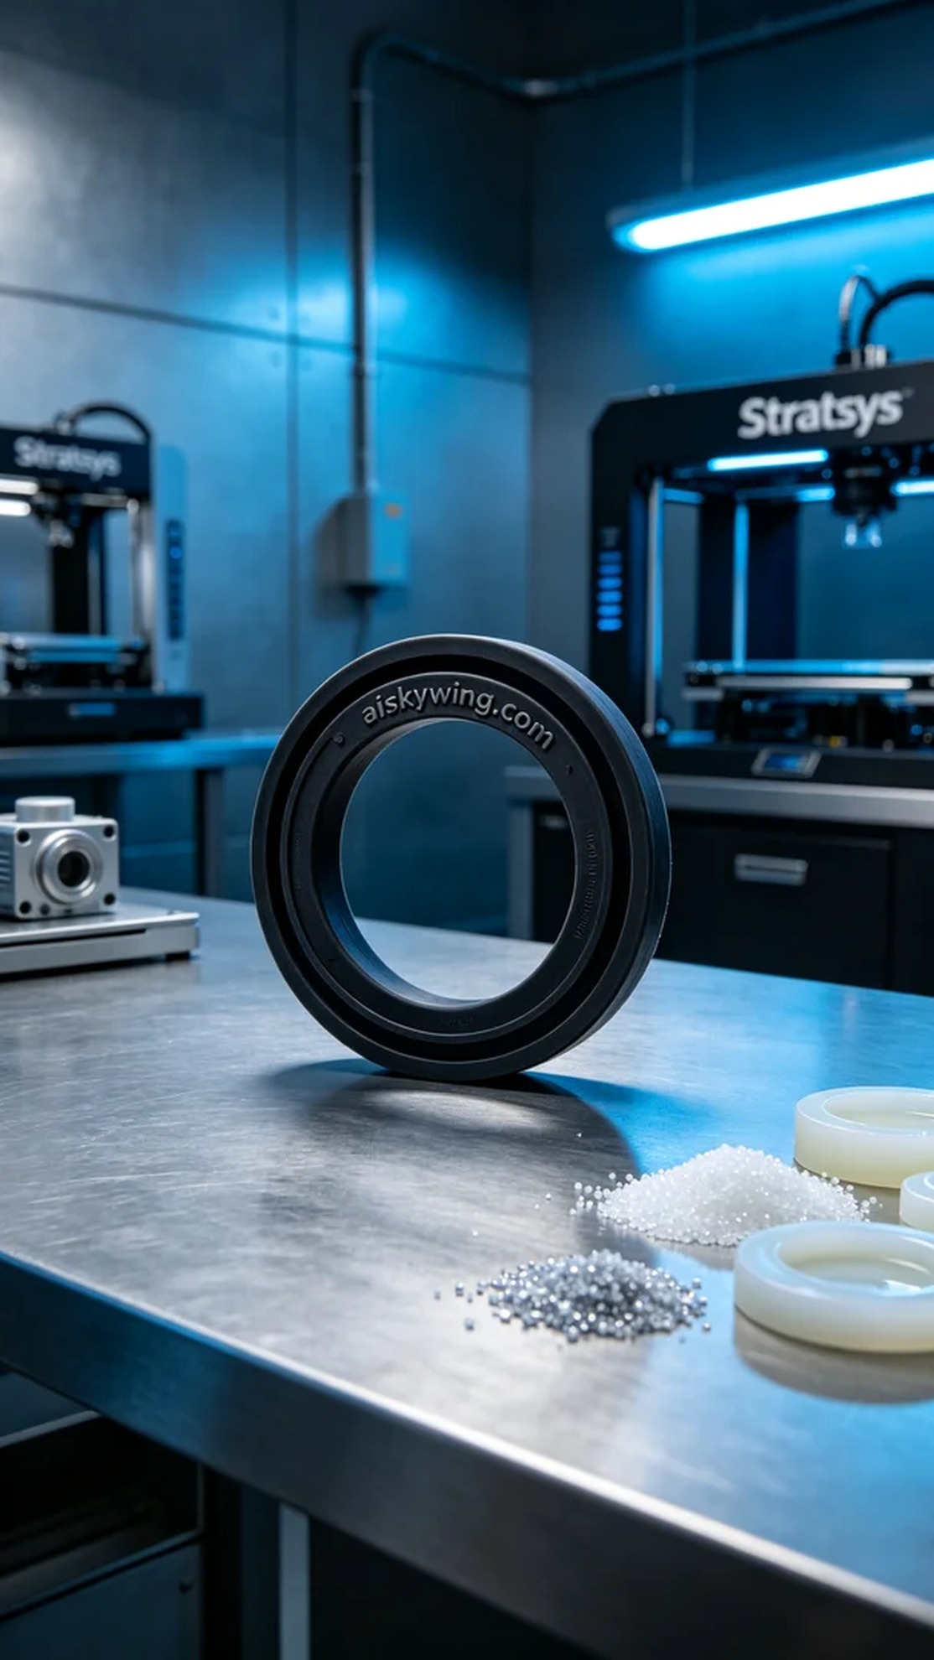
Aiskywing Industrial 3D Printing
Sealing gasket for reducer


