1097-刮痧硅胶板的3D打印生产记录
Gua Sha Silicone Board
🖨️ 硅胶复模
🖥️ 打印机: EOS
📦 材料: 硅胶复模
在生活的每个阶段，我们都在努力追求更好的自己。就像这次接到的刮痧硅胶板项目，有人希望通过它找到身体的舒适和放松。
In every stage of life, we strive to become a better version of ourselves. Just like with the recent project involving the guasha silicone board, some people hope to find comfort and relaxation for their bodies through it.
________________________________________________________________________________
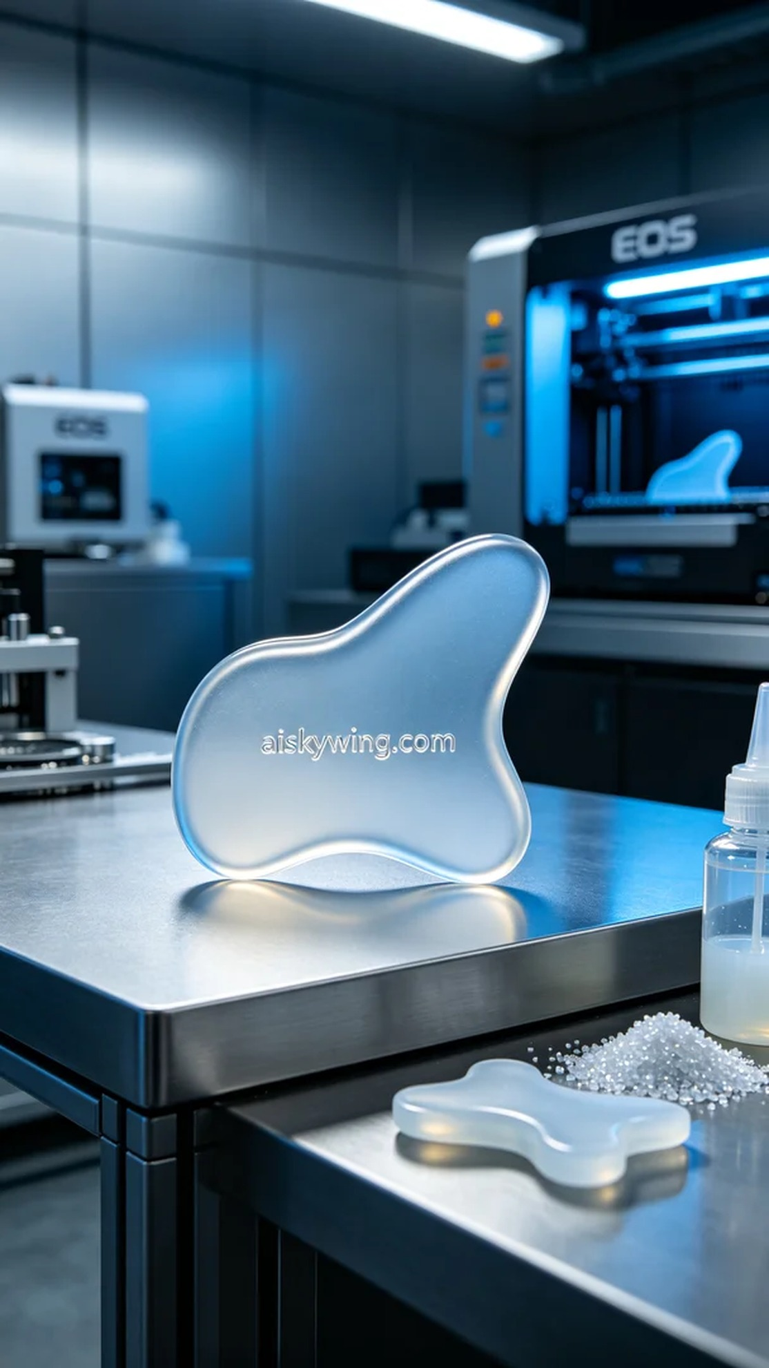
People saw the benefits of guasha on YouTube and approached us to customize a guasha silicone board to help relieve fatigue for themselves and their families. We immediately began processing this task to ensure it was both functional and aesthetically pleasing.
In the preparation phase, we chose silicone molding materials, known for their transparent and soft characteristics, which perfectly fit the ergonomic design. We used an EOS printer, setting a layer thickness of 0.1mm, with a printing temperature of 25°C, a power output of 80%, and a printing speed of 50mm per second, expecting the print to take around 4 hours.
During the printing process, the EOS printer operated steadily, and the equipment's temperature and humidity levels remained within the normal range. We closely monitored the printing quality to ensure every layer displayed clear detail. After several hours of meticulous output, the guasha silicone board was perfectly formed.
In the post-processing phase, we first placed the finished product in an ultrasonic cleaner to remove surface residues and impurities. Next, we carefully polished it to ensure smooth edges and a pleasant feel. We then used UV light for curing to enhance its durability, and finally conducted a comprehensive inspection of the product to ensure there were no defects.
Through this process, we delivered a beautiful and practical guasha silicone board, supporting a journey of comfort and relaxation.
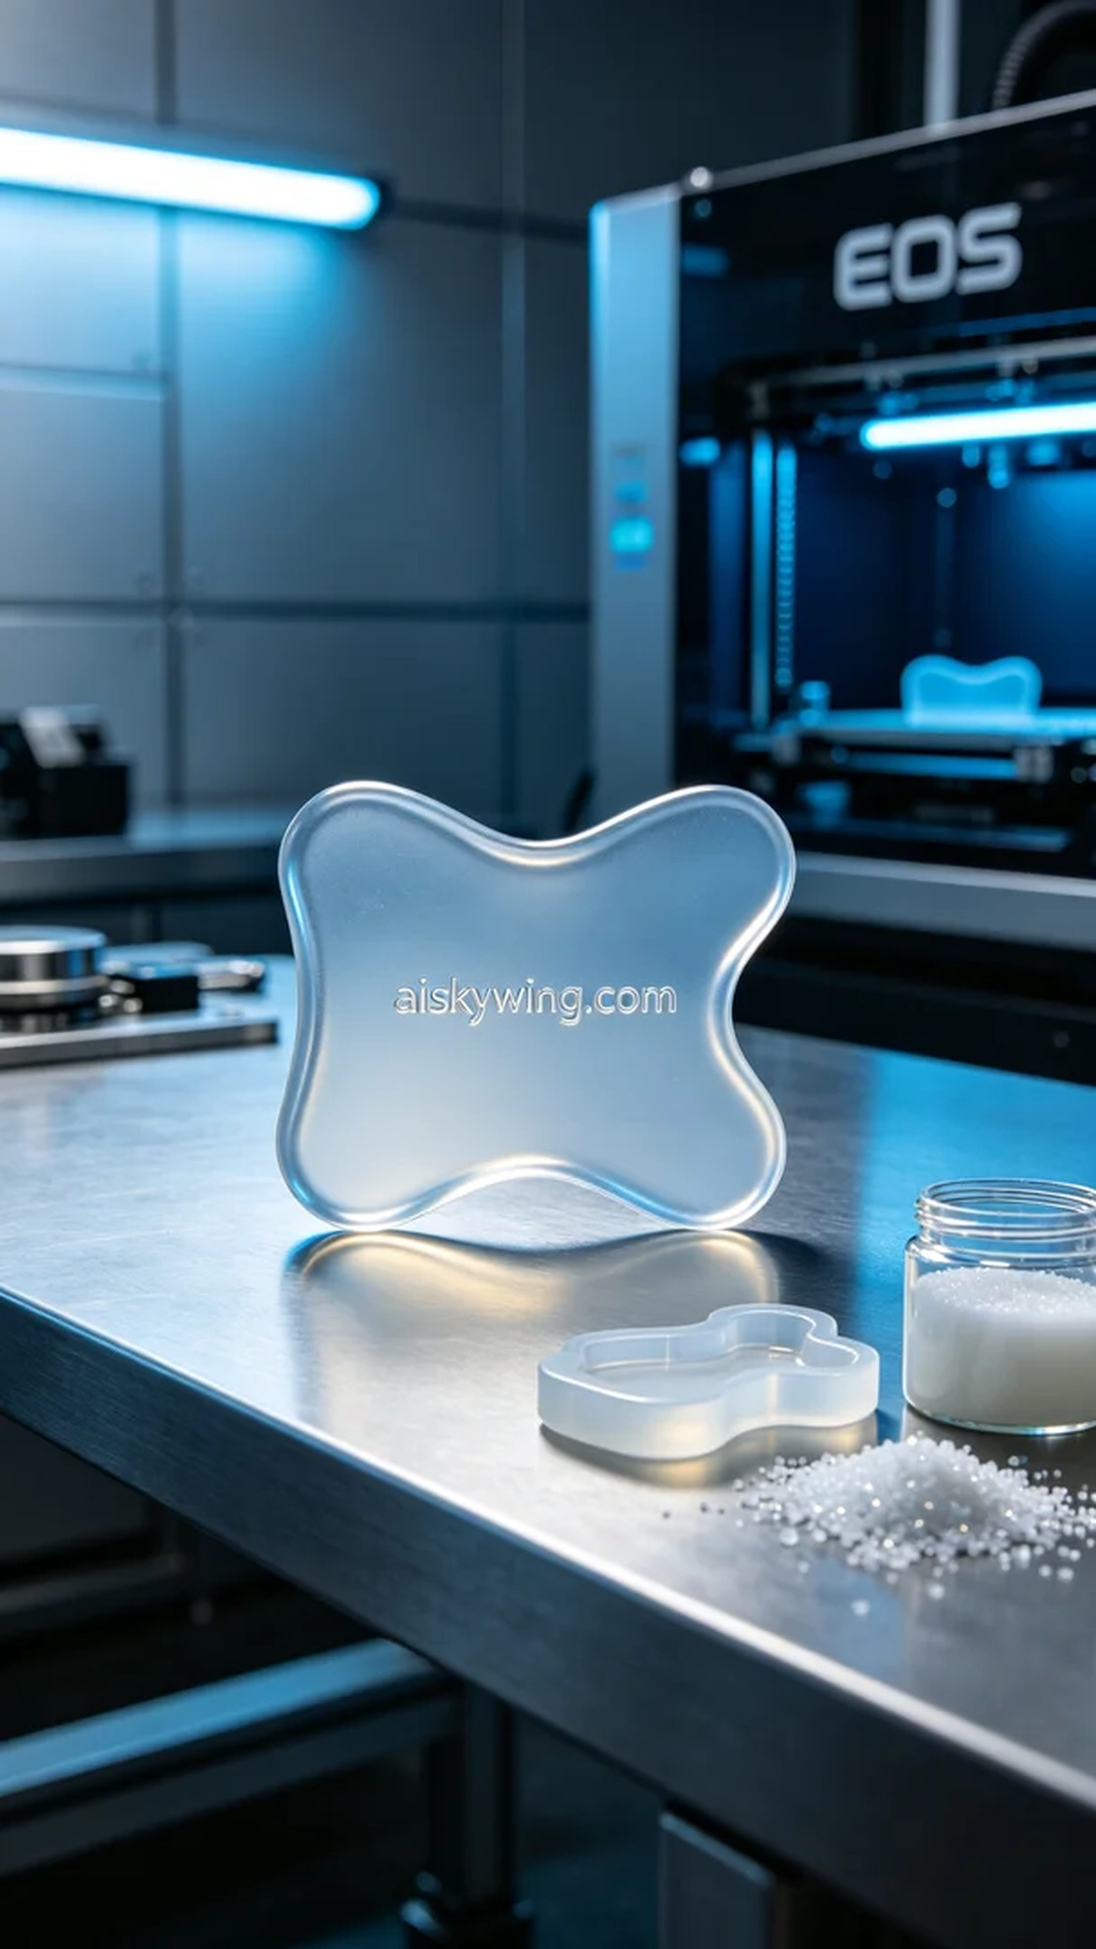
有人在YouTube上看到刮痧的好处，特意找上我们，希望能定制一款刮痧硅胶板，以帮助自己和家人缓解身体疲劳。我们立刻着手处理这个任务，确保它的功能与美观兼具。
在准备工作中，我们选用了硅胶复模材料，这种材料具有透明且柔软的特性，能很好地贴合人体工程学设计。我们使用的EOS打印机，设置了0.1毫米的层厚，打印温度保持在25摄氏度，功率为80%，打印速度设定为50毫米每秒，预计打印时间为4小时。
打印过程中，EOS打印机稳定运行，设备的温度与湿度指标均在正常范围内。我们全程对打印质量进行监控，确保每一层的细节都能清晰展现。经过几个小时的耐心输出，刮痧硅胶板终于完美成型。
后处理阶段，我们首先将成品放入超声波清洗机中，去除表面的残留物和杂质。之后进行细致的打磨，使其边缘光滑，手感极佳。接着，使用紫外线灯进行固化，增强其耐用性，最后对成品进行全面检验，确保没有瑕疵。
通过这样的过程，最终呈现出一个既美观又实用的刮痧硅胶板，助力在舒适与放松的旅程中前行。
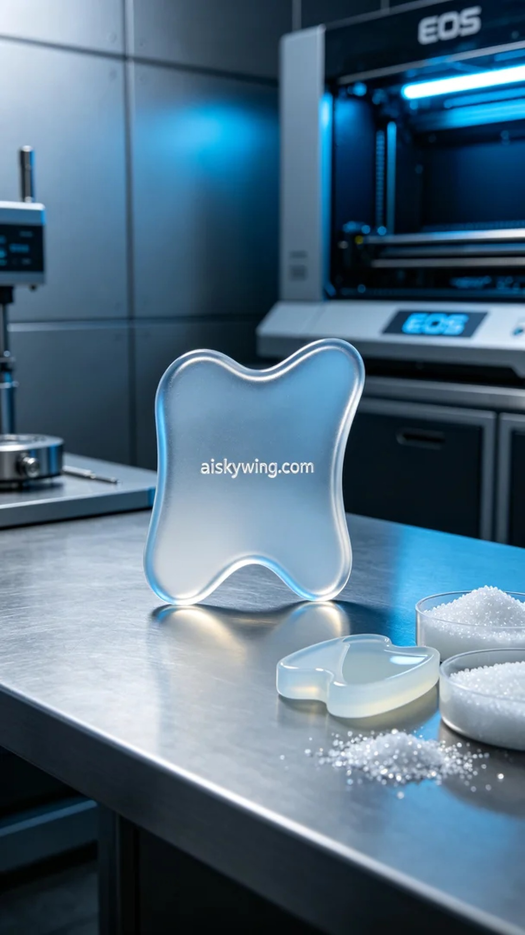
Aiskywing Industrial 3D Printing
Gua Sha Silicone Board


