1098-助听器硅胶管生产记录
Hearing aid silicone tube
🖨️ 硅胶复模
🖥️ 打印机: Carbon
📦 材料: 硅胶复模
在Twitter上，有人因为助听问题向我们求助，这促使我们开始了助听器硅胶管的生产。这是一次技术与关怀的结合。
On Twitter, someone reached out to us for help with hearing aid issues, which prompted us to start the production of silicone tubes for hearing aids. This is a combination of technology and care.
________________________________________________________________________________
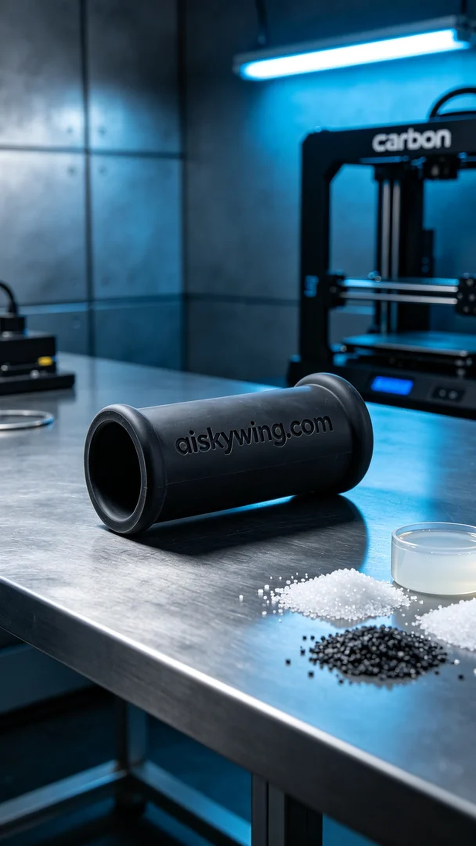
First, material selection is crucial. For this project, we utilized silicone molding material, which is soft and durable, making it perfect for the design needs of hearing aids. To ensure product quality, we chose the Carbon 3D printer, known for its precision and efficiency. To print the perfect silicone tube, we set a layer thickness of 0.1 mm, a temperature of 25 degrees Celsius, a power of 80%, and a print speed of 50 mm per second, with an estimated print time of 3 hours.
During the printing process, the efficient operation of the Carbon printer was reassuring. As each layer gradually built up, the shape of the silicone tube began to take form. We maintained constant monitoring of the equipment to ensure no defects occurred. Throughout the printing, the noise and vibrations of the machine remained within acceptable limits, and the quality monitoring system reported a good printing status.
Once the printing was complete, we moved into the post-processing phase. First, we thoroughly cleaned the finished product with water and a specialized cleaning agent to remove any residual uncured resin from the surface. Next, we meticulously polished the silicone tube to ensure a smooth surface, preventing any potential wear. Then, we placed it in a curing device for appropriate light curing treatment to enhance its strength and durability. Lastly, we conducted strict quality inspections to ensure each silicone tube met the standards.
After this series of processes, we successfully produced high-quality silicone tubes for hearing aids. This is not only a demonstration of technology but also a commitment to every person in need of assistance.
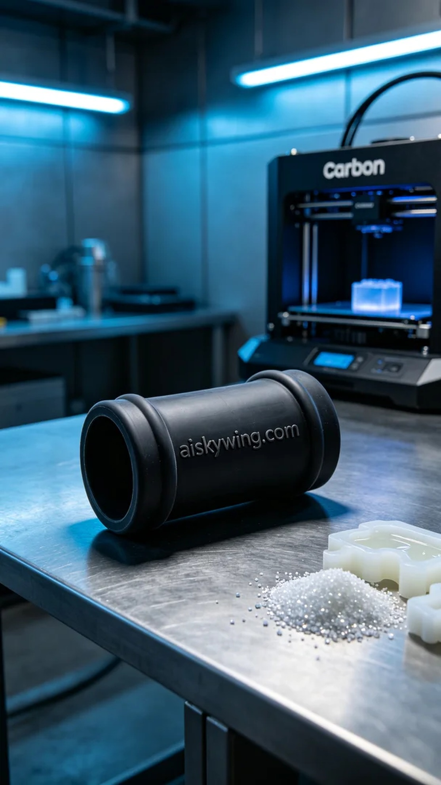
首先，材料的选择至关重要。这次我们使用的是硅胶复模材料，其柔软耐用的特性非常适合助听器的设计需求。为了确保产品的品质，我们选择了Carbon品牌的3D打印机，这款设备以其高精度和高效率而闻名。为了打印出完美的硅胶管，我们设置了层厚为0.1毫米，温度为25摄氏度，功率为80%，打印速度为50毫米每秒，整个打印过程预计需时3小时。
在打印过程中，Carbon打印机的高效运行让人欣慰。随着每一层的逐步叠加，硅胶管的形状逐渐显现。我们始终保持对设备的监控，确保没有任何瑕疵出现。打印过程中，设备的噪音和震动都在可接受范围内，质量监测系统也实时反馈了良好的打印状态。
一旦打印完成，我们进入了后处理工序。首先，我们使用清水和专用清洗剂对成品进行了彻底清洗，去除表面残留的未固化树脂。接下来，我们对硅胶管进行了细致打磨，确保表面光滑，避免任何可能的磨损。随后，我们将其放入固化设备中，进行了适当的光固化处理，以增强其强度和耐用性。最后，我们进行了严格的质量检验，确保每一条硅胶管都达到标准。
经过这一系列流程，我们成功地生产出了高质量的助听器硅胶管。这不仅是技术的体现，更是对每一位需要帮助的人的一种承诺。
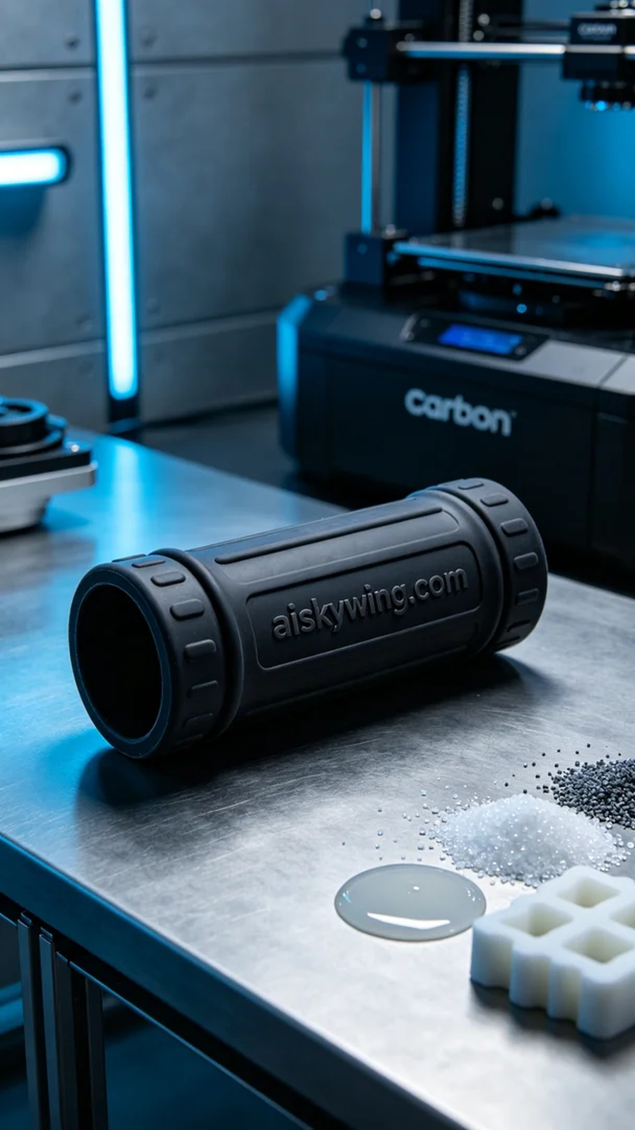
Aiskywing Industrial 3D Printing
Hearing aid silicone tube


