1099-助听器硅胶耳模生产记录
Hearing aid silicone ear mold
🖨️ 硅胶复模
🖥️ 打印机: Mimaki
📦 材料: 硅胶复模
生活中的小细节，常常能改变大局。就像有人在Instagram上找我们，希望定制这款助听器硅胶耳模，以解决听力问题。
The small details in life often have the power to change the bigger picture. Just like when someone reaches out to us on Instagram, hoping to customize this silicone ear mold for hearing aids to address their hearing issues.
________________________________________________________________________________
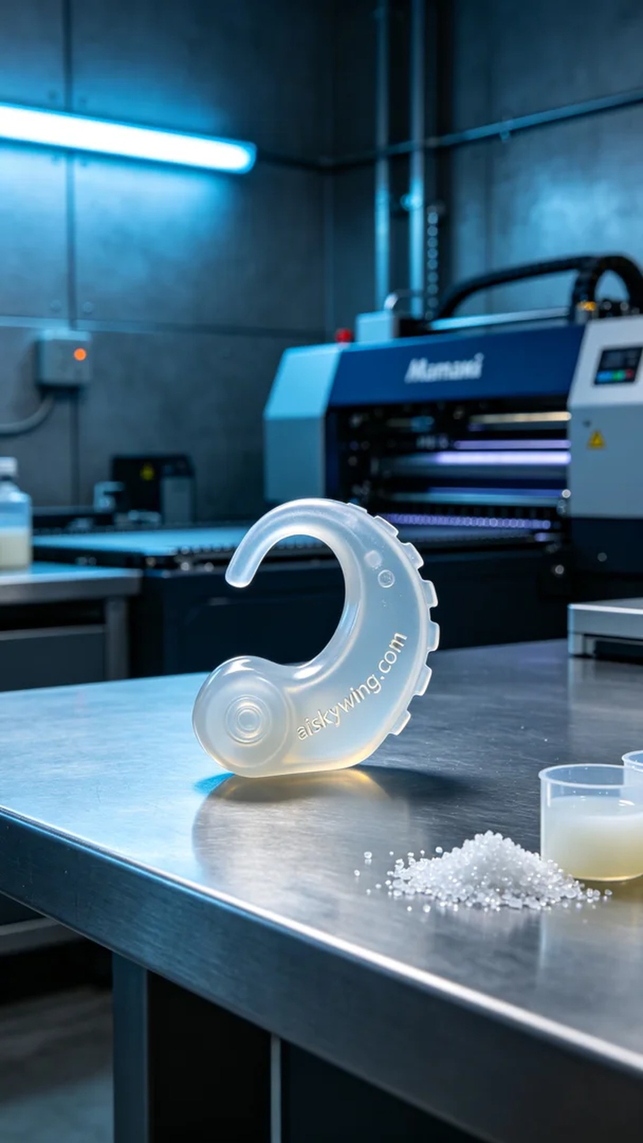
In this fast-paced world, someone reached out to us on Instagram, seeking a customized hearing aid silicone ear mold to enhance their hearing experience. To meet this need, we decided to initiate the silicone molding production process.
The raw material we used is medical-grade silicone molding, which possesses a translucent, soft, and elastic quality to ensure comfort when worn. During the preparation phase, we selected the Mimaki brand 3D printer and set the parameters to a layer thickness of 0.1mm, a printing temperature of 25℃, a power of 80%, and a printing speed of 50mm/s to ensure the quality and precision of the final product.
Throughout the printing process, the Mimaki printer performed exceptionally well as the liquid photopolymer resin gradually stacked layer by layer to form the silicone ear mold. We monitored the operation of the equipment continuously to ensure every detail met our expectations, especially the clarity of the engraved text "aiskywing.com" on the surface.
After printing, we entered the post-processing phase. We first cleaned the molded ear piece to remove any uncured resin on the surface. Then, we carefully sanded the edges to ensure a smooth finish, followed by placing the mold in a curing chamber to enhance its strength and durability. Finally, we conducted strict inspections on each ear mold to ensure they met medical standards.
After a series of meticulous processes, this hearing aid silicone ear mold was successfully completed. We feel immensely gratified to help someone improve their hearing.
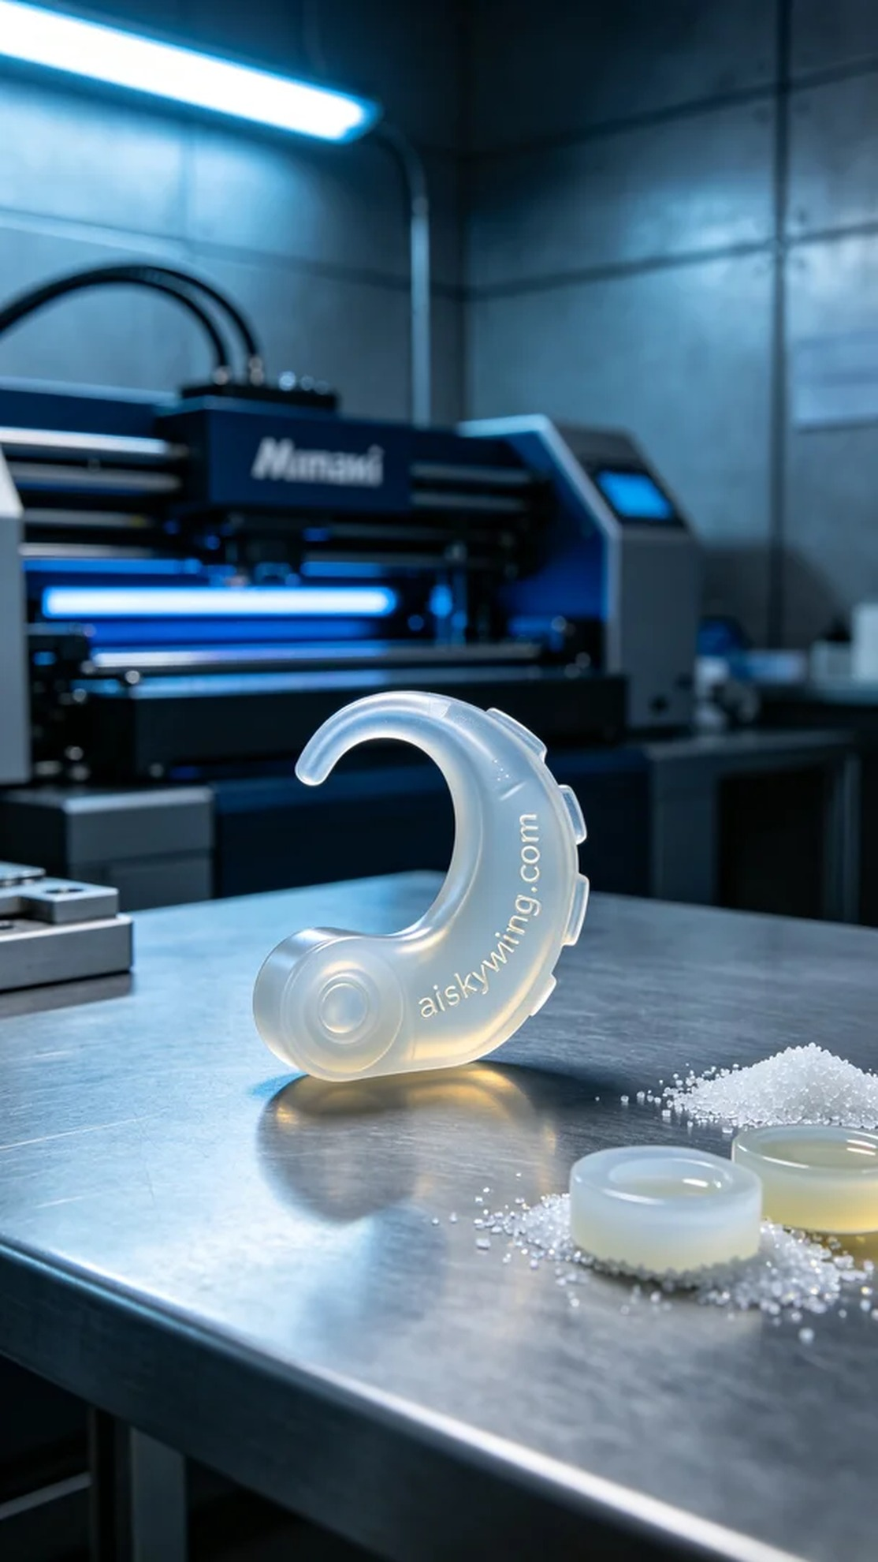
在这个快节奏的时代，有人通过Instagram向我们求助，希望定制一款助听器硅胶耳模，以帮助改善他们的听力体验。为了满足这个需求，我们决定启动硅胶复模的生产流程。
我们使用的原材料是医用级硅胶复模，这种材质具有半透明、柔软弹性的特点，确保佩戴舒适。准备工作中，我们选择了Mimaki品牌的3D打印机，并设置参数为0.1mm的层厚，打印温度为25℃，功率为80%，打印速度则定在50mm/s，以确保成品的质量和精确度。
在打印过程中，Mimaki打印机的表现相当稳定，随着液态光敏树脂的逐层堆积，助听器硅胶耳模逐渐成型。我们全程监控设备运行情况，确保每个细节都能达到预期的标准，特别是对于表面雕刻“aiskywing.com”字样的清晰度要求。
打印完成后，我们进入后处理环节。首先对成型的耳模进行清洗，以去除表面的未固化树脂。随后，我们会小心地进行打磨，确保边缘光滑，最后将耳模放入固化箱中进行固化，确保材料的强度和耐用性。最后，我们对每一个耳模进行严格检验，确保它们符合医疗标准。
经过一系列精细的工序，这款助听器硅胶耳模顺利诞生。能够帮助有人改善听力，我们也感到无比欣慰。
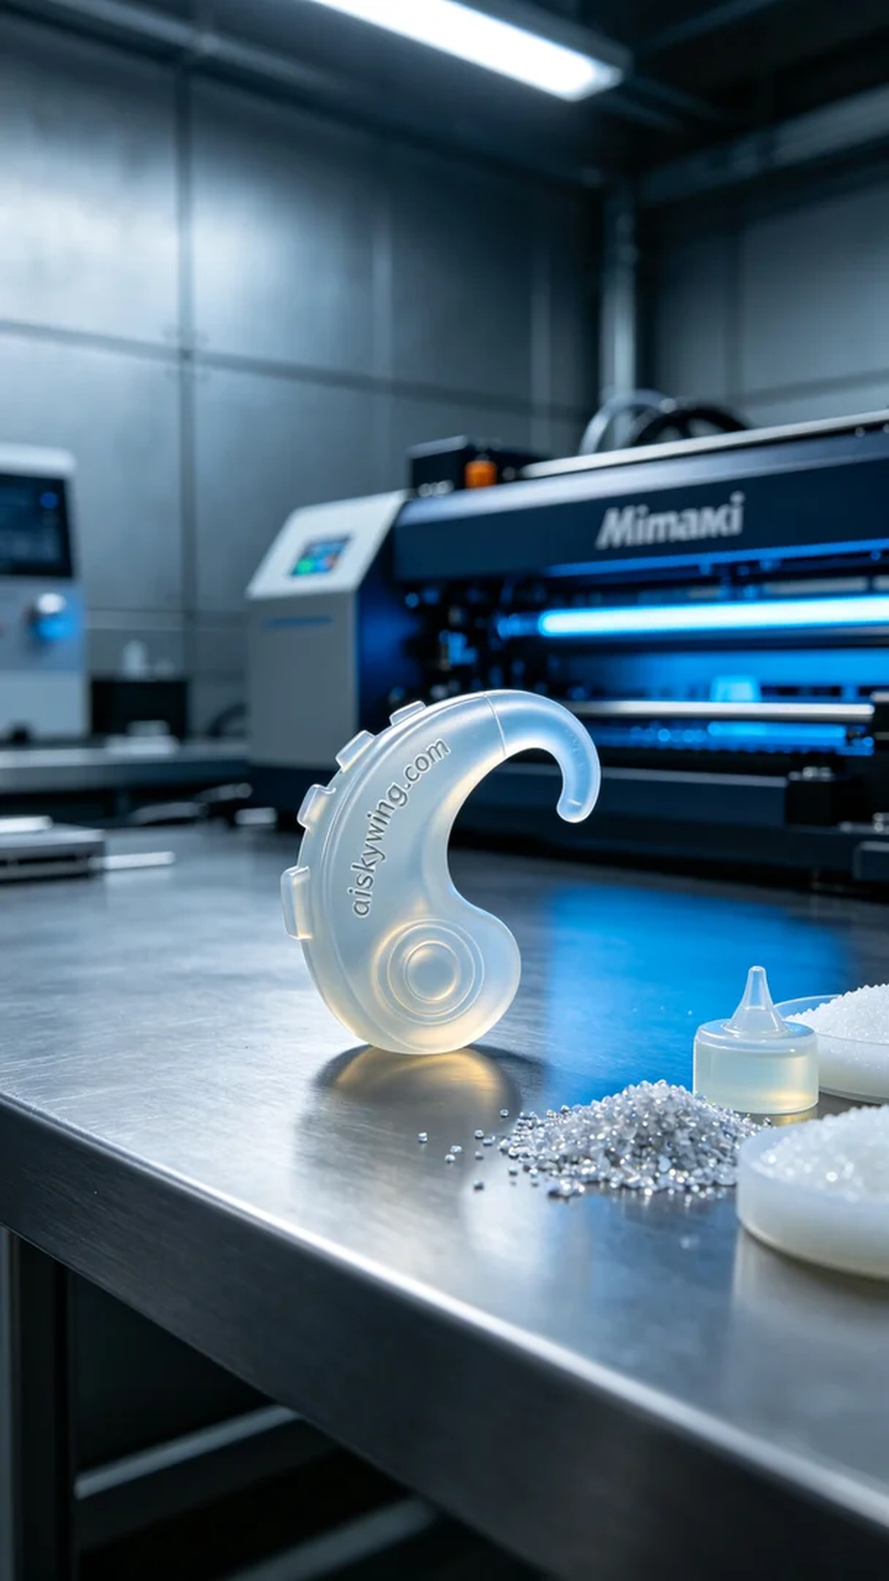
Aiskywing Industrial 3D Printing
Hearing aid silicone ear mold


