1100-医用导管连接件3D打印生产记录
Medical catheter connector
🖨️ 硅胶复模
🖥️ 打印机: Voxeljet
📦 材料: 硅胶复模
生活再难，也别停下脚步。就像接下这个医用导管连接件的单子，朋友在WhatsApp上跟我说急需解决方案。
No matter how difficult life gets, don't stop moving forward. Just like when I took on the order for this medical catheter connector; a friend messaged me on WhatsApp saying they urgently needed a solution.
________________________________________________________________________________
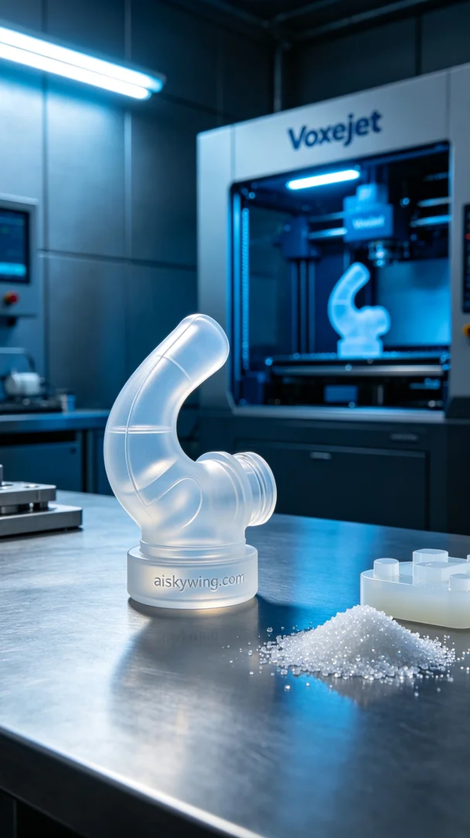
Life can be tough, but we should never stop moving forward. Just like when we received a message on WhatsApp from a friend in urgent need of a medical catheter connector.
For this project, we chose silicone casting as the raw material. This material is transparent and flexible, making it ideal for medical applications. We used the Voxeljet 3D printer, setting the parameters to a layer thickness of 0.1 mm, a working temperature of 25°C, a power of 120W, a speed of 20mm/s, with an expected total print time of around 3 hours.
During the printing process, the machine operated smoothly while we monitored the quality in real-time to ensure each detail met our expectations. The noise level was acceptable, which gave us peace of mind. As the print progressed, the outline of the catheter connector gradually emerged, building everyone's anticipation.
Once the printing was completed, we moved on to the post-processing phase. The printed piece was first cleaned with a solution to remove excess material from the surface. Then, we carefully hand-sanded it to achieve a smoother finish. After that, we placed the connector in a curing device to ensure its structural integrity met the required standards. Finally, after stringent inspections, we confirmed that every detail was up to standard, marking the project as officially completed.
After all the hard work, the medical catheter connector was successfully finished, meeting our friend's needs. Seeing the final product filled me with immense satisfaction, showcasing a perfect blend of friendship and technology.
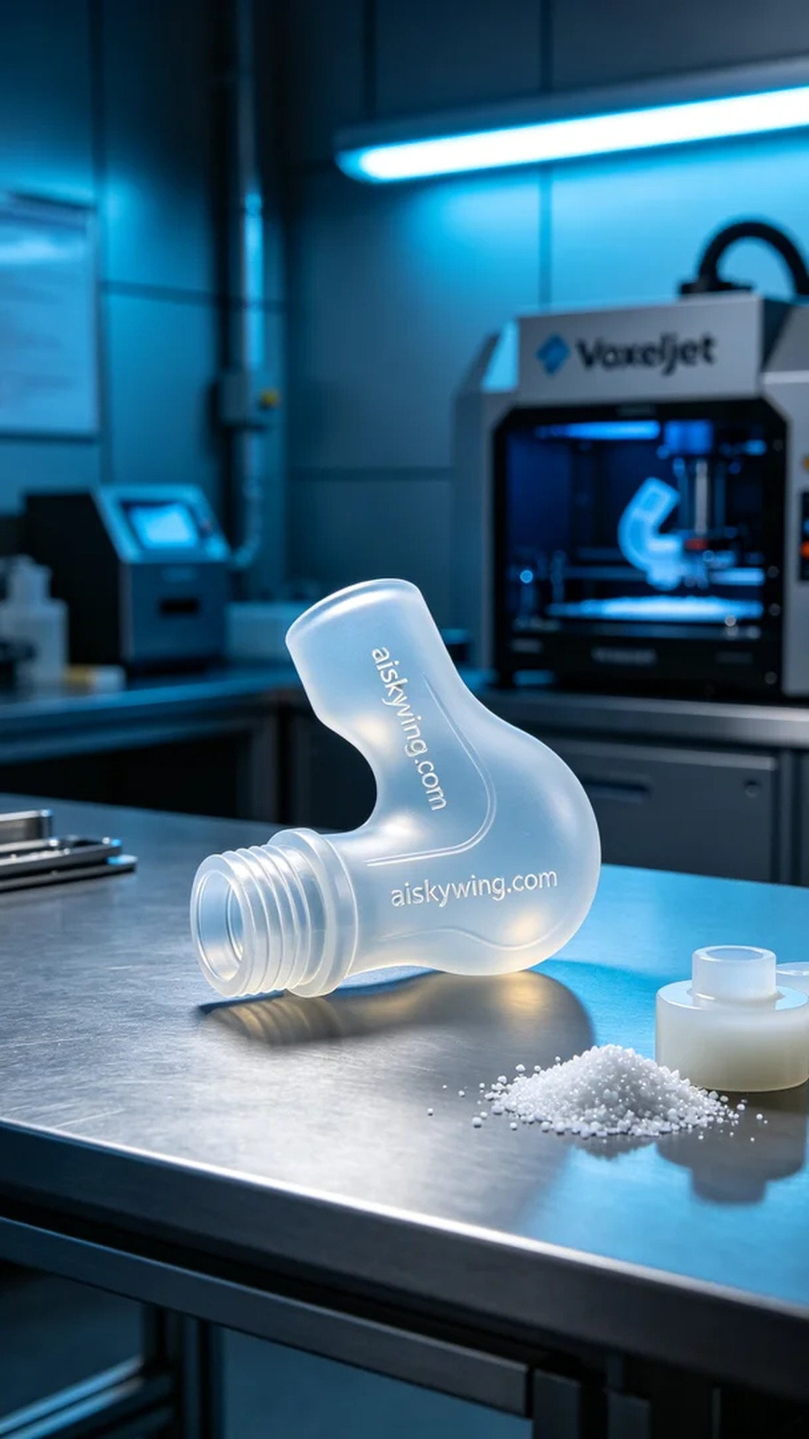
今天我们接到一个朋友的消息，他急需一款医用导管连接件，问题出在现有连接件的供货周期太长。于是我们决定使用3D打印技术来解决这个问题。
为了确保品质，我们选用了硅胶复模作为原材料。这种材料既透明又柔软，非常适合医用产品的需求。我们使用的是Voxeljet品牌的3D打印机，设置的参数包括层厚0.1毫米，工作温度为25°C，打印功率设为120W，速度为20mm/s，预计总打印时间在3小时左右。
打印过程中，设备运行相当稳定。我们实时监控打印质量，确保每个细节都能够达到预期效果。机器的噪音在可接受范围内，让我们都感到心安。随着打印的进行，导管连接件的轮廓逐渐显现，大家都充满期待。
完成打印后，我们进入了后处理工序。首先用清洗液对打印件进行清洗，去除表面的多余材料。接着，我们仔细地手工打磨，使表面更加光滑。然后将连接件放入固化设备中，确保其结构强度达到标准。最后，经过严格的检验，确认每一个细节都符合要求后，才算是正式完成。
经过一系列的努力，这个医用导管连接件终于顺利完成，达到了朋友的需求。看着成品，我心里感到无比欣慰，友谊加科技，真是个完美的结合。
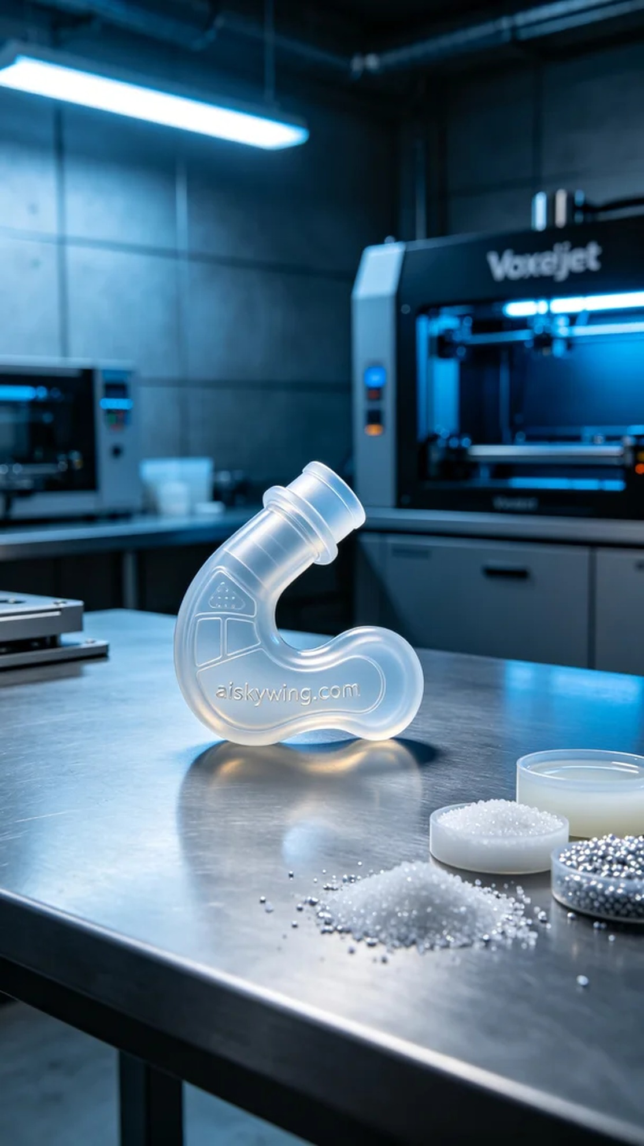
Aiskywing Industrial 3D Printing
Medical catheter connector


