1101-医用引流管3D打印生产记录
Medical drainage tube
🖨️ 硅胶复模
🖥️ 打印机: Xjet
📦 材料: 硅胶复模
生活的每一步都值得珍惜，就像在TikTok上看到的医用引流管项目一样，让我们一起解决现实中的难题，提升人们的生活质量。
Every step in life is worth cherishing, just like the medical drainage tube project seen on TikTok. Let's work together to solve real-life problems and improve people's quality of life.
________________________________________________________________________________
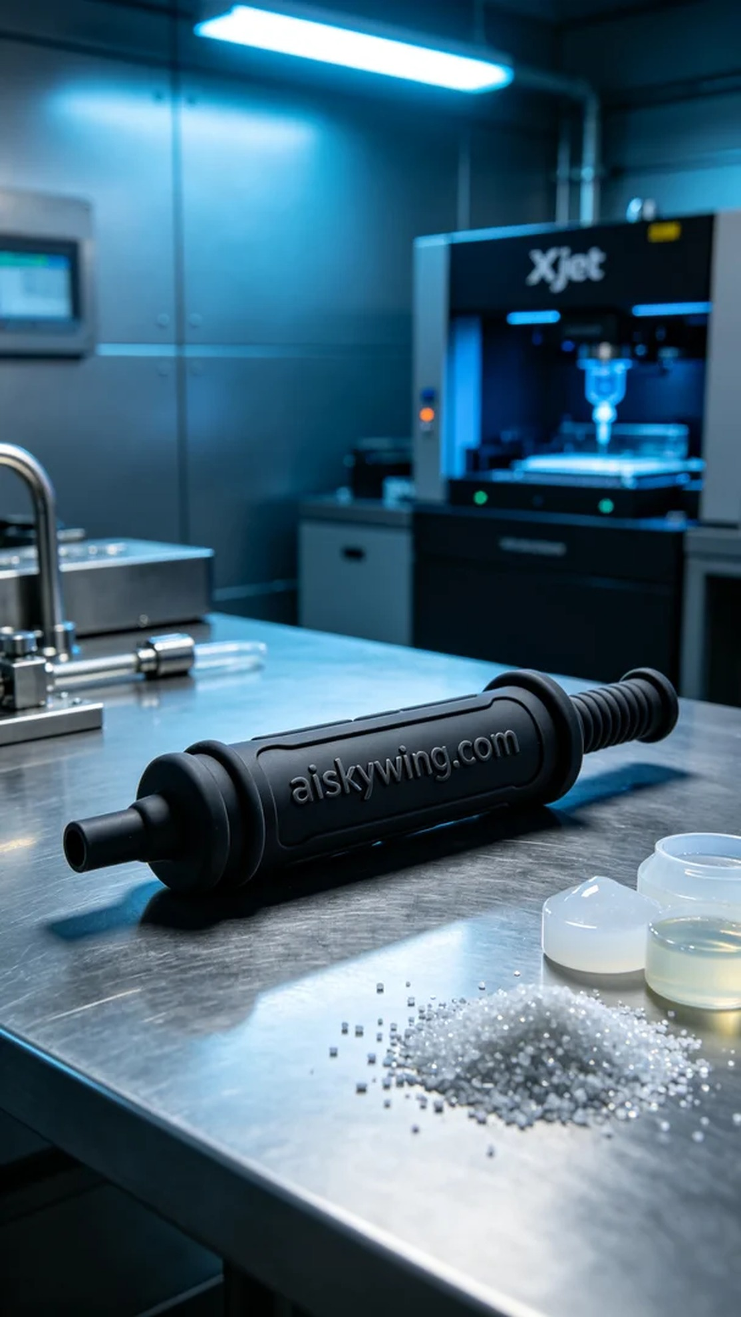
Recently, someone reached out to us with a medical need, looking to produce a high-quality drainage tube. This product not only needed to be durable but also flexible enough to adapt to various environments. We immediately set to work on this project.
To ensure the quality of the product, we selected silicone molding as the raw material. The softness and durability of silicone make it ideal for medical devices, providing excellent anti-slip properties during use. We then used an Xjet printer for the printing process, setting the layer thickness to 0.1mm, maintaining the printing temperature at 60 degrees Celsius, with a power of 200W and a speed of 50mm/s, with an estimated printing time of 4 hours.
During the printing process, we closely monitored the running status of the equipment to ensure that every detail met expectations. The performance of the Xjet printer was very stable, with no abnormalities occurring during the print. We were very pleased with the fine texture of the surface and the clear engraving of the text, and the silicone material adapted well during the forming process.
After printing, we conducted thorough post-processing procedures. First, we soaked the product in a cleaning solution to remove any excess photopolymer resin. Then, we used fine sandpaper for sanding to ensure a smooth surface. Next, the product was placed in a curing device for light curing, ensuring its durability and safety for use. Finally, we carefully inspected each finished product to ensure there were no defects.
After a series of meticulous procedures, the drainage tube was successfully completed and met the expected results. This not only showcases our technical capabilities but also reflects our commitment to improving the quality of healthcare.
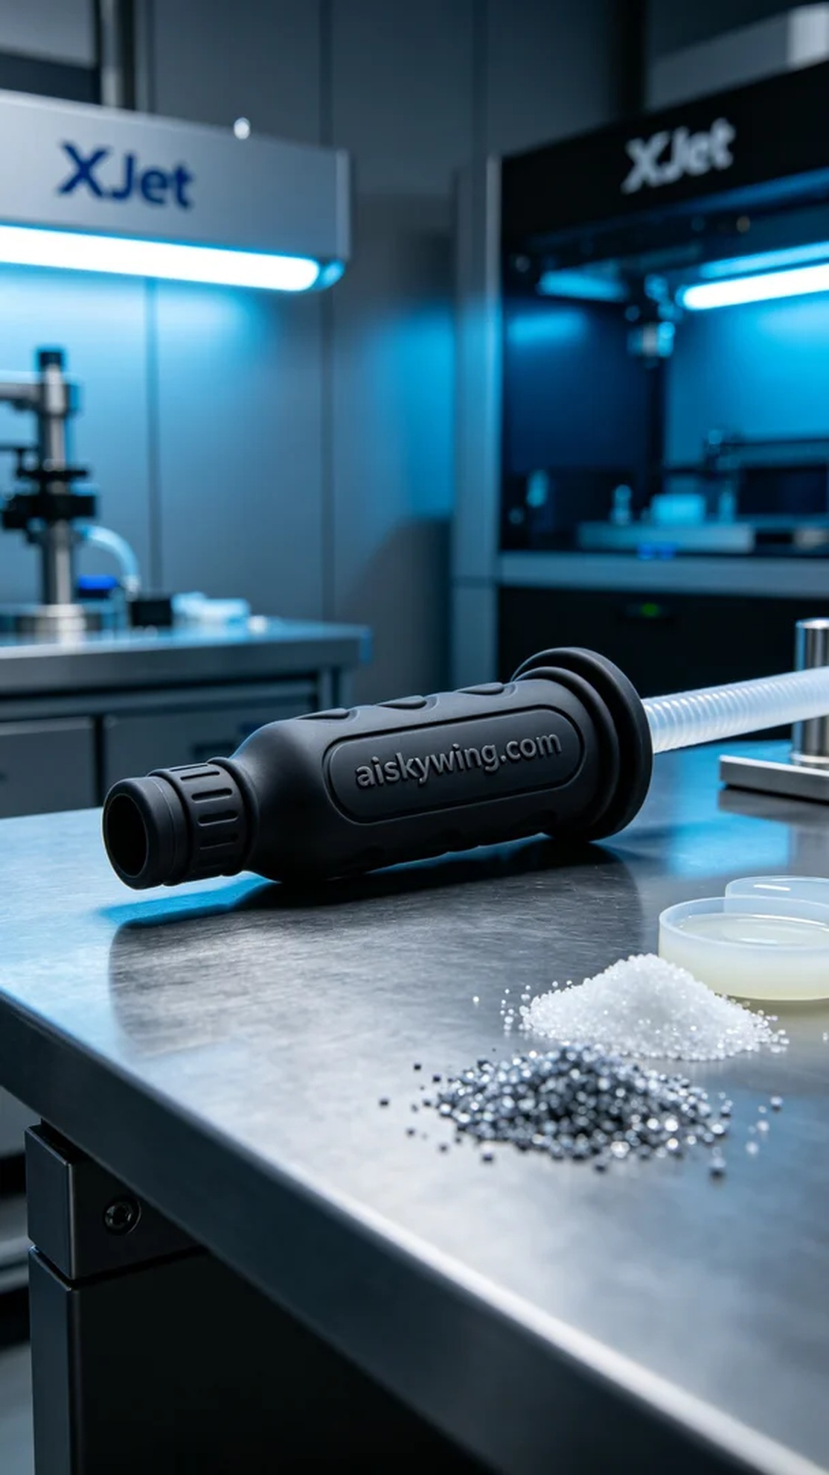
最近，有人因为医疗需求找到我们，希望制作一款高质量的医用引流管。这个产品不仅需要耐用，还要具备一定的柔性，以适应不同的使用环境。我们立即准备开始这个项目。
为了确保产品的质量，我们选择了硅胶复模作为原材料。硅胶的柔软和耐用特性非常适合医用器械，能在使用过程中提供良好的防滑效果。接着，我们使用Xjet打印机进行打印，设定层厚为0.1mm，打印温度保持在60摄氏度，功率为200W，速度设定在50mm/s，预计打印时间为4小时。
在打印过程中，我们仔细监控设备的运行状态，确保每个细节都达到预期。Xjet打印机的表现非常稳定，打印过程中没有出现任何异常情况。产品表面的细致纹理和清晰的雕刻字样让我们十分满意，硅胶材料在成型时的适应性也表现良好。
打印完成后，我们进行了全面的后处理工序。首先将产品浸泡在清洗液中，去除多余的光敏树脂。然后，采用细砂纸进行打磨，以确保表面光滑。接下来，将产品放置在固化设备中进行光固化，确保其耐用性和使用安全。最后，对每一件成品进行仔细的检验，确保没有瑕疵。
经过一系列的精细工序，医用引流管成功完成，达到预期效果。这不仅是我们技术的体现，更是我们为改善医疗质量而努力的结果。
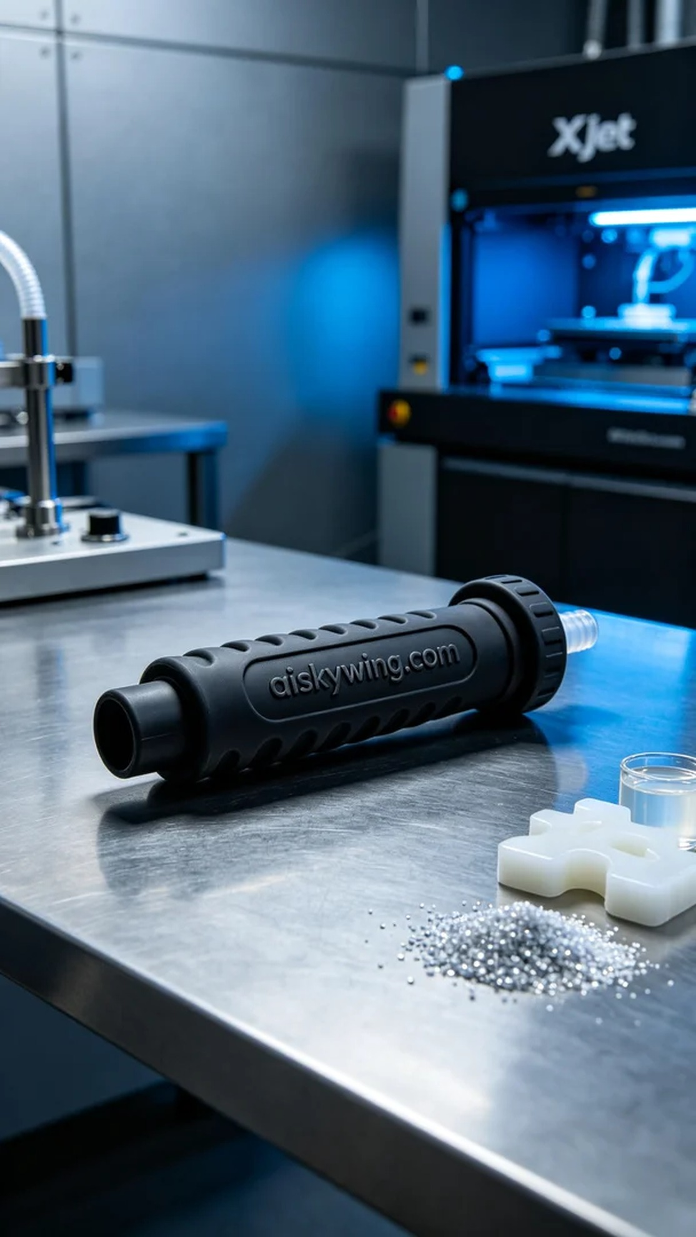
Aiskywing Industrial 3D Printing
Medical drainage tube


