1102-医用止液夹3D打印生产记录
Medical Liquid Clamp
🖨️ 硅胶复模
🖥️ 打印机: EOS
📦 材料: 硅胶复模
生活就像一块千变万化的画布，有时候需要我们用心去雕刻。有人找我们做这个医用止液夹，希望能解决他们在使用上的困扰，让每一个细节都完美无瑕。
Life is like a constantly changing canvas, sometimes requiring us to carve it with care. Someone approached us to create this medical fluid clamp, hoping to solve their usage issues and ensure that every detail is flawless.
________________________________________________________________________________
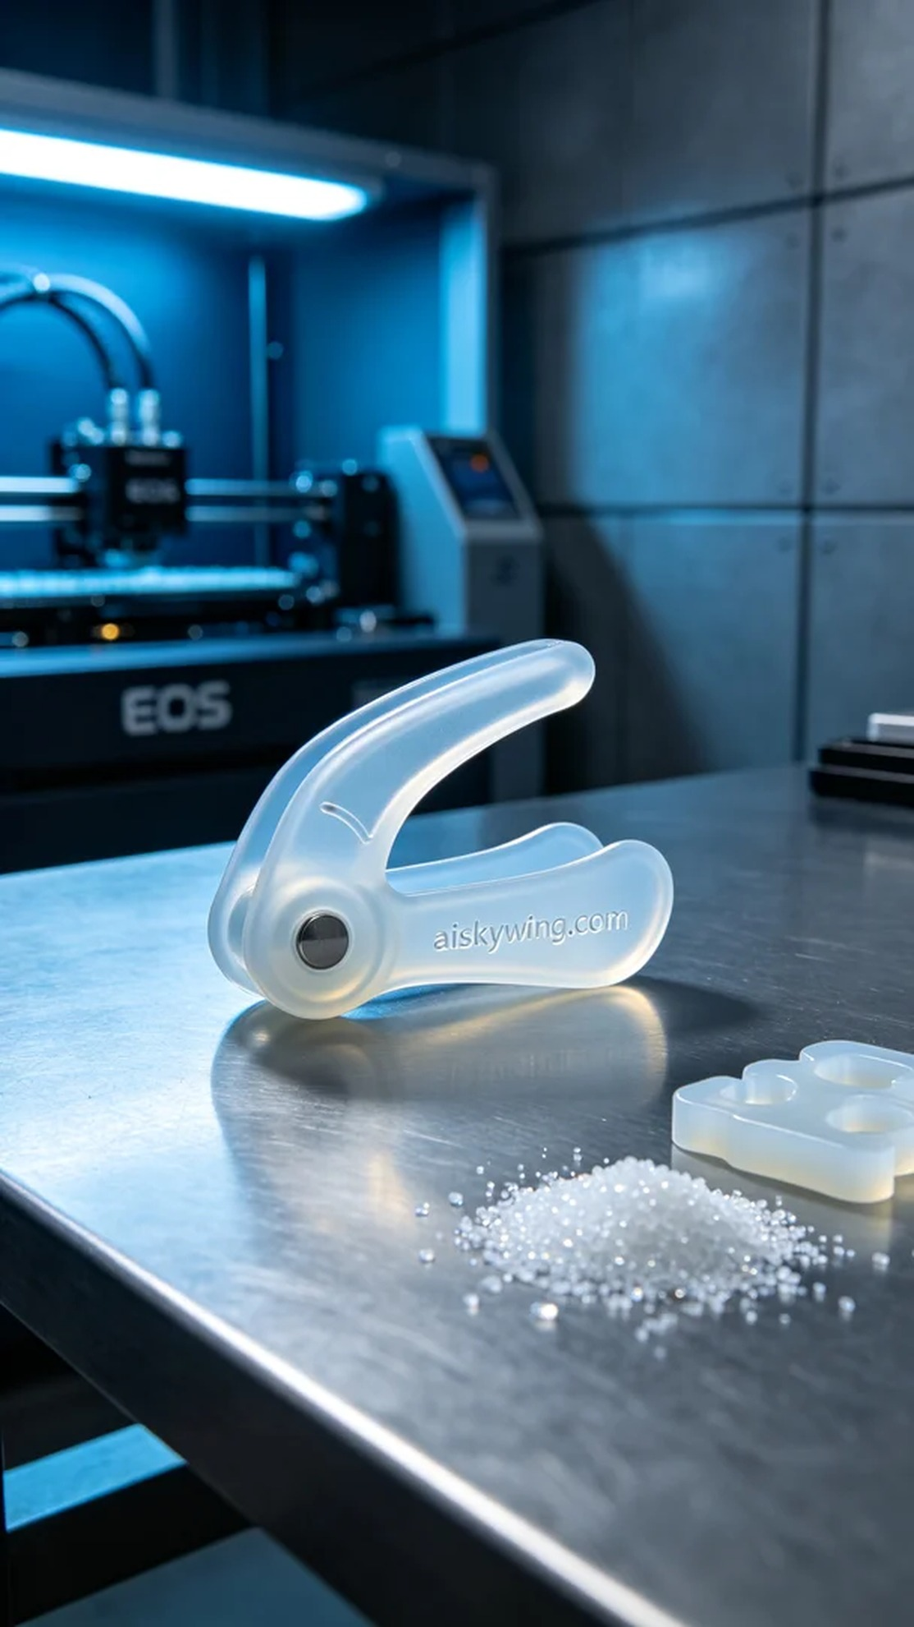
Life is a canvas that often requires us to carve out details with care. Someone contacted us on Twitter about the medical liquid clamp, hoping to solve some usability issues and achieve perfection in every detail.
We chose silicone replica molding as the raw material for this task due to its excellent softness and elasticity, making it ideal for medical devices. For the equipment, we used an EOS 3D printer and set the printing parameters: layer thickness of 0.1 mm, temperature at 60°C, power set to 95%, and a printing speed of 50 mm per second to ensure high-quality results.
During the printing process, the EOS printer operated steadily, with the print head moving continuously to layer the material. We monitored the print quality throughout to ensure there were no clogs or adhesion issues. After several hours of continuous printing, the medical liquid clamp began to take shape, with clear details and a smooth surface.
After printing, we carried out a thorough post-processing procedure. First, we placed the printed piece in a washing tank, using a specialized cleaning agent to remove any uncured resin from the surface. Next, we carefully sanded each edge to eliminate sharp burrs and conducted a secondary curing process to enhance the product's durability. Finally, we conducted rigorous quality inspections to ensure compliance with medical standards.
In the end, our medical liquid clamp was successfully completed, meeting the required functionality and quality. This was not just a production record but a perfect showcase of our technology and craftsmanship.
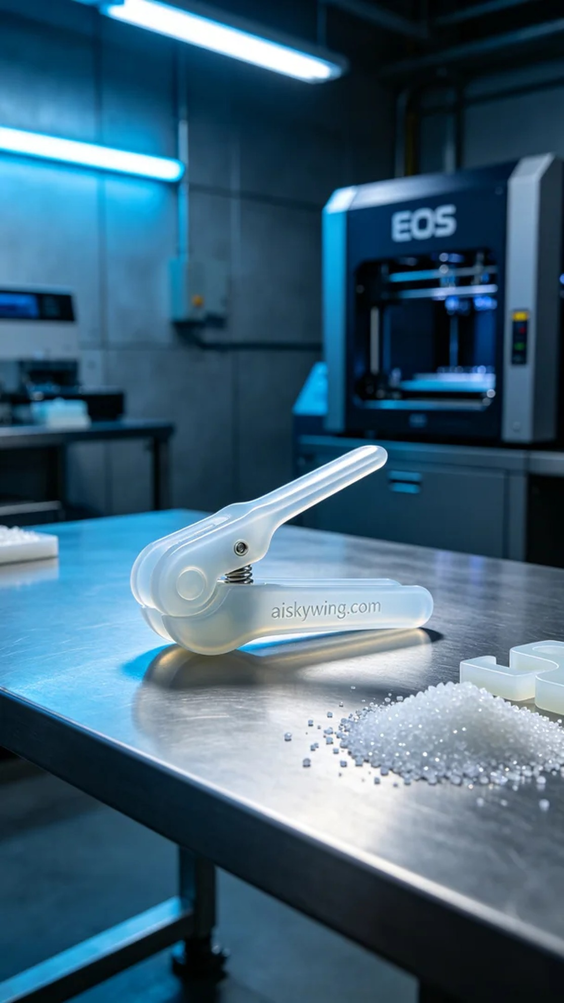
在社交平台Twitter上，有人因为现有的医用止液夹在使用时不够灵活，找到了我们，希望能制作一款更具弹性和适应性的产品。于是，我们接下了这个医用止液夹的制作任务，力求满足他们的需求。
我们选择了硅胶复模作为原材料，这种材料具有优异的柔软性和弹性，非常适合医疗器械的需求。设备准备方面，我们使用了EOS的3D打印机，设置了打印参数：层厚0.1毫米，温度为60°C，功率设置为95%，打印速度保持在50毫米每秒，以确保高质量的打印效果。
在打印过程中，EOS打印机稳定地运行着，打印头不停地移动，逐层叠加材料。我们全程监控打印质量，确保没有出现材料堵塞或层间粘连等问题。经过数小时的持续打印，医用止液夹逐渐成型，细节清晰可见，表面光滑。
打印完成后，我们进行了详细的后处理工序。首先，将打印件置于清洗槽中，使用专业的清洗剂去除表面未固化的树脂。接着，我们仔细打磨每个边缘，确保没有锐利的毛刺，并且再次进行固化处理，以增强产品的耐用性。最后，对成品进行了严格的质量检验，确保符合医用标准。
最终，我们的医用止液夹如预期般成功出炉，具备了所需的功能和品质。这不仅是一次生产记录，更是我们技术和工艺的一次完美展示。
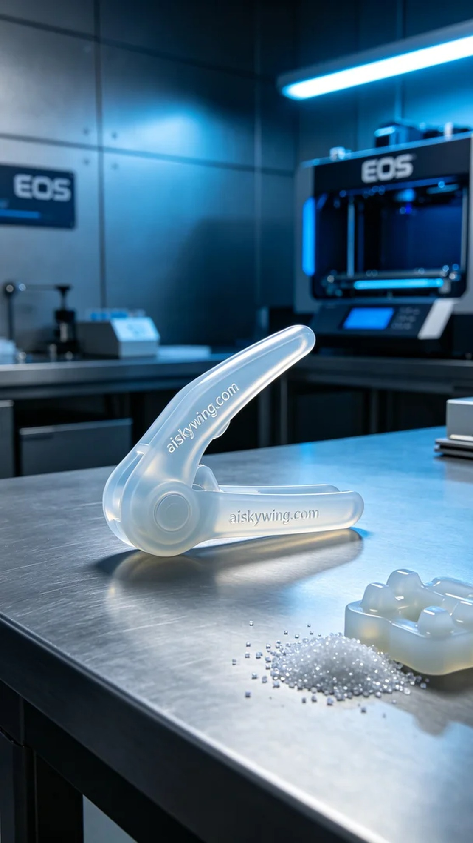
Aiskywing Industrial 3D Printing
Medical Liquid Clamp


