1103-医用注射器活塞3D打印生产记录
Medical syringe piston
🖨️ 硅胶复模
🖥️ 打印机: Mimaki
📦 材料: 硅胶复模
生活就像一场3D打印的旅程，只有坚持细节，才能塑造出完美的作品。就像我们这次制作的医用注射器活塞，不容有失。
Life is like a journey of 3D printing; only by paying attention to the details can we create a perfect masterpiece. Just like the medical syringe pistons we produced this time, there can be no mistakes.
________________________________________________________________________________
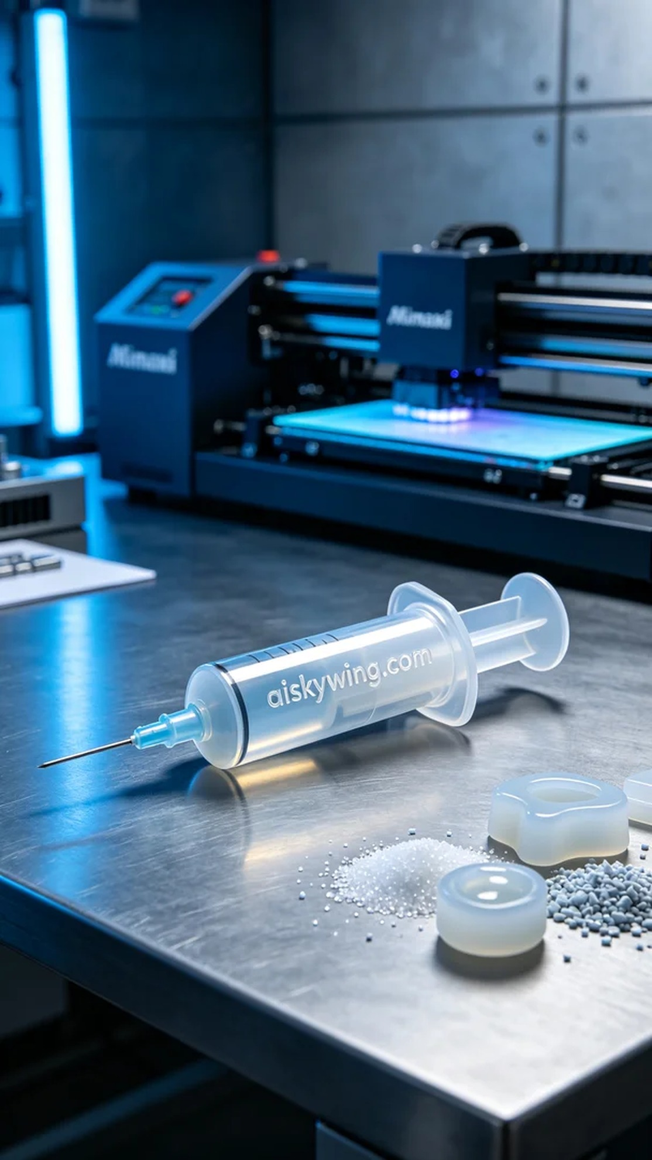
Recently, someone reached out to us because they needed a medical syringe piston. They hoped we could quickly and accurately produce a piston that met their standards for clinical use. So, we took on this challenge, ensuring that no detail was overlooked.
We used silicone replica material, which has excellent flexibility and transparency, making it perfect for manufacturing medical devices. To ensure high precision during the print, we set the parameters on the Mimaki printer to a layer thickness of 0.1mm, a temperature of 25 degrees Celsius, a print speed of 60mm per second, and a power setting of 80%. The entire printing process was estimated to take four hours.
During printing, the Mimaki printer operated quietly and efficiently like a precision craft machine. We regularly monitored the print quality to ensure that each layer adhered perfectly without bubbles or defects. As time passed, the piston gradually took shape, showcasing detailed textures and the engraved words "aiskywing.com."
After printing, we moved into the post-processing phase. First, we cleaned the finished product with a special cleaning solution to remove any residual photosensitive resin. Next, we sanded the surface with fine sandpaper to ensure a smooth touch. Finally, the piston was placed in a curing machine for solidification, ensuring its strength and stability, after which we conducted strict quality checks to ensure each product met the standards.
After a series of meticulous operations, we successfully completed the production of the medical syringe piston and achieved satisfying results. Each print is a learning experience, and we look forward to the next challenge.
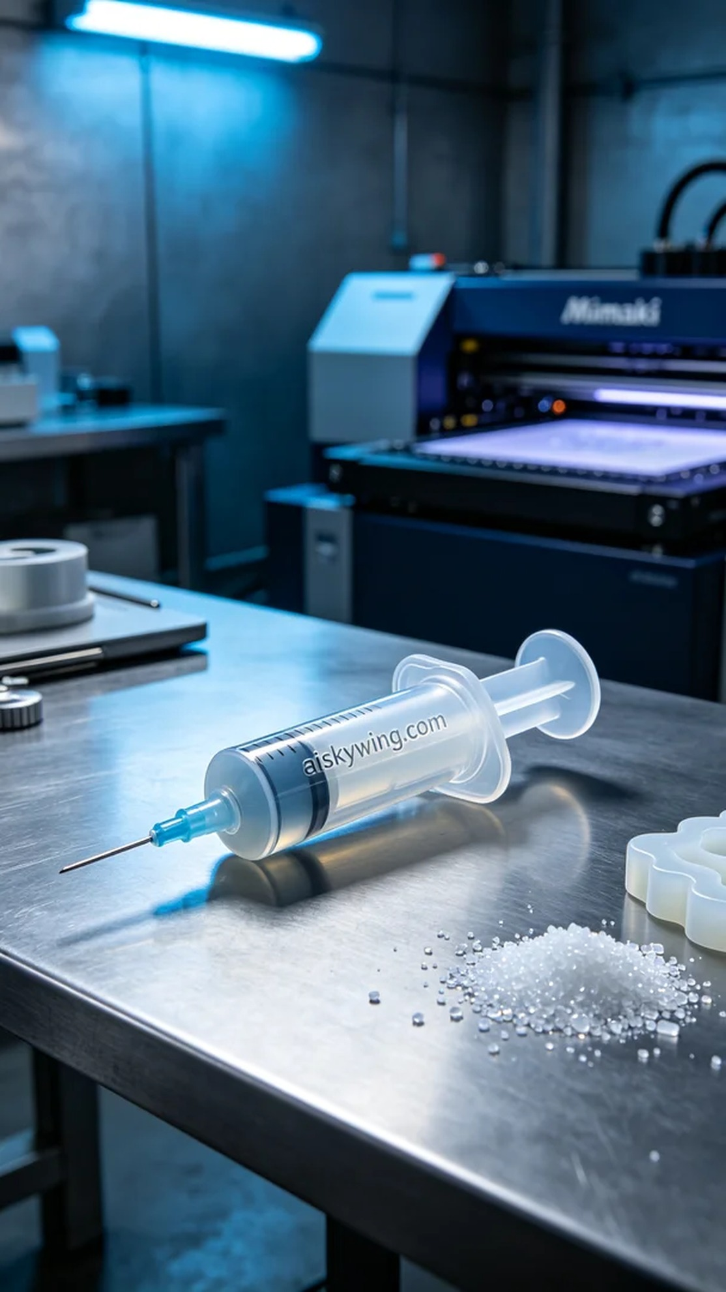
最近，有人因为对医用注射器活塞的需求而找到我们。他们希望我们能快速、精准地制作出符合他们标准的活塞，以便在临床上使用。于是，我们开始了这项挑战，确保每一个细节都不被忽视。
我们使用的是硅胶复模材料，这种材料具有极好的柔软性和透明度，非常适合制造医用设备。为了确保打印的高精度，我们将Mimaki打印机的参数设置为层厚0.1毫米，温度控制在25摄氏度，打印速度调整为60毫米每秒，功率设定在80%。整个打印过程预计需要4个小时。
打印过程中，Mimaki打印机如同一台精密的工艺机器，安静而高效地工作。我们定期监控打印质量，确保每一层都能贴合完美，没有气泡或瑕疵。随着时间的推移，活塞逐渐成型，展现出细致的纹理和"aiskywing.com"的雕刻字样。
打印完成后，我们进入了后处理阶段。首先，我们用专用清洗液对成品进行清洗，以去除残留的光敏树脂。接着，使用细砂纸对表面进行打磨，确保触感光滑。最后，将活塞放入固化机中进行固化处理，确保其强度和稳定性，完成后进行严格的品质检验，确保每个产品都符合标准。
经过一系列的精细操作，我们成功地完成了医用注射器活塞的生产，得到了令人满意的结果。每一次打印都是一次学习，我们期待下次的挑战。
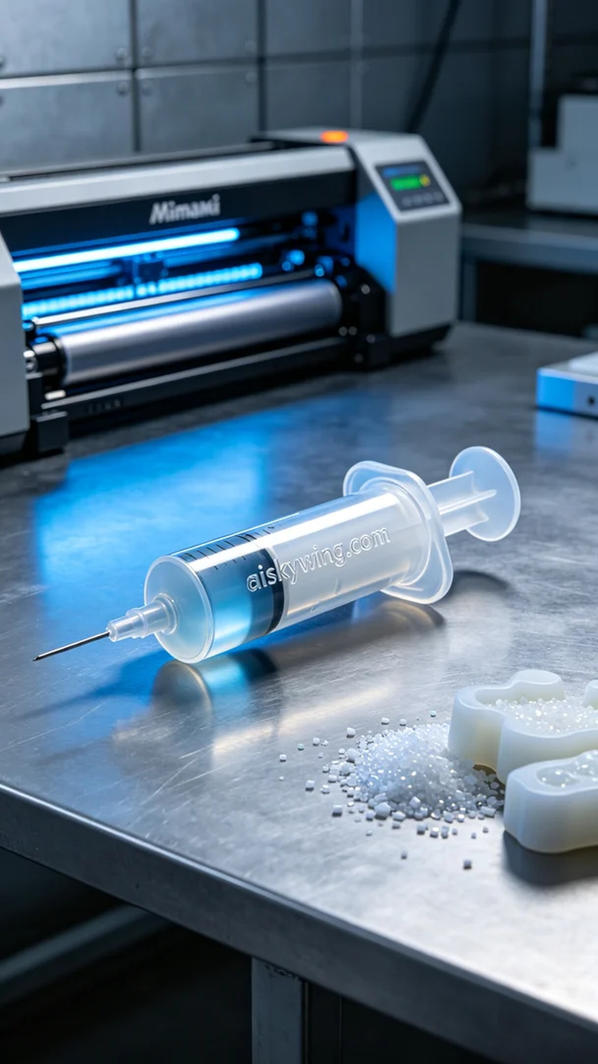
Aiskywing Industrial 3D Printing
Medical syringe piston


