1106-医用硅胶垫生产记录
Medical silicone pad
🖨️ 硅胶复模
🖥️ 打印机: Voxeljet
📦 材料: 硅胶复模
生活就像打印一样，细节决定成败。有时候有人在TikTok上看到医用硅胶垫，想要解决他们的使用问题，于是我们接下了这个项目。
Life is like printing; details determine success or failure. Sometimes, people see medical silicone pads on TikTok and want to solve their usage problems, so we took on this project.
________________________________________________________________________________
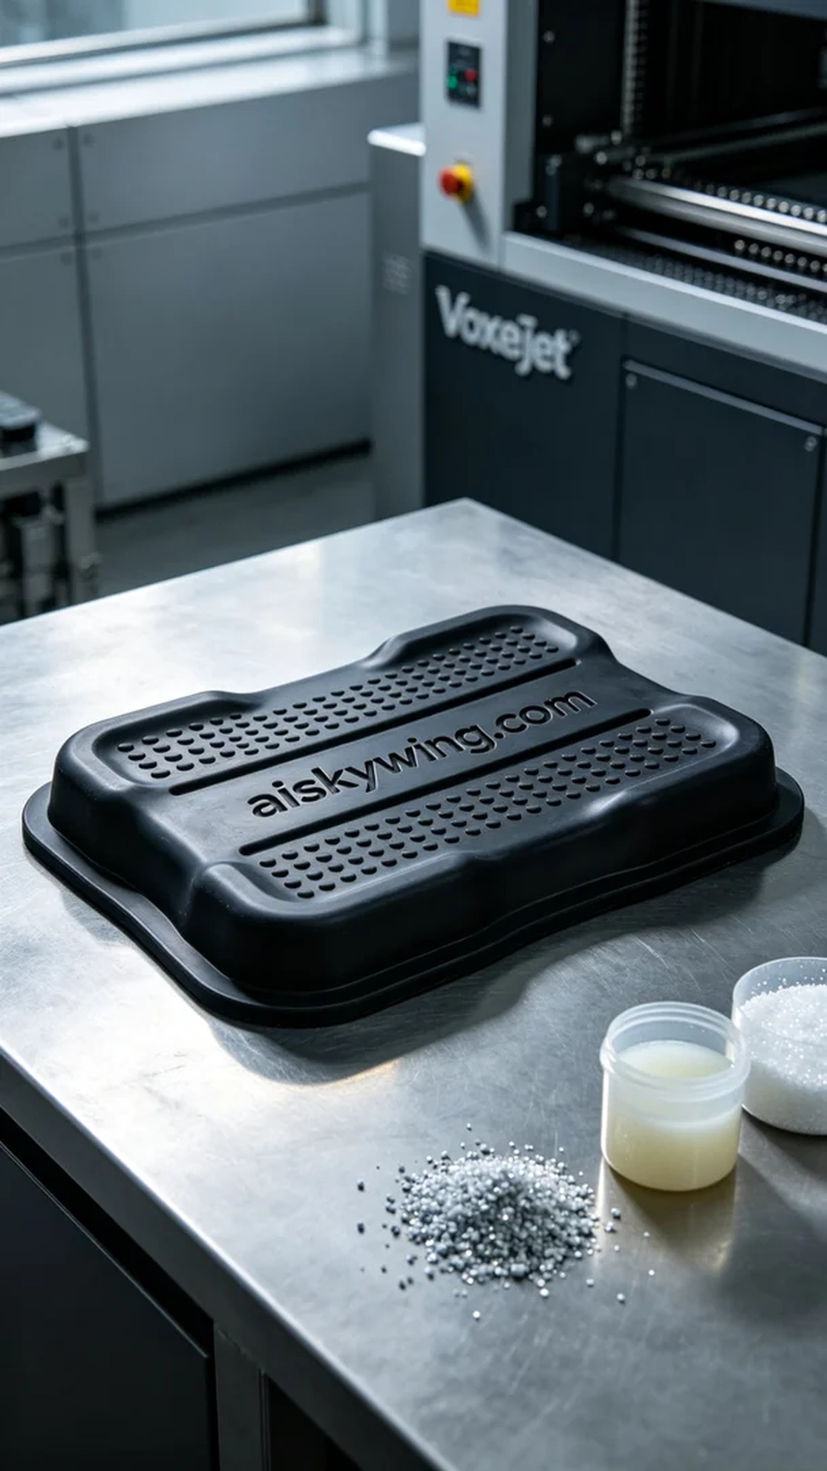
Life is like printing; details make all the difference. Sometimes, people see a medical silicone pad on TikTok and want to solve their usage problems, so we took on this project.
This time, we were tasked with creating a medical silicone pad. Someone saw this product on a social platform and wanted to use it to enhance the usability and comfort of medical devices. We decided to leverage advanced 3D printing technology to meet their needs, ensuring that every detail meets the highest standards.
For the materials, we chose high-quality silicone molding material. This material offers excellent flexibility and durability, with a surface design that provides effective slip resistance. To achieve a high-quality printing effect, we used the Voxeljet printer, setting a layer thickness of 0.1 mm, a printing temperature of 60°C, a power level of 85%, and a printing speed of 40 mm/s, with the entire process estimated to take 3 hours.
During the printing process, the Voxeljet printer operated smoothly, and we closely monitored the print quality. Each layer's deposition was carefully observed to ensure no bubbles or defects. As the printing progressed, the outline of the medical silicone pad became increasingly clear, with the machine's operation sound steady, filling us with confidence about the final result.
After printing, we carried out thorough post-processing. First, we cleaned the printed silicone pad to remove any residual resin. Next, we sanded the edges with fine sandpaper to ensure every corner was smooth and free of sharp edges. Finally, we placed it in a UV curing device to ensure the material's strength and durability met the standards. After curing, we conducted a comprehensive inspection to ensure each medical silicone pad met the expected requirements.
The production process concluded successfully, as the medical silicone pad not only looked exquisite but also performed satisfactorily. Through this experience, we once again appreciated the tremendous potential of 3D printing technology in enhancing product quality and functionality.
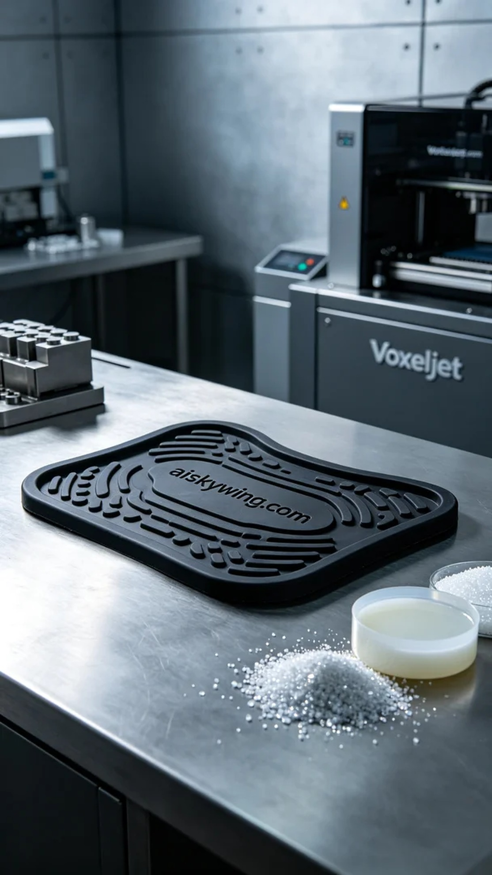
这次我们接到一个制作医用硅胶垫的需求。有人在社交平台上看到这个产品，希望用它来提升医疗器械的使用便捷性与舒适性。我们决定利用先进的3D打印技术来满足他们的需求，确保每个细节都能达到最高标准。
原材料方面，我们选择了高质量的硅胶复模材料。这种材料具有优秀的柔韧性和耐用性，表面设计的防滑纹理能有效提升使用安全性。为了获得优质的打印效果，我们使用了Voxeljet打印机，设置了层厚0.1毫米，打印温度为60℃，功率为85%，打印速度设定为40mm/s，预计整个打印过程需要3小时完成。
在打印过程中，Voxeljet打印机运转平稳，我们严格监控着打印质量。每一层的沉积都经过仔细观察，确保没有气泡或其他缺陷。随着打印的进行，我们能看到医用硅胶垫的轮廓逐渐清晰，设备的工作状态良好，并且发出的声音也十分规律，这让我们对最终效果充满信心。
打印完成后，我们进行了详尽的后处理。首先，将打印好的硅胶垫进行清洗，去除表面的树脂残留。接着，我们用细砂纸进行打磨，以确保每个边角都光滑无刺。最后，将其放置在UV固化设备中进行固化，确保材料的强度和耐用性达到标准。固化完成后，我们进行了全面的检验，确保每个医用硅胶垫都符合预期要求。
制作过程圆满结束，医用硅胶垫不仅外观精致，功能也令人满意。通过这样的经历，我们再次体会到了3D打印技术在提升产品质量和功能方面的巨大潜力。
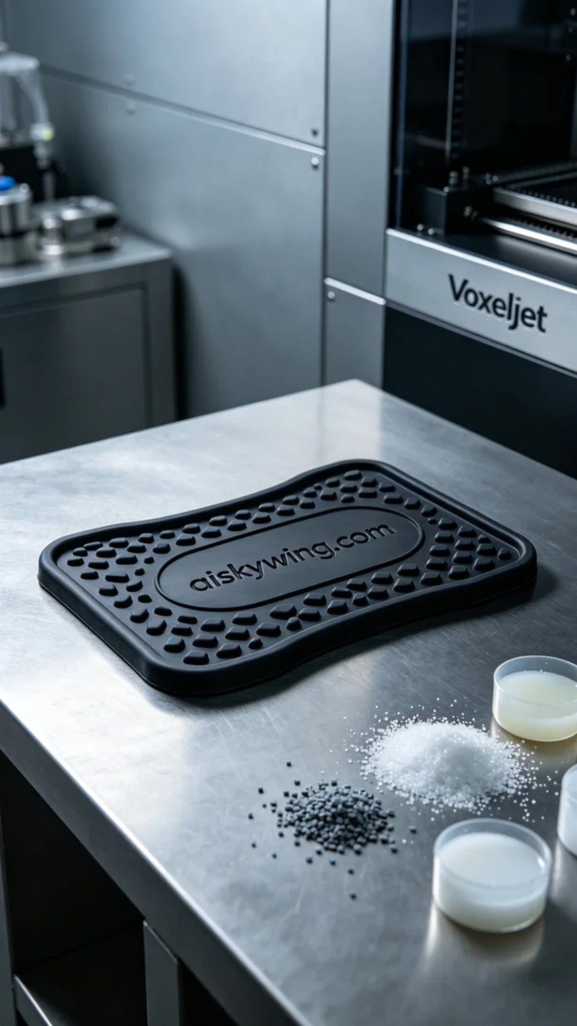
Aiskywing Industrial 3D Printing
Medical silicone pad


