1110-医用硅胶管3D打印生产记录
Medical silicone tube
🖨️ 硅胶复模
🖥️ 打印机: EOS
📦 材料: 硅胶复模
生活中的每个挑战都是一次成长的机会，就像今天我们接下了制作医用硅胶管的任务，准备在Instagram上展示我们的工艺成果。
Every challenge in life is an opportunity for growth, just like today we took on the task of producing medical silicone tubes and are preparing to showcase our craftsmanship on Instagram.
________________________________________________________________________________
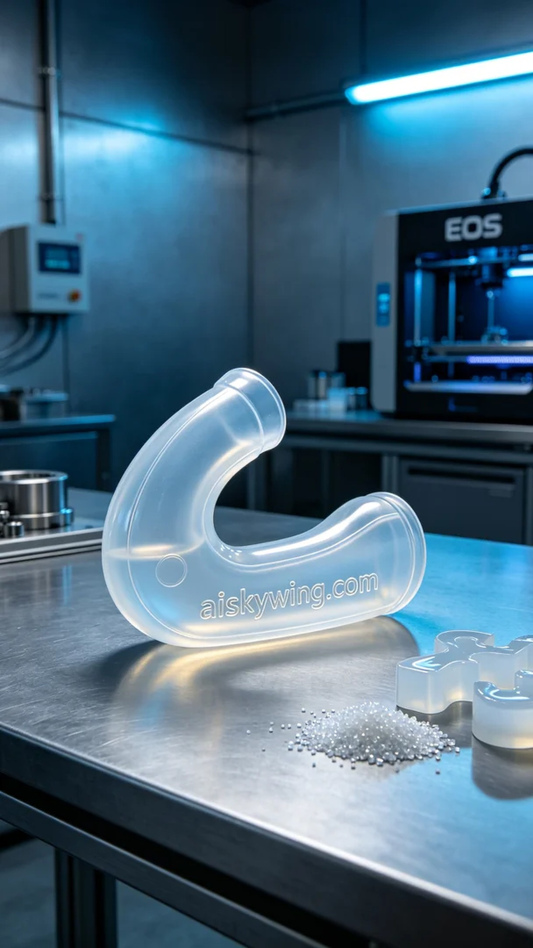
Every challenge in life is an opportunity for growth, just like today when we took on the task of creating a medical silicone tube, ready to showcase our craftsmanship on Instagram.
We chose silicone casting material for its high transparency and softness, making it suitable for ergonomic design. To ensure print quality, we utilized an EOS 3D printer, setting the layer thickness at 0.1mm, maintaining a printing temperature of 25 degrees Celsius, with a power setting of 80% and a print speed of 50mm per second, expecting a total print time of about 6 hours.
During the printing process, the performance of the EOS printer was remarkable, running smoothly and ensuring uniform deposition of each layer of material. We monitored the equipment closely, regularly checking the progress to ensure no faults or abnormalities occurred. Once completed, the contours of the silicone tube were sharp, and the engraved "aiskywing.com" text stood out distinctly.
Next came the post-processing steps. We first conducted a thorough cleaning of the final product with specialized cleaning solution to remove excess resin and impurities. Then, meticulous polishing was performed to enhance the surface smoothness. The silicone tube was placed in a curing device for precise curing, ensuring the material's strength and durability. Finally, comprehensive inspections were conducted to ensure each silicone tube met medical standards.
After a series of diligent efforts, today's outcome is finally complete. The medical silicone tubes were not only successfully printed but also met our expectations, leaving us feeling greatly satisfied.
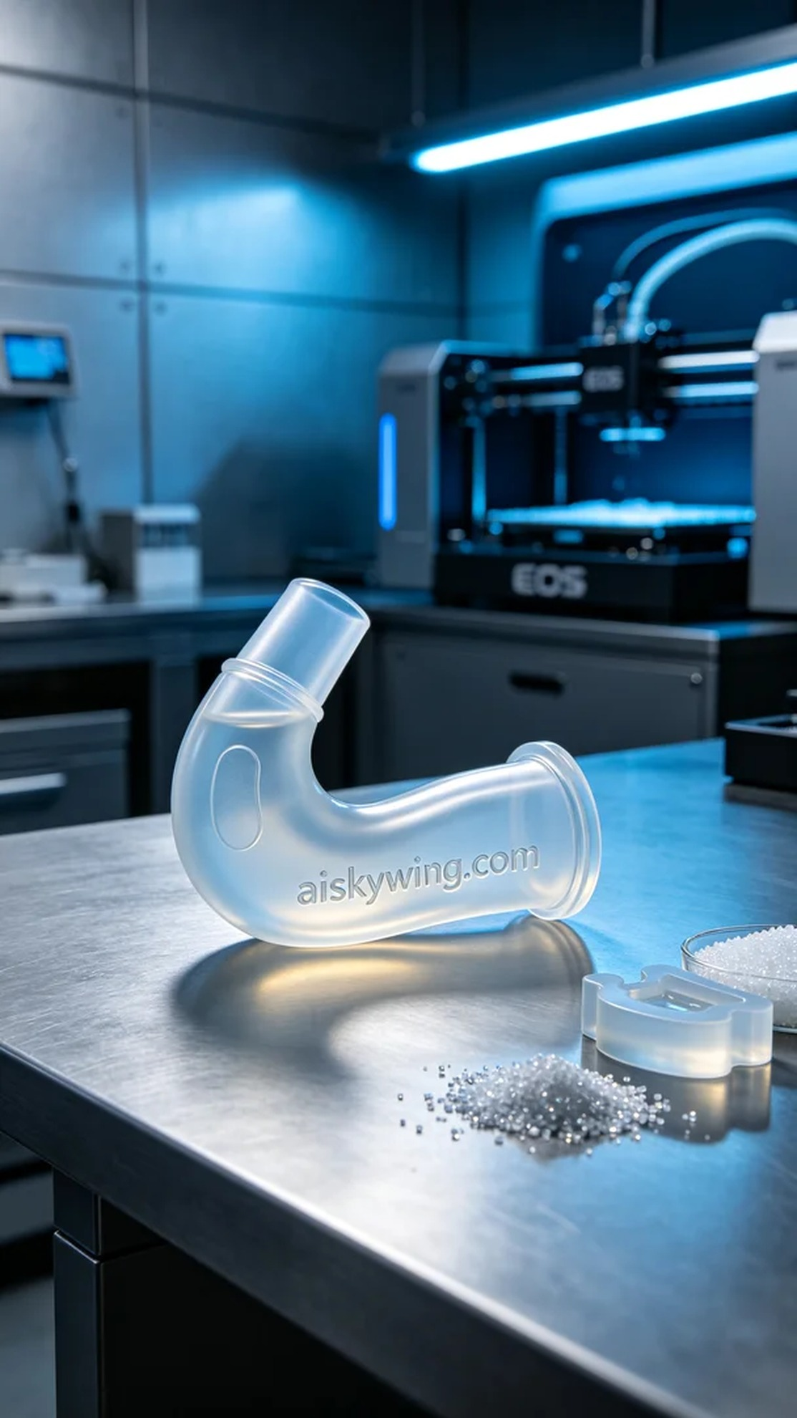
在Instagram上，有人因为急需一款医用硅胶管找到我们，希望我们能帮助他们解决医疗器械上的一些问题。为了满足他们的需求，我们决定利用3D打印技术来制作这款医用硅胶管。
我们选择使用硅胶复模材料，这种材料具有高度的透明度和柔软性，适合人体工程学设计。为了确保打印质量，我们使用EOS品牌的3D打印机，设置层厚为0.1毫米，打印温度保持在25摄氏度，功率设定在80%，打印速度为50毫米每秒，预计打印时间在6小时左右。
在打印过程中，EOS打印机的性能展现无遗，运行稳定，确保了每一层材料的均匀沉积。我们全程监督设备状态，定期检查打印进度，确保没有出现任何故障或异常情况。打印完毕后，我们看到的硅胶管轮廓清晰，表面雕刻的“aiskywing.com”字样也显得格外鲜明。
接下来是后处理工序。首先，我们用专用清洗液对成品进行彻底清洗，去除多余的树脂和杂质。然后进行细致的打磨，使表面更加光滑。接着将硅胶管放入固化设备中，进行精准固化，确保材料的强度和耐用性。最后，我们进行了全面的检验，以确保每一根硅胶管都符合医疗标准。
经过一系列的努力，今天的成果终于完成。医用硅胶管不仅成功打印，还达到了预期的效果，这让我们感到十分欣慰。
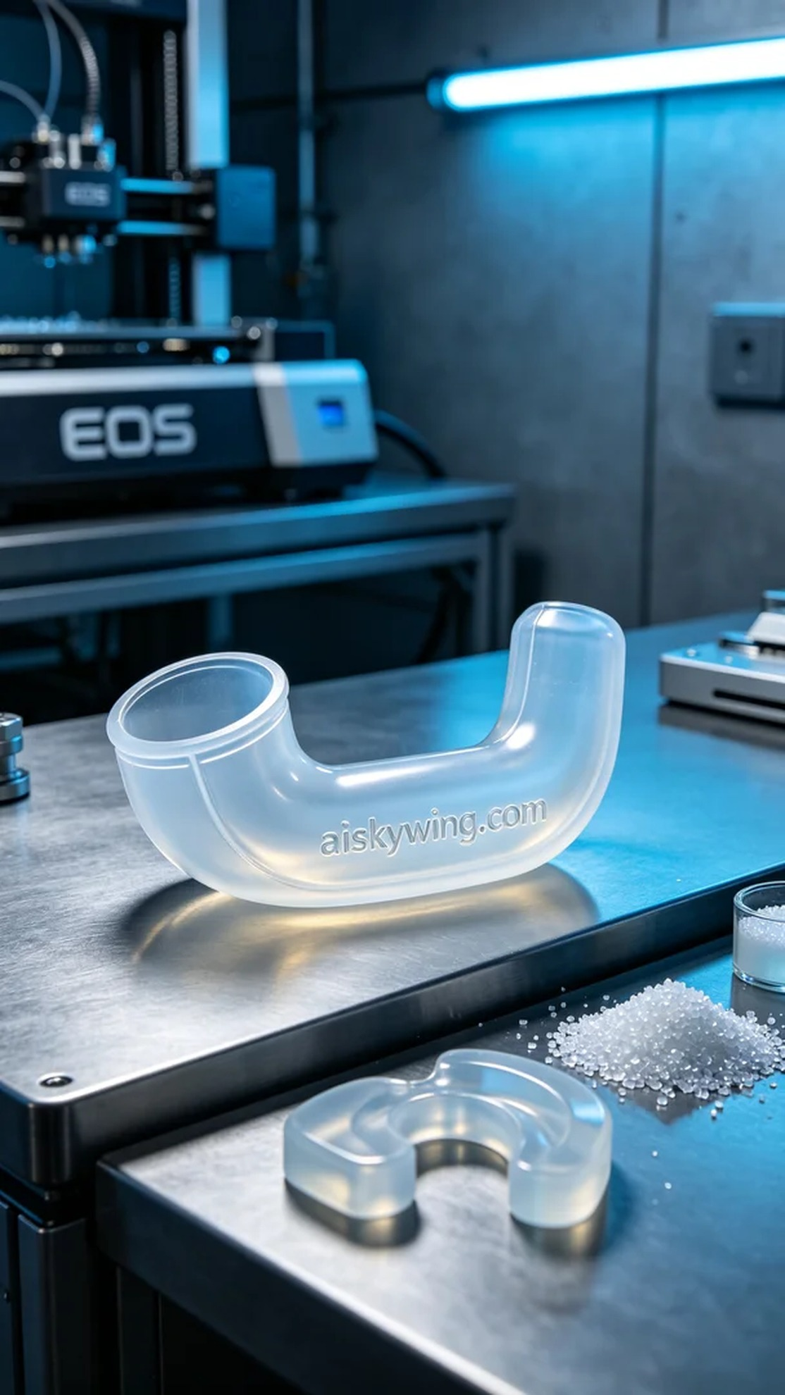
Aiskywing Industrial 3D Printing
Medical silicone tube


