1117-医用硅胶管接头3D打印生产记录
Medical silicone tube connector
🖨️ 硅胶复模
🖥️ 打印机: Voxeljet
📦 材料: 硅胶复模
在LinkedIn上，有人因为急需医用硅胶管接头而找到了我们。生活总是会给你意外的挑战，就像这次的订单。
On LinkedIn, someone reached out to us because they urgently needed medical silicone tube connectors. Life always presents unexpected challenges, just like this order.
________________________________________________________________________________
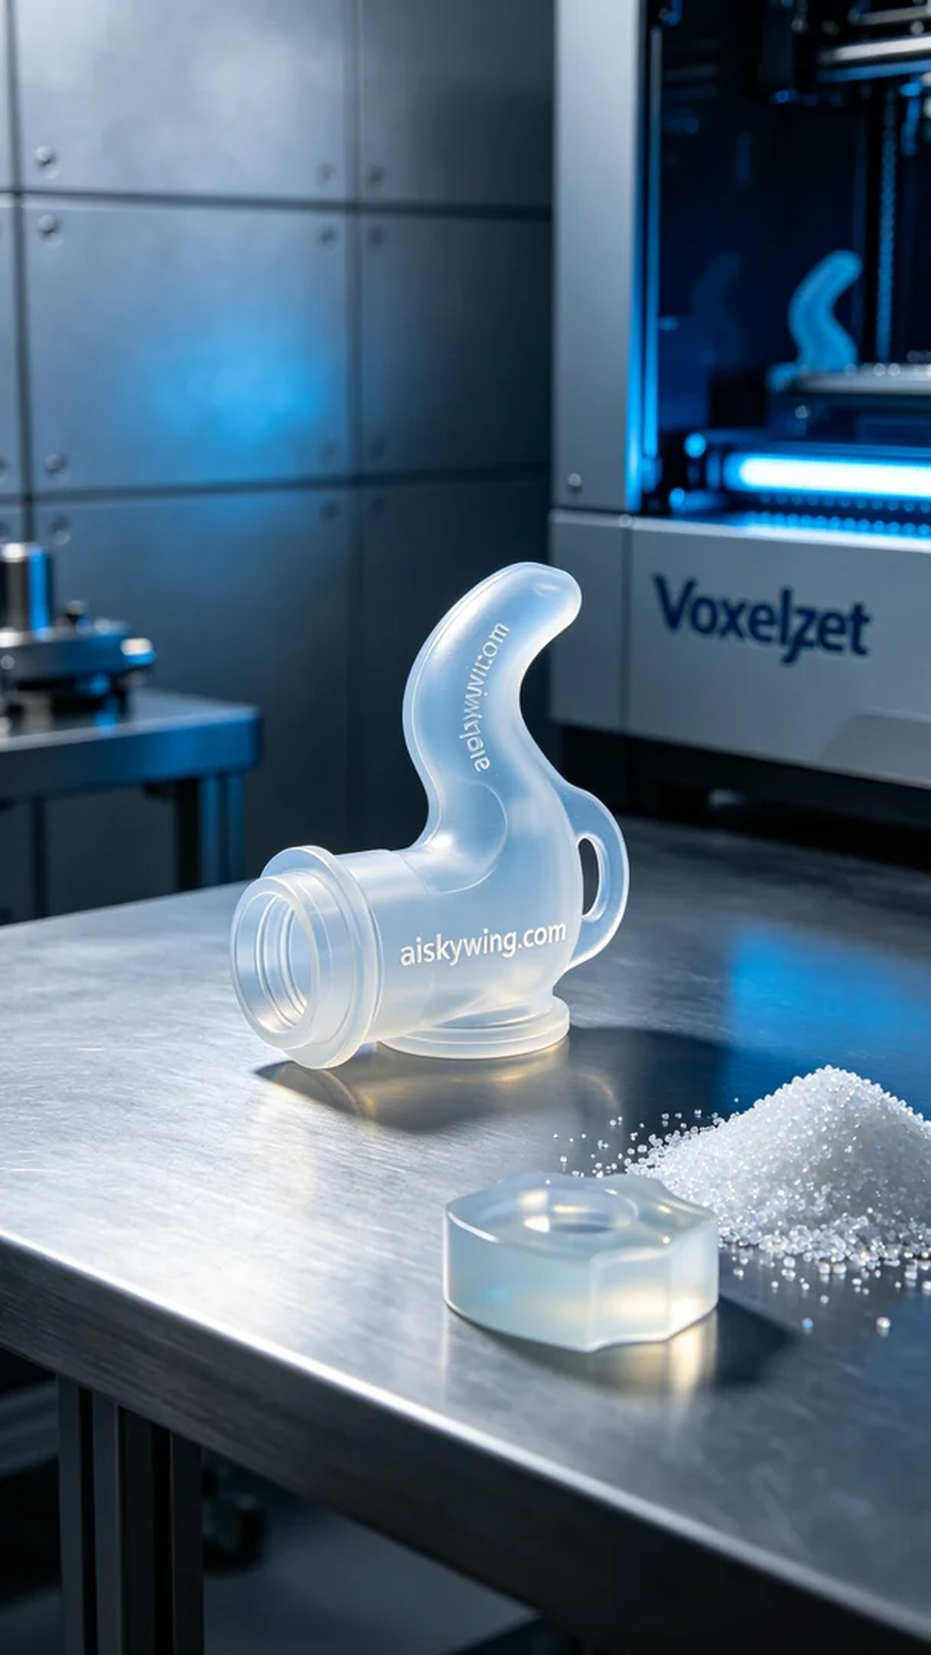
Recently, someone reached out to us on LinkedIn because they urgently needed a medical silicone tube connector. Life often throws unexpected challenges our way, just like this order did.
For this project, we prepared silicone molding material as it offers exceptional transparency and softness, making it ideally suited for medical applications. In terms of printing parameters, we opted for a fine layer thickness of 0.1mm, maintained a temperature of 25°C, set the power at 80%, and the printing speed was set to 60mm/s, with an estimated total print time of 4 hours using the Voxeljet printer.
During the printing process, the machine ran smoothly, and we monitored the screen closely to observe each layer's crisp details. We continuously checked the print status to ensure there were no defects while keeping the cooling system operational to prevent material warping.
Once printing was completed, we moved on to post-processing. We first placed the 3D printed part into the cleaning tank, using ultrasonic cleaning to remove any residual resin from the surface. Next, we meticulously sanded the surface for a smooth finish. During the curing phase, we placed the product evenly in the UV curing machine under ultraviolet light for 30 minutes, followed by a rigorous inspection to ensure each piece met our quality standards.
Through this production run, we successfully delivered a high-quality solution for the individual in need of a medical silicone tube connector, continuing our tradition of professionalism and dedication.
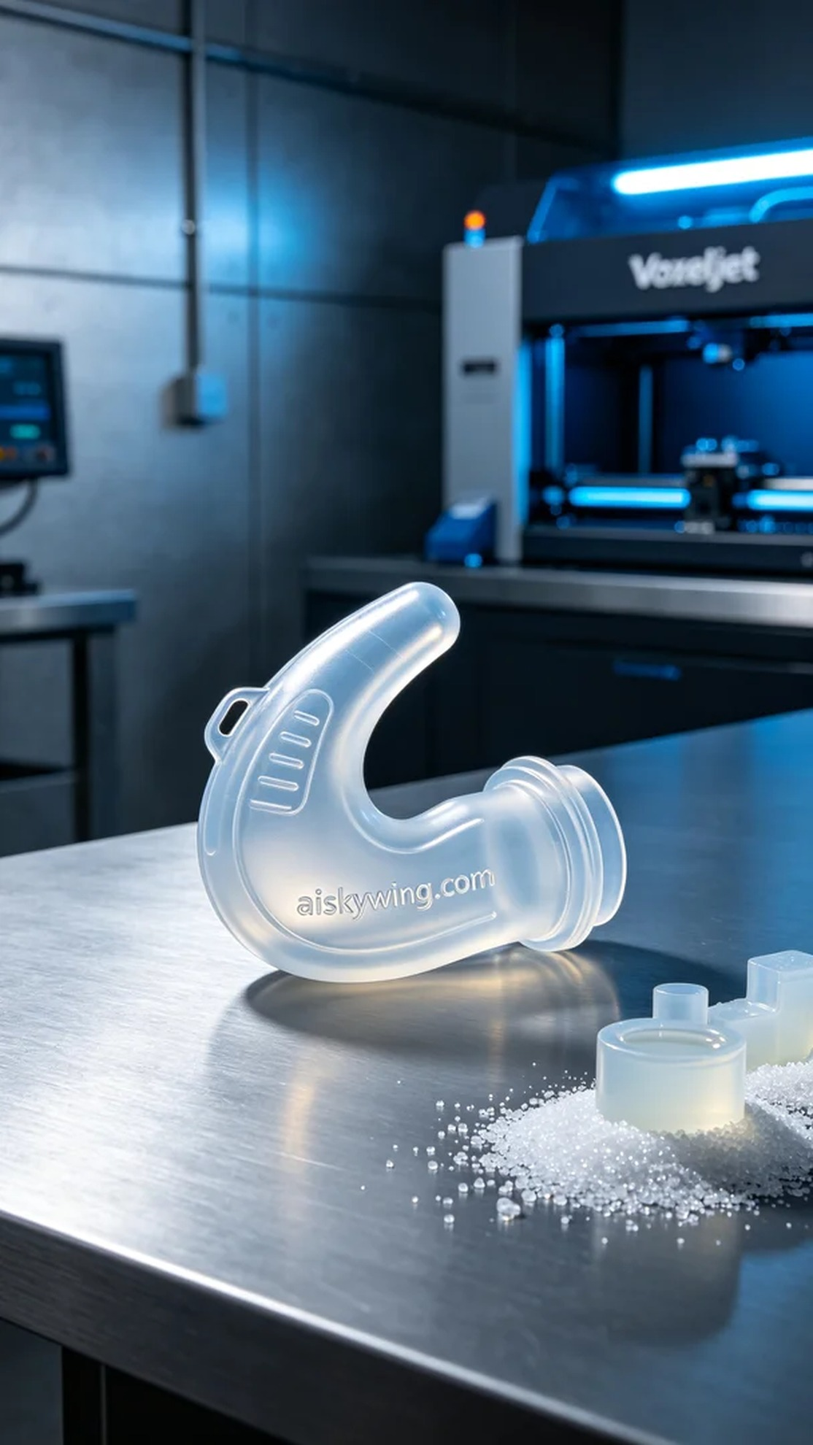
这次的任务是为一位需要医用硅胶管接头的人士提供解决方案。他们希望能够尽快得到高质量、符合人体工学设计的接头，以满足医疗设备的需求。我们决定使用硅胶复模材料来实现这个目标。
在打印之前，我们首先准备了硅胶复模材料。这种材料的透明柔软特性使其非常适合医疗用途，能够很好地贴合人体。打印参数设定上，我们选择了较为精细的层厚，设定为0.1毫米，温度保持在25摄氏度，功率设定为80%，打印速度为60mm/s，整个打印过程预计需要4个小时。我们使用了Voxeljet打印机，确保打印质量。
打印过程中，设备运行得十分顺利。在监控屏幕上，我们注意到层层叠加的细节清晰可见。通过不断地检查打印状态，确保没有出现任何瑕疵，同时保持冷却系统的正常运作，以避免材料变形。
打印完成后，我们进入了后处理工序。首先将3D打印件放入清洗槽，使用超声波清洗确保去除表面残留的树脂。接下来进行打磨，将表面进行细致处理，确保光滑。固化环节中，我们将产品均匀放置在UV固化机内，让其在紫外线照射下固化了30分钟，最后进行严格的检验，以确保每一件产品都符合标准。
通过这次生产，我们成功地为需要医用硅胶管接头的人士提供了高质量的解决方案，延续了我们一贯的专业和敬业精神。
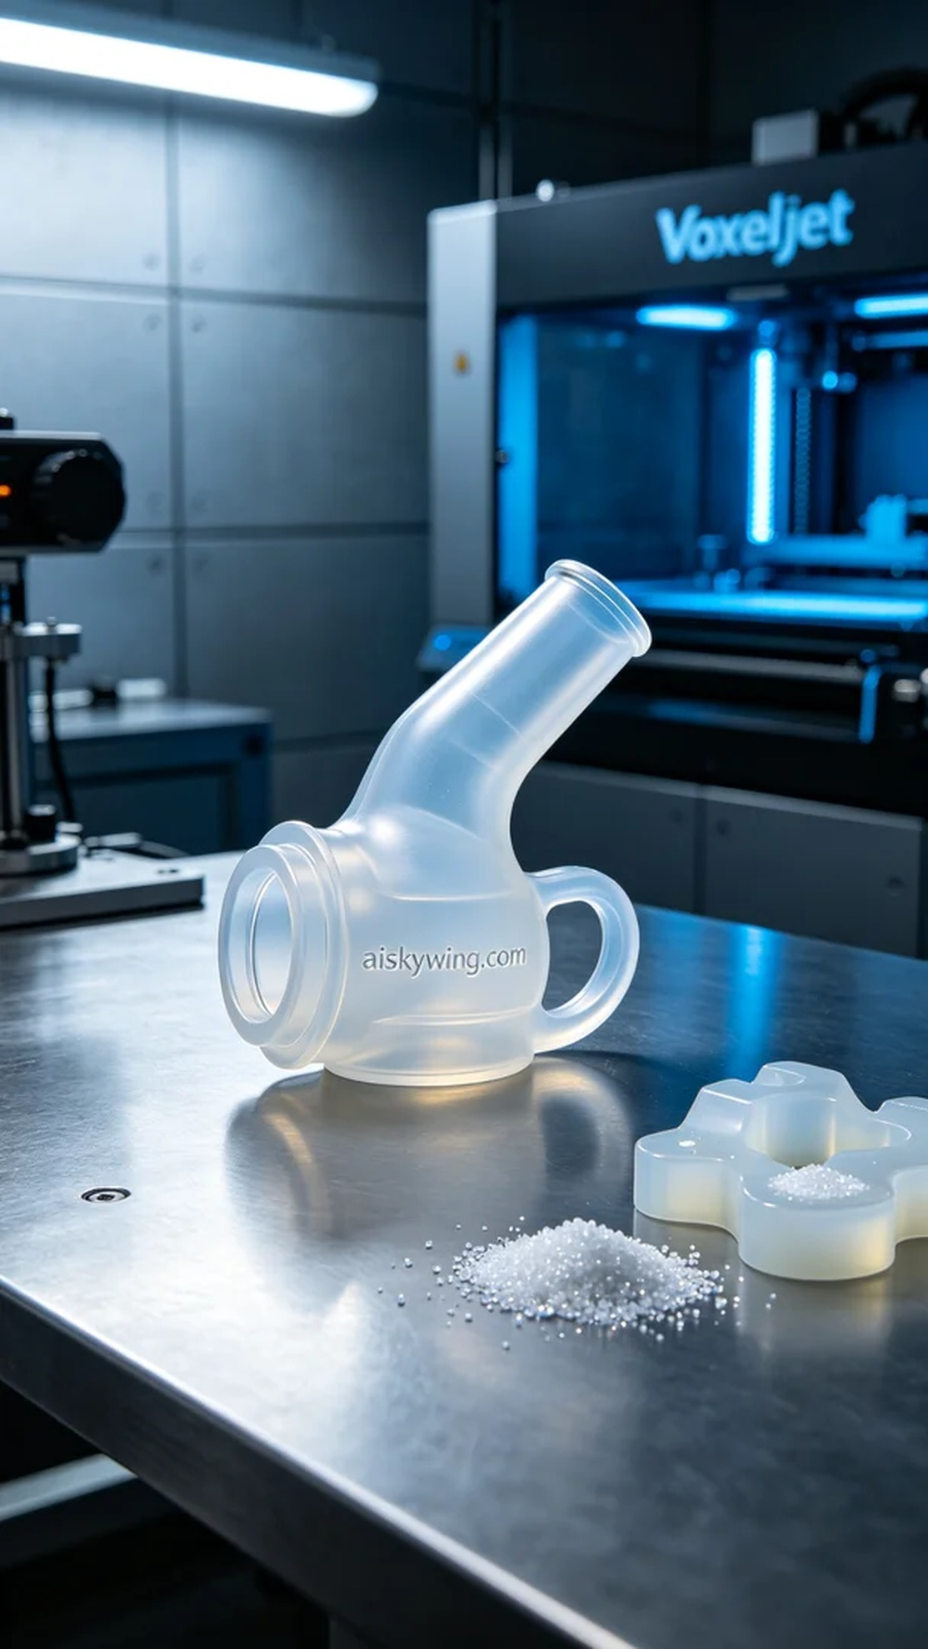
Aiskywing Industrial 3D Printing
Medical silicone tube connector


