1118-医用硅胶面罩的3D打印生产记录
Medical silicone mask
🖨️ 硅胶复模
🖥️ 打印机: Rize
📦 材料: 硅胶复模
生活就像3D打印，每一步都是积累，最终成型的医用硅胶面罩让我们看到希望。有些人在TikTok上寻找解决方案，我们应运而生。
Life is like 3D printing; every step is accumulation, and the final molded medical silicone mask gives us hope. Some people are looking for solutions on TikTok, and we have emerged to meet that need.
________________________________________________________________________________
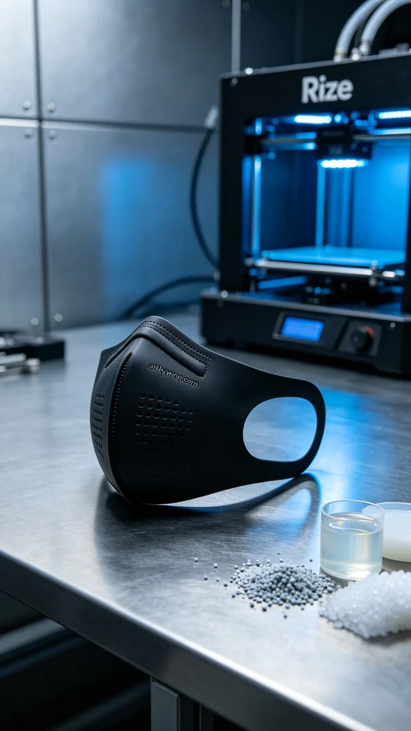
Recently, someone mentioned on TikTok their need for a medical silicone mask to enhance comfort and safety during medical procedures. This prompted us to get to work on this task. The medical silicone mask design requires not only high precision but also excellent flexibility and durability.
We opted for silicone casting material, known for its excellent flexibility and anti-slip texture, ideal for mask production. For this task, we used a Rize printer, setting parameters to a layer thickness of 0.1mm, a print temperature of 200°C, a power setting of 80%, and a printing speed of 60mm/s, with an expected print time of about 4 hours. Such settings ensured that we could achieve sharp details in the printed mask.
During the printing process, the Rize printer operated steadily, layer by layer. We monitored the print quality closely, ensuring that each layer bonded perfectly, especially the engraving of "aiskywing.com" on the mask's surface, which needed to be clearly visible. The rhythmic sound of the machine blended with our rigorous pursuit of product quality, creating an inspiring atmosphere.
After printing, we moved on to the post-processing phase. First, we placed the finished product into a cleaning tank, using an ultrasonic cleaner to remove any excess liquid photopolymer resin from the surface. Next, we meticulously sanded the mask to ensure the edges were smooth. Then, we placed the mask into a curing machine for UV curing to ensure material stability and durability. Finally, we conducted a comprehensive inspection to ensure every detail met the standards.
After a series of intricate processes, the medical silicone mask was finally completed. This isn’t just a product; it’s our commitment to every user, and we look forward to its significant role in medical practice.
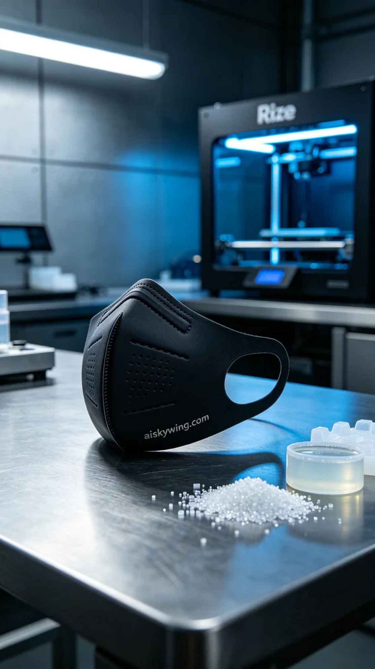
最近，有人在TikTok上提到他们需要一种医用硅胶面罩，寻求解决医疗操作中的舒适性和安全性。这让我们立刻着手准备，开始了这项任务。医用硅胶面罩的设计要求不仅要高精度，还要具备良好的柔韧性和耐用性。
我们选择使用硅胶复模材料，这种材料具有优良的柔性和防滑纹理，适合制作面罩。设备上我们使用的是Rize打印机，设置参数为层厚0.1mm，打印温度为200°C，打印功率设定为80%，打印速度为60mm/s，预计打印时间约为4个小时。这样的设置能够确保打印出清晰锐利的细节。
打印过程中，Rize打印机的运行稳定，逐层推进。我们时刻监控着打印质量，确保每一层都能完美结合，特别是面罩表面雕刻的“aiskywing.com”字样要清晰可见。设备的运行声中夹杂着对产品品质的严谨追求，令人振奋。
打印完成后，我们进入后处理阶段。首先将成品放入清洗槽中，使用超声波清洗器去除表面多余的液态光敏树脂。接着，我们对面罩进行细致的打磨，以确保边缘的光滑度。之后，将面罩放入固化设备中，进行UV固化，确保材料的稳定性与耐用性。最后，我们进行全面检验，确保每一个细节都达到标准。
经过一系列精细的流程，医用硅胶面罩终于完成。这不仅仅是一份产品，更是我们对每一位使用者的承诺，期待它能够在医疗工作中发挥重要作用。
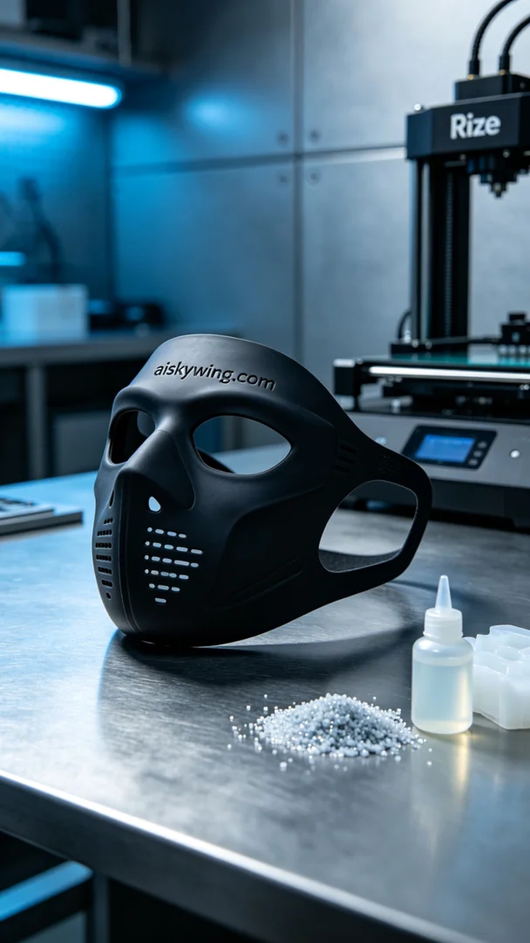
Aiskywing Industrial 3D Printing
Medical silicone mask


