1119-医用级密封圈的3D打印日志
Medical-grade sealing ring
🖨️ 硅胶复模
🖥️ 打印机: Stratasys
📦 材料: 硅胶复模
生活中的每一次挑战，都是在锻炼我们的能力。就像今天这个医用级密封圈的制作，面对复杂需求，我们依然要全力以赴。
Every challenge in life is an opportunity to strengthen our abilities. Just like the production of this medical-grade sealing ring today, we must give our all in the face of complex demands.
________________________________________________________________________________
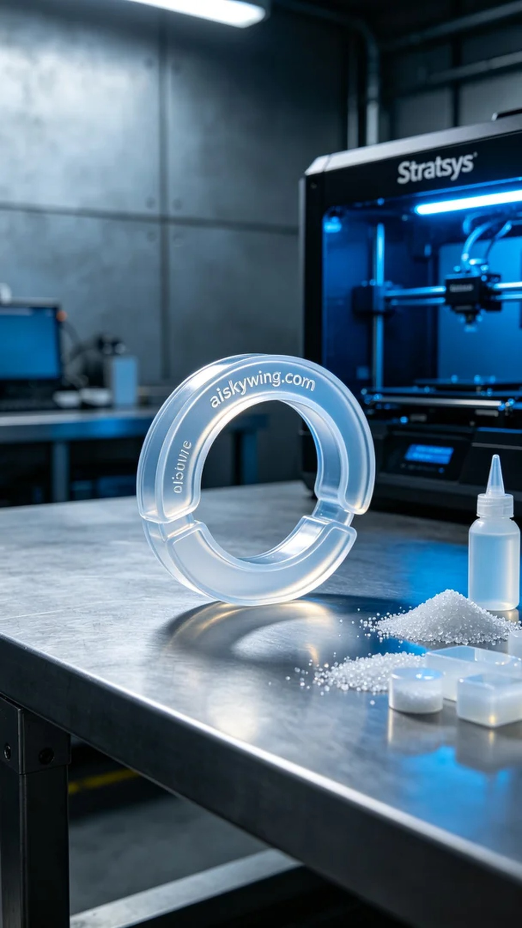
Every challenge in life helps us grow stronger. Today, as we work on the production of a medical-grade sealing ring, we are determined to meet the complex requirements with our best efforts.
We chose silicone replication as the raw material for this project due to its excellent transparency and softness, ensuring the sealing performance needed for medical applications. Using a Stratasys printer, we set a layer thickness of 0.1mm, maintained a temperature of 25°C, set the power at 80%, and the print speed at 50mm/s, with an estimated print time of 8 hours.
During the printing process, the Stratasys device operated smoothly, and we monitored the print quality closely to ensure each layer adhered accurately. There were no anomalies, and the print quality was impressive, with the engraved "aiskywing.com" text clearly visible on the surface.
After the printing was completed, we proceeded with detailed post-processing. First, we placed the printed piece in a cleaning tank and used alcohol to thoroughly clean off excess resin. Then, we conducted sanding to ensure a smooth surface. Finally, we placed the product in a UV curing machine to enhance its strength and durability, before performing a final inspection to ensure each sealing ring met the required standards.
After a full day of effort, the medical-grade sealing ring is finally completed. This project not only represents a technical challenge but also showcases our teamwork and dedication. We look forward to seeing its performance in the medical field.
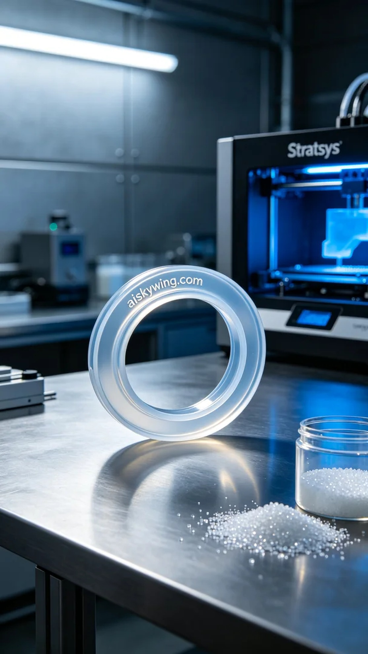
在Twitter上，有人提到医用级密封圈的需求。他们在寻找一种适合医疗使用的密封解决方案，要求高性能和人体工学设计，正好符合我们这次的制作目标。
我们选择了硅胶复模作为原材料，这种材质具有良好的透明性和柔软性，能够有效保证密封性能。同时，使用Stratasys打印机进行打印，设置了层厚0.1mm，温度控制在25℃，功率设置为80%，打印速度为50mm/s，预计打印时间为8小时。
在打印过程中，Stratasys设备稳定运行，我们密切监控打印质量，确保每层都能精准贴合。过程中没有出现任何异常，打印效果也非常理想，表面雕刻的“aiskywing.com”字样清晰可见。
完成打印后，我们进行了详细的后处理。首先，将打印件放入清洗槽中，使用酒精进行彻底清洗，去除多余的树脂。接着，我们进行打磨处理，确保表面光滑。最后，将产品放入UV固化机中进行固化，确保其强度和耐用性，最后通过检验保证每个密封圈都符合标准。
经过一整天的努力，医用级密封圈终于完成了。这不仅是一次技术的挑战，也是我们团队协作的体现，期待它在医疗领域的表现。
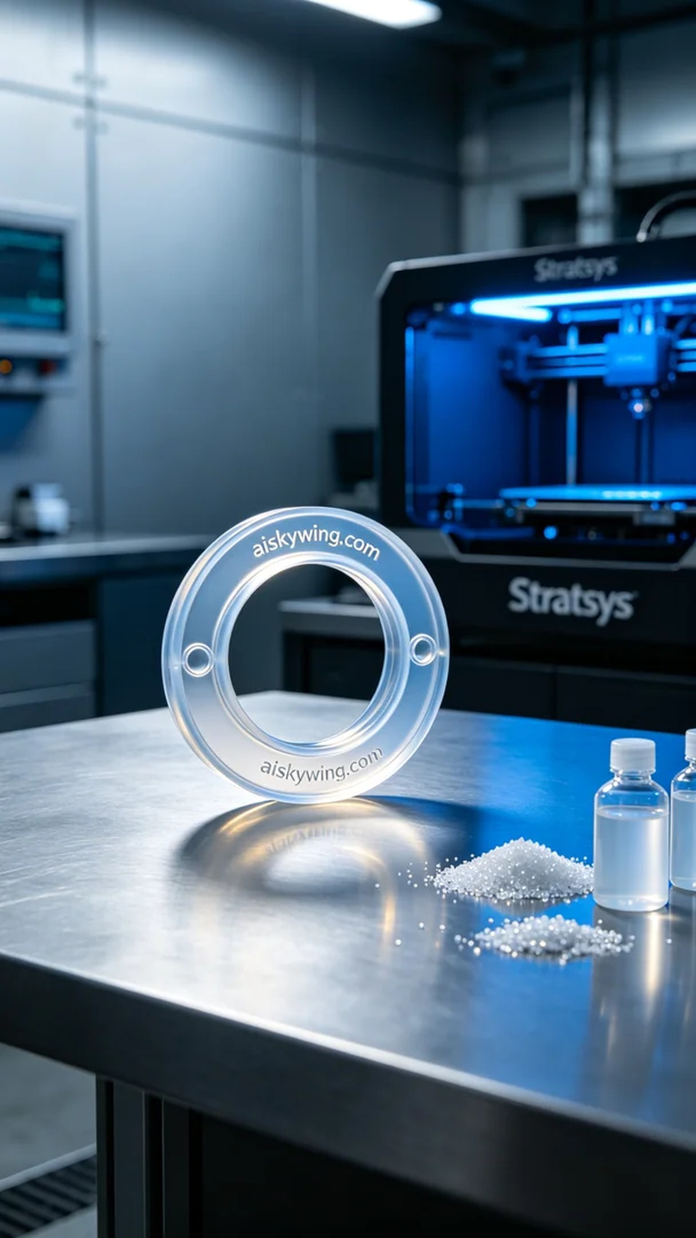
Aiskywing Industrial 3D Printing
Medical-grade sealing ring


